**OUTPUT:**

**Add Student:**

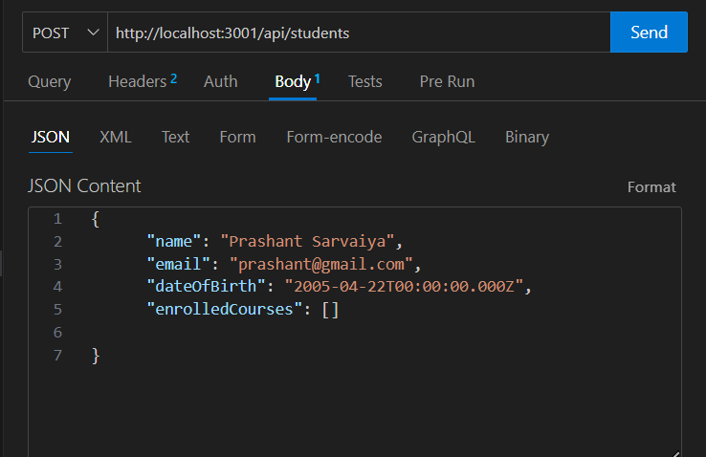

**ADD Course :**

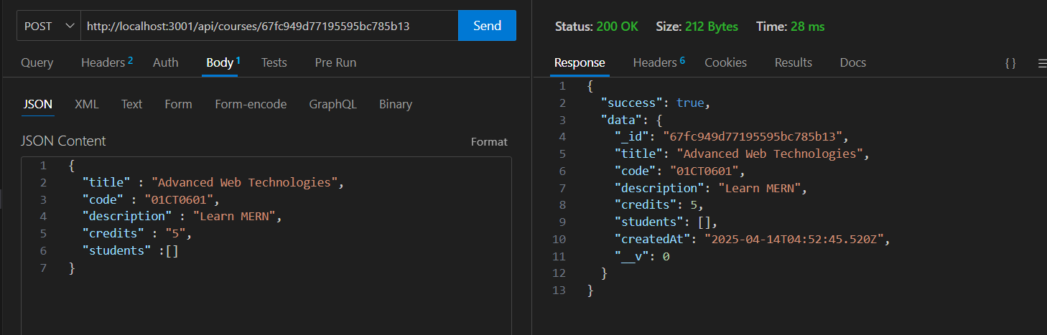

**Assign Course:**

