**Step 1 : Make a repository and commit any app into that**

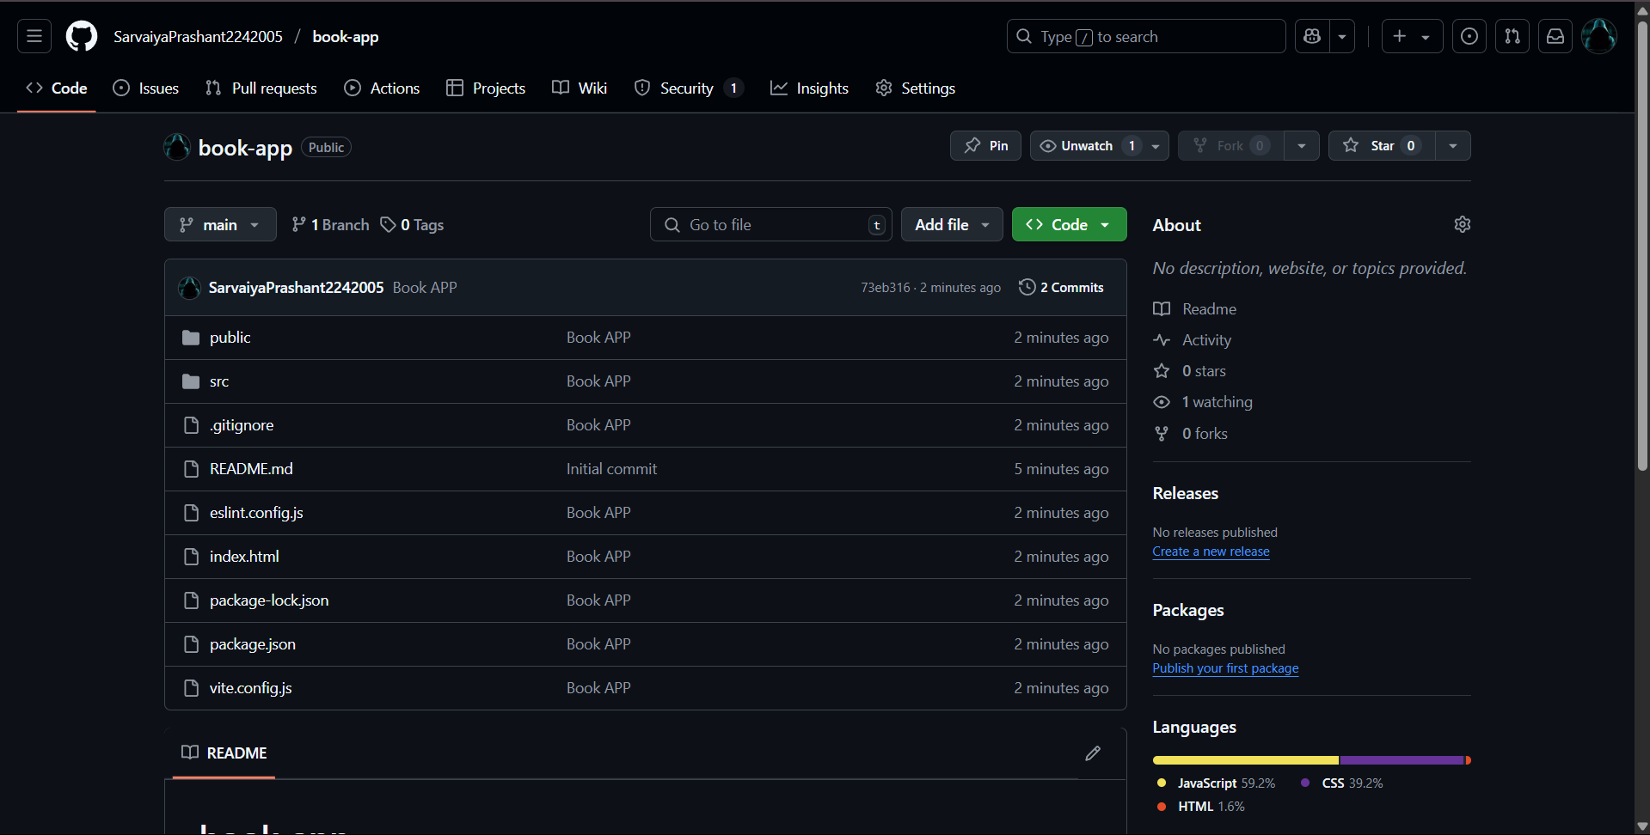

**Step 2 : Make Account in natlify**

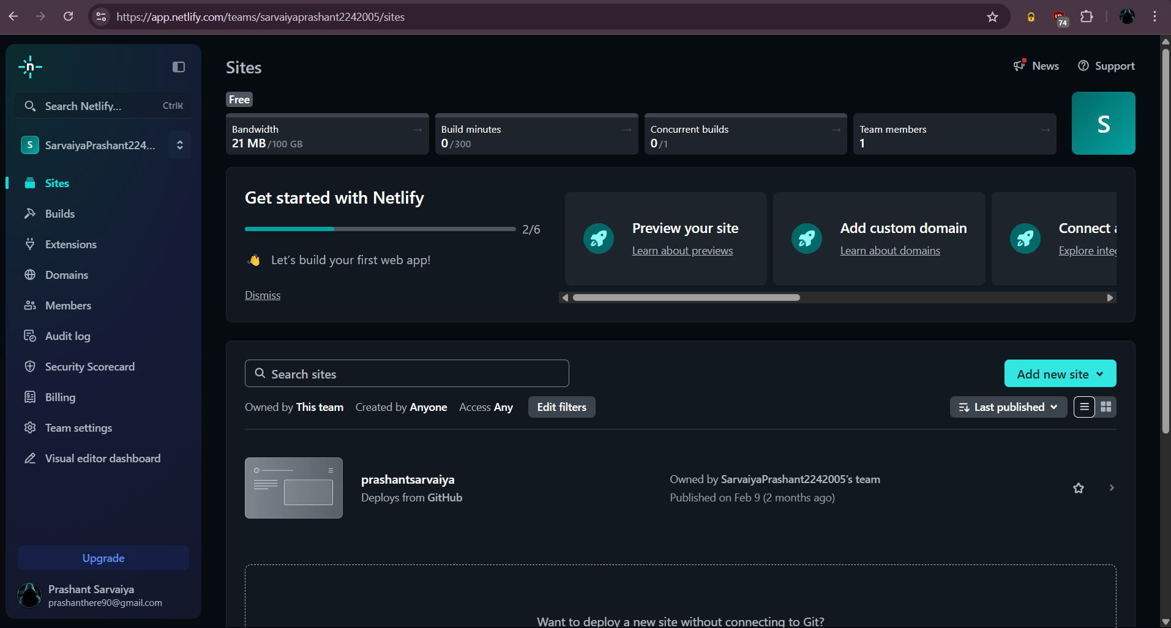

**Step 3 : Click add new sites and update github repository**

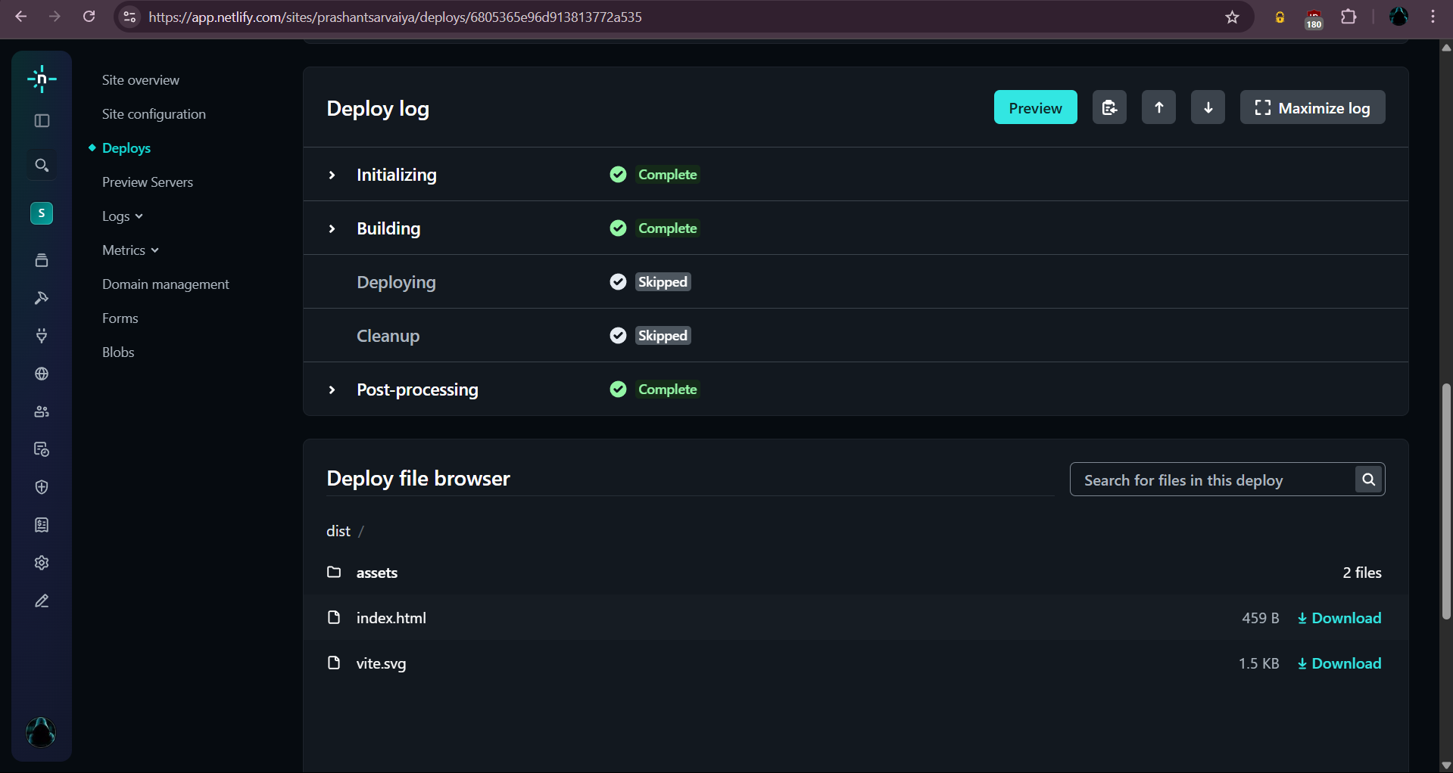

**Click preview**

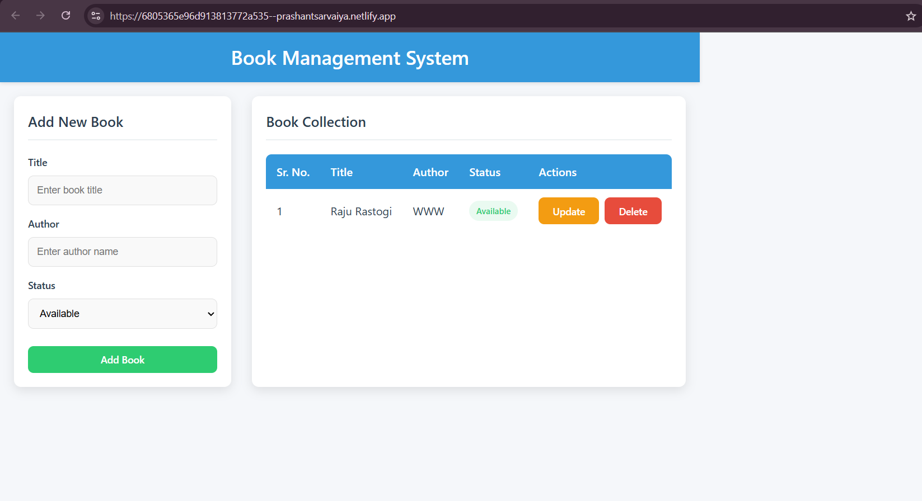

Site is published