Inventory

Management  
System

[IOT Components]

Information and Communication Technology

**2023-24**

**CERTIFICATE**

This is to certify that the project entitled **Component Inventory Management system** has been carried out by **Prashhant Sarvaiya(92200133003) , Abhay Padariya(92200133017)** under my guidance in partial fulfillment of the degree of Bachelor Engineering in Information and Communication Technology (4th Semester) of Marwadi University, Rajkot during the academic year 2023-24.

|  |  |
| --- | --- |
| Date : 03-05-2024  **Internal Guide** | **Head of the Department** |
| Mr. Shamsagazarzoo Alam | Prof . C. D. Parmar |
| Subject Co-ordinator  C.T.O. Ally Soft Solutions | Head of Department ICT Engineering |

* **Abstract :**

The Inventory Management System for IoT Components is a comprehensive solution designed to streamline the management of various electronic components utilized in IoT projects. The system encompasses both an Admin and User interface, providing distinct functionalities tailored to the needs of each user group. Users can easily browse through available components, request items, and track the status of their requests. On the other hand, administrators have access to advanced features such as component management, user administration, and request approval. The system aims to enhance efficiency, organization, and transparency in managing IoT component inventories.

* **Project Description:**
  + **Description:**

The Inventory Management System for IoT Components is divided into two main components: the Userside and the Admin Side.

**Userside:**

The Userside interface offers a user-friendly platform for individuals to explore available IoT components and request items as needed. Key features include:

Home Page: Displays various categories of components such as Microcontroller, Sensor, Drone Components, and Electronic items through interactive cards.

Component Listing: Users can browse through the list of components within each category and request specific items.

Request Page: Allows users to track the status of their component requests, indicating whether they have been approved or rejected.

Contact Us Page: Provides a means for users to reach out for assistance or inquiries.

About Us Page: Offers information about the project and its creators.

Account Page: Enables users to manage their account settings and preferences.

**Admin Side:**

The Admin Side interface is tailored for administrators to efficiently manage the inventory system and user requests. Key features include:

Home Page: Presents statistical analysis and insights regarding different aspects of the system.

Component Management: Allows administrators to add, edit, or delete components within categories such as Microcontroller, Sensor, Drone Components, and Electronics.

User Administration: Provides functionality to add or manage user and admin accounts.

Users Page: Displays a comprehensive list of all users registered within the system.

Request Page: Facilitates the approval or rejection of component requests submitted by users.

* + **Needs:**
* Browser
* VS code
* Xampp
* phplocal database
  + **Features:**
* User-friendly interface for both users and administrators.
* Categorized browsing of IoT components.
* Seamless component request process with status tracking.
* Efficient component management for administrators, including addition, editing, and deletion.
* User and admin account management functionalities.
* Transparent request approval system for administrators.
* Contact and About Us pages for user engagement and information dissemination.
  + **Technologies :**
* HTML
* CSS
* JavaScript
* PHP
* Bootsrap
* MySQL

* + **Tools:**
* VS code
* Phpmyadmin
* **Flowchart :**

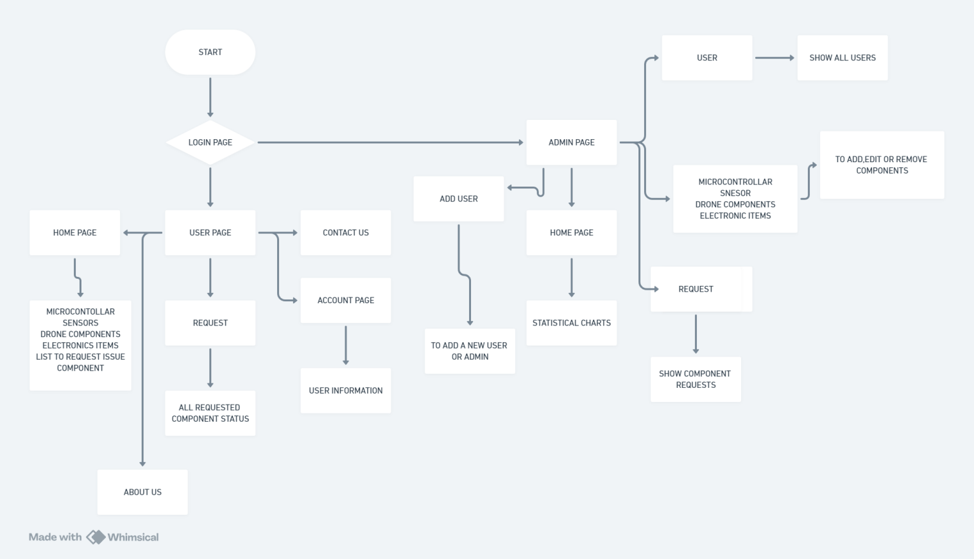

* **Screenshots:**

**LOGIN PAGE :**

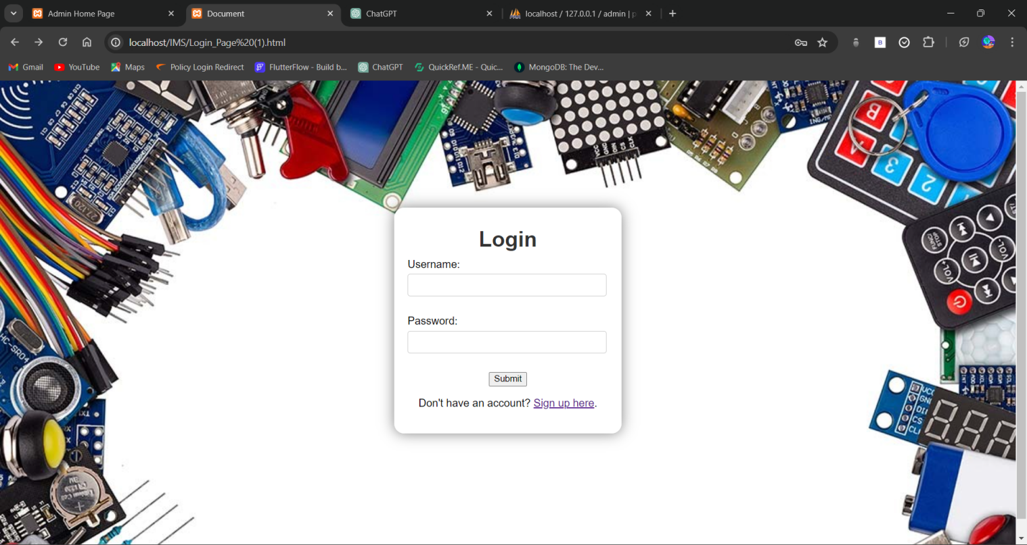

**USER HOME PAGE :**

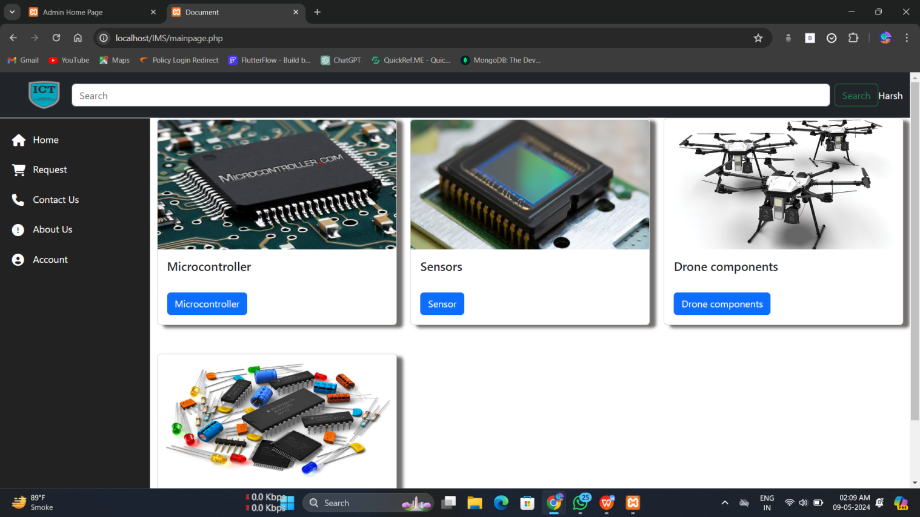

**Admin home page :**

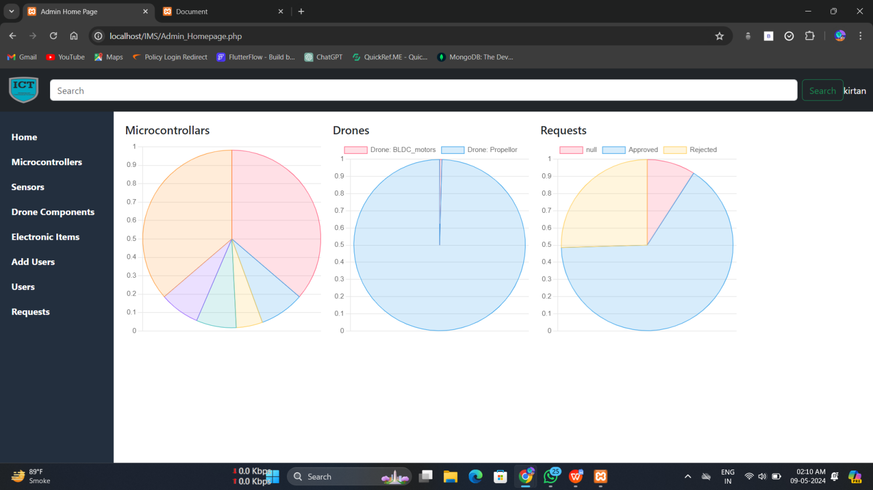

**Admin side Microcontrollar page**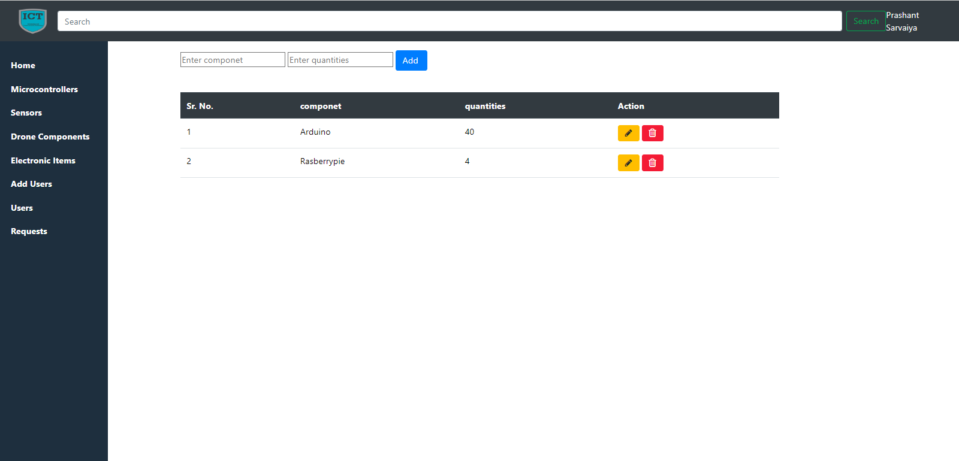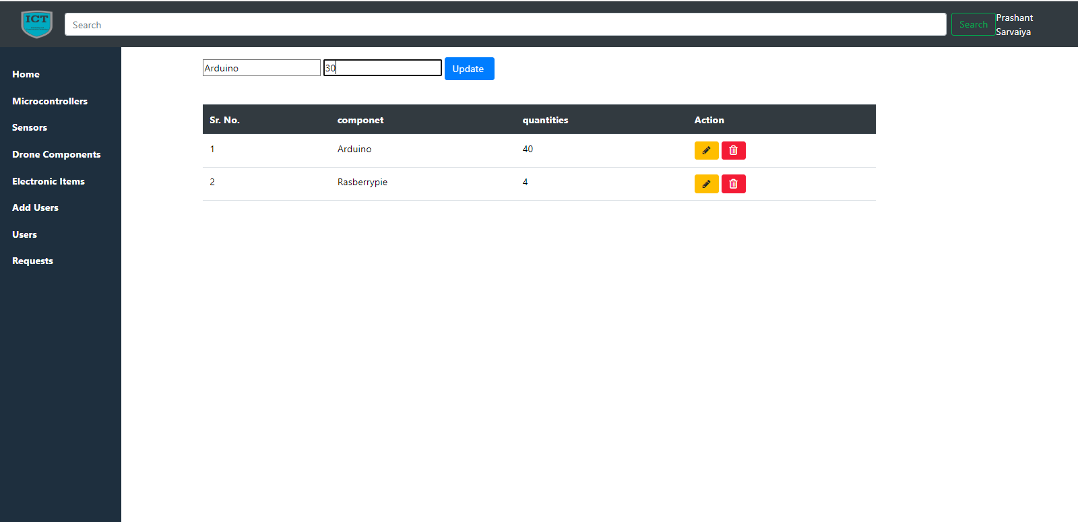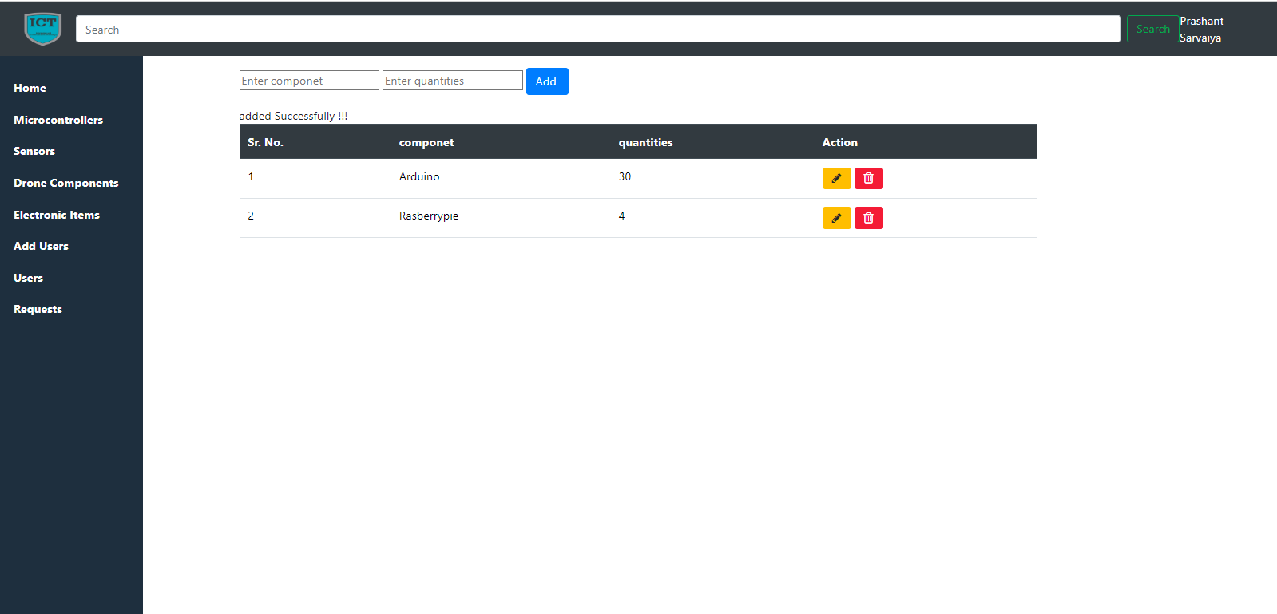

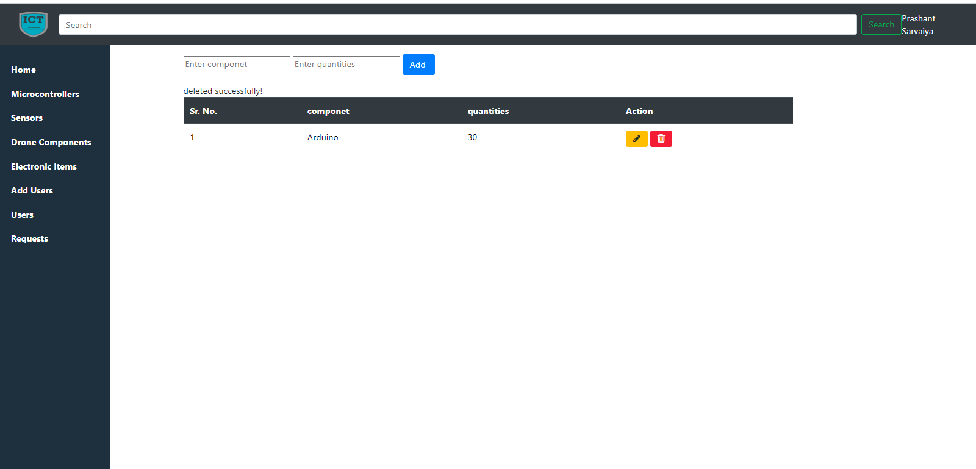

**Admin side Add User page**

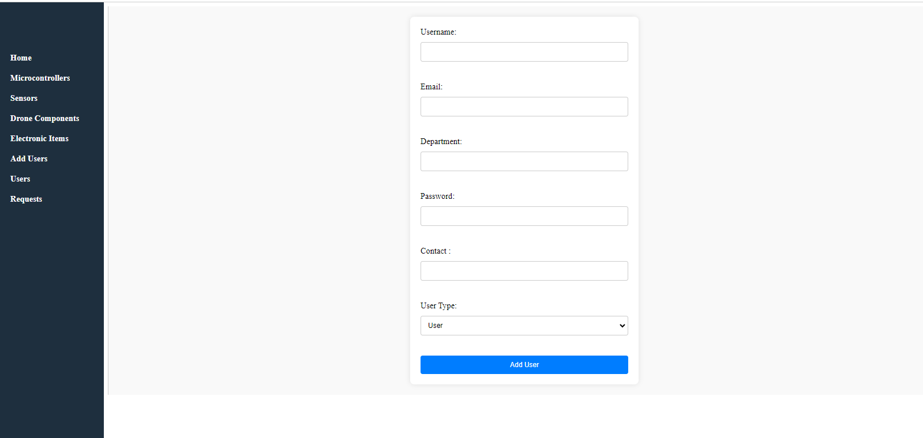

**Admin side User page**

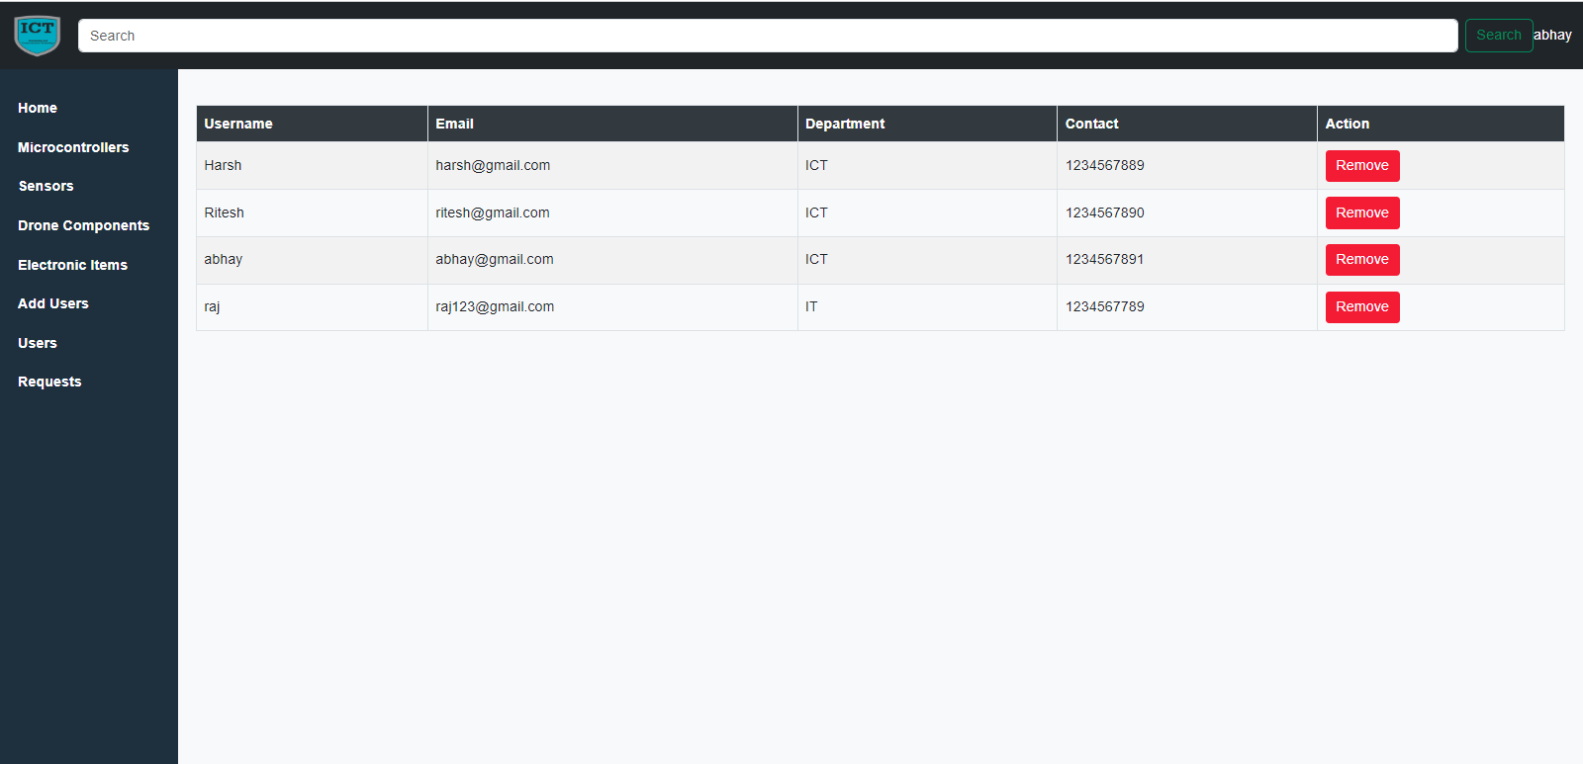 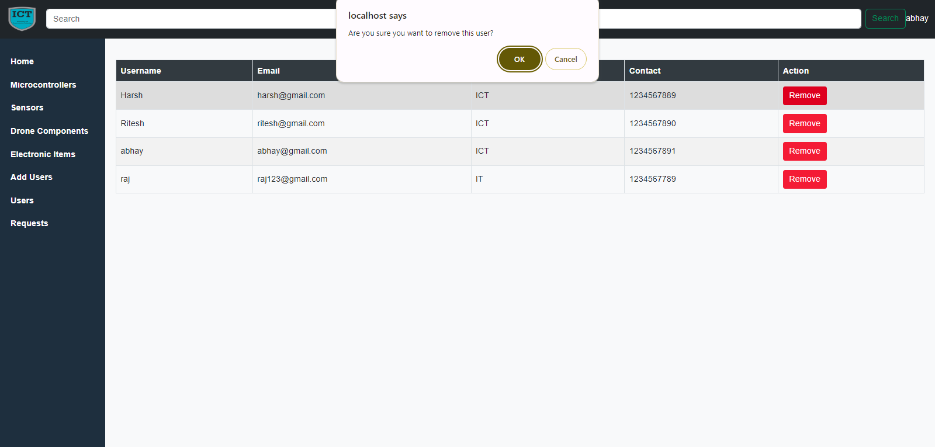

**Admin side Request page**

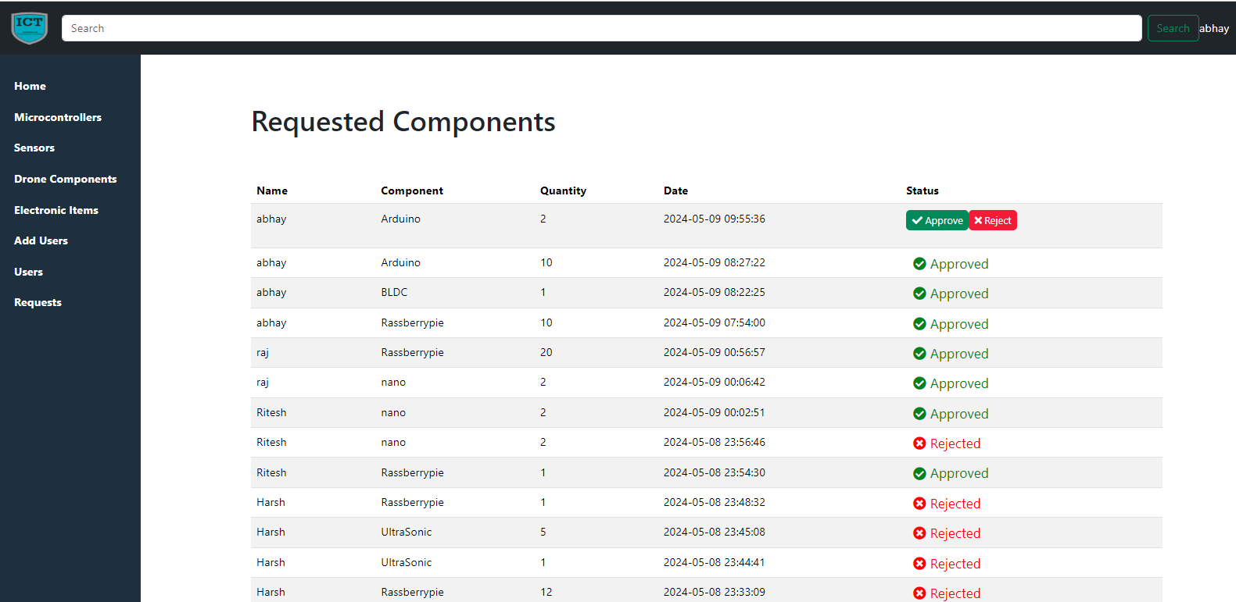

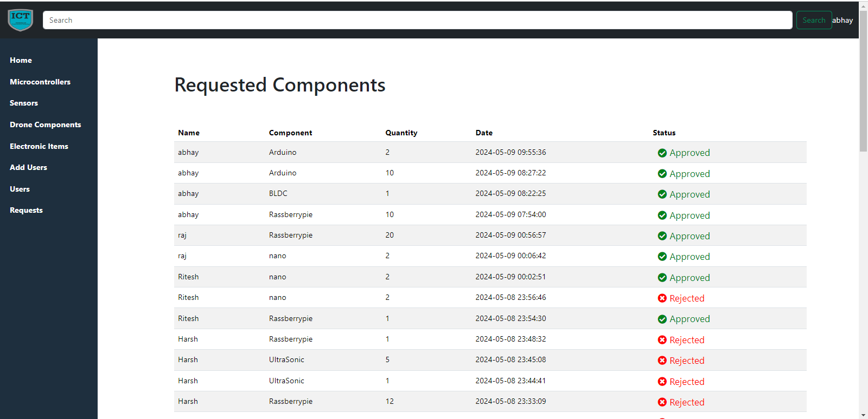

**User side Microcontrollar page**

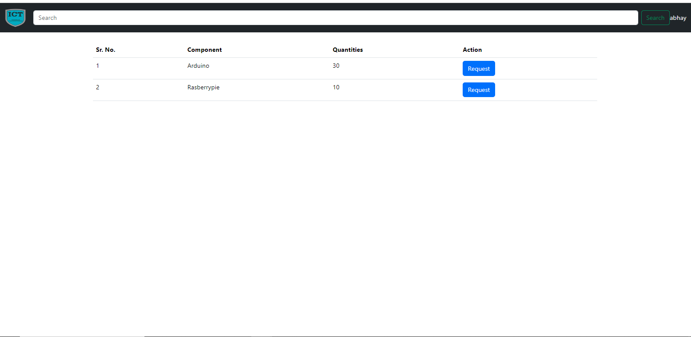 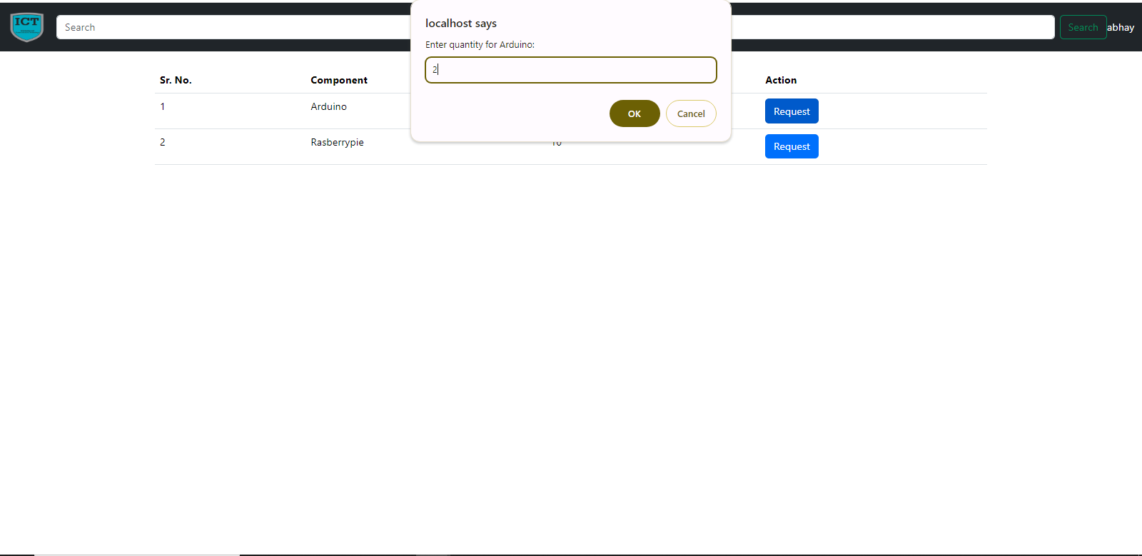 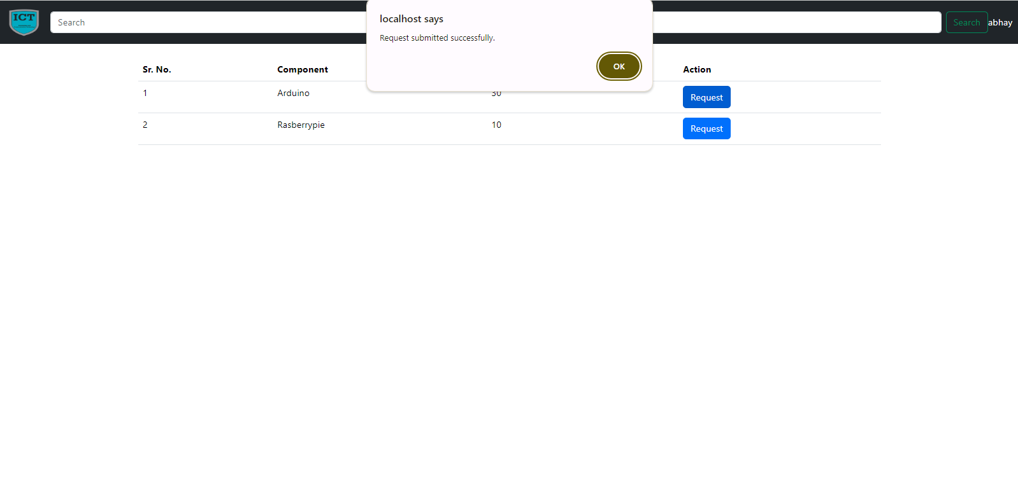

**User side Request page**

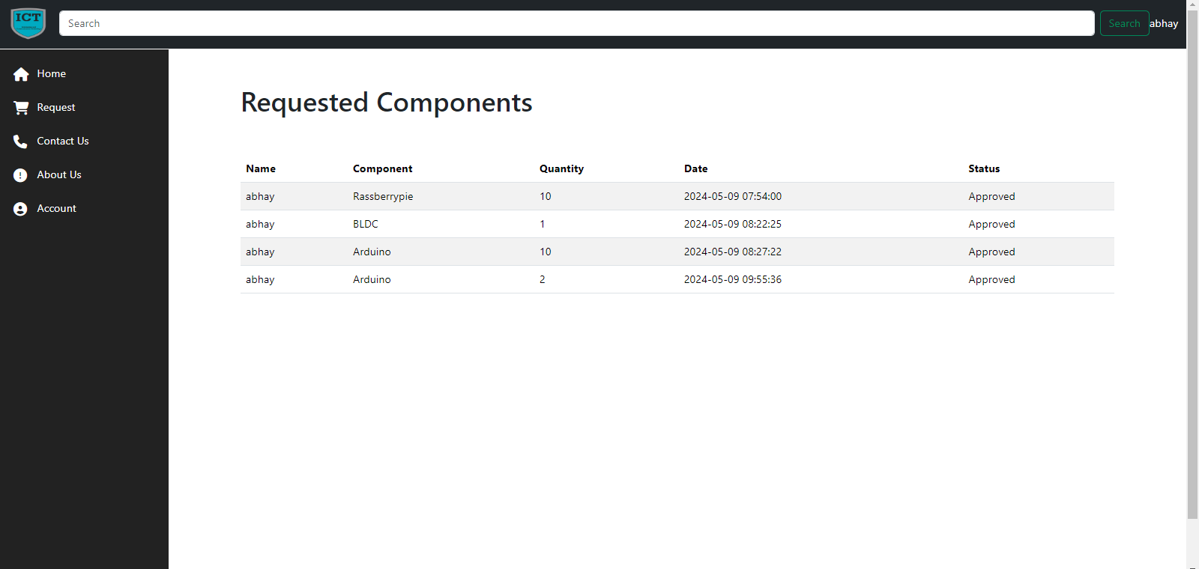

**User side Contact US page**

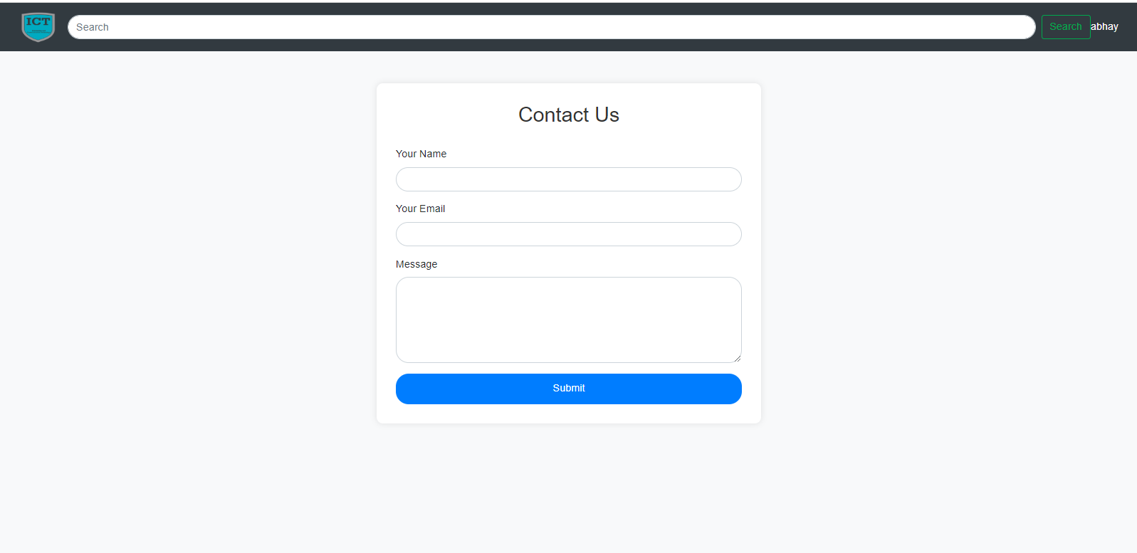

**User side About US page**

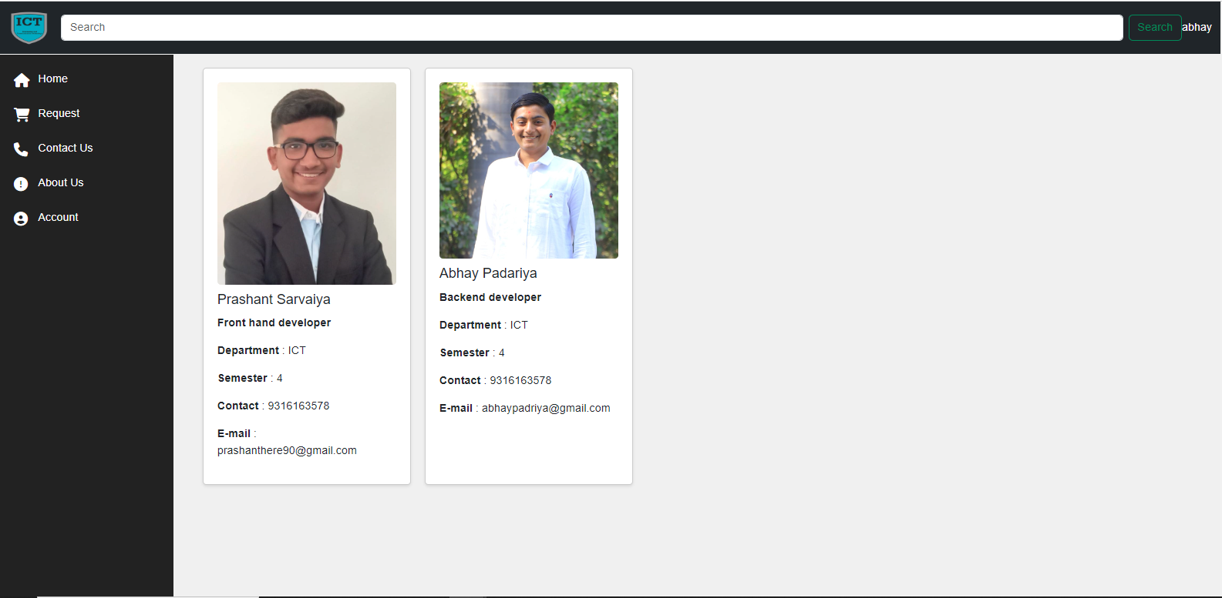

**User side Account page**

