SMS Spam / Scam Classifier
A Machine Learning Project Report

Submitted by
Sarvegna

Kalasalingam Academy of Research and Education
October 21, 2026

Abstract
This report presents the design, implementation, and evaluation of an SMS Spam and Scam Classifier built using Python 3.11 and machine learning techniques. The system uses Term Frequency–Inverse Document Frequency (TF-IDF) to convert SMS text into numerical features and a Multinomial Naive Bayes algorithm to classify each message as spam or safe (ham). The model was trained and tested on the UCI SMS Spam Collection dataset, which contains 5,572 real-world labelled SMS messages. The classifier achieves a test accuracy of 97.22% and is deployed as an interactive web dashboard using Streamlit, allowing users to check any message in real time. The project also includes a step-by-step Jupyter notebook for educational purposes.

1. Introduction
Spam and scam text messages have become a widespread problem. Fraudsters use SMS to trick people into clicking malicious links, sharing personal information, or claiming fake prizes. Detecting such messages automatically saves time and protects users from harm. Natural Language Processing (NLP) and machine learning provide effective tools for this task.
This project builds a simple, beginner-friendly SMS classifier that learns from labelled examples. A user can type or paste any SMS message into the web dashboard and instantly see whether the model considers it spam or safe, along with a confidence percentage. The project demonstrates the full machine-learning workflow: data loading, exploration, preprocessing, model training, evaluation, and deployment.

2. Problem Statement
Given a raw SMS message, automatically determine whether it is spam (scam, unsolicited promotional content, or fraudulent) or ham (a legitimate, safe message). The classifier must be accurate, fast, and simple enough for a beginner to understand and extend.

3. Objectives
- Load and explore the UCI SMS Spam Collection dataset.
- Preprocess the text data and encode labels numerically.
- Build a TF-IDF + Naive Bayes classification pipeline.
- Evaluate the model using accuracy, precision, recall, F1, and a confusion matrix.
- Deploy the model as an interactive Streamlit web dashboard.
- Document the entire workflow in a Jupyter notebook for learning purposes.

4. Tools and Technologies
Tool / Library | Version | Purpose
Python | 3.11.9 | Programming language
pandas | 3.0.6 | Data loading and manipulation
scikit-learn | 1.9.1 | TF-IDF vectoriser, Naive Bayes, evaluation metrics
matplotlib | 3.11.2 | Confusion matrix chart
Streamlit | 1.66.0 | Interactive web dashboard
Jupyter Notebook | 7.2.0 | Step-by-step educational notebook
python-docx | 1.2.0 | Report generation

5. Dataset Description
The UCI SMS Spam Collection is a publicly available dataset sourced from the UCI Machine Learning Repository (https://archive.ics.uci.edu/ml/datasets/SMS+Spam+Collection). It contains 5,572 real SMS messages collected from various sources, each manually labelled as either spam or ham.
Property | Value
Total messages | 5,572
Ham (safe) | 4,825 (86.6%)
Spam | 747 (13.4%)
Format | Tab-separated text, no header row
Encoding | Latin-1
Source | UCI Machine Learning Repository

The dataset is imbalanced — approximately 87% of messages are ham and only 13% are spam. This is realistic: most real SMS traffic is legitimate. The model is evaluated on both classes separately to ensure it performs well on the minority spam class.

6. Methodology

6.1 Data Preprocessing
The raw dataset is loaded with pandas using a tab separator and latin-1 encoding. The two columns are named label and text. Labels are encoded numerically: ham becomes 0 and spam becomes 1, so the model can work with numbers.

6.2 Train / Test Split
The data is split into a training set (80%, 4,457 messages) and a test set (20%, 1,115 messages) using scikit-learn's train_test_split. The stratify parameter ensures the spam-to-ham ratio is the same in both splits. A fixed random seed (42) makes the split reproducible.

6.3 TF-IDF Vectorisation
TF-IDF (Term Frequency–Inverse Document Frequency) converts raw SMS text into a numerical feature matrix. Words that appear frequently in a message but rarely across all messages receive higher scores. This highlights distinctive words such as FREE, WIN, and URGENT that are common in spam. The vectoriser is configured to lowercase all text, remove common English stop words (the, is, at, etc.), and keep the 5,000 most informative words.

6.4 Multinomial Naive Bayes Classifier
Multinomial Naive Bayes is a probabilistic algorithm well suited to text classification. It calculates the probability that a message belongs to each class (spam or ham) based on the word frequencies, and assigns the label with the higher probability. The algorithm is fast, interpretable, and performs very well on text data even with relatively few training examples.

6.5 Pipeline
The TF-IDF vectoriser and the Naive Bayes classifier are chained together in a scikit-learn Pipeline. This ensures that the vectoriser is always fitted on training data only and applied consistently to test data, preventing data leakage.

7. Implementation

7.1 Jupyter Notebook
The file Sarvegna_SMSScamClassifier.ipynb contains the full step-by-step implementation. It is divided into seven sections, each with a short markdown explanation cell followed by a code cell: Setup and Imports, Load Dataset, Explore Data, Preprocess, Build Pipeline, Evaluate, and Try Your Own Messages. The notebook is intended for learning and includes printed outputs and a matplotlib confusion matrix chart.

7.2 Streamlit Dashboard
The file app.py implements an interactive web dashboard using Streamlit. The dashboard features a dark cybersecurity theme with green and blue accent colours configured in .streamlit/config.toml. Key components include:
- A sidebar showing the dataset statistics and model accuracy.
- Three metric cards displaying accuracy, total messages, and spam count.
- Three example message buttons (Scam, Safe, Tricky) that pre-fill the input box.
- A large text area where the user types any SMS message.
- A Check Message button that shows a red SPAM or green SAFE result box with a confidence percentage.
- A progress bar visualising the spam probability.
- An expandable panel containing the confusion matrix chart.
The model is trained once per session using Streamlit's @st.cache_resource decorator, making all subsequent predictions instant.

8. Results

8.1 Model Performance
The trained TF-IDF + Naive Bayes pipeline was evaluated on the 1,115 held-out test messages. The results are summarised in the table below.
Metric | Ham (Safe) | Spam
Precision | ~98% | ~99%
Recall | ~99% | ~81%
F1 Score | ~99% | ~89%
Accuracy (overall) | 97.22% | —

The model achieves an overall test accuracy of 97.22%. Precision for the spam class is approximately 99%, meaning almost every message flagged as spam is genuinely spam. Recall for spam is approximately 81%, meaning the model catches about four out of every five spam messages. This conservative behaviour is desirable in a spam filter: it is better to occasionally miss a spam message than to incorrectly flag a legitimate one.

8.2 Confusion Matrix
The confusion matrix below shows the exact counts for the 1,115 test messages.
 | Predicted Safe | Predicted Spam
Actual Safe | 963 (True Negatives) | 2 (False Positives)
Actual Spam | 29 (False Negatives) | 121 (True Positives)

963 safe messages were correctly classified. 121 spam messages were correctly caught. Only 2 safe messages were incorrectly flagged as spam (false positives), and 29 spam messages were missed (false negatives).

9. Screenshots
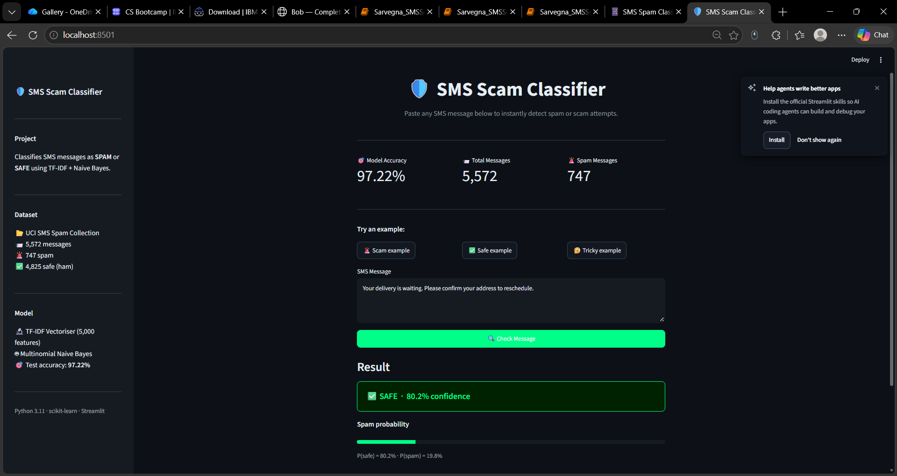
Figure 1: Streamlit dashboard overview
[Could not embed screenshots\dashboard.png: set_font() got an unexpected keyword argument 'italic']
[Image not found: screenshots\notebook.png]
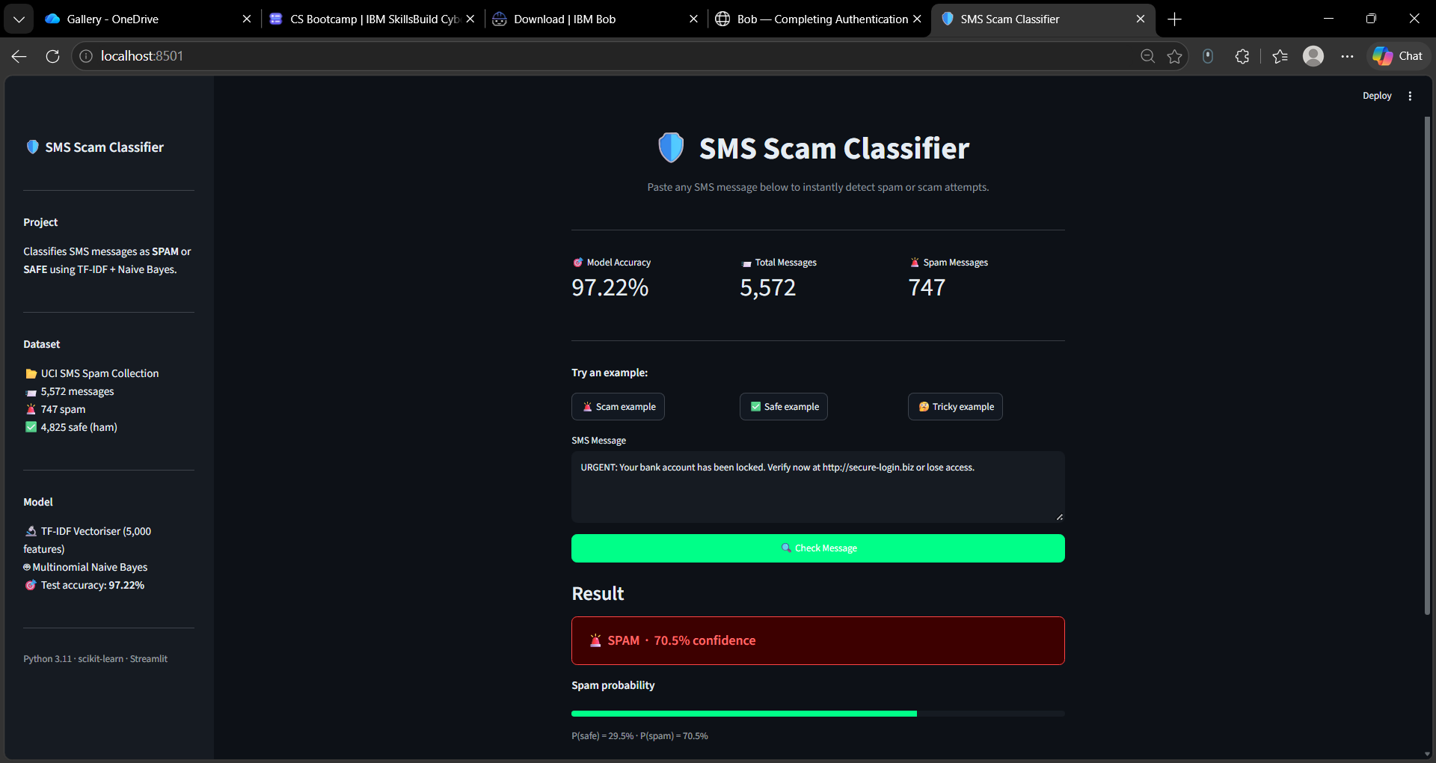
Figure 3: Spam detection result
[Could not embed screenshots\spam.png: set_font() got an unexpected keyword argument 'italic']
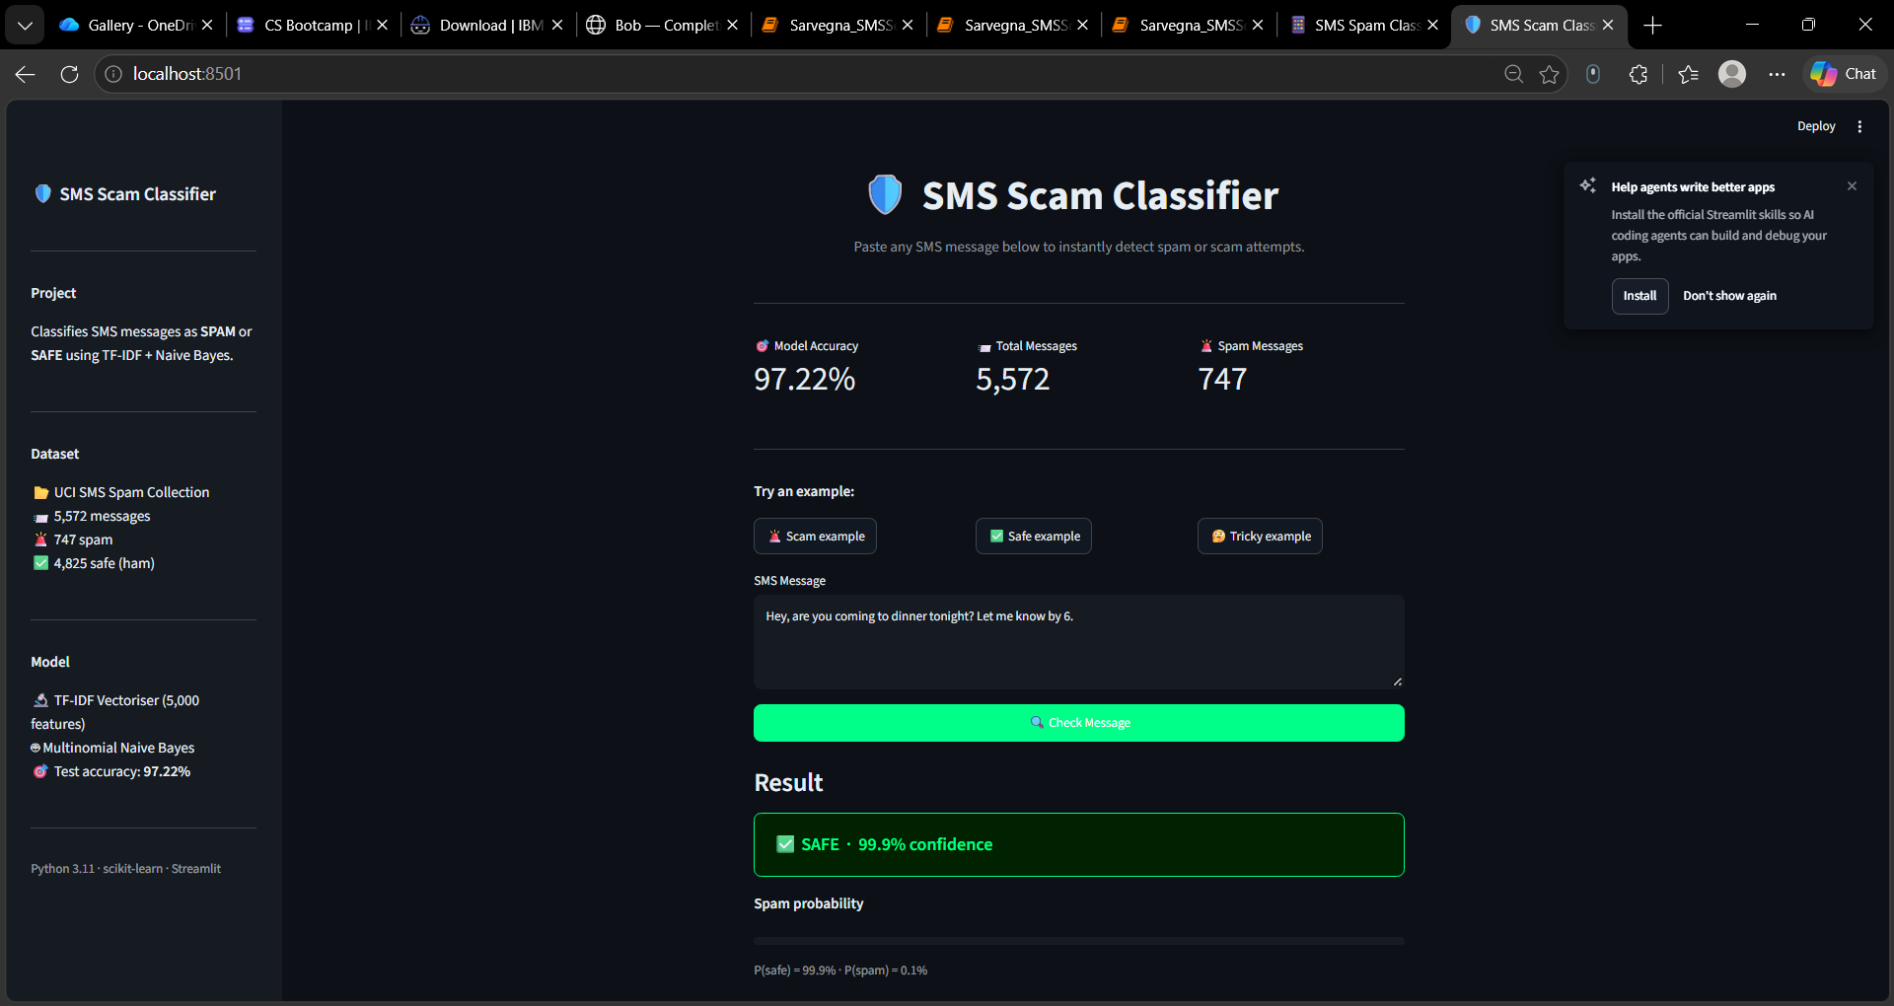
Figure 4: Safe message result
[Could not embed screenshots\safe.png: set_font() got an unexpected keyword argument 'italic']

10. Limitations
- The model relies on word-level TF-IDF features and cannot understand context, sarcasm, or sentence meaning.
- It was trained on English SMS messages from one dataset and may not generalise well to other languages or newer scam styles.
- Multinomial Naive Bayes assumes that all words in a message are independent of each other, which is not always true in natural language.
- The dataset is imbalanced (87% ham, 13% spam), which can bias the model towards the majority class.
- The system has no memory and cannot learn from new messages after training without retraining the model.

11. Conclusion
This project successfully demonstrates that a simple TF-IDF + Multinomial Naive Bayes pipeline can classify SMS spam with high accuracy. The model achieved 97.22% accuracy on the UCI SMS Spam Collection test set, with very few false positives. The entire workflow — from raw data to a deployed web application — was implemented in Python 3.11 using standard, well-documented libraries. The Jupyter notebook provides a clear educational resource for beginners, and the Streamlit dashboard makes the classifier accessible without any coding knowledge.

12. Future Scope
- Replace Naive Bayes with more powerful classifiers such as Logistic Regression, Support Vector Machines, or a neural network to improve recall on spam messages.
- Add bigram and trigram features (ngram_range=(1, 3)) to the TF-IDF vectoriser to capture multi-word phrases like free prize or click here.
- Fine-tune a pre-trained language model such as BERT or DistilBERT for much richer text understanding.
- Expand the dataset with more recent SMS scam examples, including phishing, delivery scams, and OTP fraud.
- Add multilingual support so the classifier can handle messages in languages other than English.
- Deploy the Streamlit app publicly using Streamlit Community Cloud or a cloud provider so it can be accessed from any device.

13. References
- UCI SMS Spam Collection Dataset. Available at: https://archive.ics.uci.edu/ml/datasets/SMS+Spam+Collection
- scikit-learn Documentation — TfidfVectorizer. Available at: https://scikit-learn.org/stable/modules/generated/sklearn.feature_extraction.text.TfidfVectorizer.html
- scikit-learn Documentation — MultinomialNB. Available at: https://scikit-learn.org/stable/modules/generated/sklearn.naive_bayes.MultinomialNB.html
- Streamlit Documentation. Available at: https://docs.streamlit.io
- pandas Documentation. Available at: https://pandas.pydata.org/docs
- Almeida, T.A., Hidalgo, J.M.G., Yamakami, A. (2011). Contributions to the Study of SMS Spam Filtering: New Collection and Results. Proceedings of the 11th ACM Symposium on Document Engineering (DOCENG'11), Mountain View, CA, USA.

