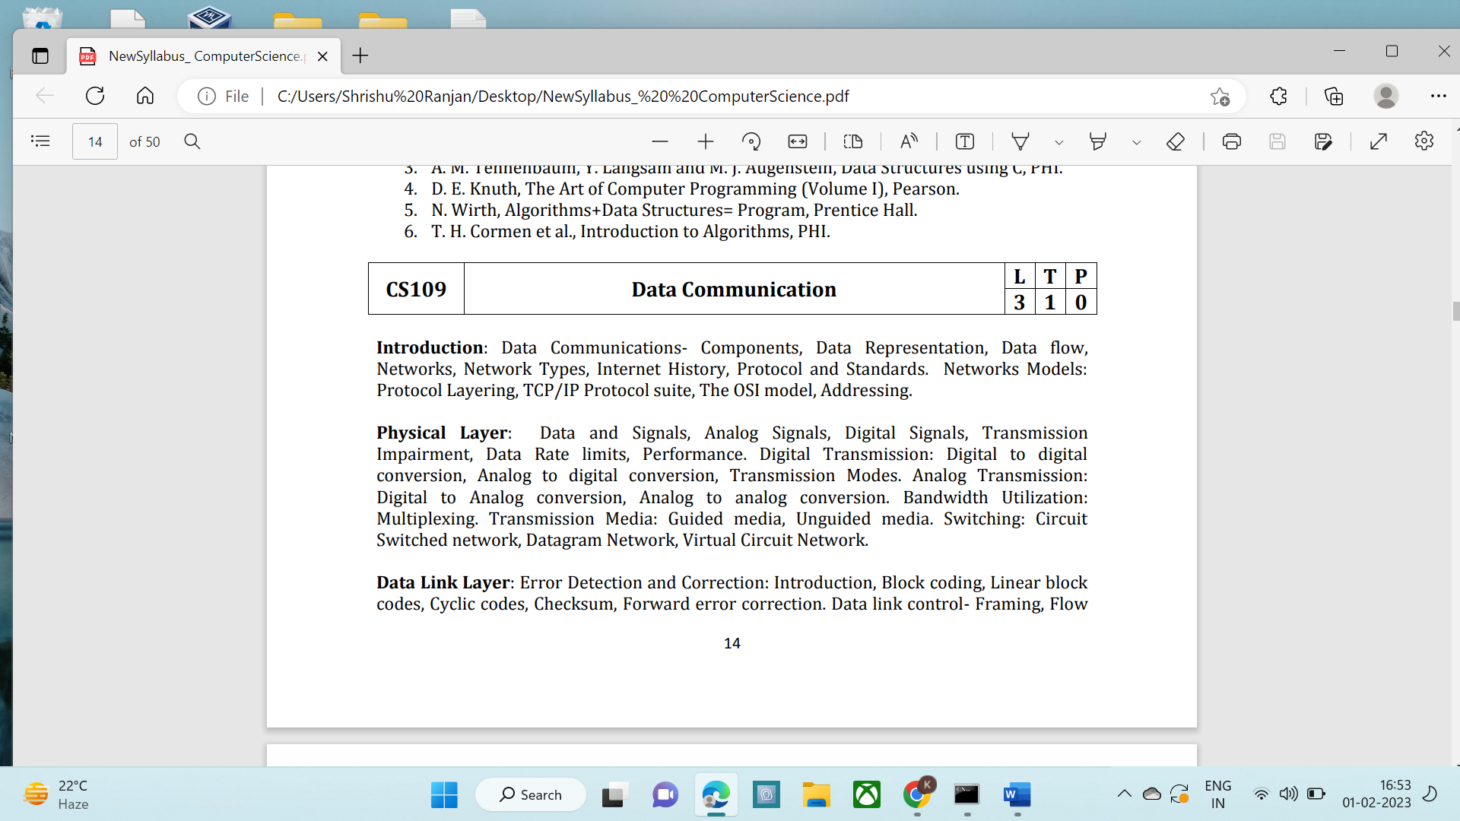

**Introduction:** Data Communications- Components, Data Representation, Data flow, Networks, Network Types, Internet History, Protocol and Standards. Networks Models: Protocol Layering, TCP/IP Protocol suite, The OSI model, Addressing.

**Physical Layer:** Data and Signals, Analog Signals, Digital Signals, Transmission Impairment, Data Rate limits, Performance. Digital Transmission: Digital to digital conversion, Analog to digital conversion, Transmission Modes. Analog Transmission: Digital to Analog conversion, Analog to analog conversion. Bandwidth Utilization: Multiplexing. Transmission Media: Guided media, Unguided media. Switching: Circuit Switched network, Datagram Network, Virtual Circuit Network.

**Data Link Layer:** Error Detection and Correction: Introduction, Block coding, Linear block codes, Cyclic codes, Checksum, Forward error correction. Data link control- Framing, Flow 15 and Error Control, Protocols: Simplest, Stop-and-wait, Go-back-N, Selective Repeat, Piggybacking, HDLC, Point-to-Point protocol. Multiple Access: Random Access- ALOHA, CSMA, CSMA/CD, CSMA/CA. Controlled Access- Reservation, Polling, Token Passing. Channelization- FDMA, TDMA, CDMA.

**Wired LANs:** Ethernet: IEEE Standards, Standard Ethernet, Bridged Ethernet, Switched Ethernet, Full Duplex Ethernet, Fast Ethernet, Gigabit Ethernet.

**Wireless LANs**: IEEE802.11 Standard, Bluetooth. Connecting LANs, Backbone Networks and Virtual LANs.

**Suggested Readings:**

1. B. A. Forouzan: Data Communications and Networking, Fourth edition, TMH.

2. A. S. Tanenbaum, Computer Networks, Fourth edition, PHI.

3. D. E. Comer, Computer Networks and Internets, Pearson.

4. W. Stallings, Data and Computer Communications, Pearson