Problem Statement
Build a small Python 3.x calculator app (add/subtract/multiply, positive integers) with unit tests. Containerize the app with Docker, and write a GitHub Actions workflow -- triggered automatically on push, no separate webhook needed -- whose CI job builds the image and runs the unit tests inside that container. Automate AWS infrastructure with CloudFormation (SAM for any Lambda functions). Run the full workflow end to end (CI: containerized build + test; CD: deploy to AWS). Deliverables: a runbook/architecture-diagram document, plus a live demo of the working pipeline (commit to AWS deployment) to the DevOps/CI-CD learning panel.

Steps to complete the Project
Step 1. Understand the requirements
The assignment required:
- A calculator supporting addition, subtraction, and multiplication of two positive integers.
- Python unit tests.
- A Docker image for the application.
- A GitHub Actions CI/CD workflow.
- Automated infrastructure deployment to AWS using CloudFormation, with SAM templates for Lambda.
- A document describing the implementation and a demonstration of the pipeline.

Step 2. Prepare the project folder
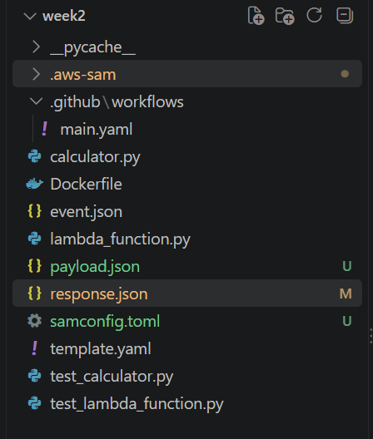

Step 3. Create calculator.py
This file contains the calculator’s business logic.
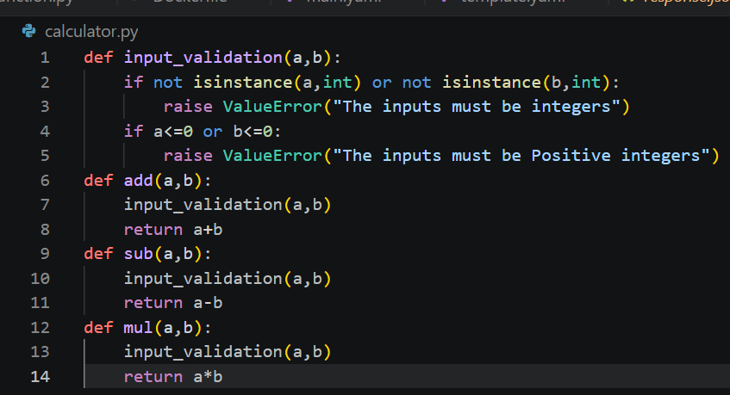

STEP 4: CREATE THE AWS LAMBDA HANDLER
Create a file named lambda_function.py. The handler receives input, performs the requested calculation, and returns a JSON response.
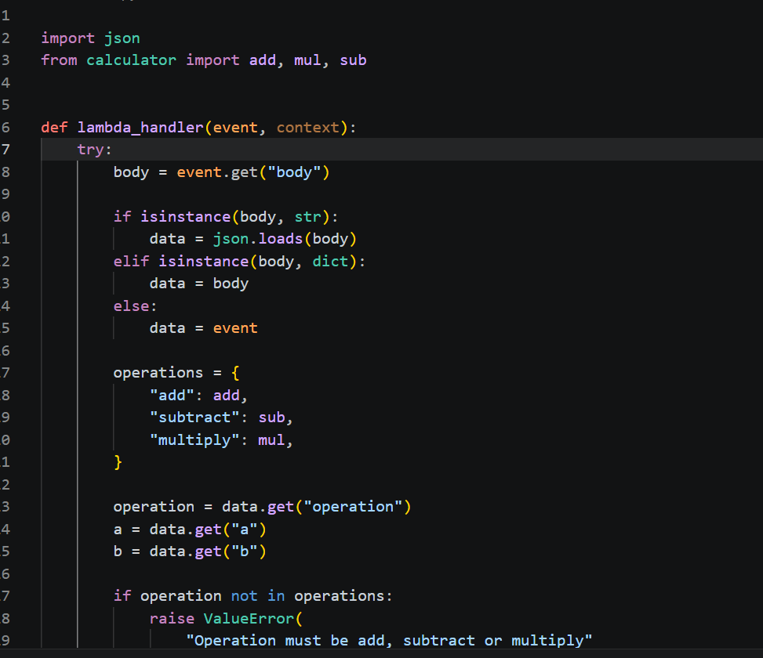

STEP 5: WRITE UNIT TESTS
Create unit tests for the calculator Lambda handler.
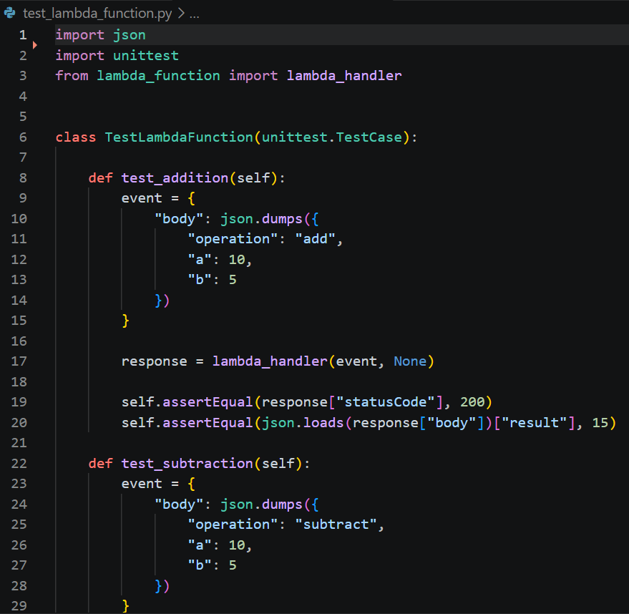

Run the tests using:
python -m unittest discover -v
These tests verify calculation logic, input validation, and the Lambda handler's response.

STEP 6: CREATE THE DOCKERFILE
Create a file named Dockerfile in the project root.
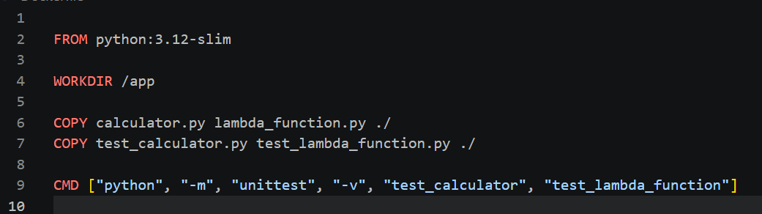

Build and test the Docker image:
docker build -t calculator-app .
docker run --rm calculator-app

STEP 7: PUSH THE PROJECT TO GITHUB

Create a GitHub repository named CI-CD and push the project.
git init
git add .
git commit -m "Initial calculator CI/CD project"
git branch -M main
git remote add origin https://github.com/Sarvesh-DG/CI-CD.git
git push -u origin main

STEP 8: CONFIGURE AWS

1. Create an AWS account.
2. Create an S3 bucket named calculator-lambda-614126170623-us-east-1 in the us-east-1 region.
3. Create a Lambda execution role with the AWSLambdaBasicExecutionRole policy.
4. Configure the GitHub OIDC identity provider.
5. Create an IAM deployment role named GitHubCalculatorDeployRole.
6. Configure the role's trust policy to allow the GitHub repository to assume it.
7. Add the role ARN to GitHub repository secrets using the name AWS_DEPLOY_ROLE_ARN.

STEP 9: CREATE THE SAM TEMPLATE

Create a file named template.yaml.

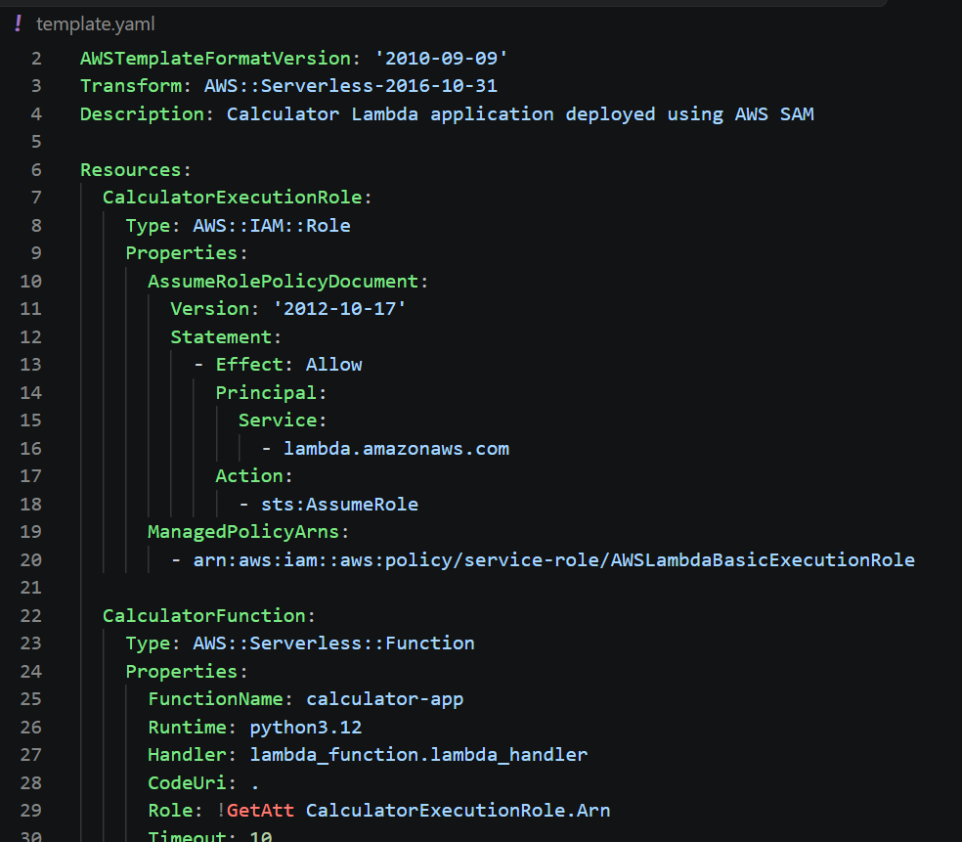

STEP 10: VALIDATE AND BUILD THE SAM APPLICATION

Run these commands from the project root:

sam validate --template-file template.yaml --lint
sam build --template-file template.yaml

Validation checks the SAM template, and the build command prepares the application for deployment.

STEP 11: DEPLOY THE APPLICATION

Run:

sam deploy --guided

Use these settings when prompted:

Stack name: calculator-lambda-stack
AWS Region: us-east-1
Confirm changes before deploy: Yes
Allow SAM CLI IAM role creation: Yes
Save arguments to configuration file: Yes

Review the changes and complete the deployment.

STEP 12: CONFIGURE IAM PERMISSIONS FOR SAM

The GitHub deployment role needs appropriate permissions for CloudFormation, S3, Lambda, and IAM role passing.

Add this statement to the deployment role's permissions if it is missing:

{
"Sid": "AllowSAMServerlessTransform",
"Effect": "Allow",
"Action": "cloudformation:CreateChangeSet",
"Resource": "arn:aws:cloudformation:us-east-1:aws:transform/Serverless-2016-10-31"
}

The role must also be able to upload and read SAM deployment artifacts, manage the CloudFormation stack, update the Lambda function, and pass the Lambda execution role.
STEP 13: CONFIGURE GITHUB ACTIONS CI/CD

Create the workflow file .github/workflows/main.yml.

The workflow should:
1. Trigger on pushes and pull requests.
2. Check out the repository.
3. Set up Python 3.12.
4. Check Python syntax.
5. Run unit tests.
6. Build the Docker image.
7. Run tests inside the Docker container.
8. Deploy only on pushes to the main branch.
9. Authenticate to AWS using GitHub OIDC.
10. Validate, build, and deploy the SAM application.

Use this deployment command in the deploy job:

sam deploy \
--template-file .aws-sam/build/template.yaml \
--stack-name calculator-lambda-stack \
--region us-east-1 \
--capabilities CAPABILITY_IAM \
--s3-bucket calculator-lambda-614126170623-us-east-1 \
--no-confirm-changeset \
--no-fail-on-empty-changeset

Commit and push the changes:

git add .
git commit -m "Configure AWS SAM CI/CD deployment"
git push origin main

Check the Actions tab in GitHub to verify the workflow execution.

STEP 14: TEST THE LAMBDA FUNCTION

Create a file named payload.json with the following content:

{
"operation": "add",
"a": 10,
"b": 5
}

Run these commands in PowerShell:

aws lambda invoke `
--function-name calculator-app `
--region us-east-1 `
--cli-binary-format raw-in-base64-out `
--payload fileb://payload.json `
response.json

Get-Content .\response.json

Expected output:

{
"statusCode": 200,
"body": "{\"result\": 15}"
}

Repeat the test with subtract and multiply to verify the remaining operations.

STEP 15: FINAL VERIFICATION

1. Calculator operations work correctly.
2. Unit tests pass.
3. Docker image builds and runs tests successfully.
4. SAM template validates and builds.
5. Lambda deploys successfully to AWS.
6. GitHub Actions runs the CI pipeline.
7. The CD pipeline deploys changes from the main branch.
8. GitHub authenticates with AWS using OIDC.
9. Lambda invocation returns the expected result.

Architectural Diagram
