

**NATIONAL INSTITUTE OF TECHNOLOGY, WARANGAL**

DATABASE MANAGEMENT SYSTEM FOR RETAIL Garment Shop

**Submitted by:**

Name: Dhairya Ishwar Shimpi

Roll no.: 22EEB0A47

Branch: EEE (Section-A)

Subject: Python Programming

**Database Management System for Retail Garment Shop**

**1.INTRODUCTION**

The Python project aims to develop a Database Management System (DBMS) for a retail garment shop named "SHUBHAM COLLECTION." The system is designed to streamline various operations essential for the efficient management of stock, customer data, and billing processes. The key features include adding, deleting, and searching data, as well as printing and sending bills to customers via email.

This project is essential for a retail garment shop as it simplifies tasks like managing inventory, creating bills, and sending them via email. It ensures accurate record-keeping, saves time, and enhances customer service. With features like data entry, deletion, and searching, it streamlines daily operations, making it easier to track product details. The billing module adds efficiency, automating the billing process and improving customer experience. Overall, this project is crucial for the shop's smooth functioning, offering a user-friendly system that optimizes tasks, reduces manual efforts, and contributes to a more organized functioning of the shop.

**2.FEATURES**

The First Window Displays two options to the user of ‘Manage Data’ and ‘Print Bill’.

By choosing option of ‘Manage Data’ the user is taken to another window where the user gets multiple options for adding data, displaying data, searching data , and deleting data. The following information is given by user of each product:

* Brand
* Garment Type
* Product Code
* Size
* Colour
* Quantity
* MRP

The information of all the products is stored in a database in MySQL int a table named ‘Product_Details’ in a Database named ‘Shubham_Collection’ which contains the columns that are mentioned above.

**2.1. Introduction Window**

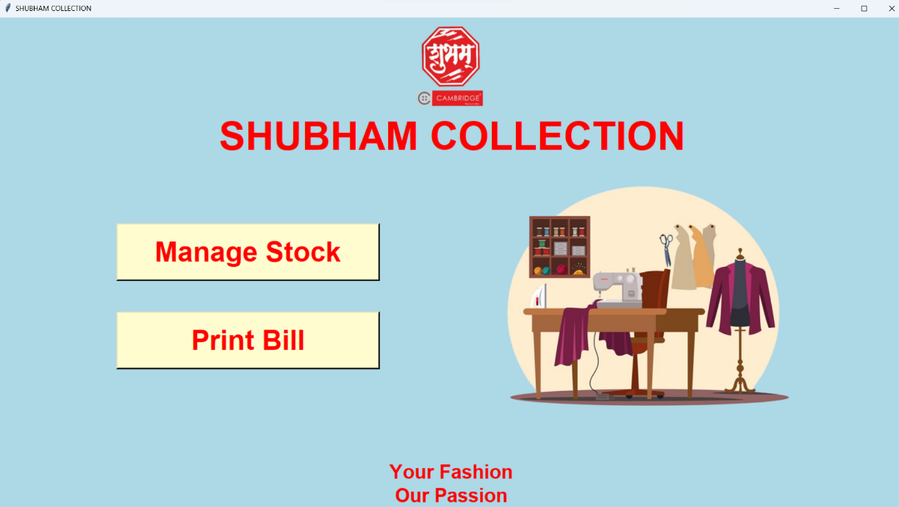

**2.2 Manage Stock**

By choosing Manage Stock the user is taken to another window.

This window provides four features to the user-

* Adding data to the database
* Showing data (Displaying the data)
* Searching data on basis of certain criterion
* Deleting of data

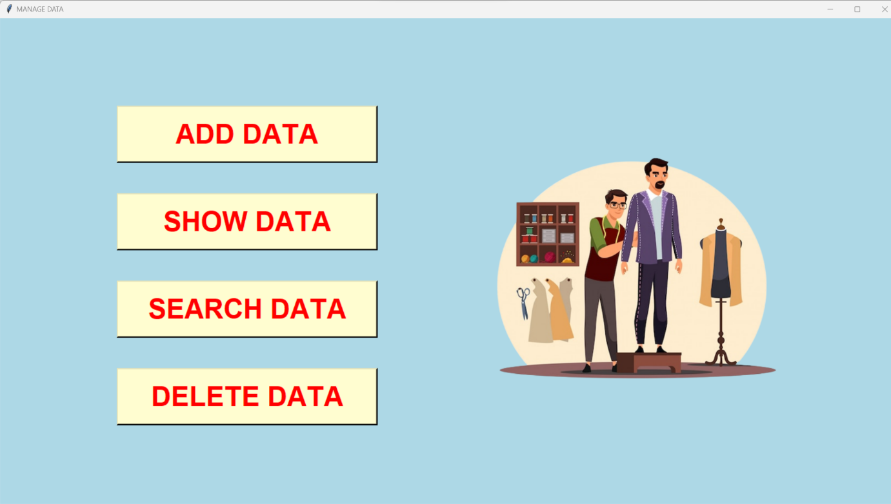

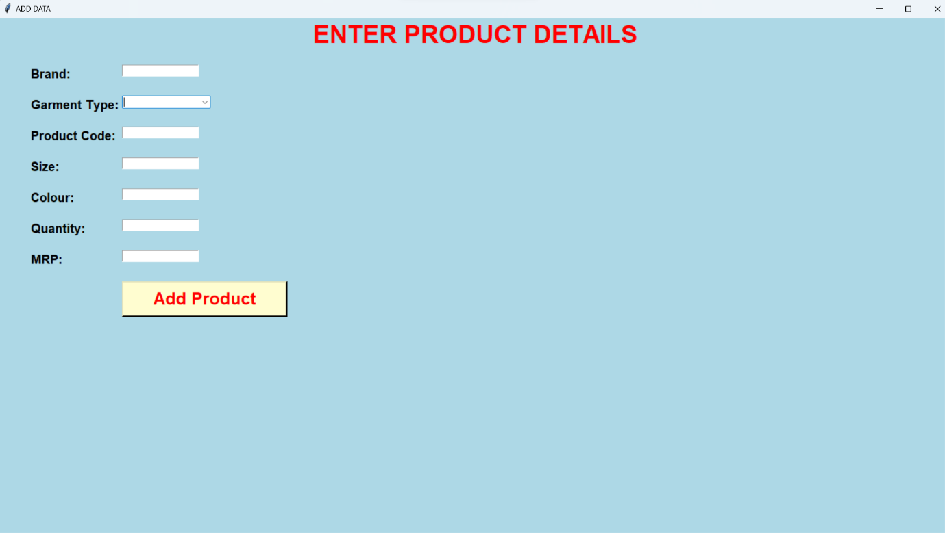**2.3 ADDING DATA**

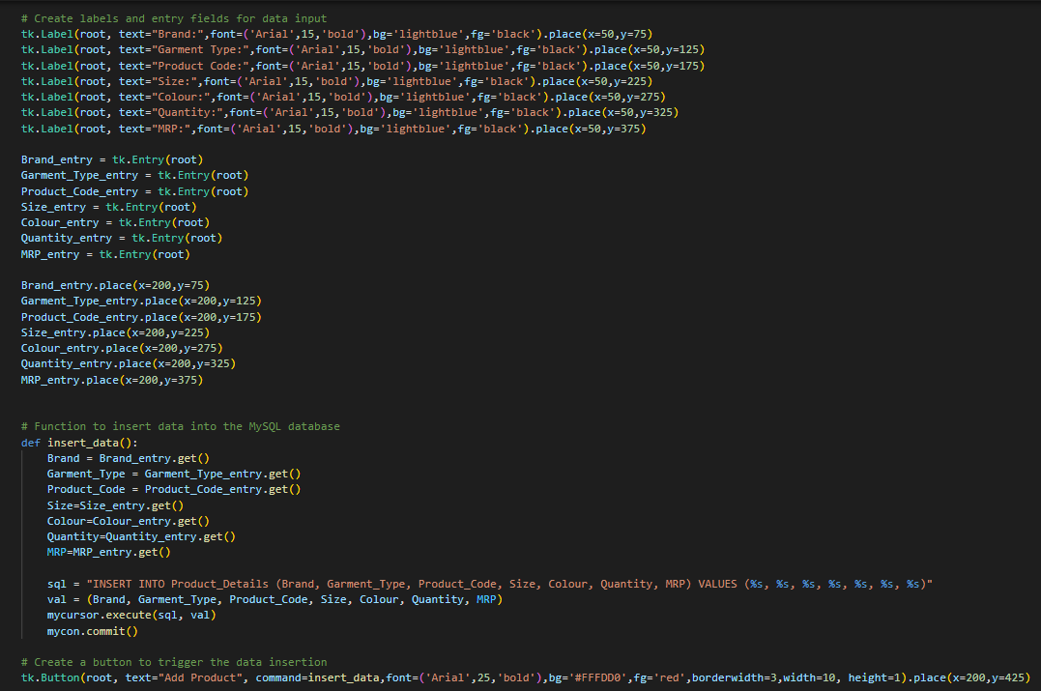

The module is designed to allow users to input and store product details, including information such as brand, garment type, product code, size, colour, quantity, and MRP (Maximum Retail Price). The entered data is then stored in a MySQL database named "Shubham_Collection".

The utilization of Tkinter for GUI and MySQL for data storage is used for making this module function.

On clicking on the button ‘Add Product’, the data is stored int the database.

**2.4 SHOWING DATA**

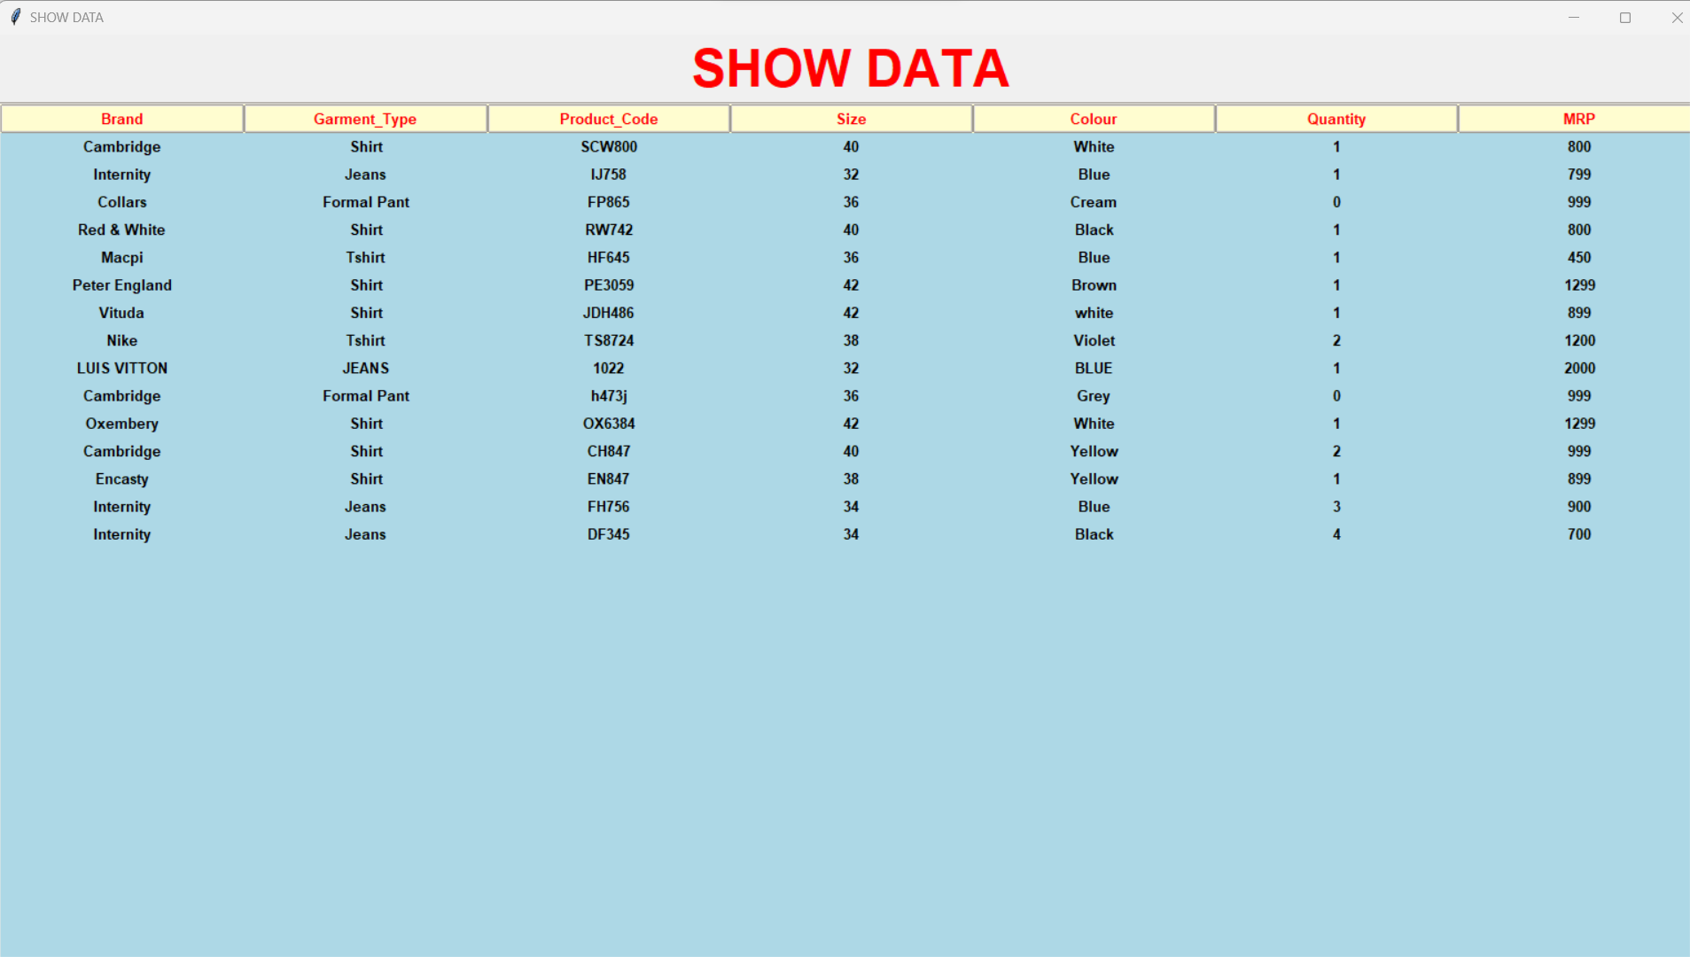

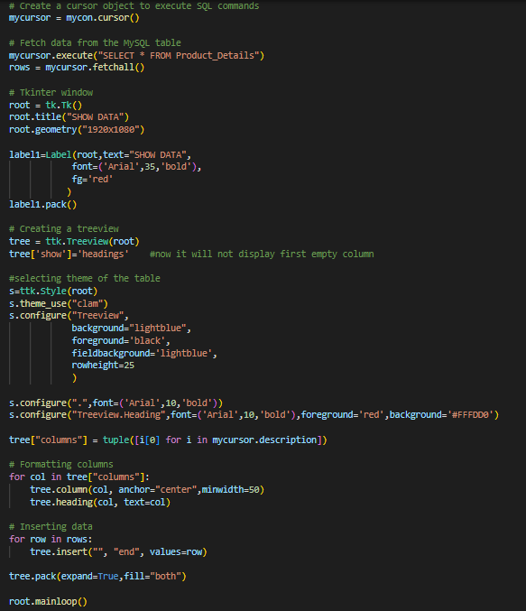

This feature provides a clear and organized representation of product details stored in the MySQL database. The use of Tkinter for GUI and Treeview for tabular data presentation ensures a user-friendly and visually appealing display. This module can be seamlessly integrated into a larger system, offering a valuable tool for monitoring and managing product information in the retail garment shop.

**2.5 SEARCH DATA**

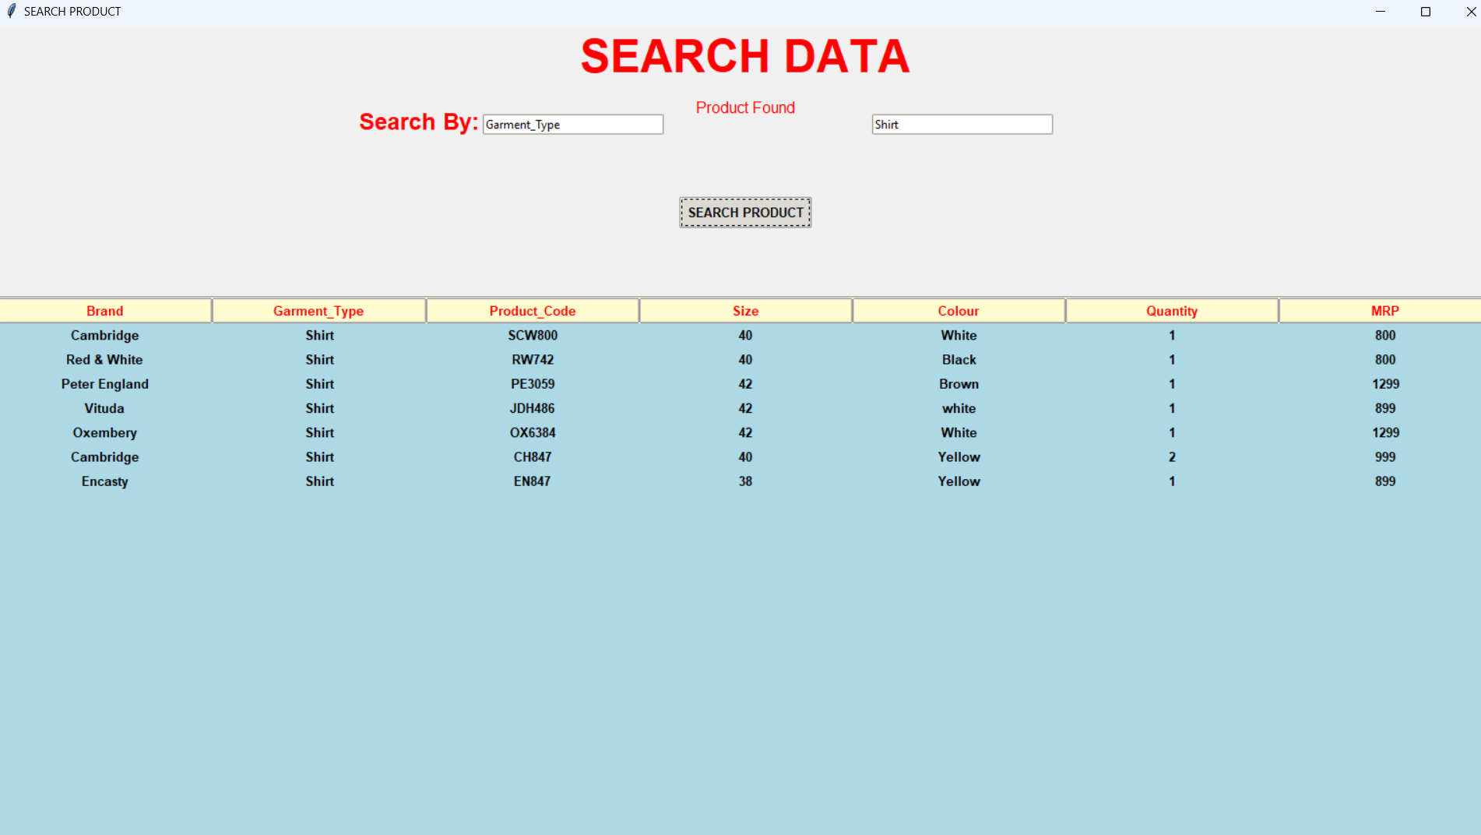

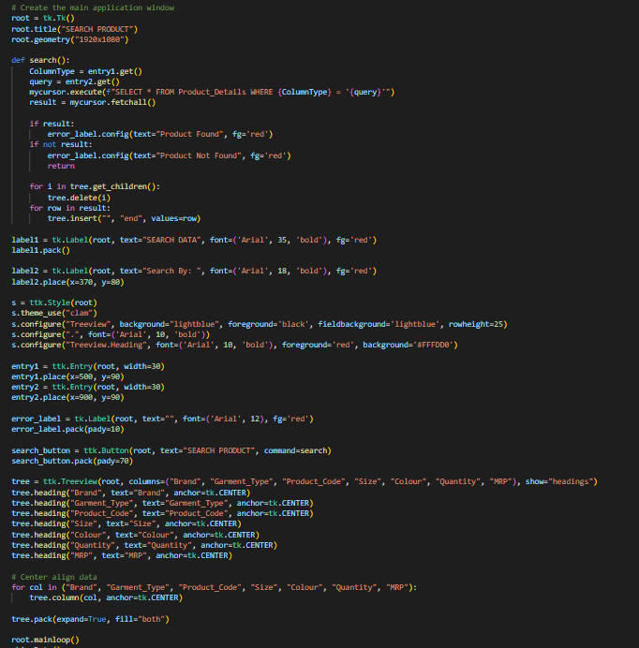

The data searching feature presented in this Python script provides an interactive and visually appealing way for users to search for specific products within the retail garment shop's database on basis of various criterias. The integration of Tkinter for GUI and Treeview for tabular data presentation enhances the user experience.

**2.6 DELETE DATA**

The module allows users to connect to a MySQL database, enter specific criteria (product code, size, and quantity), and delete the specified quantity of a product from the database.

Also, this code is linked to billing feature. When a product is purchase by a customer, that data is deleted from the database automatically.

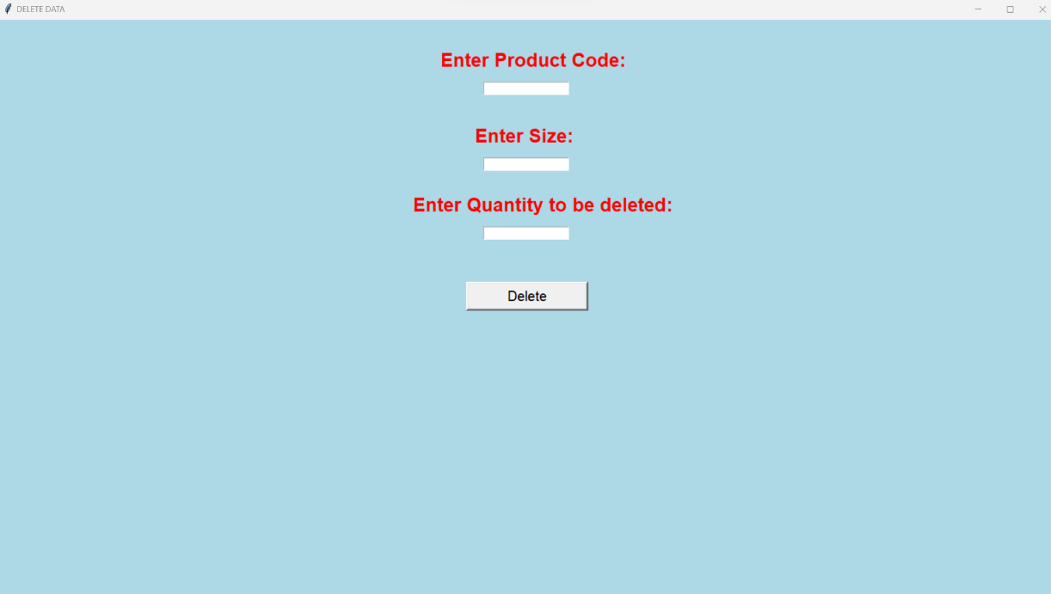

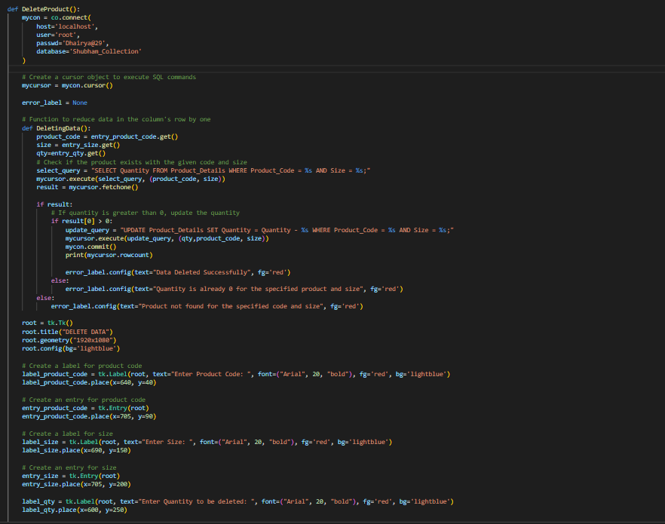

**2.7 PRINTING BILL**

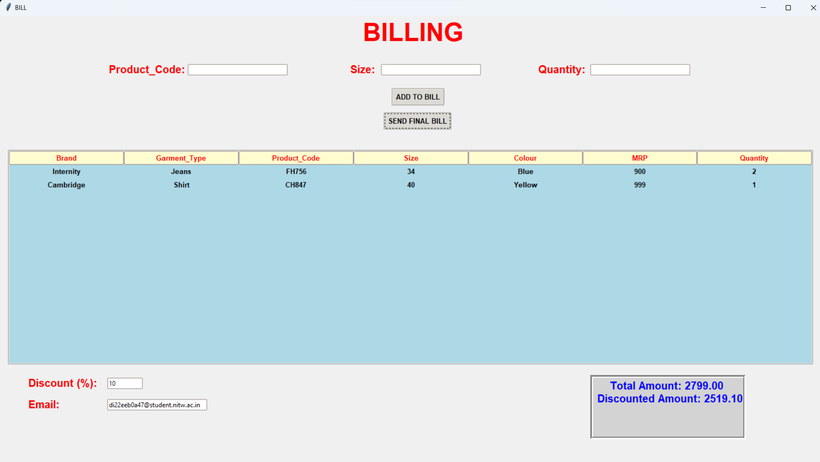

The module enables users to generate a bill for purchased items, apply discounts, and send the final bill to customers via email. The Tkinter library is used for creating a graphical user interface (GUI), and the smtplib library facilitates email communication.

The billing and email module presented in this Python script provides a comprehensive solution for generating bills, applying discounts, and sending the final bill to customers via email.

The image shown below is the image of the bill received by the customer.

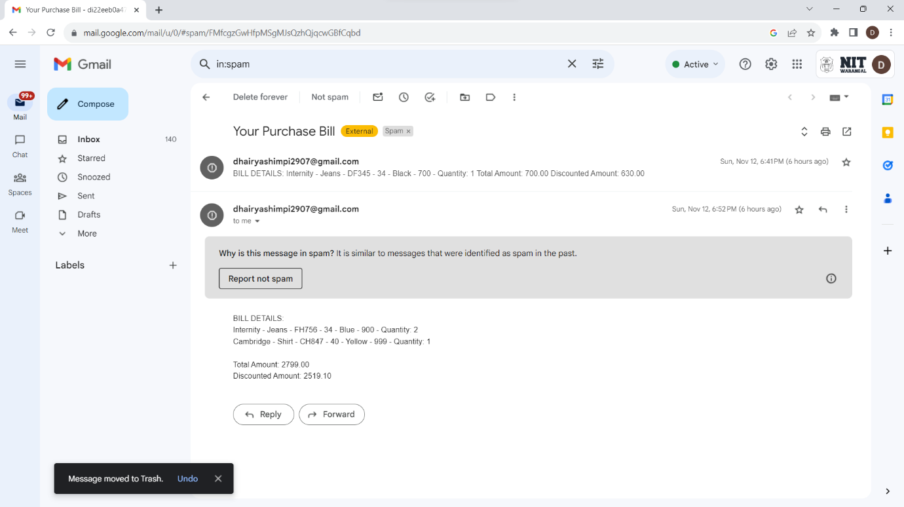

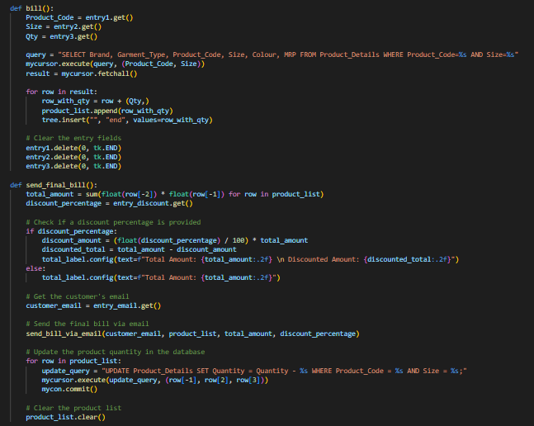

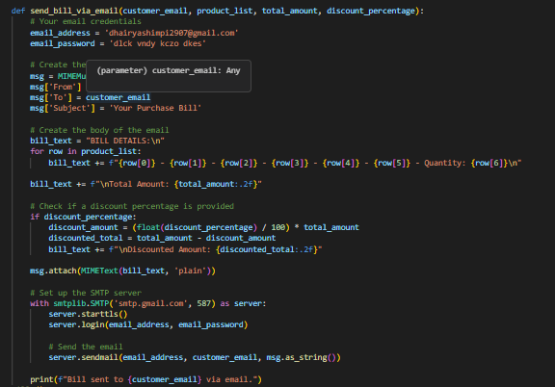

**CONCLUSION-**

In summary, the Python project we've created for "SHUBHAM COLLECTION," a clothing store, is like a smart helper for the shop. It helps in keeping track of all the clothes they have, making bills for customers, and even sending those bills through email.

The part where we manage data lets the shop easily add, see, find, and remove information about the clothes they have in stock. This helps in keeping everything organized, like a digital catalog of their products.

The billing part is like a virtual cashier. It creates bills for customers, applies any discounts, and can even send the bill directly to the customer's email. This not only makes the billing process smoother but also makes customers happy by giving them a clear record of their purchase.

This Python project is a valuable tool for the clothing store. It makes managing stock and dealing with customers much easier, saving time and keeping things running smoothly. It is like a modern and efficient assistant for the shop's daily tasks.