
Full name: Priya
Job role: Senior Data Engineer
Package: 11.54 LPA
Company name: Cymetrix
Photo:
Review:
Coming from a non-IT background, I was unsure about switching careers. JVM Institute made the transition smooth with their step-by-step training approach. The live projects gave me valuable practical exposure, and the trainers continuously motivated me throughout the course. Their placement assistance and mock interviews were incredibly helpful. Thanks to JVM Institute, I successfully started my journey in the IT industry.



Full name: Shweta
Job role: Software Engineer
Package: 12.5 LPA
Company name: Persistent
Photo:
Review:

After a career break, I wanted to restart my professional journey in a growing field. JVM Institute gave me the confidence and skills needed to enter the IT industry. The trainers were extremely supportive and explained every topic in a simple manner. The live projects and interview preparation sessions helped me gain practical experience. Today, I am successfully working in the Data Engineering domain and grateful to JVM Institute for making this transition possible


Full name: Prathamesh
Job role: Data Engineer
Package: 13 LPA
Company name: Zorba Consulting
Photo:
Review:

My journey with JVM Institute has been truly life-changing. The training program provided in-depth knowledge of SQL, Python, PySpark, AWS, Azure, and real-time Data Engineering projects. The trainers were highly supportive and ensured that every concept was understood clearly through practical implementation. The mock interviews, resume preparation, and placement support helped me build confidence and perform well in interviews. With the guidance of JVM Institute, I successfully secured multiple offers from leading companies including Zorba Consulting (13 LPA), Datametica (12.2 LPA), and IPG Mediabrands (12 LPA). I am sincerely grateful to JVM Institute for helping me achieve these career milestones and would highly recommend it to anyone aspiring to build a successful career in Data Engineering.

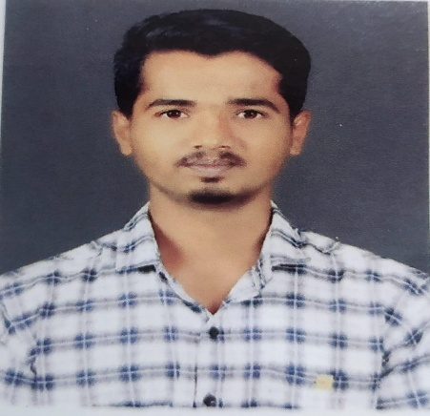

Full name: Abhishek
Job role: Data Engineer
Package: 12 LPA
Company name: Datemetica
Photo:
Review:
"I joined JVM Institute to upgrade my technical skills and improve my career prospects. The curriculum covered everything from SQL and Python to Cloud and Big Data technologies. The trainers were knowledgeable, supportive, and always encouraged us to learn beyond the classroom. The placement support and interview guidance were outstanding. It was truly a career-changing experience for me.

Full name: Ajinkya
Job role: Senior Data Engineer
Package: 16 LPA
Company name: LTI Mindtree
Photo:
Review:
"I joined JVM Institute to upgrade my technical skills and improve my career prospects. The curriculum covered everything from SQL and Python to Cloud and Big Data technologies. The trainers were knowledgeable, supportive, and always encouraged us to learn beyond the classroom. The placement support and interview guidance were outstanding. It was truly a career-changing experience for me



Full name: Nikhil
Job role: Senior Software Engineer
Package: 11 LPA
Company name: Prodapt
Photo:
Review-
"I am extremely grateful to JVM Institute for helping me achieve this milestone in my career. The practical training, real-time projects, and continuous mentorship played a crucial role in enhancing my technical skills. The trainers were always supportive and guided me throughout the learning journey. The mock interviews and placement assistance boosted my confidence and prepared me for opportunities in top companies. Thanks to JVM Institute, I successfully received offers from Prodapt (11 LPA) and Senzcraft (10 LPA). I highly recommend JVM Institute to anyone looking to build a successful career in the IT industry

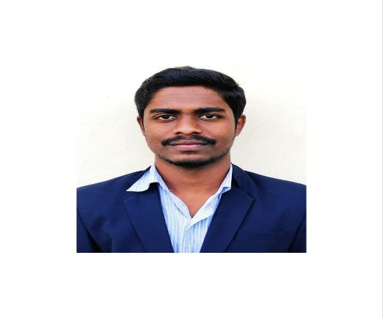
Full name: Satyajeet
Job role: Lead Software Engineer
Package: 13.20 LPA
Company name: Persistent
Photo:
Review:
After spending several years in the preparing for goverment exams, I wanted a career with better growth opportunities. JVM Institute helped me learn industry-relevant technologies such as SQL, Python, AWS, and PySpark. The trainers provided personal attention and cleared every doubt patiently. The practical assignments and placement support made a huge difference. I successfully switched from Banking to IT and started my Data Engineering career.



Full name: Rohini
Job role: Lead Software Engineer
Package: 13.66 LPA
Company name: Persistent
Photo:
Review:
"Coming from a non-IT background, I always dreamed of building a successful career in the technology industry but wasn't sure where to begin. JVM Institute provided me with the right guidance, structured learning path, and practical exposure through real-time projects. The trainers were incredibly supportive and helped me understand complex concepts in a simple way. The mock interviews, resume preparation, and continuous mentorship boosted my confidence and made me industry-ready. With the skills and knowledge gained at JVM Institute, I successfully secured a position as a Lead Software Engineer at Persistent with a package of 13.66 LPA. I am truly grateful to JVM Institute for helping me transform my career and achieve this milestone

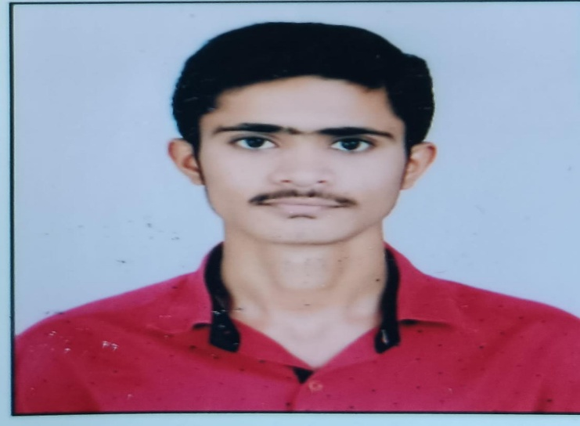

Full name: Rahul
Job role: Data Engineer
Package: 10 LPA
Company name: Anchanto
Photo:
Review:
Coming from an Non IT background, I had limited technical knowledge. JVM Institute helped me understand Data Engineering concepts from scratch through hands-on learning and real-world projects. The trainers focused on practical implementation rather than just theory. The placement support and mock interviews played a huge role in my success. Thanks to JVM Institute, I was able to make a successful career transition into IT.



Full name: Ankit
Job role: Senior Consultant
Package: 12.75 LPA
Company name: Mindcraft
Photo:
Review:

My experience with JVM Institute was fantastic. The trainers not only taught technical concepts but also guided us on resume building and interview preparation. The hands-on assignments and projects strengthened my practical knowledge. The supportive learning environment kept me motivated throughout the course. Thanks to JVM Institute, I was able to achieve my career goals successfully.

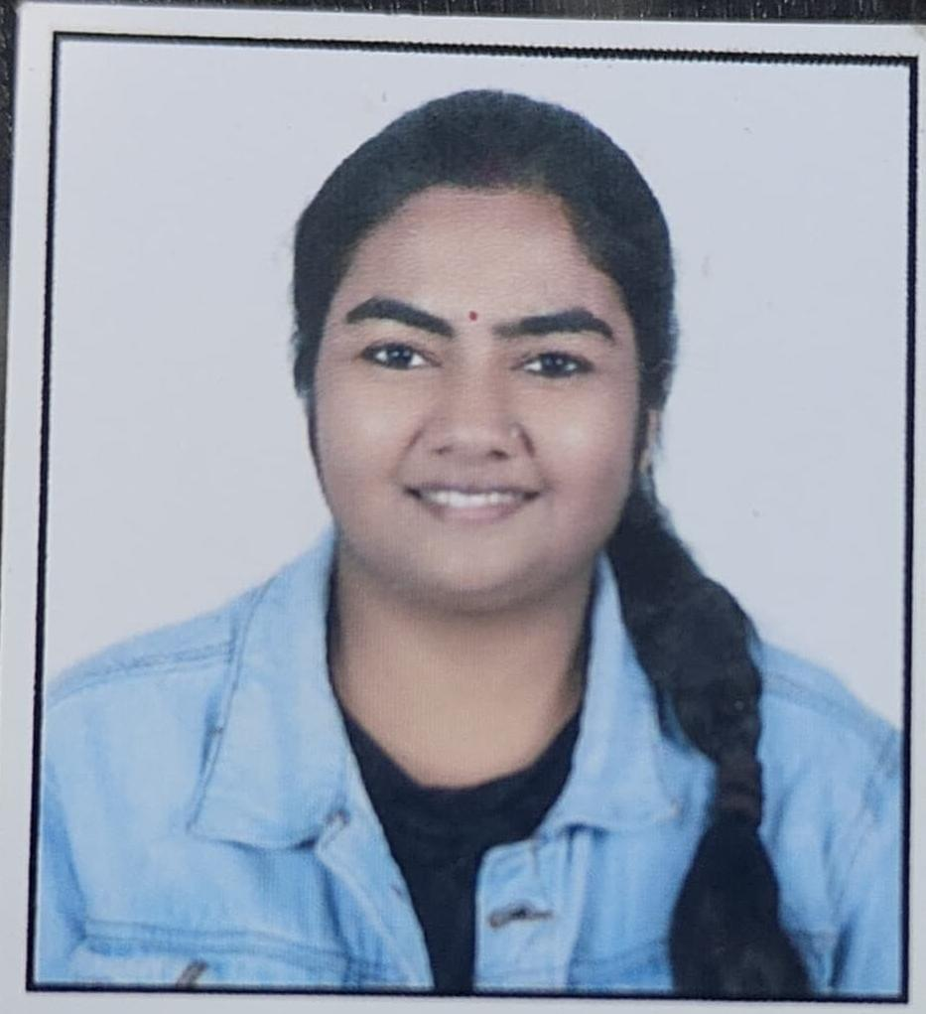
Full name: Vaishnavi
Job role: Technical Lead
Package: 11 LPA
Company name: HCL Tech
Photo:
Review:
"I came from a non-IT background with a strong desire to build a career in technology. JVM Institute helped me bridge the gap with hands-on training, practical assignments, and expert mentorship. The trainers focused on real-world scenarios and ensured that every concept was understood thoroughly. The placement support and mock interviews prepared me to confidently face recruitment challenges. Thanks to JVM Institute, I successfully secured a Technical Lead position at HCLTech with a package of 11 LPA. This achievement would not have been possible without their guidance and support.

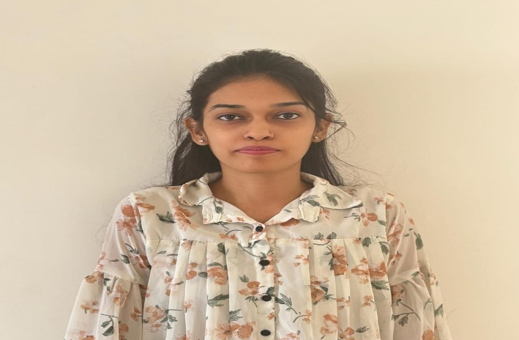
Full name: Pooja
Job role: Developer
Package: 12 LPA
Company name: Wipro
Photo:
Review:
entering the software industry seemed challenging at first. JVM Institute's structured training program and practical learning approach made the transition smooth and achievable. The trainers patiently guided me through every concept and provided constant support throughout the course. The interview preparation sessions and real-world projects helped me develop the skills required by top companies. Today, I am proud to have secured a Developer role at Wipro with a package of 12 LPA. I sincerely thank JVM Institute for helping me build a successful IT career."

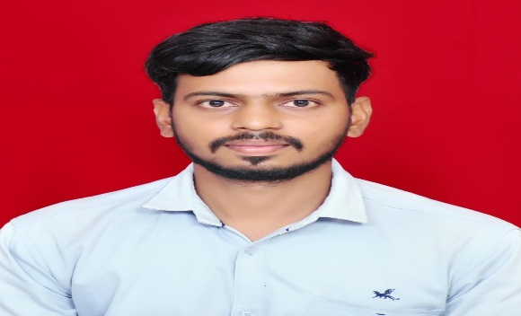
Full name: Kartik
Job role: Data Engineer
Package: 11 LPA
Company name: Code Chavo
Photo:
Review:
Coming from a non-IT background, I was uncertain about how to start my journey in the technology field. JVM Institute provided me with the right guidance, practical training, and industry-focused learning. The trainers helped me build a strong foundation in SQL, Python, PySpark, and Cloud technologies through real-time projects. The mock interviews and placement support significantly improved my confidence. With the continuous mentorship from JVM Institute, I successfully secured a Data Engineer position at CodeChavo with a package of 11 LPA. I am thankful to JVM Institute for helping me achieve this career transformation.

