Name: Sarvesh Mishra
Roll No: 2401330100319
Branch: CSE
Section: E
Workshop Lab Number: 012

Question 1
Student.java

package com.workshop.student.model;

import jakarta.persistence.Column;
import jakarta.persistence.Entity;
import jakarta.persistence.GeneratedValue;
import jakarta.persistence.GenerationType;
import jakarta.persistence.Id;
import jakarta.persistence.Table;
import lombok.AllArgsConstructor;
import lombok.Getter;
import lombok.NoArgsConstructor;
import lombok.Setter;

@Entity
@Table(name = "students")
@Getter
@Setter
@NoArgsConstructor
@AllArgsConstructor
public class Student {
@Id
@GeneratedValue(strategy = GenerationType.IDENTITY)
private Long id;

@Column(nullable = false)
private String name;

@Column(nullable = false, unique = true)
private String rollNumber;

private String department;

private Double marks;
}

StudentRepository.java
package com.workshop.student.repository;

import org.springframework.data.jpa.repository.JpaRepository;

import com.workshop.student.model.Student;

public interface StudentRepository extends JpaRepository<Student, Long> {
}

StudentController.java
package com.workshop.student.controller;

import java.util.List;

import org.springframework.http.HttpStatus;
import org.springframework.http.ResponseEntity;
import org.springframework.web.bind.annotation.GetMapping;
import org.springframework.web.bind.annotation.PathVariable;
import org.springframework.web.bind.annotation.PostMapping;
import org.springframework.web.bind.annotation.RequestBody;
import org.springframework.web.bind.annotation.RequestMapping;
import org.springframework.web.bind.annotation.RestController;

import com.workshop.student.exception.StudentNotFoundException;
import com.workshop.student.model.Student;
import com.workshop.student.repository.StudentRepository;

@RestController
@RequestMapping("/api/students")
public class StudentController {
private final StudentRepository studentRepository;

public StudentController(StudentRepository studentRepository) {
this.studentRepository = studentRepository;
}

@PostMapping
public ResponseEntity<Student> saveStudent(@RequestBody Student student) {
Student savedStudent = studentRepository.save(student);
return ResponseEntity.status(HttpStatus.CREATED).body(savedStudent);
}

@GetMapping
public ResponseEntity<List<Student>> getAllStudents() {
return ResponseEntity.ok(studentRepository.findAll());
}

@GetMapping("/{id}")
public ResponseEntity<Student> getStudentById(@PathVariable Long id) {
Student student = studentRepository.findById(id)
.orElseThrow(() -> new StudentNotFoundException("Student not found with id " + id));
return ResponseEntity.ok(student);
}
}

StudentNotFoundException.java
package com.workshop.student.exception;

public class StudentNotFoundException extends RuntimeException {
public StudentNotFoundException(String message) {
super(message);
}
}

GlobalExceptionHandler.java
package com.workshop.student.exception;

import org.springframework.http.HttpStatus;
import org.springframework.http.ResponseEntity;
import org.springframework.web.bind.MethodArgumentNotValidException;
import org.springframework.web.bind.annotation.ExceptionHandler;
import org.springframework.web.bind.annotation.RestControllerAdvice;

@RestControllerAdvice
public class GlobalExceptionHandler {

@ExceptionHandler(StudentNotFoundException.class)
public ResponseEntity<ApiError> handleStudentNotFound(StudentNotFoundException exception) {
ApiError apiError = new ApiError(HttpStatus.NOT_FOUND.value(), exception.getMessage());
return ResponseEntity.status(HttpStatus.NOT_FOUND).body(apiError);
}

@ExceptionHandler(MethodArgumentNotValidException.class)
public ResponseEntity<ApiError> handleValidationError(MethodArgumentNotValidException exception) {
ApiError apiError = new ApiError(HttpStatus.BAD_REQUEST.value(), "Invalid student details provided.");
return ResponseEntity.status(HttpStatus.BAD_REQUEST).body(apiError);
}

@ExceptionHandler(Exception.class)
public ResponseEntity<ApiError> handleGenericError(Exception exception) {
ApiError apiError = new ApiError(HttpStatus.INTERNAL_SERVER_ERROR.value(), "Something went wrong: " + exception.getMessage());
return ResponseEntity.status(HttpStatus.INTERNAL_SERVER_ERROR).body(apiError);
}
}

application.properties
server.port=8083

spring.datasource.url=jdbc:h2:mem:studentdb
spring.datasource.driver-class-name=org.h2.Driver
spring.datasource.username=sa
spring.datasource.password=

spring.jpa.hibernate.ddl-auto=update
spring.jpa.show-sql=true
spring.jpa.database-platform=org.hibernate.dialect.H2Dialect

spring.h2.console.enabled=true
spring.h2.console.path=/h2-console

Output
POST /api/students
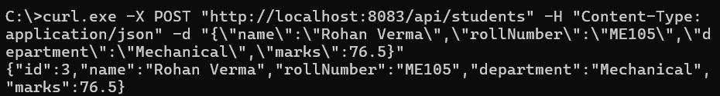
GET /api/students
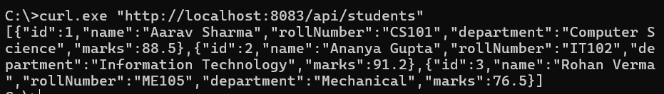

GET /api/students/{id}

GET /api/students/99

Question 2
Product.java

package com.workshop.product.model;

import jakarta.persistence.Column;
import jakarta.persistence.Entity;
import jakarta.persistence.GeneratedValue;
import jakarta.persistence.GenerationType;
import jakarta.persistence.Id;
import jakarta.persistence.Table;

@Entity
@Table(name = "products")
public class Product {
@Id
@GeneratedValue(strategy = GenerationType.IDENTITY)
private Long id;

@Column(nullable = false)
private String name;

private String category;

@Column(nullable = false)
private Double price;

private Integer quantity;

public Product() {
}

public Product(String name, String category, Double price, Integer quantity) {
this.name = name;
this.category = category;
this.price = price;
this.quantity = quantity;
}

public Long getId() {
return id;
}

public void setId(Long id) {
this.id = id;
}

public String getName() {
return name;
}

public void setName(String name) {
this.name = name;
}

public String getCategory() {
return category;
}

public void setCategory(String category) {
this.category = category;
}

public Double getPrice() {
return price;
}

public void setPrice(Double price) {
this.price = price;
}

public Integer getQuantity() {
return quantity;
}

public void setQuantity(Integer quantity) {
this.quantity = quantity;
}
}

ProductRepository.java

package com.workshop.product.repository;

import org.springframework.data.jpa.repository.JpaRepository;

import com.workshop.product.model.Product;

public interface ProductRepository extends JpaRepository<Product, Long> {
}

ProductService.java
package com.workshop.product.service;

import java.util.List;

import org.springframework.stereotype.Service;

import com.workshop.product.exception.ProductNotFoundException;
import com.workshop.product.model.Product;
import com.workshop.product.repository.ProductRepository;

@Service
public class ProductService {
private final ProductRepository productRepository;

public ProductService(ProductRepository productRepository) {
this.productRepository = productRepository;
}

public Product createProduct(Product product) {
return productRepository.save(product);
}

public List<Product> getAllProducts() {
return productRepository.findAll();
}

public Product getProductById(Long id) {
return productRepository.findById(id)
.orElseThrow(() -> new ProductNotFoundException("Product not found with id " + id));
}

public Product updateProduct(Long id, Product updatedProduct) {
Product existingProduct = getProductById(id);
existingProduct.setName(updatedProduct.getName());
existingProduct.setCategory(updatedProduct.getCategory());
existingProduct.setPrice(updatedProduct.getPrice());
existingProduct.setQuantity(updatedProduct.getQuantity());
return productRepository.save(existingProduct);
}

public void deleteProduct(Long id) {
Product existingProduct = getProductById(id);
productRepository.delete(existingProduct);
}
}

ProductController.java
package com.workshop.product.controller;

import java.util.List;

import org.springframework.http.HttpStatus;
import org.springframework.http.ResponseEntity;
import org.springframework.web.bind.annotation.DeleteMapping;
import org.springframework.web.bind.annotation.GetMapping;
import org.springframework.web.bind.annotation.PathVariable;
import org.springframework.web.bind.annotation.PostMapping;
import org.springframework.web.bind.annotation.PutMapping;
import org.springframework.web.bind.annotation.RequestBody;
import org.springframework.web.bind.annotation.RequestMapping;
import org.springframework.web.bind.annotation.RestController;

import com.workshop.product.model.Product;
import com.workshop.product.service.ProductService;

@RestController
@RequestMapping("/api/products")
public class ProductController {
private final ProductService productService;

public ProductController(ProductService productService) {
this.productService = productService;
}

@PostMapping
public ResponseEntity<Product> createProduct(@RequestBody Product product) {
Product savedProduct = productService.createProduct(product);
return ResponseEntity.status(HttpStatus.CREATED).body(savedProduct);
}

@GetMapping
public ResponseEntity<List<Product>> getAllProducts() {
return ResponseEntity.ok(productService.getAllProducts());
}

@GetMapping("/{id}")
public ResponseEntity<Product> getProductById(@PathVariable Long id) {
return ResponseEntity.ok(productService.getProductById(id));
}

@PutMapping("/{id}")
public ResponseEntity<Product> updateProduct(@PathVariable Long id, @RequestBody Product product) {
return ResponseEntity.ok(productService.updateProduct(id, product));
}

@DeleteMapping("/{id}")
public ResponseEntity<String> deleteProduct(@PathVariable Long id) {
productService.deleteProduct(id);
return ResponseEntity.ok("Product with id " + id + " deleted successfully.");
}
}

ProductNotFoundException.java
package com.workshop.product.exception;

public class ProductNotFoundException extends RuntimeException {
public ProductNotFoundException(String message) {
super(message);
}
}

GlobalExceptionHandler.java
package com.workshop.product.exception;

import org.springframework.http.HttpStatus;
import org.springframework.http.ResponseEntity;
import org.springframework.web.bind.annotation.ExceptionHandler;
import org.springframework.web.bind.annotation.RestControllerAdvice;

@RestControllerAdvice
public class GlobalExceptionHandler {

@ExceptionHandler(ProductNotFoundException.class)
public ResponseEntity<ApiError> handleProductNotFound(ProductNotFoundException exception) {
ApiError apiError = new ApiError(HttpStatus.NOT_FOUND.value(), exception.getMessage());
return ResponseEntity.status(HttpStatus.NOT_FOUND).body(apiError);
}

@ExceptionHandler(Exception.class)
public ResponseEntity<ApiError> handleGenericError(Exception exception) {
ApiError apiError = new ApiError(HttpStatus.INTERNAL_SERVER_ERROR.value(), "Something went wrong: " + exception.getMessage());
return ResponseEntity.status(HttpStatus.INTERNAL_SERVER_ERROR).body(apiError);
}
}

application.properties
server.port=8084

spring.datasource.url=jdbc:mysql://localhost:3306/product_crud_app?createDatabaseIfNotExist=true&useSSL=false&serverTimezone=UTC
spring.datasource.username=root
spring.datasource.password=
spring.datasource.driver-class-name=com.mysql.cj.jdbc.Driver

spring.jpa.hibernate.ddl-auto=update
spring.jpa.show-sql=true
spring.jpa.open-in-view=false

Output
POST /api/products
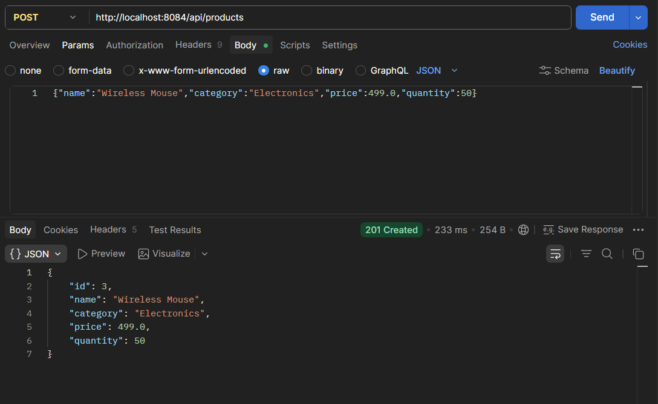

GET api/products
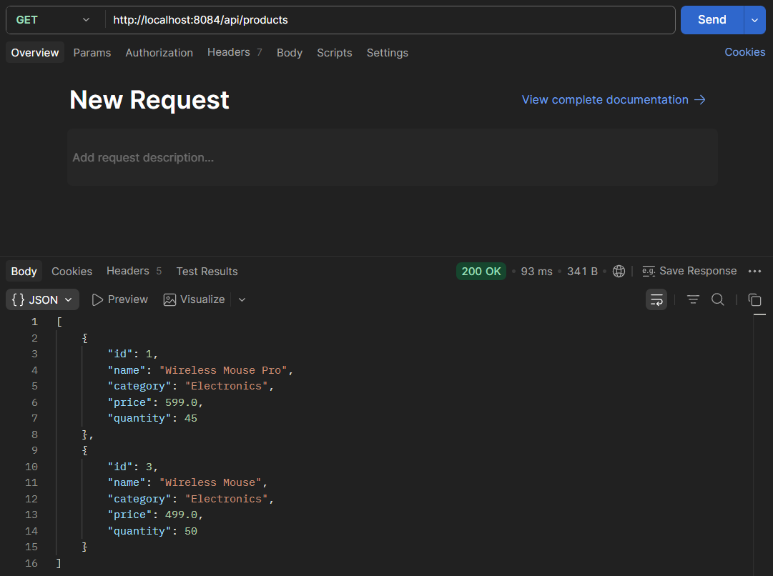

GET /api/products/1
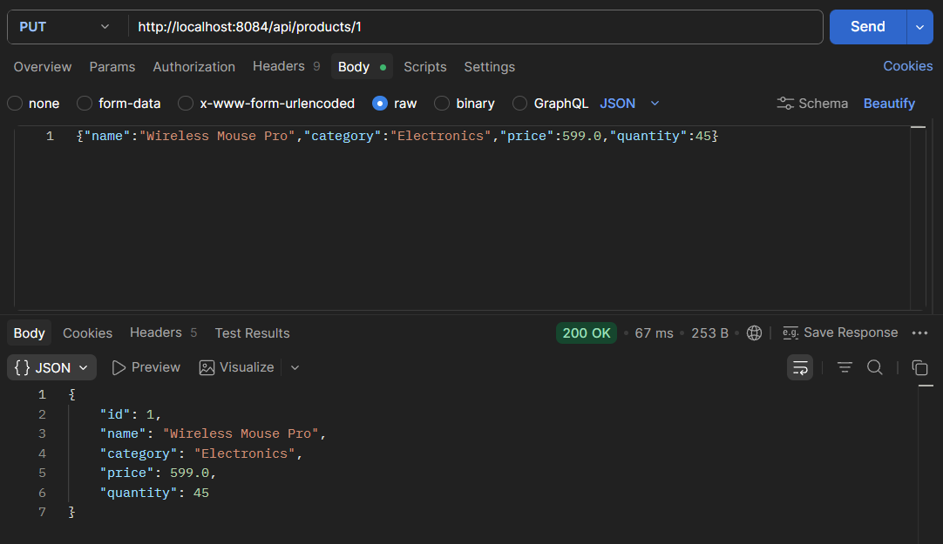

DELETE /api/products/1
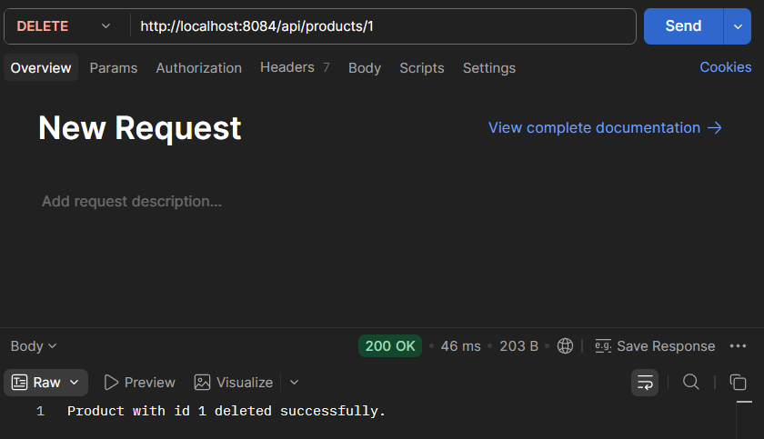

GET /api/products/1
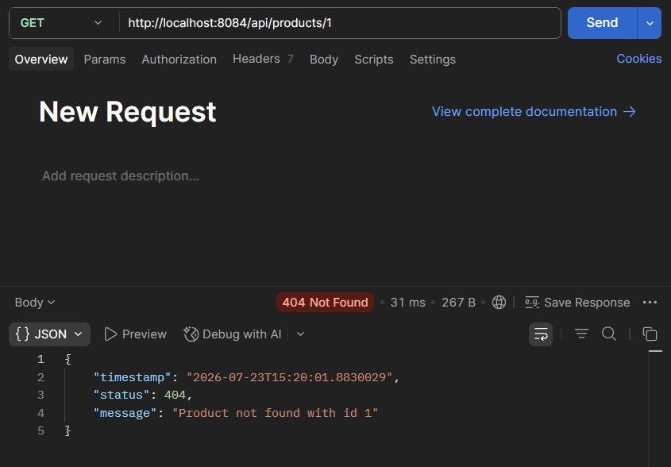

Question 3
Book.java
package com.workshop.book.model;

import jakarta.persistence.Column;
import jakarta.persistence.Entity;
import jakarta.persistence.GeneratedValue;
import jakarta.persistence.GenerationType;
import jakarta.persistence.Id;
import jakarta.persistence.Table;

@Entity
@Table(name = "books")
public class Book {
@Id
@GeneratedValue(strategy = GenerationType.IDENTITY)
private Long id;

@Column(nullable = false)
private String title;

@Column(nullable = false)
private String author;

@Column(nullable = false, unique = true)
private String isbn;

private Double price;

public Book() {
}

public Book(String title, String author, String isbn, Double price) {
this.title = title;
this.author = author;
this.isbn = isbn;
this.price = price;
}

public Long getId() {
return id;
}

public void setId(Long id) {
this.id = id;
}

public String getTitle() {
return title;
}

public void setTitle(String title) {
this.title = title;
}

public String getAuthor() {
return author;
}

public void setAuthor(String author) {
this.author = author;
}

public String getIsbn() {
return isbn;
}

public void setIsbn(String isbn) {
this.isbn = isbn;
}

public Double getPrice() {
return price;
}

public void setPrice(Double price) {
this.price = price;
}
}

BookRepository.java
package com.workshop.book.repository;

import java.util.Optional;

import org.springframework.data.jpa.repository.JpaRepository;

import com.workshop.book.model.Book;

public interface BookRepository extends JpaRepository<Book, Long> {
Optional<Book> findByIsbn(String isbn);
}

BookService.java
package com.workshop.book.service;

import java.util.List;

import org.springframework.stereotype.Service;

import com.workshop.book.exception.BookNotFoundException;
import com.workshop.book.exception.DuplicateIsbnException;
import com.workshop.book.model.Book;
import com.workshop.book.repository.BookRepository;

@Service
public class BookService {
private final BookRepository bookRepository;

public BookService(BookRepository bookRepository) {
this.bookRepository = bookRepository;
}

public Book createBook(Book book) {
if (bookRepository.findByIsbn(book.getIsbn()).isPresent()) {
throw new DuplicateIsbnException("A book with ISBN " + book.getIsbn() + " already exists.");
}
return bookRepository.save(book);
}

public List<Book> getAllBooks() {
return bookRepository.findAll();
}

public Book getBookById(Long id) {
return bookRepository.findById(id)
.orElseThrow(() -> new BookNotFoundException("Book not found with id " + id));
}

public Book updateBook(Long id, Book updatedBook) {
Book existingBook = getBookById(id);
existingBook.setTitle(updatedBook.getTitle());
existingBook.setAuthor(updatedBook.getAuthor());
existingBook.setIsbn(updatedBook.getIsbn());
existingBook.setPrice(updatedBook.getPrice());
return bookRepository.save(existingBook);
}

public void deleteBook(Long id) {
Book existingBook = getBookById(id);
bookRepository.delete(existingBook);
}
}

BookController.java
package com.workshop.book.controller;

import java.util.List;

import org.springframework.http.HttpStatus;
import org.springframework.http.ResponseEntity;
import org.springframework.web.bind.annotation.DeleteMapping;
import org.springframework.web.bind.annotation.GetMapping;
import org.springframework.web.bind.annotation.PathVariable;
import org.springframework.web.bind.annotation.PostMapping;
import org.springframework.web.bind.annotation.PutMapping;
import org.springframework.web.bind.annotation.RequestBody;
import org.springframework.web.bind.annotation.RequestMapping;
import org.springframework.web.bind.annotation.RestController;

import com.workshop.book.model.Book;
import com.workshop.book.service.BookService;

@RestController
@RequestMapping("/api/books")
public class BookController {
private final BookService bookService;

public BookController(BookService bookService) {
this.bookService = bookService;
}

@PostMapping
public ResponseEntity<Book> createBook(@RequestBody Book book) {
Book savedBook = bookService.createBook(book);
return ResponseEntity.status(HttpStatus.CREATED).body(savedBook);
}

@GetMapping
public ResponseEntity<List<Book>> getAllBooks() {
return ResponseEntity.ok(bookService.getAllBooks());
}

@GetMapping("/{id}")
public ResponseEntity<Book> getBookById(@PathVariable Long id) {
return ResponseEntity.ok(bookService.getBookById(id));
}

@PutMapping("/{id}")
public ResponseEntity<Book> updateBook(@PathVariable Long id, @RequestBody Book book) {
return ResponseEntity.ok(bookService.updateBook(id, book));
}

@DeleteMapping("/{id}")
public ResponseEntity<String> deleteBook(@PathVariable Long id) {
bookService.deleteBook(id);
return ResponseEntity.ok("Book with id " + id + " deleted successfully.");
}
}

BookNotFoundException.java
package com.workshop.book.controller;

import java.util.List;

import org.springframework.http.HttpStatus;
import org.springframework.http.ResponseEntity;
import org.springframework.web.bind.annotation.DeleteMapping;
import org.springframework.web.bind.annotation.GetMapping;
import org.springframework.web.bind.annotation.PathVariable;
import org.springframework.web.bind.annotation.PostMapping;
import org.springframework.web.bind.annotation.PutMapping;
import org.springframework.web.bind.annotation.RequestBody;
import org.springframework.web.bind.annotation.RequestMapping;
import org.springframework.web.bind.annotation.RestController;

import com.workshop.book.model.Book;
import com.workshop.book.service.BookService;

@RestController
@RequestMapping("/api/books")
public class BookController {
private final BookService bookService;

public BookController(BookService bookService) {
this.bookService = bookService;
}

@PostMapping
public ResponseEntity<Book> createBook(@RequestBody Book book) {
Book savedBook = bookService.createBook(book);
return ResponseEntity.status(HttpStatus.CREATED).body(savedBook);
}

@GetMapping
public ResponseEntity<List<Book>> getAllBooks() {
return ResponseEntity.ok(bookService.getAllBooks());
}

@GetMapping("/{id}")
public ResponseEntity<Book> getBookById(@PathVariable Long id) {
return ResponseEntity.ok(bookService.getBookById(id));
}

@PutMapping("/{id}")
public ResponseEntity<Book> updateBook(@PathVariable Long id, @RequestBody Book book) {
return ResponseEntity.ok(bookService.updateBook(id, book));
}

@DeleteMapping("/{id}")
public ResponseEntity<String> deleteBook(@PathVariable Long id) {
bookService.deleteBook(id);
return ResponseEntity.ok("Book with id " + id + " deleted successfully.");
}
}

DuplicateIsbnException.java
package com.workshop.book.exception;

public class DuplicateIsbnException extends RuntimeException {
public DuplicateIsbnException(String message) {
super(message);
}
}

GlobalExceptionHandler.java
package com.workshop.book.exception;

import org.springframework.http.HttpStatus;
import org.springframework.http.ResponseEntity;
import org.springframework.web.bind.annotation.ControllerAdvice;
import org.springframework.web.bind.annotation.ExceptionHandler;
import org.springframework.web.bind.annotation.ResponseBody;

@ControllerAdvice
public class GlobalExceptionHandler {

@ExceptionHandler(BookNotFoundException.class)
@ResponseBody
public ResponseEntity<ApiError> handleBookNotFound(BookNotFoundException exception) {
ApiError apiError = new ApiError(HttpStatus.NOT_FOUND.value(), exception.getMessage());
return ResponseEntity.status(HttpStatus.NOT_FOUND).body(apiError);
}

@ExceptionHandler(DuplicateIsbnException.class)
@ResponseBody
public ResponseEntity<ApiError> handleDuplicateIsbn(DuplicateIsbnException exception) {
ApiError apiError = new ApiError(HttpStatus.CONFLICT.value(), exception.getMessage());
return ResponseEntity.status(HttpStatus.CONFLICT).body(apiError);
}

@ExceptionHandler(Exception.class)
@ResponseBody
public ResponseEntity<ApiError> handleGenericError(Exception exception) {
ApiError apiError = new ApiError(HttpStatus.INTERNAL_SERVER_ERROR.value(), "Something went wrong: " + exception.getMessage());
return ResponseEntity.status(HttpStatus.INTERNAL_SERVER_ERROR).body(apiError);
}
}

Output
POST /api/books
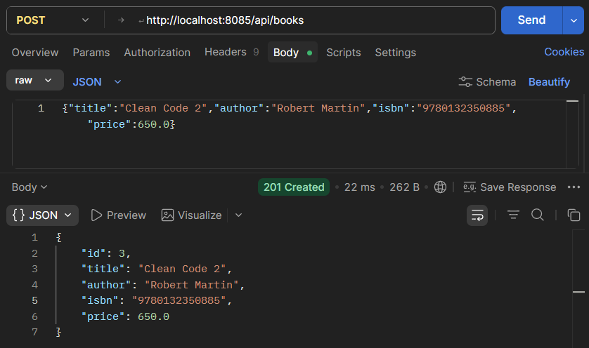

PUT /api/books/2

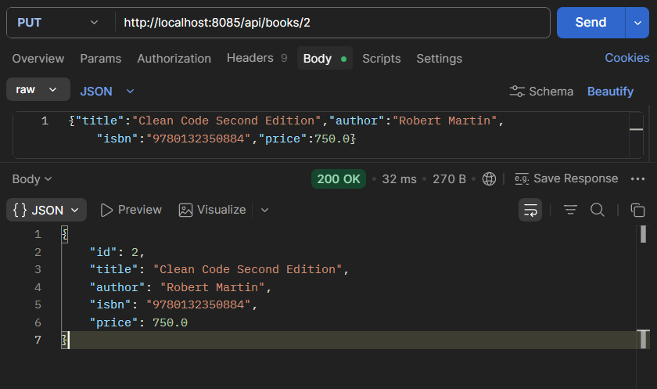

GET /api/books/2

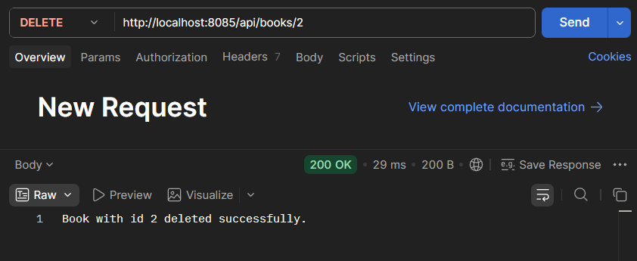

GET /api/books/2

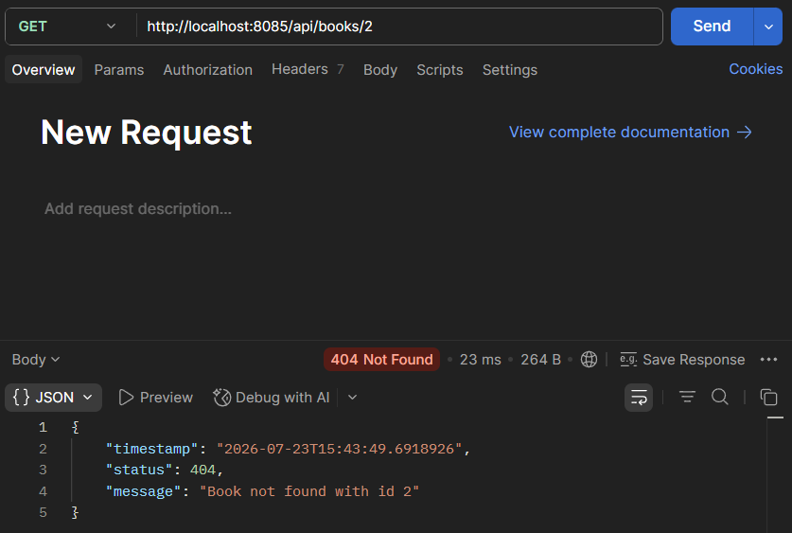

POST /api/books

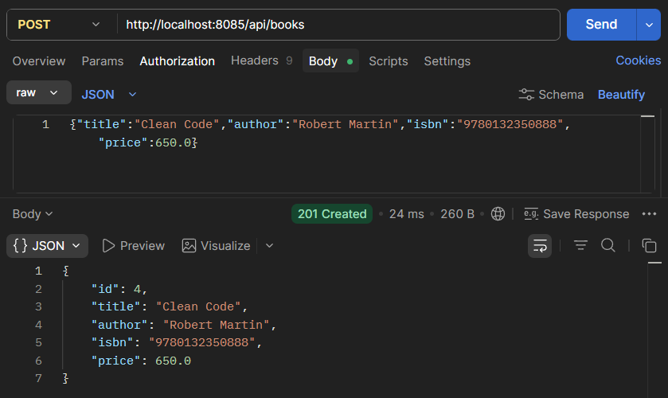

POST /api/books

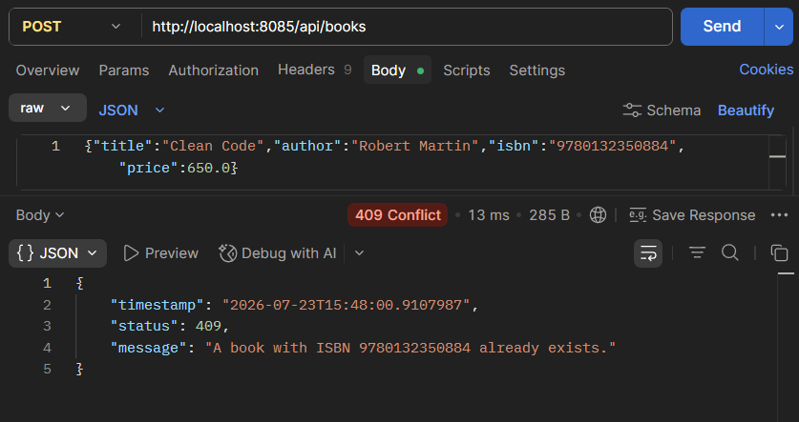

Question 4
Course.java
package com.workshop.course.model;

import lombok.AllArgsConstructor;
import lombok.Getter;
import lombok.NoArgsConstructor;
import lombok.Setter;
import lombok.ToString;

@Getter
@Setter
@NoArgsConstructor
@AllArgsConstructor
@ToString
public class Course {
private int id;
private String courseCode;
private String courseName;
private String instructor;
private int credits;
}

Course.java
package com.workshop.course.model;

import org.springframework.stereotype.Component;

@Component
public class Course {
private int courseId = 501;
private String courseName = "Advanced Java";
private String facultyName = "Dr. Sharma";

public int getCourseId() {
return courseId;
}

public String getCourseName() {
return courseName;
}

public String getFacultyName() {
return facultyName;
}
}

CourseService.java
package com.workshop.course.service;

import java.util.List;

import org.springframework.stereotype.Service;

import com.workshop.course.exception.CourseNotFoundException;
import com.workshop.course.model.Course;

@Service
public class CourseService {
private final List<Course> courses = List.of(
new Course(1, "CS301", "Advanced Java", "Dr. Neha Sharma", 4),
new Course(2, "CS302", "Data Structures", "Prof. Amit Rao", 3),
new Course(3, "CS303", "Database Management Systems", "Dr. Kavita Joshi", 3));

public List<Course> getAllCourses() {
return courses;
}

public Course getCourseById(int id) {
return courses.stream()
.filter(course -> course.getId() == id)
.findFirst()
.orElseThrow(() -> new CourseNotFoundException("Course not found with id " + id));
}
}

CourseController.java
package com.workshop.course.controller;

import java.util.List;

import org.springframework.http.HttpStatus;
import org.springframework.http.MediaType;
import org.springframework.http.ResponseEntity;
import org.springframework.web.bind.annotation.GetMapping;
import org.springframework.web.bind.annotation.PathVariable;
import org.springframework.web.bind.annotation.RequestMapping;
import org.springframework.web.bind.annotation.RestController;

import com.workshop.course.model.Course;
import com.workshop.course.service.CourseService;

@RestController
@RequestMapping("/api/courses")
public class CourseController {
private final CourseService courseService;

public CourseController(CourseService courseService) {
this.courseService = courseService;
}

@GetMapping
public ResponseEntity<List<Course>> getAllCourses() {
return ResponseEntity.ok(courseService.getAllCourses());
}

@GetMapping("/{id}")
public ResponseEntity<Course> getCourseById(@PathVariable int id) {
return ResponseEntity.ok(courseService.getCourseById(id));
}

@GetMapping(value = "/{id}/view", produces = MediaType.TEXT_HTML_VALUE)
public ResponseEntity<String> viewCourse(@PathVariable int id) {
Course course = courseService.getCourseById(id);
String html = """
<html>
<body style="font-family:Arial;padding:20px;">
<h2>Course Details</h2>
<table border="1" cellpadding="8" cellspacing="0">
<tr><th>Course Code</th><td>%s</td></tr>
<tr><th>Course Name</th><td>%s</td></tr>
<tr><th>Instructor</th><td>%s</td></tr>
<tr><th>Credits</th><td>%d</td></tr>
</table>
</body>
</html>
""".formatted(course.getCourseCode(), course.getCourseName(), course.getInstructor(), course.getCredits());
return ResponseEntity.status(HttpStatus.OK).body(html);
}
}

CourseInfoAppApplication.java
package com.workshop.course;

import org.springframework.boot.SpringApplication;
import org.springframework.boot.autoconfigure.SpringBootApplication;

@SpringBootApplication
public class CourseInfoAppApplication {
public static void main(String[] args) {
SpringApplication.run(CourseInfoAppApplication.class, args);
}
}

CourseInfoAppApplication.java
<!DOCTYPE html>
<html lang="en">
<head>
<meta charset="UTF-8">
<title>Course Info App</title>
<style>
body { font-family: Arial, sans-serif; padding: 30px; background: #f4f6f8; }
h1 { color: #2c3e50; }
a { display: inline-block; margin: 6px 0; color: #2563eb; }
.card { background: white; padding: 20px; border-radius: 8px; max-width: 480px; box-shadow: 0 1px 4px rgba(0,0,0,0.1); }
</style>
</head>
<body>
<div class="card">
<h1>Course Info App</h1>
<p>This page is served automatically by Spring Boot's static content auto-configuration, directly from <code>src/main/resources/static</code>, with no controller code.</p>
<p>Try these API endpoints:</p>
<a href="/api/courses">GET /api/courses (all courses, JSON)</a><br>
<a href="/api/courses/1">GET /api/courses/1 (one course, JSON)</a><br>
<a href="/api/courses/1/view">GET /api/courses/1/view (formatted HTML)</a><br>
<a href="/api/courses/99">GET /api/courses/99 (not found, JSON error)</a>
</div>
</body>
</html>

Output
Landing Page
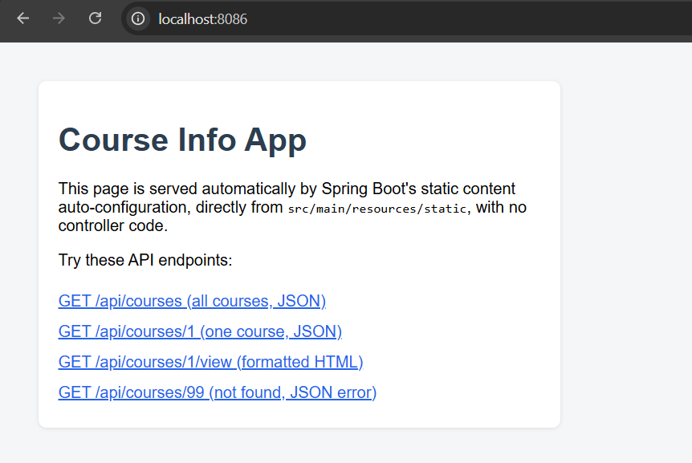

/api/courses
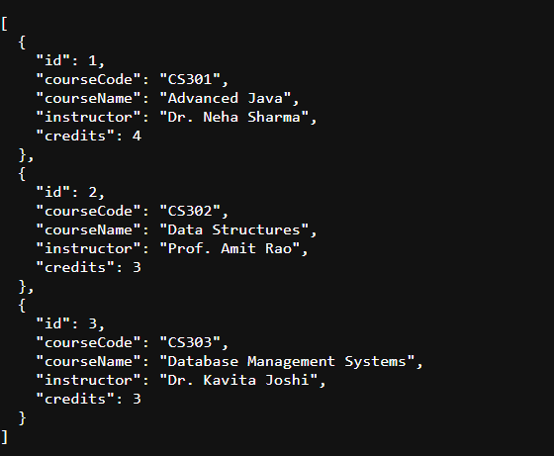

/api/courses/1

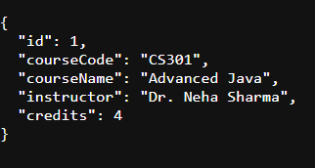

/api/courses/1/view

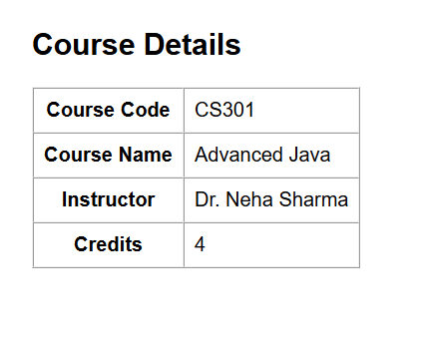

/api/courses/99

