Name: Sarvesh Mishra
Roll No: 2401330100319
Branch: CSE
Section: E
Workshop Lab Number: 012

Question 1
import java.sql.Connection;
import java.sql.DriverManager;
import java.sql.PreparedStatement;
import java.sql.ResultSet;
import java.sql.SQLException;
import java.sql.Statement;

public class JdbcProject {
private static final String JDBC_URL = "jdbc:mysql://localhost:3306/NIET";
private static final String USERNAME = "root";
private static final String PASSWORD = "";

public static void main(String[] args) {
try (Connection connection = DriverManager.getConnection(JDBC_URL, USERNAME, PASSWORD)) {
createStudentTable(connection);
insertSampleStudents(connection);
displayStudents(connection);
} catch (SQLException exception) {
System.out.println("Database operation failed.");
System.out.println("Reason: " + exception.getMessage());
}
}

private static void createStudentTable(Connection connection) throws SQLException {
String createTableSql = "CREATE TABLE IF NOT EXISTS STUDENT ("
+ "ID INT PRIMARY KEY AUTO_INCREMENT, "
+ "Name VARCHAR(50), "
+ "Age INT, "
+ "Department VARCHAR(50), "
+ "City VARCHAR(50)"
+ ")";

try (Statement statement = connection.createStatement()) {
statement.execute(createTableSql);
System.out.println("STUDENT table created successfully.");
}
}

private static void insertSampleStudents(Connection connection) throws SQLException {
String insertSql = "INSERT INTO STUDENT (Name, Age, Department, City) VALUES (?, ?, ?, ?)";

Object[][] students = {
{"Aarav Sharma", 20, "Computer Science", "Noida"},
{"Ananya Gupta", 21, "Information Technology", "Delhi"},
{"Rohan Verma", 22, "Electronics", "Ghaziabad"},
{"Priya Singh", 20, "Mechanical", "Lucknow"},
{"Kunal Mehta", 23, "Civil", "Jaipur"},
{"Neha Yadav", 21, "Computer Science", "Gurugram"},
{"Vivek Kumar", 22, "Information Technology", "Meerut"},
{"Isha Saxena", 20, "Electronics", "Kanpur"},
{"Sahil Khan", 24, "Mechanical", "Agra"},
{"Meera Joshi", 21, "Civil", "Dehradun"}
};

try (PreparedStatement preparedStatement = connection.prepareStatement(insertSql)) {
for (Object[] student : students) {
preparedStatement.setString(1, (String) student[0]);
preparedStatement.setInt(2, (Integer) student[1]);
preparedStatement.setString(3, (String) student[2]);
preparedStatement.setString(4, (String) student[3]);
preparedStatement.addBatch();
}

preparedStatement.executeBatch();
System.out.println("10 sample student records inserted successfully.");
}
}

private static void displayStudents(Connection connection) throws SQLException {
String selectSql = "SELECT ID, Name, Age, Department, City FROM STUDENT";

try (Statement statement = connection.createStatement(); ResultSet resultSet = statement.executeQuery(selectSql)) {
System.out.println();
System.out.println("STUDENT RECORDS");
System.out.printf("%-5s %-20s %-5s %-24s %-15s%n", "ID", "Name", "Age", "Department", "City");

while (resultSet.next()) {
System.out.printf(
"%-5d %-20s %-5d %-24s %-15s%n",
resultSet.getInt("ID"),
resultSet.getString("Name"),
resultSet.getInt("Age"),
resultSet.getString("Department"),
resultSet.getString("City"));
}
}
}
}

Output
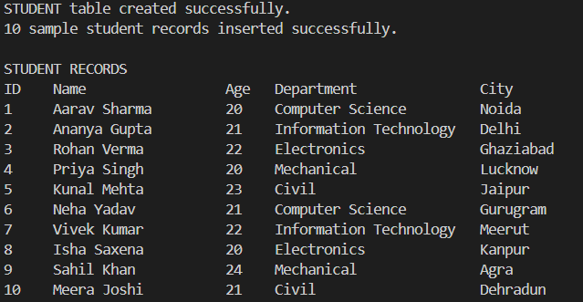

Question 2
import java.sql.Connection;
import java.sql.DriverManager;
import java.sql.PreparedStatement;
import java.sql.ResultSet;
import java.sql.SQLException;
import java.sql.Statement;

public class JdbcProjectUpdate {
private static final String JDBC_URL = "jdbc:mysql://localhost:3306/NIET";
private static final String USERNAME = "root";
private static final String PASSWORD = "";

public static void main(String[] args) {
try (Connection connection = DriverManager.getConnection(JDBC_URL, USERNAME, PASSWORD)) {
createStudentTable(connection);
updateStudent(connection);
deleteStudent(connection);
insertNewStudents(connection);
displayStudents(connection);
} catch (SQLException exception) {
System.out.println("Database operation failed.");
System.out.println("Reason: " + exception.getMessage());
}
}

private static void createStudentTable(Connection connection) throws SQLException {
String createTableSql = "CREATE TABLE IF NOT EXISTS STUDENT ("
+ "ID INT PRIMARY KEY AUTO_INCREMENT, "
+ "Name VARCHAR(50), "
+ "Age INT, "
+ "Department VARCHAR(50), "
+ "City VARCHAR(50)"
+ ")";

try (Statement statement = connection.createStatement()) {
statement.execute(createTableSql);
}
}

private static void updateStudent(Connection connection) throws SQLException {
String updateSql = "UPDATE STUDENT SET Age = ?, Department = ? WHERE ID = ?";

try (PreparedStatement preparedStatement = connection.prepareStatement(updateSql)) {
preparedStatement.setInt(1, 23);
preparedStatement.setString(2, "Artificial Intelligence");
preparedStatement.setInt(3, 1);
int affectedRows = preparedStatement.executeUpdate();
System.out.println(affectedRows + " student record updated.");
}
}

private static void deleteStudent(Connection connection) throws SQLException {
String deleteSql = "DELETE FROM STUDENT WHERE ID = ?";

try (PreparedStatement preparedStatement = connection.prepareStatement(deleteSql)) {
preparedStatement.setInt(1, 2);
int affectedRows = preparedStatement.executeUpdate();
System.out.println(affectedRows + " student record deleted.");
}
}

private static void insertNewStudents(Connection connection) throws SQLException {
String insertSql = "INSERT INTO STUDENT (Name, Age, Department, City) VALUES (?, ?, ?, ?)";
Object[][] students = {
{"Tanya Bansal", 22, "Data Science", "Noida"},
{"Aditya Raj", 23, "Cyber Security", "Delhi"}
};

try (PreparedStatement preparedStatement = connection.prepareStatement(insertSql)) {
for (Object[] student : students) {
preparedStatement.setString(1, (String) student[0]);
preparedStatement.setInt(2, (Integer) student[1]);
preparedStatement.setString(3, (String) student[2]);
preparedStatement.setString(4, (String) student[3]);
preparedStatement.addBatch();
}
preparedStatement.executeBatch();
System.out.println("2 new student records inserted.");
}
}

private static void displayStudents(Connection connection) throws SQLException {
String selectSql = "SELECT ID, Name, Age, Department, City FROM STUDENT";

try (Statement statement = connection.createStatement(); ResultSet resultSet = statement.executeQuery(selectSql)) {
System.out.println();
System.out.println("UPDATED STUDENT RECORDS");
System.out.printf("%-5s %-20s %-5s %-24s %-15s%n", "ID", "Name", "Age", "Department", "City");

while (resultSet.next()) {
System.out.printf(
"%-5d %-20s %-5d %-24s %-15s%n",
resultSet.getInt("ID"),
resultSet.getString("Name"),
resultSet.getInt("Age"),
resultSet.getString("Department"),
resultSet.getString("City"));
}
}
}
}

Output
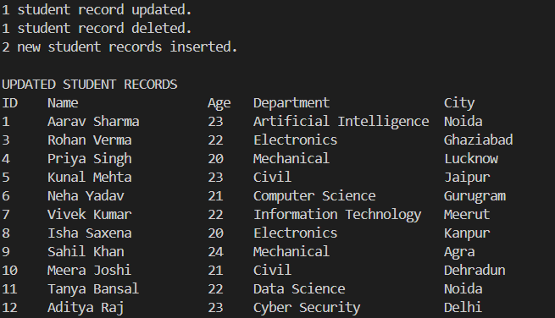

Question 3
display.jsp
<%@ page contentType="text/html;charset=UTF-8" language="java" %>
<%
RequestDispatcher header = request.getRequestDispatcher("header.jsp");
header.include(request, response);

String studentName = (String) request.getAttribute("studentName");
String rollNumber = (String) request.getAttribute("rollNumber");
%>

<h2>WELCOME TO NOIDA INSTITUTE OF ENGINEERING AND TECHNOLOGY</h2>

<p>Student Name : <%= studentName %></p>

<p>Roll Number : <%= rollNumber %></p>

<%
out.flush();
RequestDispatcher footer = request.getRequestDispatcher("footer.jsp");
footer.include(request, response);
%>

footer.jsp
<p>Thank You for Visiting</p>

header.jsp
<h1>NOIDA INSTITUTE OF ENGINEERING AND TECHNOLOGY</h1>

process.jsp
<%@ page contentType="text/html;charset=UTF-8" language="java" %>
<%
String studentName = request.getParameter("studentName");
String rollNumber = request.getParameter("rollNumber");

if (studentName == null || studentName.trim().isEmpty()
|| rollNumber == null || rollNumber.trim().isEmpty()) {
response.sendRedirect("student.jsp");
} else {
request.setAttribute("studentName", studentName.trim());
request.setAttribute("rollNumber", rollNumber.trim());

RequestDispatcher dispatcher = request.getRequestDispatcher("display.jsp");
dispatcher.forward(request, response);
}
%>

student.jsp
<%@ page contentType="text/html;charset=UTF-8" language="java" %>
<!DOCTYPE html>
<html>
<head>
<title>Student Information</title>
</head>
<body>
<h2>Student Information System</h2>

<form action="process.jsp" method="post">
<label>Name:</label>
<input type="text" name="studentName">
<br><br>

<label>Roll Number:</label>
<input type="text" name="rollNumber">
<br><br>

<input type="submit" value="Submit">
</form>
</body>
</html>

Output
Student page
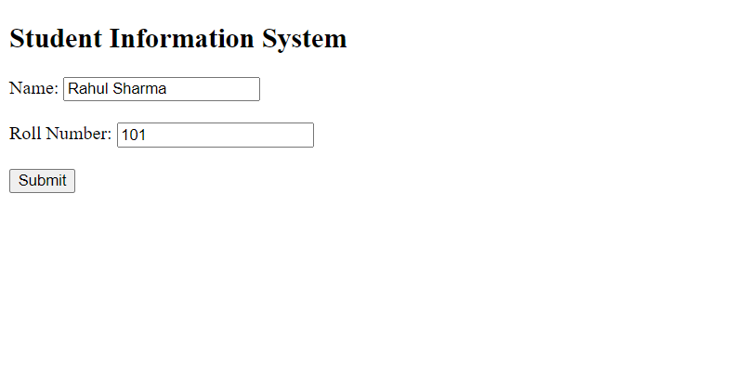
Process page
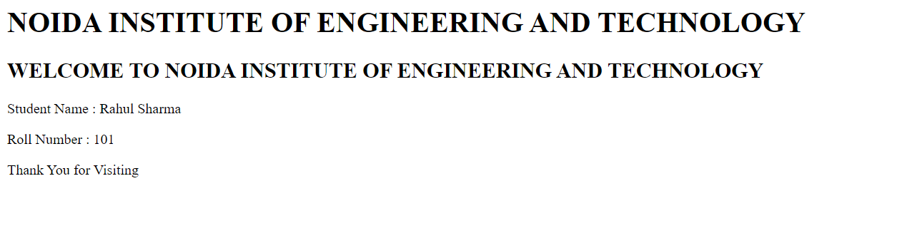

Question 4
login.jsp
<%@ page contentType="text/html;charset=UTF-8" language="java" %>
<!DOCTYPE html>
<html>
<head>
<title>Login</title>
</head>
<body>
<h2>Login Page</h2>

<form action="validate.jsp" method="post">
<label>Email:</label>
<input type="text" name="email">
<br><br>

<label>Password:</label>
<input type="password" name="password">
<br><br>

<input type="submit" value="Login">
</form>
</body>
</html>

logout.jsp
<%@ page contentType="text/html;charset=UTF-8" language="java" %>
<%
session.invalidate();
%>
<!DOCTYPE html>
<html>
<head>
<meta http-equiv="refresh" content="2;url=login.jsp">
<title>Logged Out</title>
</head>
<body>
<p>You have successfully logged out.</p>
<p><a href="login.jsp">Back to login.jsp</a></p>
</body>
</html>

profile.jsp
<%@ page contentType="text/html;charset=UTF-8" language="java" %>
<%
String email = (String) session.getAttribute("email");

if (email == null) {
response.sendRedirect("login.jsp");
return;
}
%>
<!DOCTYPE html>
<html>
<head>
<title>Profile</title>
</head>
<body>
<h1>WELCOME NOIDA INSTITUTE OF ENGINEERING AND TECHNOLOGY</h1>
<p>Logged in as: <%= email %></p>
<p><a href="logout.jsp">Logout</a></p>
</body>
</html>

validate.jsp
<%@ page contentType="text/html;charset=UTF-8" language="java" %>
<%
String email = request.getParameter("email");
String password = request.getParameter("password");

if ("admin@niet.co.in".equals(email) && "12345".equals(password)) {
session.setAttribute("email", email);
response.sendRedirect("profile.jsp");
return;
}
%>
<!DOCTYPE html>
<html>
<head>
<meta http-equiv="refresh" content="2;url=login.jsp">
<title>Invalid Login</title>
</head>
<body>
<p>Invalid email or password. Please try again.</p>
<p><a href="login.jsp">Back to login.jsp</a></p>
</body>
</html>

Output
Login page
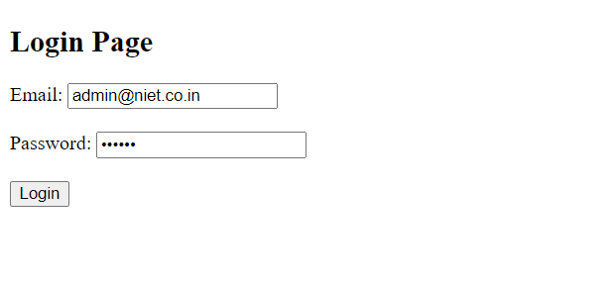

Profile page 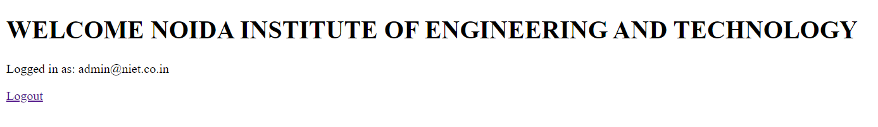

Logout page 