Name: Sarvesh Mishra
Roll No: 2401330100319
Branch: CSE
Section: E
Workshop Lab Number: 012

Question 1
Employee.java

package com.workshop.employee.model;

public class Employee {
private int employeeId;
private String name;
private String department;
private double salary;

public int getEmployeeId() {
return employeeId;
}

public void setEmployeeId(int employeeId) {
this.employeeId = employeeId;
}

public String getName() {
return name;
}

public void setName(String name) {
this.name = name;
}

public String getDepartment() {
return department;
}

public void setDepartment(String department) {
this.department = department;
}

public double getSalary() {
return salary;
}

public void setSalary(double salary) {
this.salary = salary;
}
}

EmployeeDAO.java
package com.workshop.employee.dao;

import org.springframework.dao.EmptyResultDataAccessException;
import org.springframework.jdbc.core.JdbcTemplate;

import com.workshop.employee.model.Employee;

public class EmployeeDAO {
private final JdbcTemplate jdbcTemplate;

public EmployeeDAO(JdbcTemplate jdbcTemplate) {
this.jdbcTemplate = jdbcTemplate;
}

public Employee findEmployeeById(int employeeId) {
String sql = "SELECT employee_id, name, department, salary FROM employee WHERE employee_id = ?";

try {
return jdbcTemplate.queryForObject(sql, (resultSet, rowNumber) -> {
Employee employee = new Employee();
employee.setEmployeeId(resultSet.getInt("employee_id"));
employee.setName(resultSet.getString("name"));
employee.setDepartment(resultSet.getString("department"));
employee.setSalary(resultSet.getDouble("salary"));
return employee;
}, employeeId);
} catch (EmptyResultDataAccessException exception) {
return null;
}
}
}

EmployeeController.java
package com.workshop.employee.controller;

import org.springframework.stereotype.Controller;
import org.springframework.ui.Model;
import org.springframework.web.bind.annotation.GetMapping;
import org.springframework.web.bind.annotation.PostMapping;
import org.springframework.web.bind.annotation.RequestParam;

import com.workshop.employee.dao.EmployeeDAO;
import com.workshop.employee.model.Employee;

@Controller
public class EmployeeController {
private final EmployeeDAO employeeDAO;

public EmployeeController(EmployeeDAO employeeDAO) {
this.employeeDAO = employeeDAO;
}

@GetMapping("/")
public String showSearchPage() {
return "search";
}

@PostMapping("/search")
public String searchEmployee(@RequestParam("employeeId") int employeeId, Model model) {
Employee employee = employeeDAO.findEmployeeById(employeeId);

if (employee == null) {
model.addAttribute("message", "Employee not found.");
} else {
model.addAttribute("employee", employee);
}

return "employee";
}
}

search.jsp
<%@ page contentType="text/html;charset=UTF-8" language="java" %>
<!DOCTYPE html>
<html>
<head>
<title>Employee Search Portal</title>
</head>
<body>
<h2>Employee Search Portal</h2>

<form action="search" method="post">
<label>Employee ID:</label>
<input type="number" name="employeeId" required>
<br><br>

<input type="submit" value="Search">
</form>
</body>
</html>

employee.jsp
<%@ page import="com.workshop.employee.model.Employee" %>
<%@ page contentType="text/html;charset=UTF-8" language="java" %>
<%
Employee employee = (Employee) request.getAttribute("employee");
String message = (String) request.getAttribute("message");
%>
<!DOCTYPE html>
<html>
<head>
<title>Employee Details</title>
</head>
<body>
<h2>Employee Details</h2>

<% if (message != null) { %>
<p><%= message %></p>
<% } %>

<% if (employee != null) { %>
<p>Employee ID: <%= employee.getEmployeeId() %></p>
<p>Name: <%= employee.getName() %></p>
<p>Department: <%= employee.getDepartment() %></p>
<p>Salary: <%= employee.getSalary() %></p>
<% } %>

<p><a href="${pageContext.request.contextPath}/">Search another employee</a></p>
</body>
</html>

dispatcher-servlet.xml
<?xml version="1.0" encoding="UTF-8"?>
<beans xmlns="http://www.springframework.org/schema/beans"
xmlns:context="http://www.springframework.org/schema/context"
xmlns:mvc="http://www.springframework.org/schema/mvc"
xmlns:xsi="http://www.w3.org/2001/XMLSchema-instance"
xsi:schemaLocation="
http://www.springframework.org/schema/beans https://www.springframework.org/schema/beans/spring-beans.xsd
http://www.springframework.org/schema/context https://www.springframework.org/schema/context/spring-context.xsd
http://www.springframework.org/schema/mvc https://www.springframework.org/schema/mvc/spring-mvc.xsd">

<context:component-scan base-package="com.workshop.employee" />
<mvc:annotation-driven />

<bean id="dataSource" class="org.springframework.jdbc.datasource.DriverManagerDataSource">
<property name="driverClassName" value="com.mysql.cj.jdbc.Driver" />
<property name="url" value="jdbc:mysql://localhost:3306/NIET" />
<property name="username" value="root" />
<property name="password" value="" />
</bean>

<bean id="jdbcTemplate" class="org.springframework.jdbc.core.JdbcTemplate">
<property name="dataSource" ref="dataSource" />
</bean>

<bean id="employeeDAO" class="com.workshop.employee.dao.EmployeeDAO">
<constructor-arg ref="jdbcTemplate" />
</bean>

<bean class="org.springframework.web.servlet.view.InternalResourceViewResolver">
<property name="prefix" value="/WEB-INF/views/" />
<property name="suffix" value=".jsp" />
</bean>
</beans>

web.xml
<?xml version="1.0" encoding="UTF-8"?>
<web-app xmlns="http://xmlns.jcp.org/xml/ns/javaee"
xmlns:xsi="http://www.w3.org/2001/XMLSchema-instance"
xsi:schemaLocation="http://xmlns.jcp.org/xml/ns/javaee http://xmlns.jcp.org/xml/ns/javaee/web-app_3_1.xsd"
version="3.1">

<servlet>
<servlet-name>dispatcher</servlet-name>
<servlet-class>org.springframework.web.servlet.DispatcherServlet</servlet-class>
<load-on-startup>1</load-on-startup>
</servlet>

<servlet-mapping>
<servlet-name>dispatcher</servlet-name>
<url-pattern>/</url-pattern>
</servlet-mapping>
</web-app>

database.sql
CREATE DATABASE IF NOT EXISTS NIET;

USE NIET;

CREATE TABLE IF NOT EXISTS employee (
employee_id INT PRIMARY KEY,
name VARCHAR(50),
department VARCHAR(50),
salary DOUBLE
);

INSERT INTO employee (employee_id, name, department, salary) VALUES
(101, 'Aarav Sharma', 'Computer Science', 45000),
(102, 'Ananya Gupta', 'Information Technology', 48000),
(103, 'Rohan Verma', 'Accounts', 38000),
(104, 'Priya Singh', 'Human Resources', 42000),
(105, 'Kunal Mehta', 'Sales', 40000)
ON DUPLICATE KEY UPDATE
name = VALUES(name),
department = VALUES(department),
salary = VALUES(salary);

Output
Landing Page
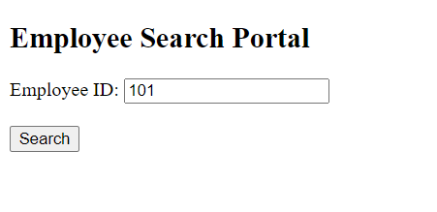
Search page
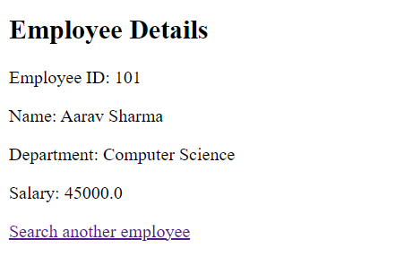

Question 2
pom.xml

<project xmlns="http://maven.apache.org/POM/4.0.0"
xmlns:xsi="http://www.w3.org/2001/XMLSchema-instance"
xsi:schemaLocation="http://maven.apache.org/POM/4.0.0 https://maven.apache.org/xsd/maven-4.0.0.xsd">
<modelVersion>4.0.0</modelVersion>

<groupId>com.workshop</groupId>
<artifactId>printer-setter-injection</artifactId>
<version>1.0.0</version>

<properties>
<maven.compiler.release>17</maven.compiler.release>
<project.build.sourceEncoding>UTF-8</project.build.sourceEncoding>
</properties>

<dependencies>
<dependency>
<groupId>org.springframework</groupId>
<artifactId>spring-context</artifactId>
<version>6.1.14</version>
</dependency>
</dependencies>

<build>
<plugins>
<plugin>
<groupId>org.apache.maven.plugins</groupId>
<artifactId>maven-compiler-plugin</artifactId>
<version>3.13.0</version>
</plugin>
<plugin>
<groupId>org.codehaus.mojo</groupId>
<artifactId>exec-maven-plugin</artifactId>
<version>3.5.0</version>
<configuration>
<mainClass>com.workshop.printer.App</mainClass>
</configuration>
</plugin>
</plugins>
</build>
</project>

Ink.java

package com.workshop.printer.model;

public class Ink {
private String brand;
private String color;
private String type;

public String getBrand() {
return brand;
}

public void setBrand(String brand) {
this.brand = brand;
}

public String getColor() {
return color;
}

public void setColor(String color) {
this.color = color;
}

public String getType() {
return type;
}

public void setType(String type) {
this.type = type;
}
}

Printer.java
package com.workshop.printer.model;

public class Printer {
private String printerName;
private String printerType;
private Ink ink;

public String getPrinterName() {
return printerName;
}

public void setPrinterName(String printerName) {
this.printerName = printerName;
}

public String getPrinterType() {
return printerType;
}

public void setPrinterType(String printerType) {
this.printerType = printerType;
}

public Ink getInk() {
return ink;
}

public void setInk(Ink ink) {
this.ink = ink;
}

public void displayPrinterDetails() {
System.out.println("Printer Details");
System.out.println("Printer Name: " + printerName);
System.out.println("Printer Type: " + printerType);
System.out.println("Ink Brand: " + ink.getBrand());
System.out.println("Ink Color: " + ink.getColor());
System.out.println("Ink Type: " + ink.getType());
}
}

AppConfig.java
package com.workshop.printer.config;

import org.springframework.context.annotation.Bean;
import org.springframework.context.annotation.Configuration;

import com.workshop.printer.model.Ink;
import com.workshop.printer.model.Printer;

@Configuration
public class AppConfig {
@Bean
public Ink ink() {
Ink ink = new Ink();
ink.setBrand("HP Original Ink");
ink.setColor("Black");
ink.setType("Cartridge");
return ink;
}

@Bean
public Printer printer(Ink ink) {
Printer printer = new Printer();
printer.setPrinterName("OfficeJet 250");
printer.setPrinterType("Inkjet Printer");
printer.setInk(ink);
return printer;
}
}

App.java
package com.workshop.printer;

import org.springframework.context.annotation.AnnotationConfigApplicationContext;

import com.workshop.printer.config.AppConfig;
import com.workshop.printer.model.Printer;

public class App {
public static void main(String[] args) {
try (AnnotationConfigApplicationContext context = new AnnotationConfigApplicationContext(AppConfig.class)) {
Printer printer = context.getBean(Printer.class);
printer.displayPrinterDetails();
}
}
}

Output
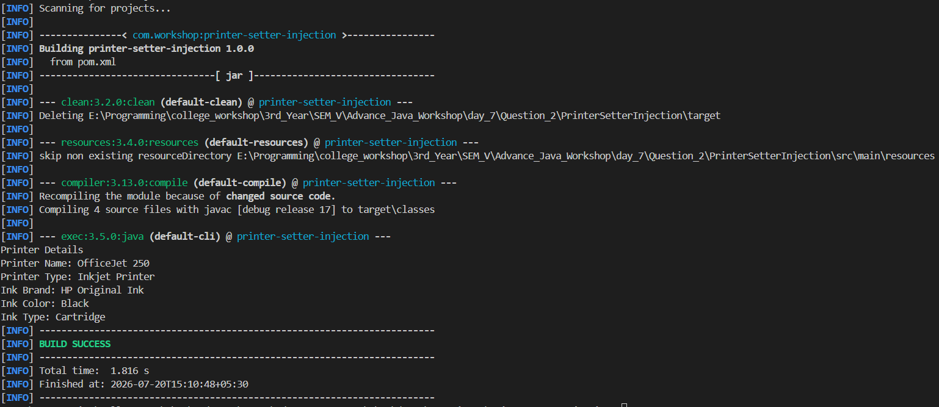

Question 3
pom.xml
<project xmlns="http://maven.apache.org/POM/4.0.0"
xmlns:xsi="http://www.w3.org/2001/XMLSchema-instance"
xsi:schemaLocation="http://maven.apache.org/POM/4.0.0 https://maven.apache.org/xsd/maven-4.0.0.xsd">
<modelVersion>4.0.0</modelVersion>

<groupId>com.workshop</groupId>
<artifactId>university-list-injection</artifactId>
<version>1.0.0</version>

<properties>
<maven.compiler.release>17</maven.compiler.release>
<project.build.sourceEncoding>UTF-8</project.build.sourceEncoding>
</properties>

<dependencies>
<dependency>
<groupId>org.springframework</groupId>
<artifactId>spring-context</artifactId>
<version>6.1.14</version>
</dependency>
</dependencies>

<build>
<plugins>
<plugin>
<groupId>org.apache.maven.plugins</groupId>
<artifactId>maven-compiler-plugin</artifactId>
<version>3.13.0</version>
</plugin>
<plugin>
<groupId>org.codehaus.mojo</groupId>
<artifactId>exec-maven-plugin</artifactId>
<version>3.5.0</version>
<configuration>
<mainClass>com.workshop.university.App</mainClass>
</configuration>
</plugin>
</plugins>
</build>
</project>

University.java
package com.workshop.university.model;

import java.util.List;

public class University {
private String universityName;
private List<String> departments;

public String getUniversityName() {
return universityName;
}

public void setUniversityName(String universityName) {
this.universityName = universityName;
}

public List<String> getDepartments() {
return departments;
}

public void setDepartments(List<String> departments) {
this.departments = departments;
}

public void displayDepartments() {
System.out.println("University Name: " + universityName);
System.out.println("Departments:");

for (String department : departments) {
System.out.println(department);
}
}
}

App.java
package com.workshop.university;

import org.springframework.context.ApplicationContext;
import org.springframework.context.support.ClassPathXmlApplicationContext;

import com.workshop.university.model.University;

public class App {
public static void main(String[] args) {
ApplicationContext context = new ClassPathXmlApplicationContext("applicationContext.xml");
University university = context.getBean("university", University.class);
university.displayDepartments();
}
}

Output
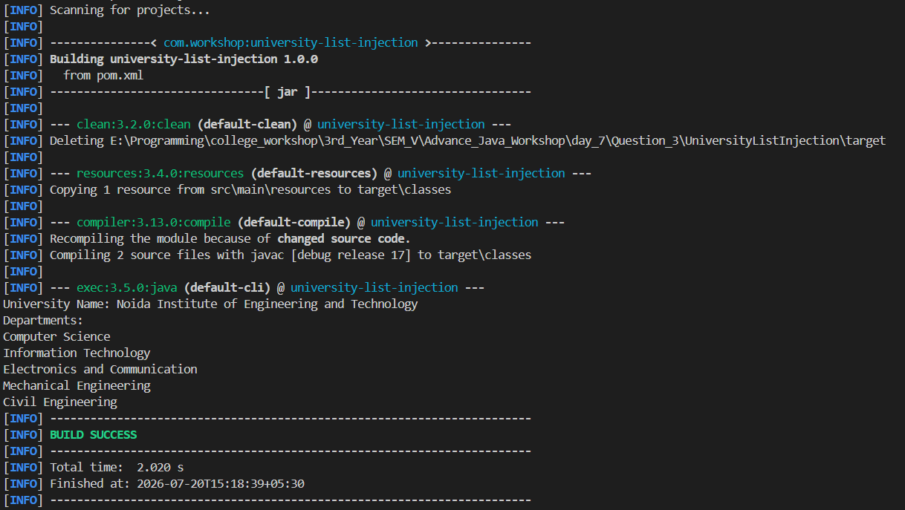

Question 4
pom.xml
<project xmlns="http://maven.apache.org/POM/4.0.0"
xmlns:xsi="http://www.w3.org/2001/XMLSchema-instance"
xsi:schemaLocation="http://maven.apache.org/POM/4.0.0 https://maven.apache.org/xsd/maven-4.0.0.xsd">
<modelVersion>4.0.0</modelVersion>

<groupId>com.workshop</groupId>
<artifactId>course-enrollment-system</artifactId>
<version>1.0.0</version>

<properties>
<maven.compiler.release>17</maven.compiler.release>
<project.build.sourceEncoding>UTF-8</project.build.sourceEncoding>
</properties>

<dependencies>
<dependency>
<groupId>org.springframework</groupId>
<artifactId>spring-context</artifactId>
<version>6.1.14</version>
</dependency>
</dependencies>

<build>
<plugins>
<plugin>
<groupId>org.apache.maven.plugins</groupId>
<artifactId>maven-compiler-plugin</artifactId>
<version>3.13.0</version>
</plugin>
<plugin>
<groupId>org.codehaus.mojo</groupId>
<artifactId>exec-maven-plugin</artifactId>
<version>3.5.0</version>
<configuration>
<mainClass>com.workshop.course.App</mainClass>
</configuration>
</plugin>
</plugins>
</build>
</project>

Course.java
package com.workshop.course.model;

import org.springframework.stereotype.Component;

@Component
public class Course {
private int courseId = 501;
private String courseName = "Advanced Java";
private String facultyName = "Dr. Sharma";

public int getCourseId() {
return courseId;
}

public String getCourseName() {
return courseName;
}

public String getFacultyName() {
return facultyName;
}
}

Student.java
package com.workshop.course.model;

import org.springframework.beans.factory.annotation.Autowired;
import org.springframework.stereotype.Component;

@Component
public class Student {
private int studentId = 101;
private String studentName = "Aarav Sharma";

@Autowired
private Course course;

public int getStudentId() {
return studentId;
}

public String getStudentName() {
return studentName;
}

public Course getCourse() {
return course;
}

public void displayStudentDetails() {
System.out.println("Student Details");
System.out.println("Student ID: " + studentId);
System.out.println("Student Name: " + studentName);
System.out.println("Course ID: " + course.getCourseId());
System.out.println("Course Name: " + course.getCourseName());
System.out.println("Faculty Name: " + course.getFacultyName());
}
}

AppConfig.java
package com.workshop.course.config;

import org.springframework.context.annotation.ComponentScan;
import org.springframework.context.annotation.Configuration;

@Configuration
@ComponentScan(basePackages = "com.workshop.course")
public class AppConfig {
}

App.java
package com.workshop.course;

import org.springframework.context.annotation.AnnotationConfigApplicationContext;

import com.workshop.course.config.AppConfig;
import com.workshop.course.model.Student;

public class App {
public static void main(String[] args) {
try (AnnotationConfigApplicationContext context = new AnnotationConfigApplicationContext(AppConfig.class)) {
Student student = context.getBean(Student.class);
student.displayStudentDetails();
}
}
}

Output
