**!!! E-CAFETERIA !!!**

Project Submitted

In Partial Fulfilment of the Requirement for the Degree of

**BACHELOR OF TECHNOLOGY**

In

**COMPUTER SCIENCE & ENGINEERING DEPARTMENT**

by

**Sanjana**

(2016021070)

**Sarvesh** **Kumar**

(2016021071)

**Saumya** **Rai**

(2016021072)

**Submitted To:**

**Ms. Ankita Singh**

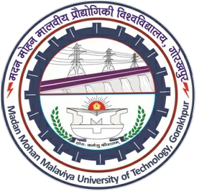

**Department of Computer Science and Engineering**

**Madan Mohan Malaviya University of Technology, Gorakhpur**

**273010(U.P.)-INDIA**

**Session: 2017-18**