Significance of Vitamins

Vitamins are essential organic compounds required by the human body in small amounts for proper functioning. They serve as vital components for various biochemical reactions, supporting growth, development, and maintenance of the body.

1. Nutrient Absorption: Vitamins play a crucial role in facilitating the absorption and utilization of other nutrients in the body. For example, vitamin D enhances the absorption of calcium, which is necessary for bone health. Similarly, vitamin C aids in the absorption of iron from plant-based sources, promoting healthy blood circulation.
2. Disease Prevention: Different vitamins have specific roles in supporting the immune system and protecting against various diseases. Vitamin C acts as an antioxidant, neutralizing harmful free radicals and strengthening immune function. Vitamin A contributes to maintaining healthy vision and promoting the immune response. Vitamin E acts as a potent antioxidant, protecting cells from damage and reducing the risk of chronic diseases.

Overall, vitamins are essential for maintaining optimal health, supporting the body's functions, and reducing the risk of deficiencies and diseases.

In a thermodynamical system, change in Gibb's Free energy of a system with change in

enthalpy as 3000 J and change in entropy as IO J/K at 298 K is

Based on the value Gibb's Free energy, can you predict whether a reaction in this system

will be spontaneous or nonspontaneous? Will energy be needed to carry out this reaction?

ChatGPT

The change in Gibbs free energy (∆G) of a system is related to the change in enthalpy (∆H) and the change in entropy (∆S) by the equation:

∆G = ∆H - T∆S

where T is the temperature in Kelvin.

In this case, the given values are:

∆H = 3000 J

∆S = 10 J/K (assuming "IO" is a typo and meant to be "10")

The temperature is given as 298 K.

Now, let's substitute these values into the equation:

∆G = 3000 J - (298 K)(10 J/K)

∆G = 3000 J - 2980 J

∆G = 20 J

Since the change in Gibbs free energy (∆G) is positive (20 J), the reaction in this system will be nonspontaneous under the given conditions. A positive ∆G indicates that the reaction requires an input of energy to proceed.

User

Which of the following reactions in a cell can be compared to the above-mentioned

thermodynamical situation?

I . Preparatory phase of glycolysis 2. Payoff phase of glycolysis/ Kreb cycle

ChatGPT

In order to determine which of the mentioned reactions can be compared to the thermodynamic situation described above, we need to consider the change in Gibbs free energy (∆G) for each reaction.

I. Preparatory phase of glycolysis:

During the preparatory phase of glycolysis, glucose is converted into two molecules of glyceraldehyde-3-phosphate. This phase involves energy-consuming steps, such as phosphorylation reactions, which require an input of ATP. The overall ∆G for this phase is positive, indicating that energy is needed to carry out the reaction. Therefore, this reaction can be compared to the nonspontaneous thermodynamic situation described above.

II. Payoff phase of glycolysis/Krebs cycle:

The payoff phase of glycolysis involves the conversion of glyceraldehyde-3-phosphate into pyruvate, generating ATP and NADH in the process. The Krebs cycle (also known as the citric acid cycle) further oxidizes pyruvate, producing ATP, NADH, and FADH2. These processes involve energy production and have a negative ∆G, indicating that the reactions are spontaneous and release energy. Therefore, the payoff phase of glycolysis and the Krebs cycle cannot be compared to the nonspontaneous thermodynamic situation described above.

To summarize, the reaction that can be compared to the nonspontaneous thermodynamic situation is the preparatory phase of glycolysis.

Xylem vs Phloem

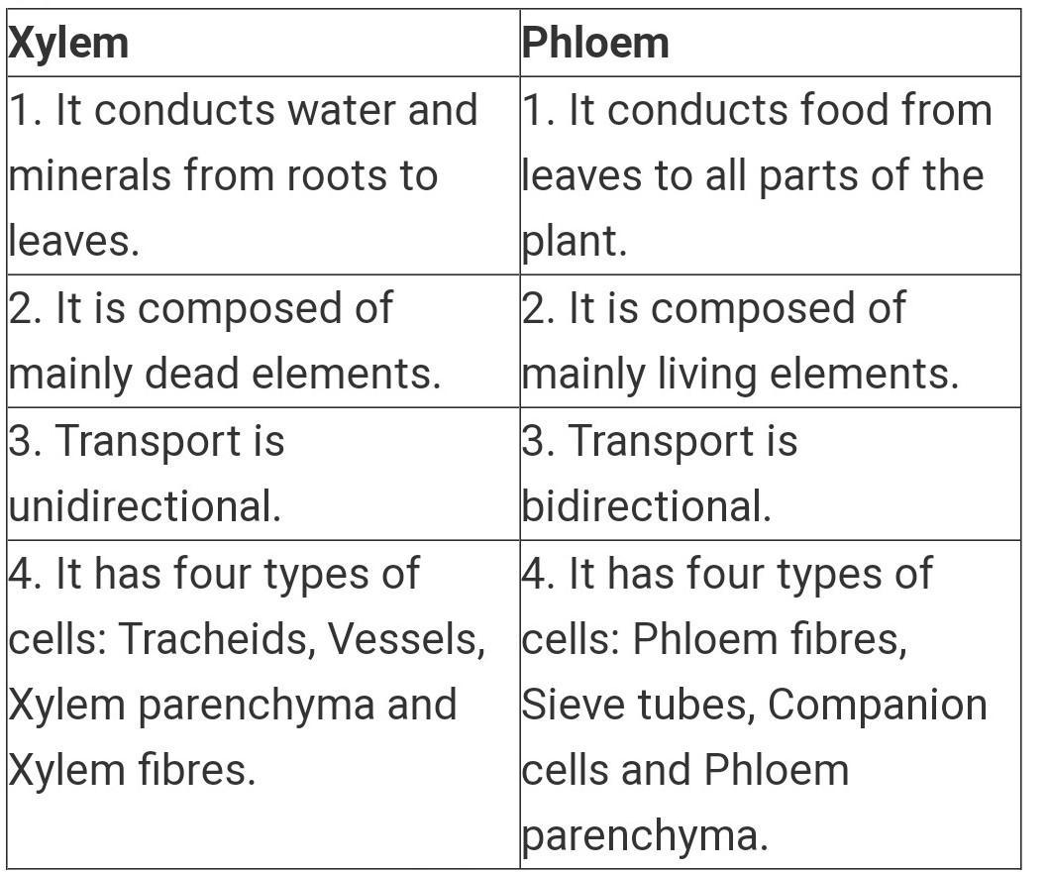

WBC vs RBC

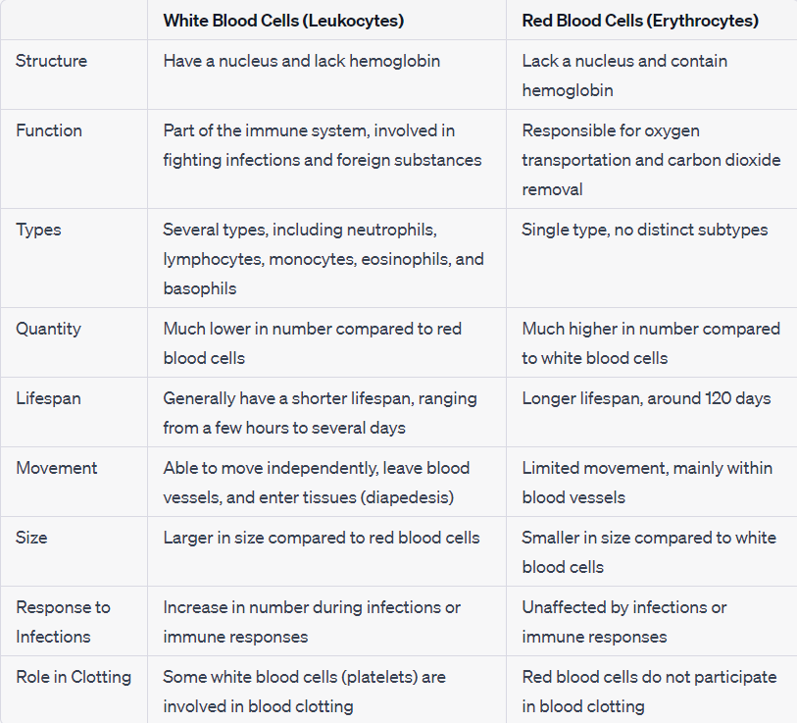

Innate vs Adaptive Immunity

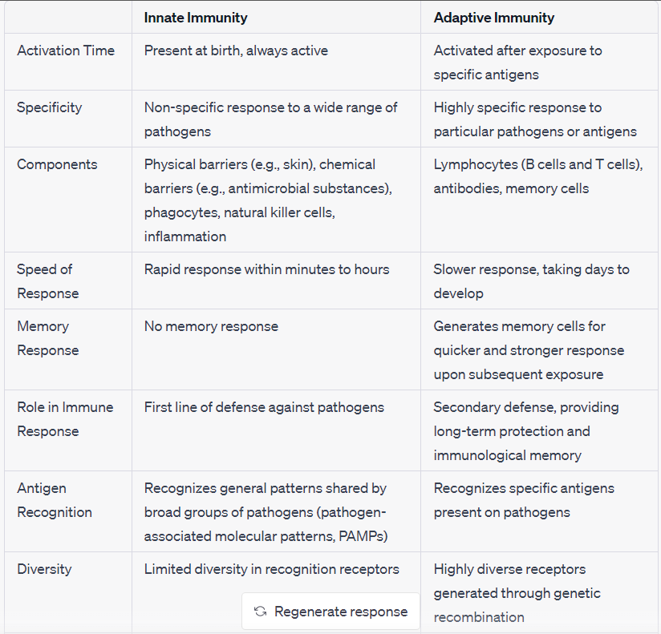

Hypothalamus

The functions of the hypothalamus can be summarized in a two-mark answer as follows:

Regulation of Homeostasis: The hypothalamus plays a crucial role in maintaining homeostasis within the body. It regulates various physiological processes such as body temperature, thirst and hunger, sleep-wake cycles, and fluid balance. It receives signals from the body and initiates appropriate responses to ensure the body's internal environment remains stable.

Control of the Endocrine System: The hypothalamus is responsible for controlling the release of hormones from the pituitary gland, which is often referred to as the "master gland." Through its production and release of specific hormones, the hypothalamus regulates the function of other endocrine glands in the body, such as the thyroid gland, adrenal glands, and reproductive glands. It helps coordinate hormonal balance and influences growth, metabolism, sexual development, and stress response.

These functions highlight the essential role of the hypothalamus in regulating homeostasis and controlling the endocrine system, ensuring the body's proper functioning and adaptation to internal and external changes.

Hemoglobin

The main functions of hemoglobin can be summarized in a 3-mark answer as follows:

Oxygen Transport: Hemoglobin is responsible for binding and carrying oxygen throughout the body. It binds to oxygen molecules in the lungs, forming oxyhemoglobin, and then releases oxygen to tissues with lower oxygen levels. This process enables efficient oxygen delivery to cells for various metabolic processes.

Carbon Dioxide Transport: Hemoglobin also aids in the transportation of carbon dioxide, a waste product of cellular respiration. It helps to pick up carbon dioxide from tissues and carries it back to the lungs, where it is released for exhalation.

Buffering Effect: Hemoglobin acts as a buffer to maintain the pH balance of blood. It can bind with excess hydrogen ions (H+) to prevent significant changes in blood acidity, helping to stabilize the pH level within a normal range.

These three functions of hemoglobin - oxygen transport, carbon dioxide transport, and buffering effect - are vital for the proper functioning of tissues and maintaining the homeostasis of the body.

Diffusion:

Diffusion is the net movement of molecules or ions from an area of higher concentration to an area of lower concentration. It is driven by the natural tendency of particles to move down their concentration gradient, seeking equilibrium. The cell membrane acts as a selectively permeable barrier, allowing certain substances to pass through.

Several factors influence the rate of diffusion, including the concentration gradient, temperature, molecular size, and membrane permeability. A steeper concentration gradient, higher temperature, smaller molecule size, and increased membrane permeability generally promote faster diffusion.

Diffusion plays a crucial role in various biological processes. It enables the exchange of gases, such as oxygen and carbon dioxide, across respiratory membranes. Nutrients, waste products, and signaling molecules also rely on diffusion to move in and out of cells. Additionally, diffusion is involved in the distribution of molecules within cells and the establishment of concentration gradients necessary for other forms of transport, such as facilitated diffusion or active transport.