

**SENSORS AND**

**AUTOMATION**

**Sarvesh Anand Mankar**

**142203013**

**SY Comp Div-2, S5 Batch**

**Practical-4: Characterization of pH, Conductivity**

**Aim:**

1. Study the working principle of pH and conductivity sensors.
2. Calibrate the pH sensor.
3. Study the effect of temperature on pH measurement.
4. Study effect of temperature and effect of contamination on conductivity measurement.

**Theory:**

pH Measurement:

pH is defined as the negative logarithm of the hydrogen ion concentration. pH = - log (H+)

**pH sensor:**

pH is one of the most common analyses used in Process Industry. pH is actually a measurement of the activity of hydrogen ions in the sample.pH measurements run on a scale from 0 - 14, with 7.0 considered as neutral.Solutions with a pH value below 7.0 are considered as acids, and above 7.0 are designated as bases.The pH scale is logarithmic, so one unit change in pH value actually reflects a ten-fold change in the acidity.

**Working principle**

The pH measurement loop can be considered as a battery where the positive terminal is the measuring electrode and the negative terminal is the reference electrode.

The measuring electrode', which is sensitive to the hydrogen ions, develop a potential (voltage) directly related to the hydrogen ion concentration of the solution.The reference electrode is stable regardless of any change in the hydrogen ion concentration.

The pH meter consists of **three major components**: pH probe,Temperature probe and the meter

The pH probe consists of a glass, hydrogen-ion selective electrode, and a reference electrode, combined into a single unit. The glass electrode is specially treated for measuring the hydrogen ions, while the reference electrode is surrounded by silver chloride. It provides a "zero" or reference point for the measurement. This "zero" point means any change in potential measured at the glass electrode is attributed to hydrogen ions, and is expressed as pH. When the temperature and pH probes are immersed in the sample, the meter measures the potential difference between the glass electrode and the reference electrode. This electronic measurement is converted from mill volts to pH units, and the result appears on the display.

If the temperature probe is not used during the pH measurement, the meter will assume a temperature of 25°C.

**Calibration of pH probe with buffer solution:**

The calibration must be performed for buffers with pH 4.0, 7.00 and 9.2.At least a 2-point calibration must be performed at room temperature using buffers that meet the expected pH value of the sample.

If a one-point calibration is performed, measurement errors are more for the sample that is being measured.If the temperature probe is not used at the time of calibration, default value considered is 25°C.

**Selected Values:**

1. pH value: 9.2

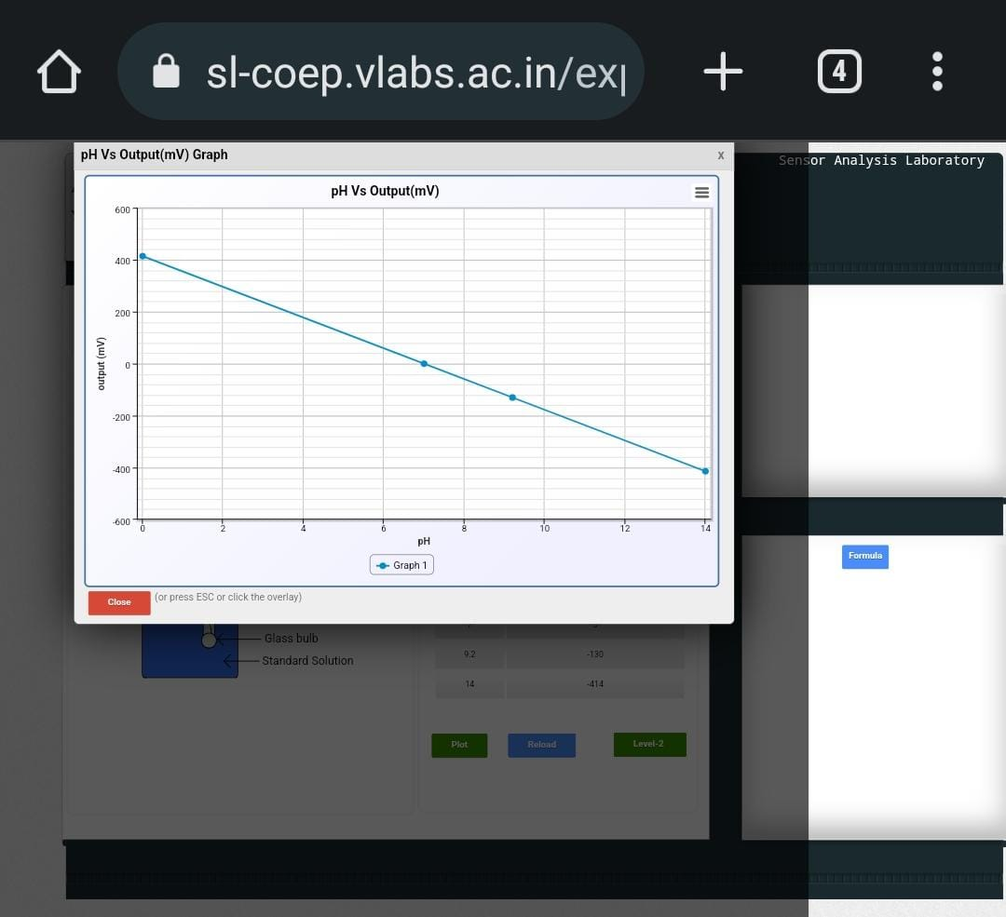

**Selected Values:**

1. Sample: Sea Water
2. pH Value: 8
3. Output Voltage: -59.16
4. Temperature: 24° C

**Calculation of Output Voltage:**  
 **E (millivolts) =(E0 - 2.3026( R * T/F)* pHc)*1000**Where,  
E0=standard potential = 0 mV  
R=Universal gas constant = 8.3144 J/K  
T=Absolute temperature (kelvin)  
25 degree Celsius = 298.15 kelvin  
F=Faraday's constant = 96485 C/mole  
For Effect of Temprature :  
kelvin = degree celsius + 273.15  
pHc = pH value deviation from 7 in the Formula

Temperature = 25°C

E=(0-2.3026(8.3144*(298.15/96485)*0.17)*1000

=-59.16 mV

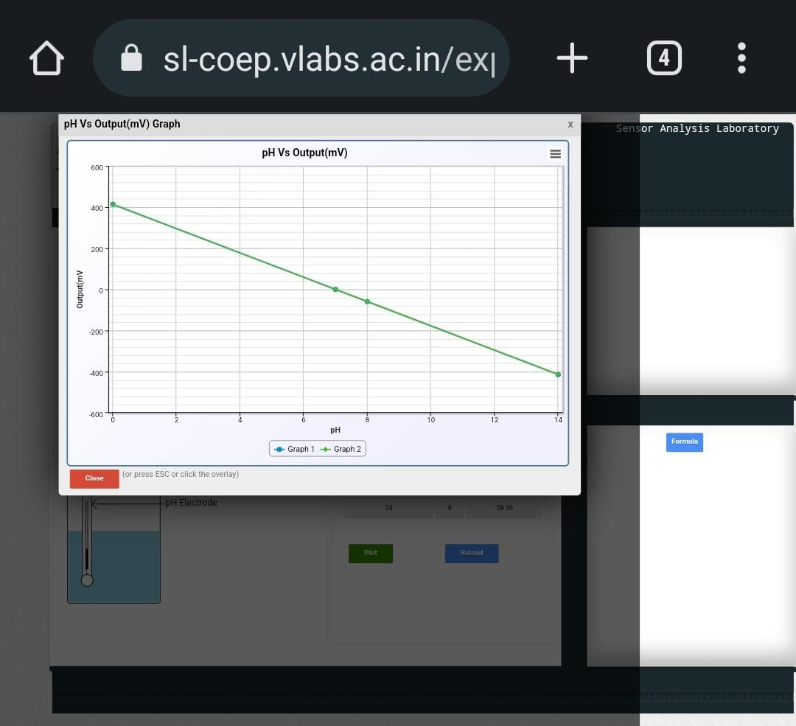

**Selected Values:**

1. Sample: Orange Juice.
2. pH Value: 3.7
3. Ouput Voltage: 195.23
4. Temperature: 35° C

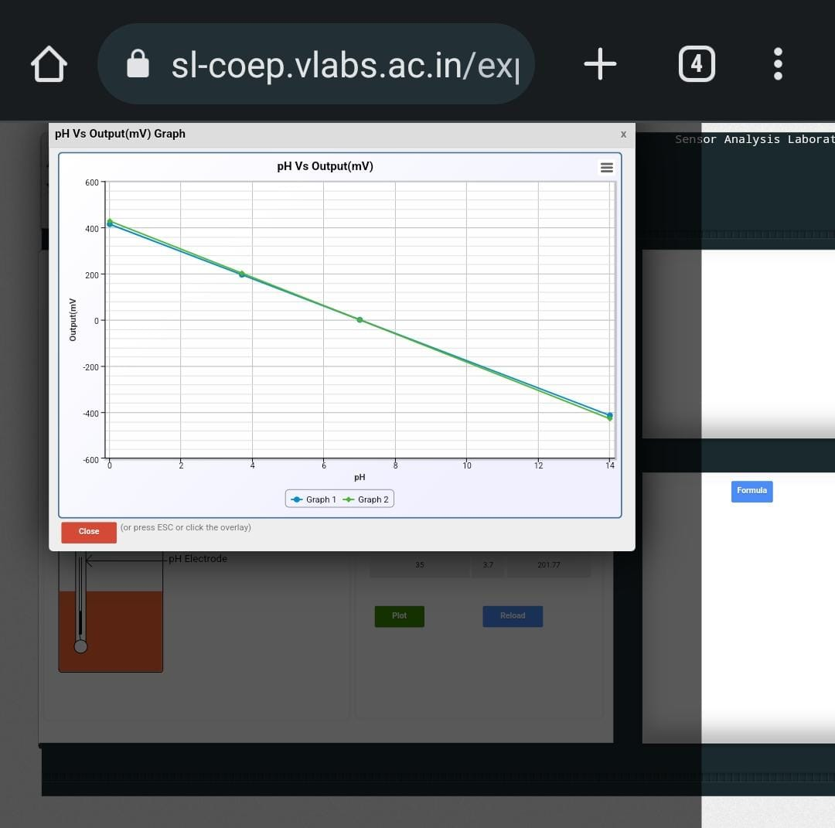

**Measurement of Conductivity:**

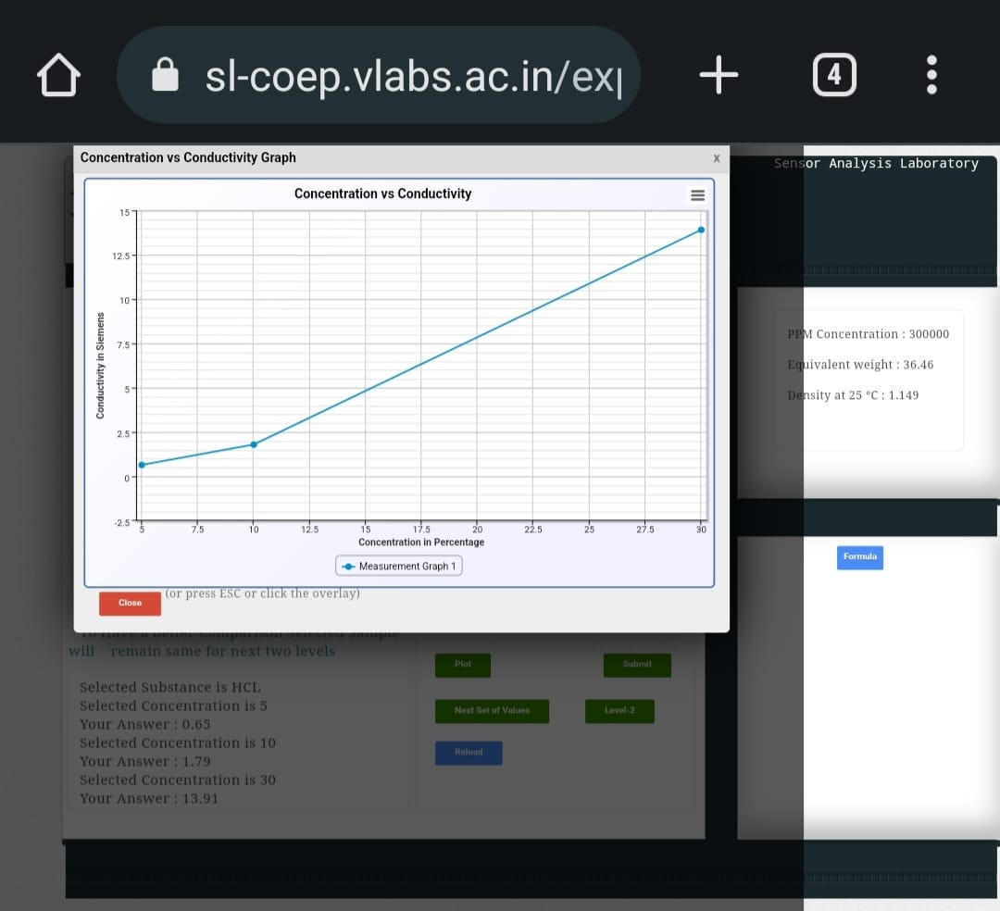

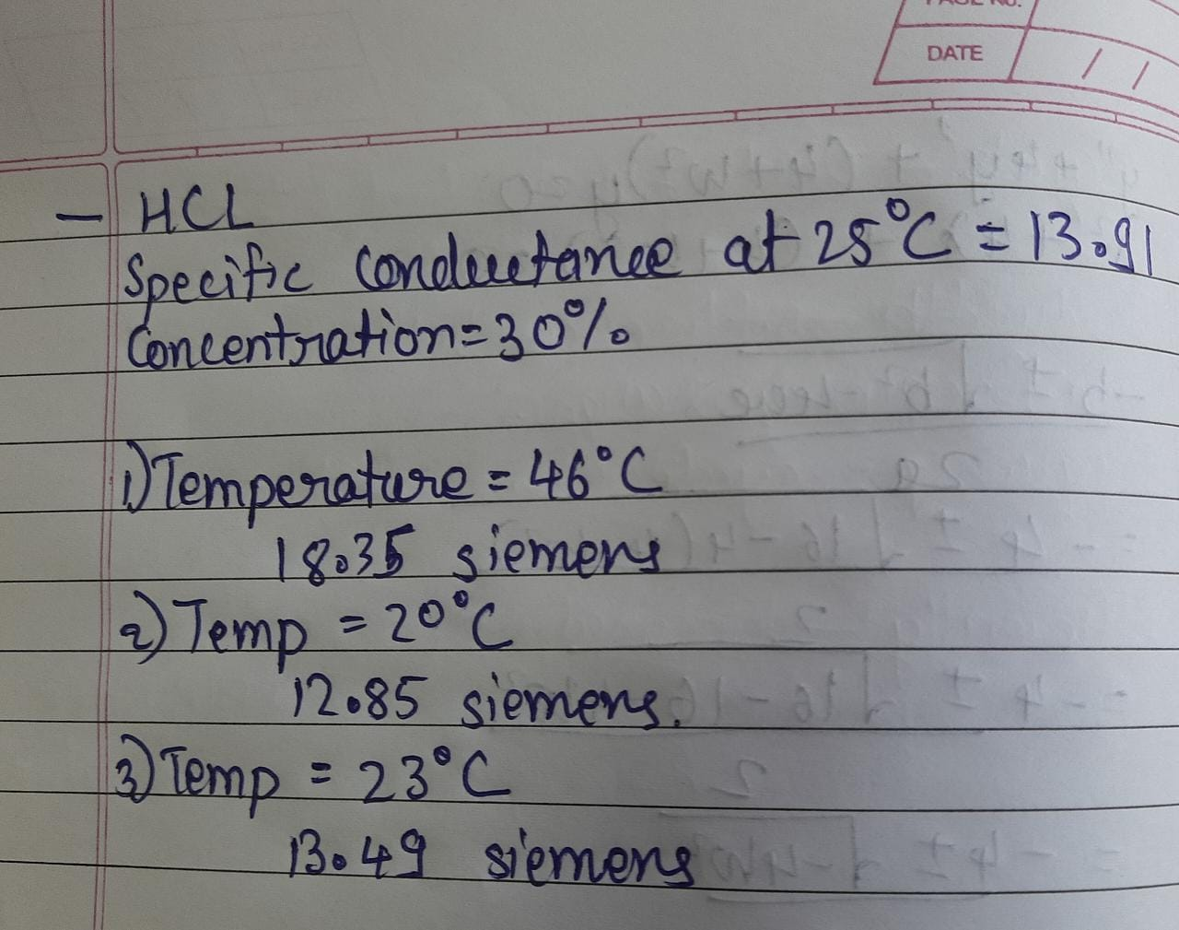

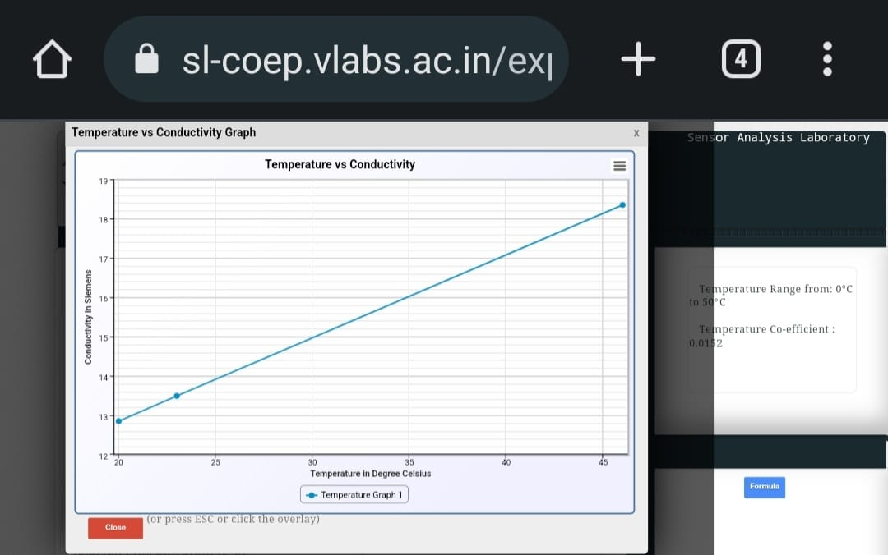

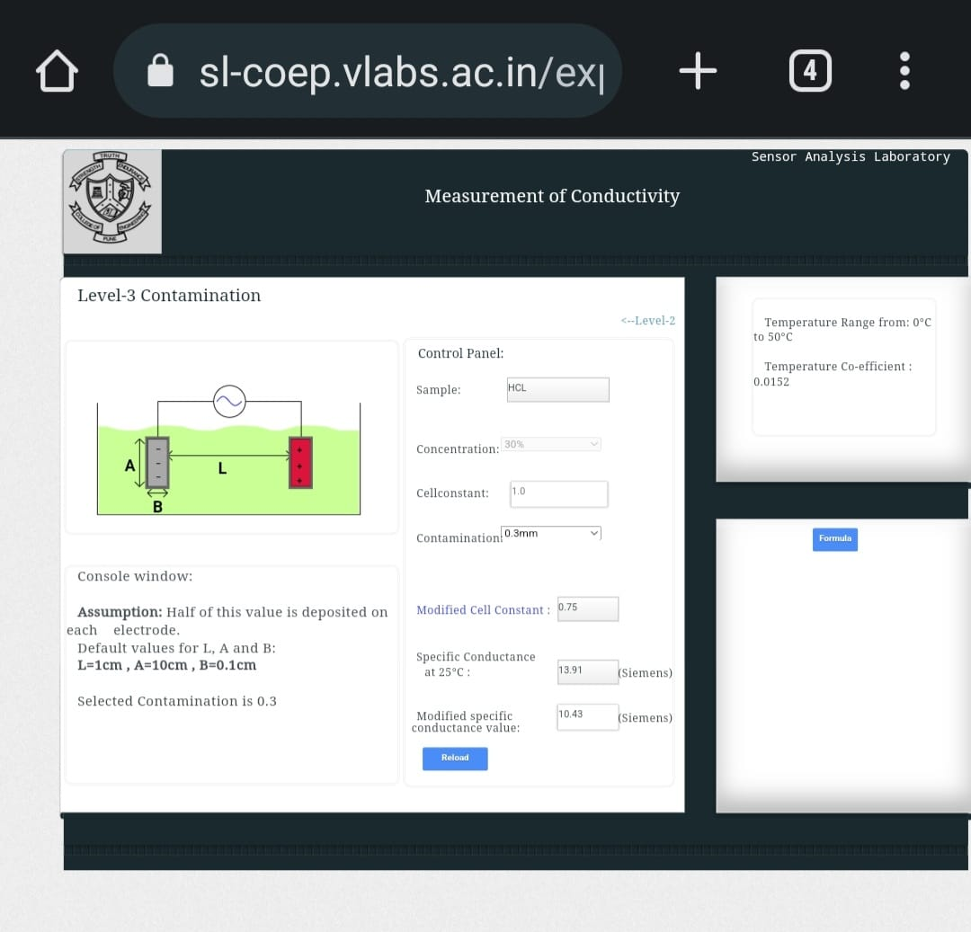

**Conclusion:**

The practical aimed to study the working principle of pH and conductivity sensors and to explore various factors that affect their measurements. The calibration of the pH sensor was done to ensure accurate readings, and the effect of temperature on pH measurements was studied. The effect of temperature and contamination on conductivity measurements was also examined. Through this practical, we gained valuable insights into the functioning of these sensors and learned about their limitations and dependencies on external factors. The knowledge gained through this practical can be applied in various industries that rely on accurate pH and conductivity measurements, such as the pharmaceutical, food, and water treatment industries.