

**SENSORS AND**

**AUTOMATION**

**Sarvesh Anand Mankar**

**142203013**

**SY Comp Div-2, S5 Batch**

**Practical-5: Introduction of PLC**

**Aim:**

1. Learn the basics and hardware components of PLC
2. Understand configuration of PLC system
3. Study various building blocks of PLC

**Theory:**

An electronic device called a Programmable Logic Controller, often known as a PLC or Programmable Controller, is used to automate industrial activities including the control of machinery on factory assembly lines. A programmable controller is a digitally operating electronic device that uses an internal programmable memory to store instructions for carrying out specific functions, such as logic, sequencing, timing, counting, and arithmetic, to control different machines or processes through digital or analogue input/output devices.The PLC is made for diverse input and output configurations, wide temperature ranges, immunity to electrical noise, and tolerance to vibrations and impacts, unlike general purpose computers.

Typically, non-volatile or battery-backed memory is where programmes that regulate machine function are kept. A real-time system is one that produces outcomes in real time, such as a PLC.

**Basic Components:**

1. CPU and Memory module
2. Power supply
3. Input and output module
4. Programming device

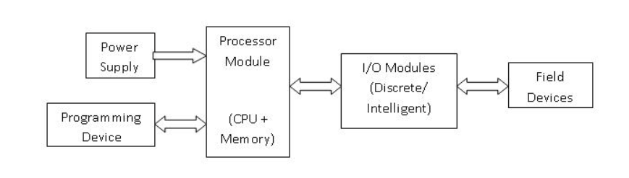

CPU and Memory Module:- This is the device where PLC program is stored and processed. The size and type of CPU determines the programming functions available, size of the application logic available, amount of memory supported, and processing speed.

Power Supply:- The power supply provides power for the PLC system. It provides internal DC current to operate the processor logic circuitry and input/output assemblies. This can be built into the PLC or an external unit. Common voltage levels required by the PLC are 24Vdc, 120Vac, 220Vac. , is used to determine temperature.

Input and Output Module:- Inputs carry signals from the field (process) to the controller. Various types of inputs can be switches, pressure sensors, transmitters etc. The field devices to whom PLC sends the results of logical operations are the output devices. Digital inputs and outputs operate on discrete or binary change i.e. on/off, open/close. Analog inputs and outputs change continuously with reference to time.

Programming Device:- The PLC is programmed using a special software using computer or hand Held Terminal(HHT) that can load and change the logic inside.

**Operation**

The operation of the PLC is determined by 3 steps.

1. Reading the field status form input devices
2. Execution or solving the logic, and
3. Updating the output devices status.

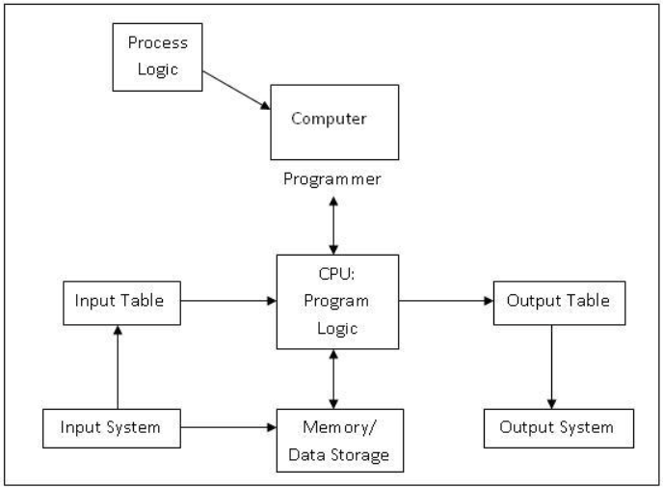

### **PLC Program:-**

PLC Program is a Logic that is executed by the CPU. This logic can be written in the form of Ladder diagram, Instruction List, Sequential Function Charts, Structured text or Functional block diagram. These are the languages used for writing logic as per IEC standard. The program is then downloaded to the PLC. This is usually done by temporarily connecting the PC or HHT to the PLC. Once the program is downloaded to the CPU, it is usually not necessary for the PC to remain connected.

### **PLC Scan:-**

Once the program is downloaded in the CPU, the PLC is switched to "run" mode and the PLC executes the application program. The CPU regularly reads the status of the input devices, and sends data to the output devices as per the logical results after execution of the program. The process of Initialization when power is turned on, Reading inputs, Executing logic, and modifying outputs is called as PLC Scan Cycle.

**Experiment:**

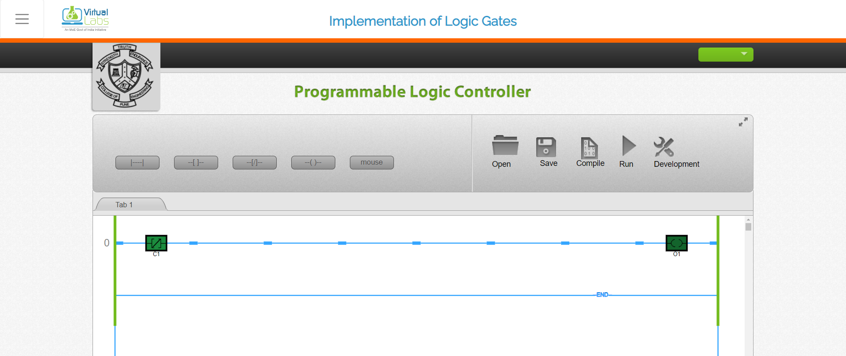

Series Connection:

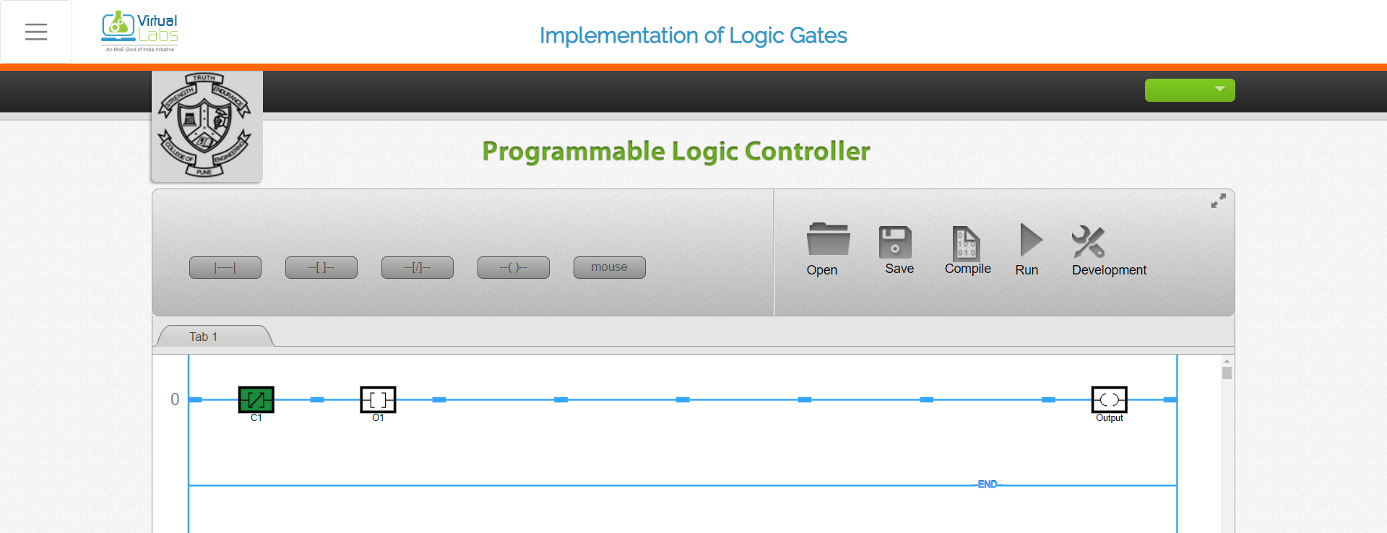

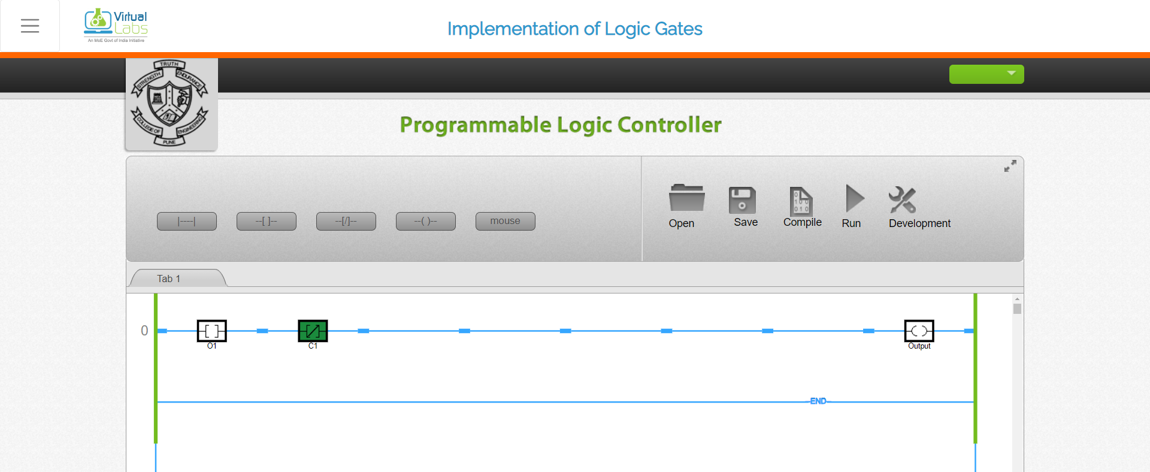

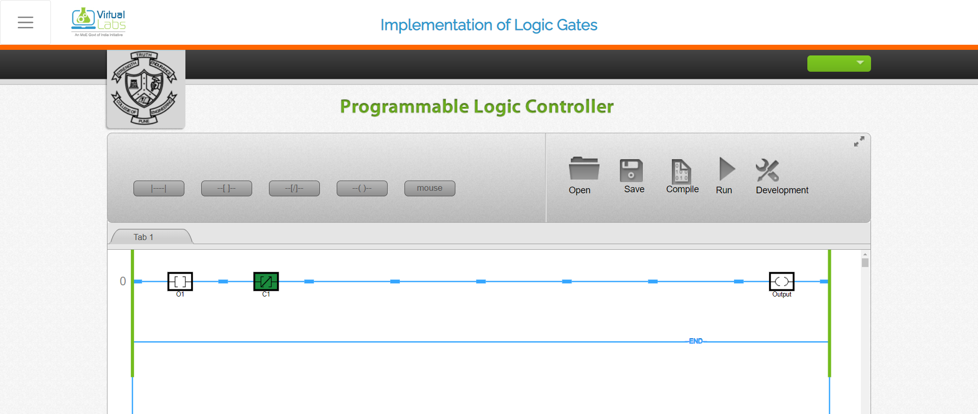

Parallel Connection:

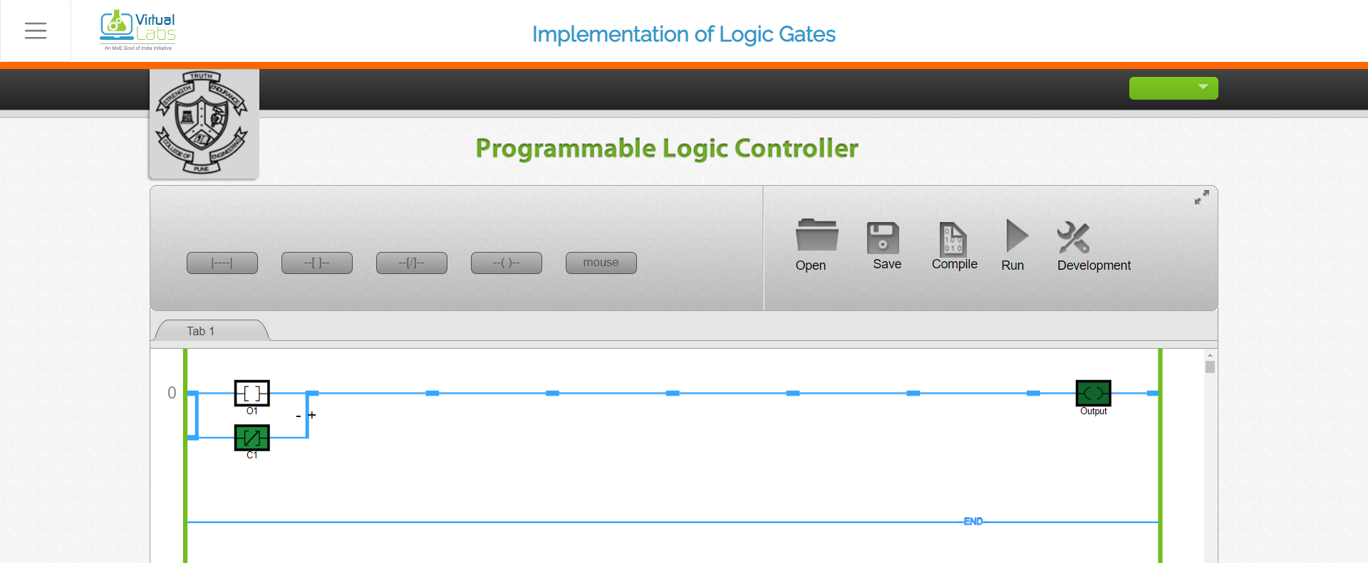

**Conclusion:**

The experiment aimed to introduce the basics and hardware components of a programmable logic controller (PLC), understand the configuration of a PLC system, and study various building blocks of PLC. Through the experiment, the participant was able to gain knowledge and hands-on experience on the components of a PLC system, including the input/output modules, power supply, and central processing unit (CPU). Additionally, they were able to understand the configuration and programming of a PLC system and identify the different types of building blocks, such as timers, counters, and sequencers. Overall, the experiment provided a comprehensive understanding of PLC technology and its application in various industrial processes.