

**SENSORS AND**

**AUTOMATION**

**Sarvesh Anand Mankar**

**142203013**

**SY Comp Div-2, S5 Batch**

**Practical-6: Arithmetic and Logical Operators**

**Aim:**

1. Develop a ladder using standard procedure.
2. Understand the use of Logical instructions.
3. Understand the use of Arithmetic instructions.

**Theory:**

Digitization is a process where continuous analog signal is converted into a finite number of discrete states. These states are well separated so that noise does not create errors.

The resulting digital signal has following advantages:

1. storage over arbitrary periods of time.
2. flawless retrieval and reproduction of the stored information.
3. flawless transmission of the information.

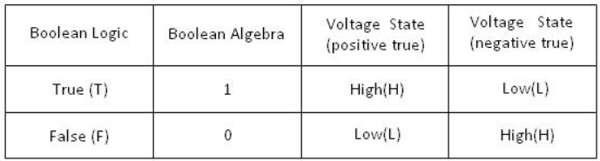

Each manufacturer of PLC systems has own style of writing the instructions. Different PLCs has different instruction sets but even some common basic instructions are shared by all the PLCs. All manufacturers give different software packages for programming PLCs. Ladder is most commonly used programming language. Prior to PLCs, relay logic was used in industry. Ladders were developed to mimic or imitate relay logic. Relay Logic / Instructions A relay is simple magnetic device which acts as a control switch.

When the switch is on, current will flow through the coil on iron piece. This iron core acts a electromagnet and due to the magnetic field upper contact gets attracted towards lower one and circuit gets completed, allowing current to flow from load.

##### **Ladder Programming:**

Ladder diagram is popular language of programming the PLCs. Ladder diagram shows the sequence of the logic execution which is presented diagrammatically. In ladder diagram, There are two vertical lines generally called as Phase (positive) or neutral. Rungs which show current flow in horizontal direction are the sequence in which the logic executes. The Analogous to relay, ladder has two main symbols which are contacts and output coil. Generally each rung has inputs (contacts) on left hand side and outputs (coil) on the right hand side. These contacts and coils are called as bits of the relays. Each input and output are individual bit in I/O files. An instruction in ladder instructs PLCs how to respond to the bits in I/O files which are stored in the memory. Input contacts are the condition area, the conditions must be fulfilled to change the status of the output coils.

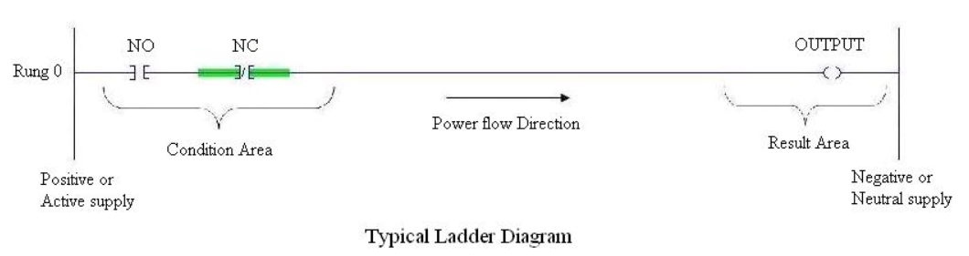

**Trurth Table:**

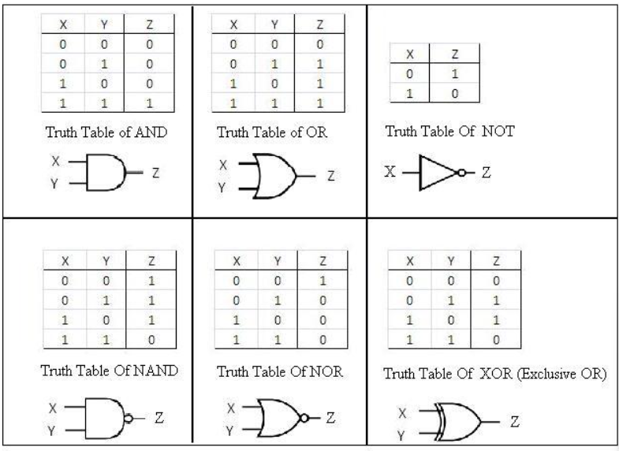

**Experiment:**

**Addition**

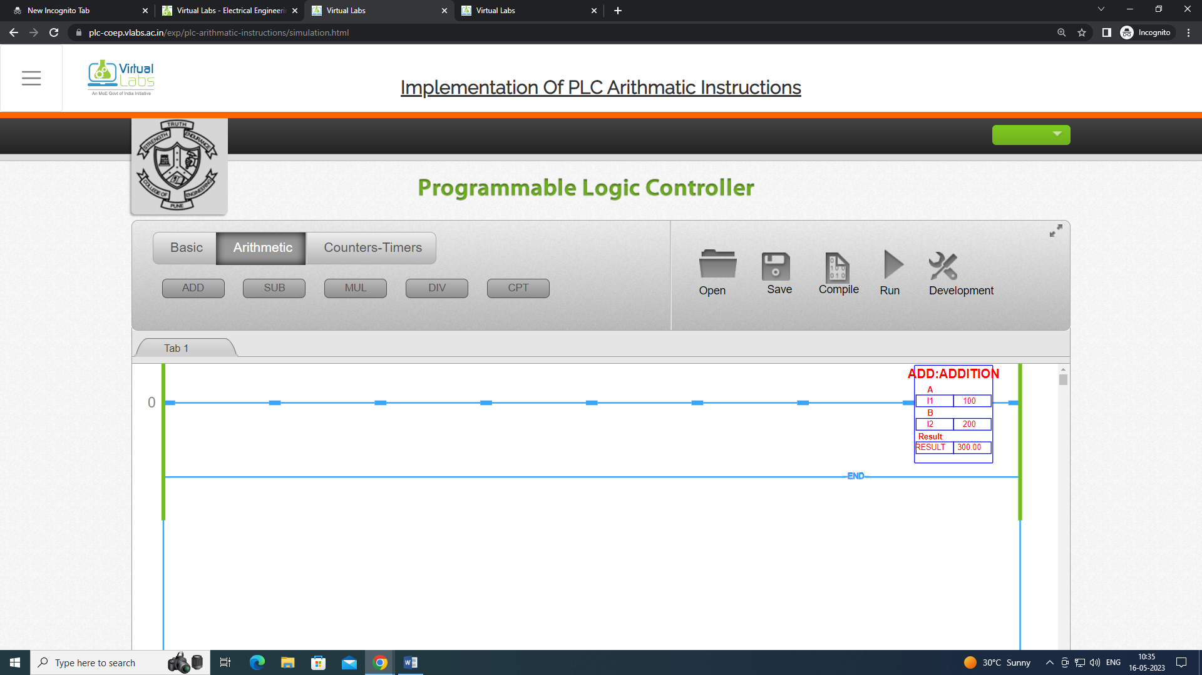

**Subtraction**

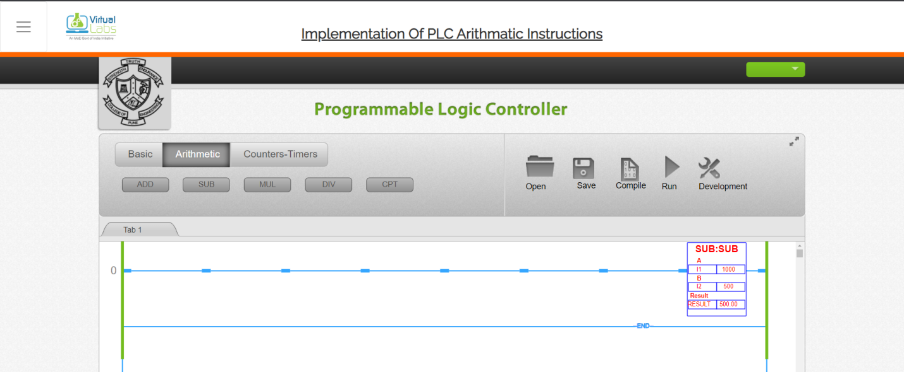

**Multiplication**

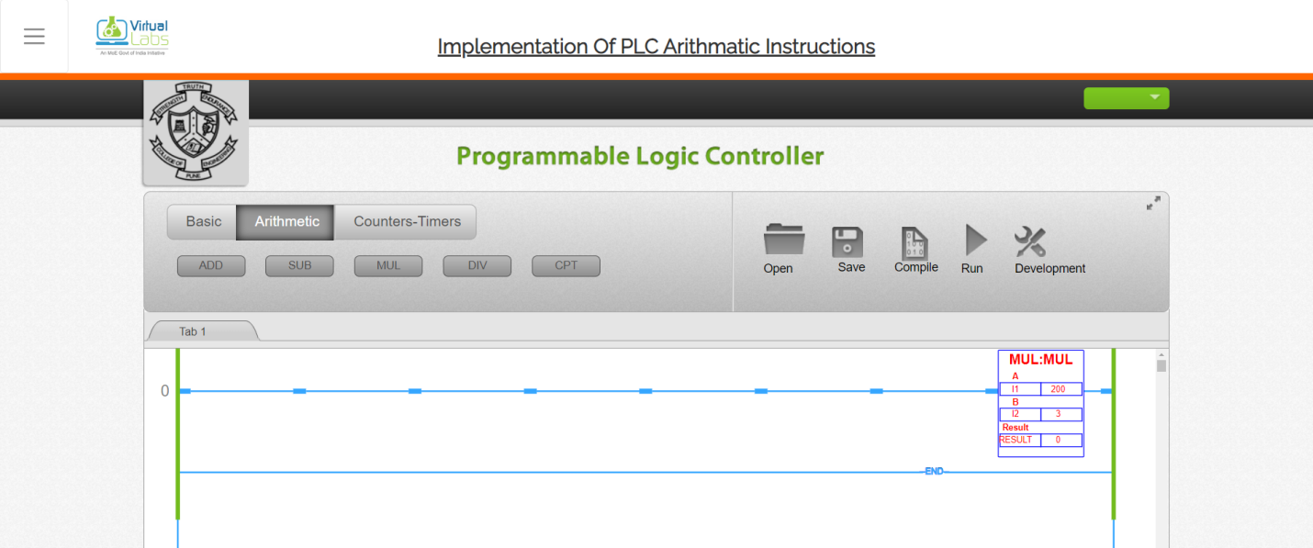

**Division**

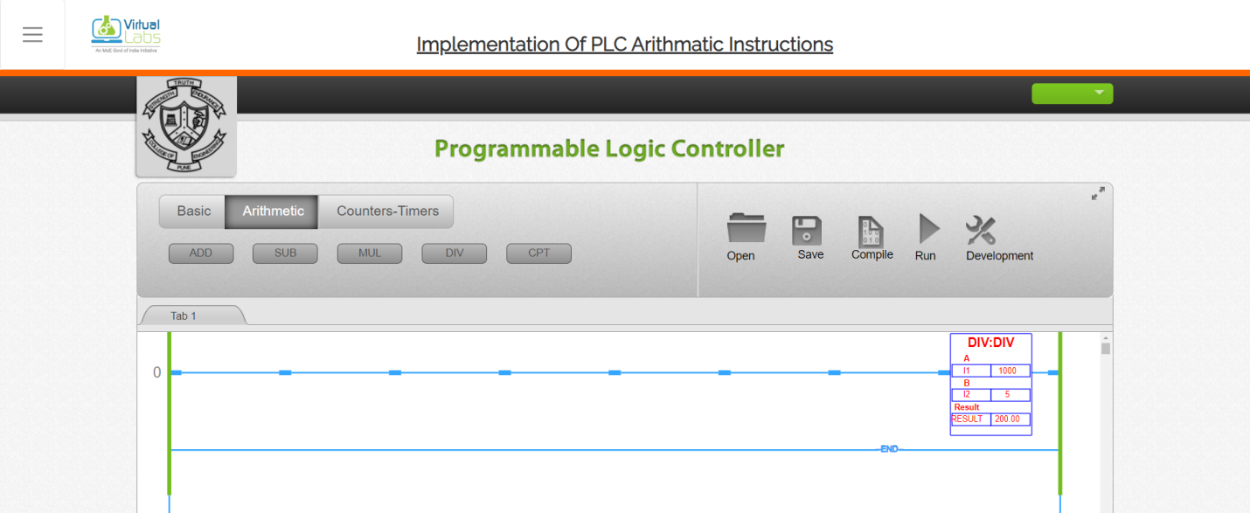

**AND Logic:**

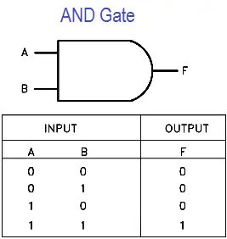

AND(0,0)=0

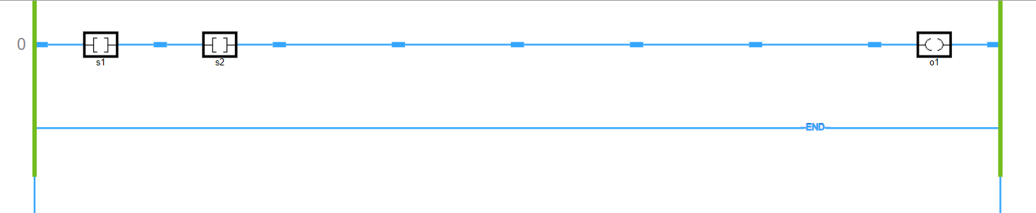

AND(0,1)=0

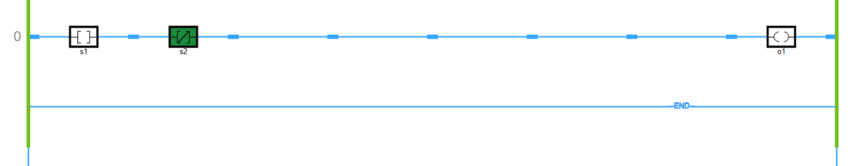

AND(1,0)=0

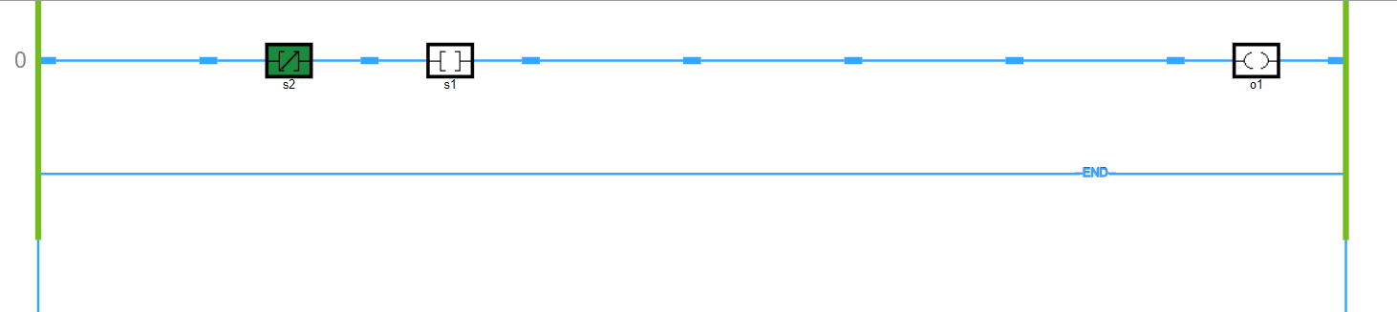

AND(1,1)=0

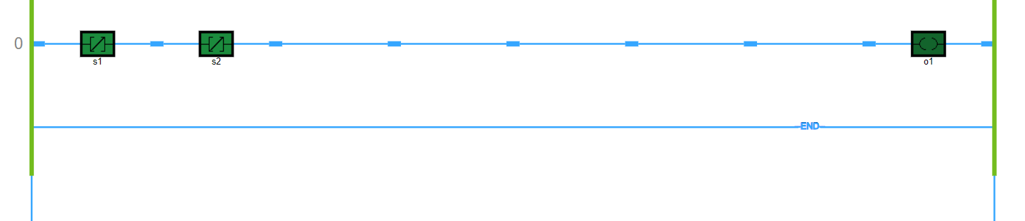

**OR Logic:**

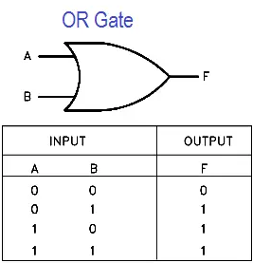

OR(0,0)=0

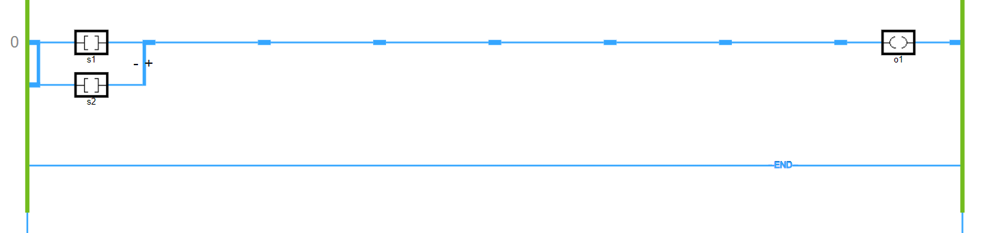

OR(0,1)=1

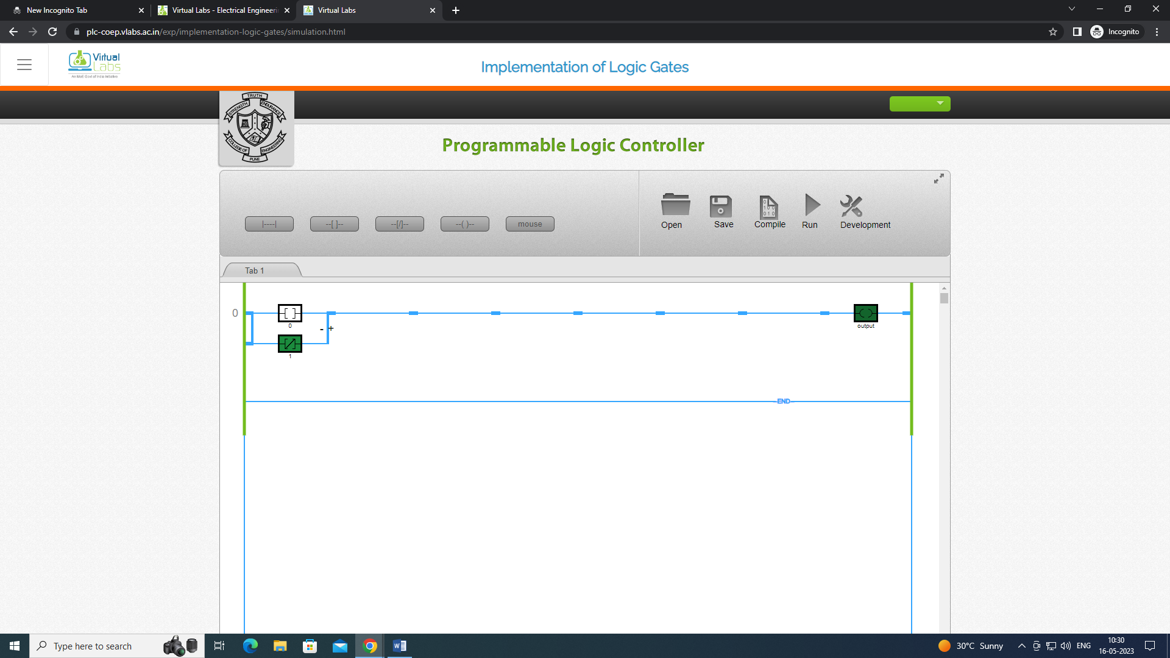

OR(1,0)=1

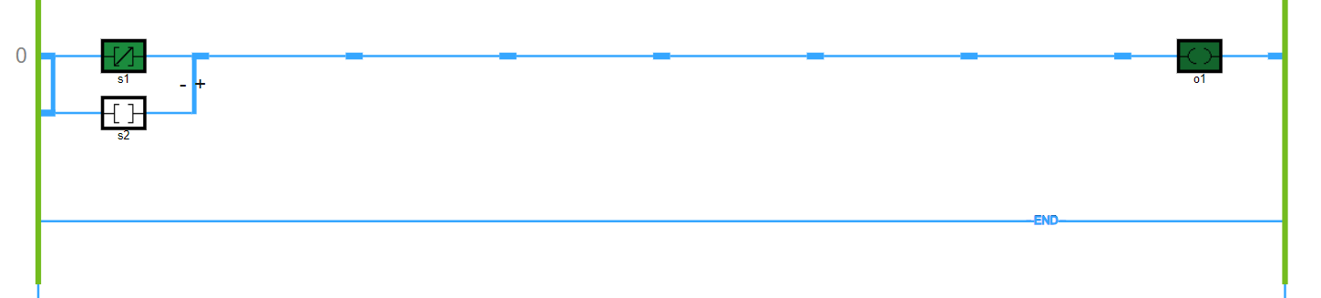

OR(1,1)=1

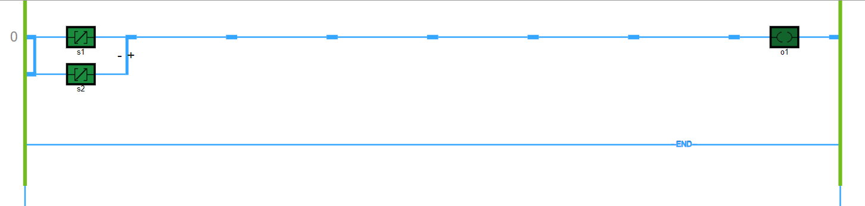

**Conclusion:**

The experiment aimed to develop a ladder using a standard procedure, understand the use of logical instructions, and understand the use of arithmetic instructions. Through the experiment, the participant was able to gain knowledge and hands-on experience in developing a ladder using the standard procedure and identify the different types of logical and arithmetic instructions used in ladder programming. Logical instructions included AND, OR operators, while arithmetic instructions included addition, subtraction, multiplication, and division. The experiment provided a comprehensive understanding of ladder programming and its application in various industrial processes, enabling the participant to develop efficient and effective ladder programs to control automation systems.