

**SENSORS AND**

**AUTOMATION**

**Sarvesh Anand Mankar**

**142203013**

**SY Comp Div-2, S5 Batch**

**Practical-7: Lamp Test Using Delay**

**Aim:**

To Perform the lamp test using the relay.

**Theory:**

**Relay** - A relay refers to an electrical component that is used for switching and controlling electrical circuits. Relays play a crucial role in PLC systems as they provide a means to interface with external devices such as motors, solenoids, lights, and other control elements.

An on/off relay is an electro-mechanical device used to control the flow of electric current to a circuit or electrical device. It has two stable states: "on" and "off." When the relay is energized, it switches from the "off" state to the "on" state, allowing current to flow through the connected circuit. When the relay is de-energized, it returns to the "off" state, interrupting the current flow.

**Function** - A relay acts as an electro=mechanical switch that is controlled by an electrical signal from the PLC's output module. When the PLC sends a signal to energize the relay coil, it creates a magnetic field that attracts the relay's armature, closing the switch contacts and allowing current to flow through the controlled circuit.

**Types of Relays** - PLCs can work with various types of relays, including general purpose relays, power relays, solid-state relays, and safety relays. The selection depends on factors such as the current and voltage requirements, switching speed, and the specific application's needs.

**Input and Outpu**t - Relays have two primary components: the coil (input) and the contacts (output). The coil is connected to the PLC's output module, while the contacts are used to control the external devices. The contacts can be normally open (NO), normally closed (NC), or both.

**Wiring** - PLC relays typically have multiple sets of contacts, allowing for different control scenarios. The wiring of the relay's contacts depends on the desired behaviour. For example, if a motor is connected to the NO contact, it will turn on when the relay is energized.

**Contact Ratings** - When selecting relays for PLC applications, it is crucial to consider the contact ratings. These ratings define the maximum current and voltage that the relay contacts can handle reliably. Exceeding the contact ratings can lead to premature failure or unsafe conditions.

**Interface Modules** - PLCs often use interface modules to connect the relays to the PLC's input and output modules. Interface modules provide isolation, which helps protect the PLC from electrical noise and voltage transients that may be present in the external circuit.

**Diagnostic Features** - Some relays designed for PLC systems include diagnostic features that aid in troubleshooting and monitoring. These features can include LED indicators for relay status, built-in surge protection, and feedback on coil continuity.

**Procedure:**

1. Add the new rung.
2. Add the relay as input device.
3. Add the lamp.
4. Whenever the relay is toggled the lamp get on and off.

**Experiment:**

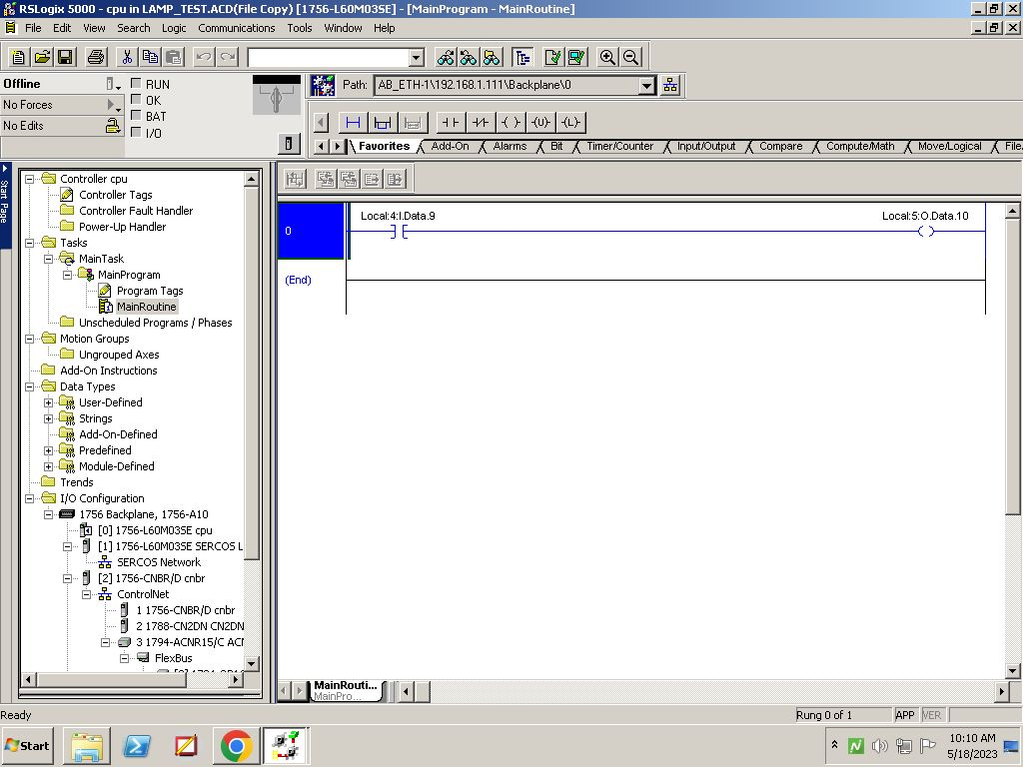

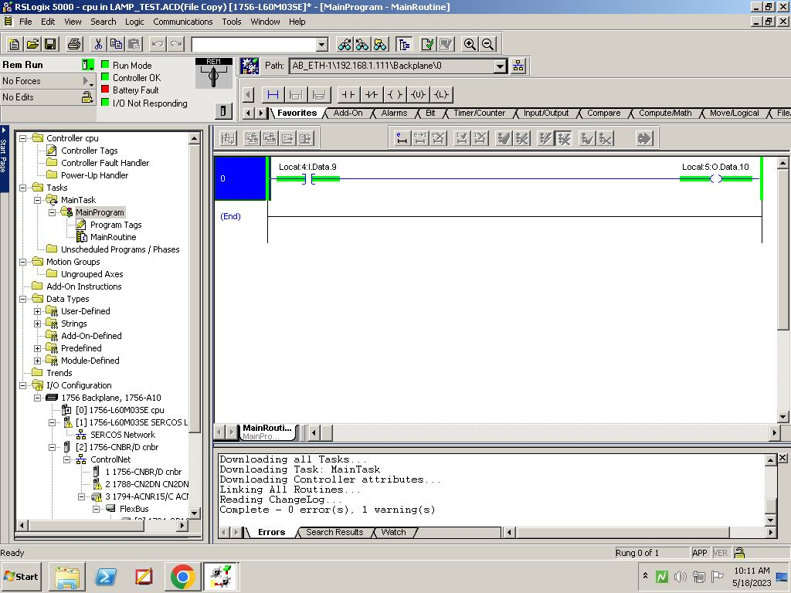

**Conclusion:**

The experiment on Lamp Test Using Delay successfully showcased the functionality of delay components in a PLC system, allowing accurate control of lamp activation and deactivation timings.