

**COMPUTER**

**NETWORKS**

**Sarvesh Anand Mankar**

**142203013**

**TY Comp Div-2, T4 Batch**

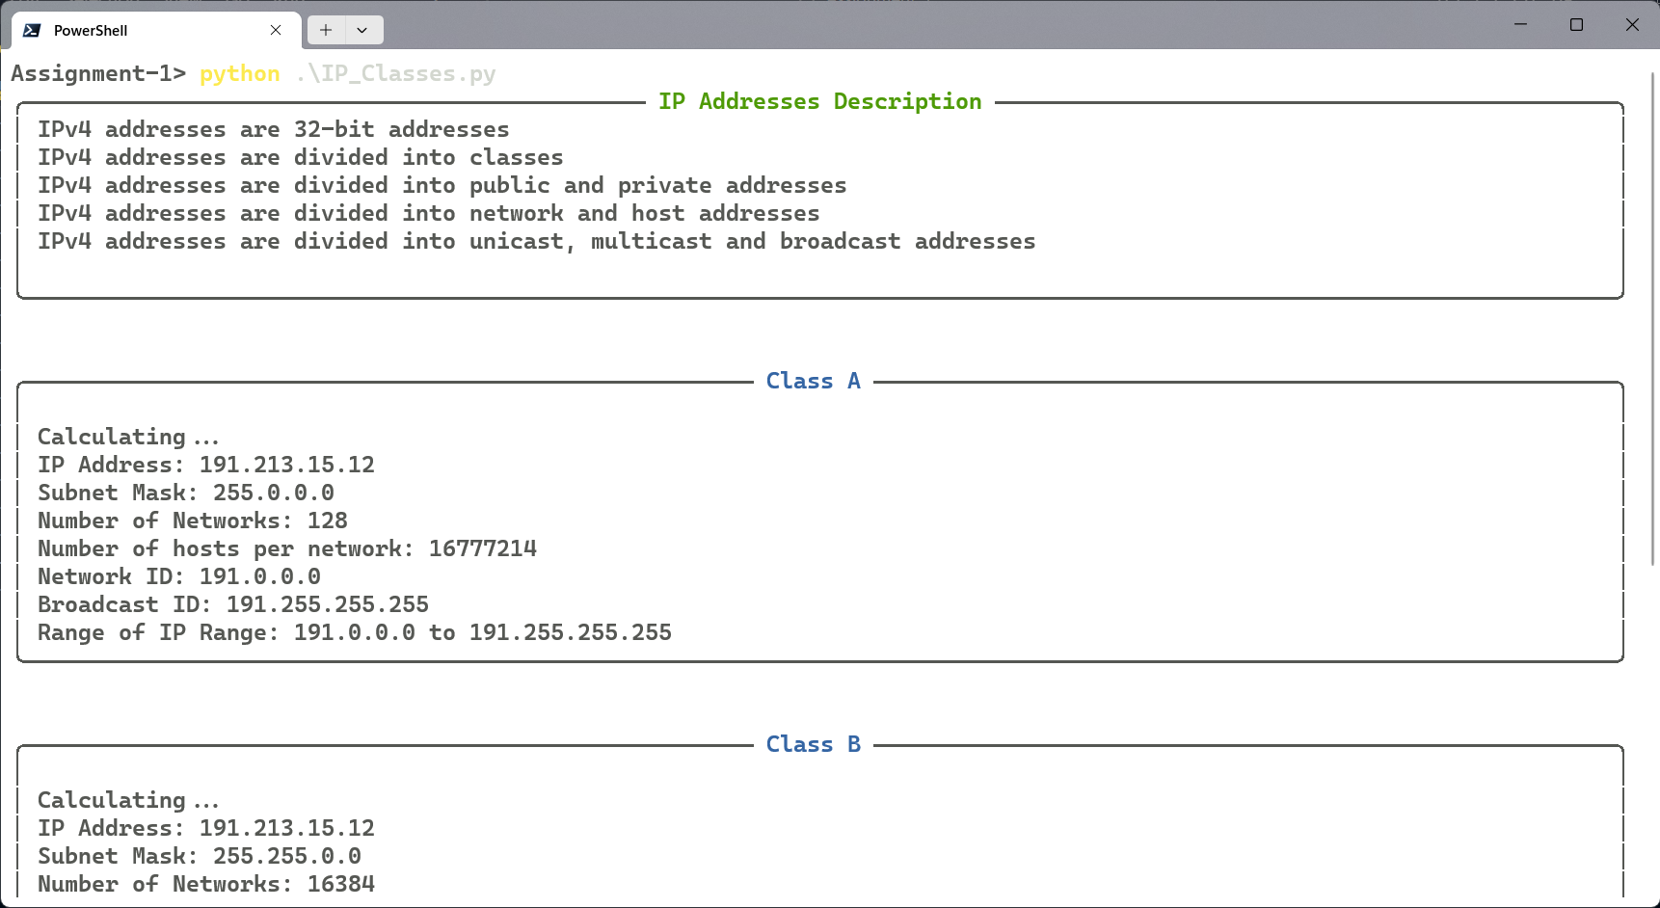

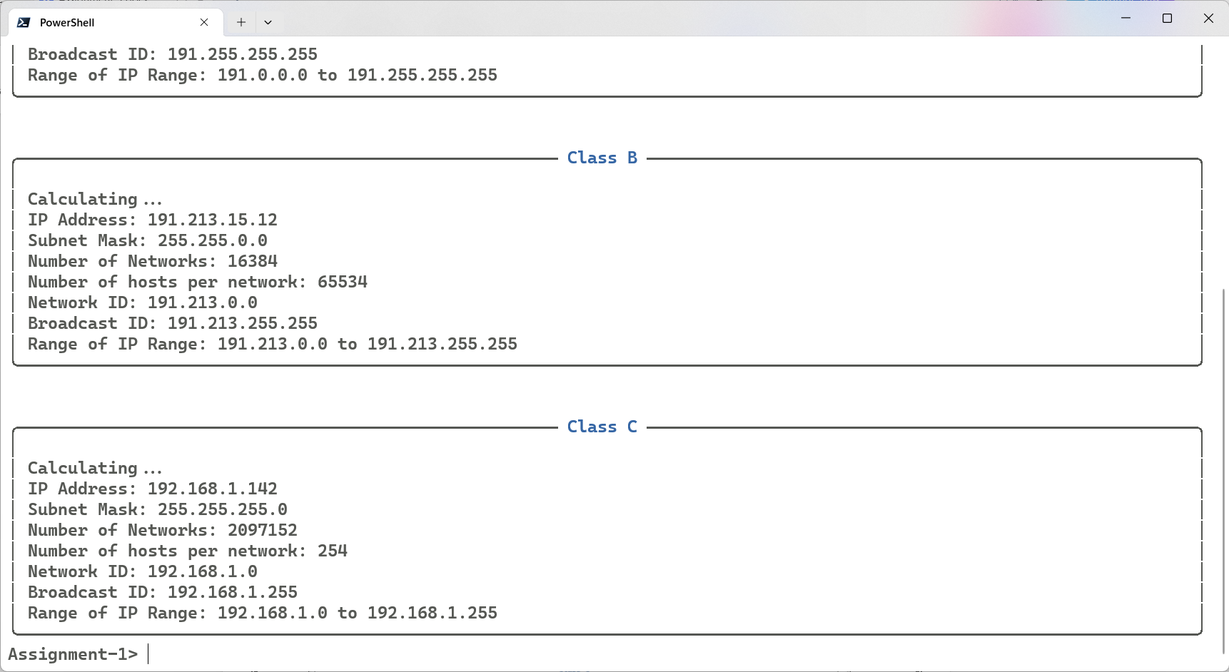

IP Address and Subnet Description

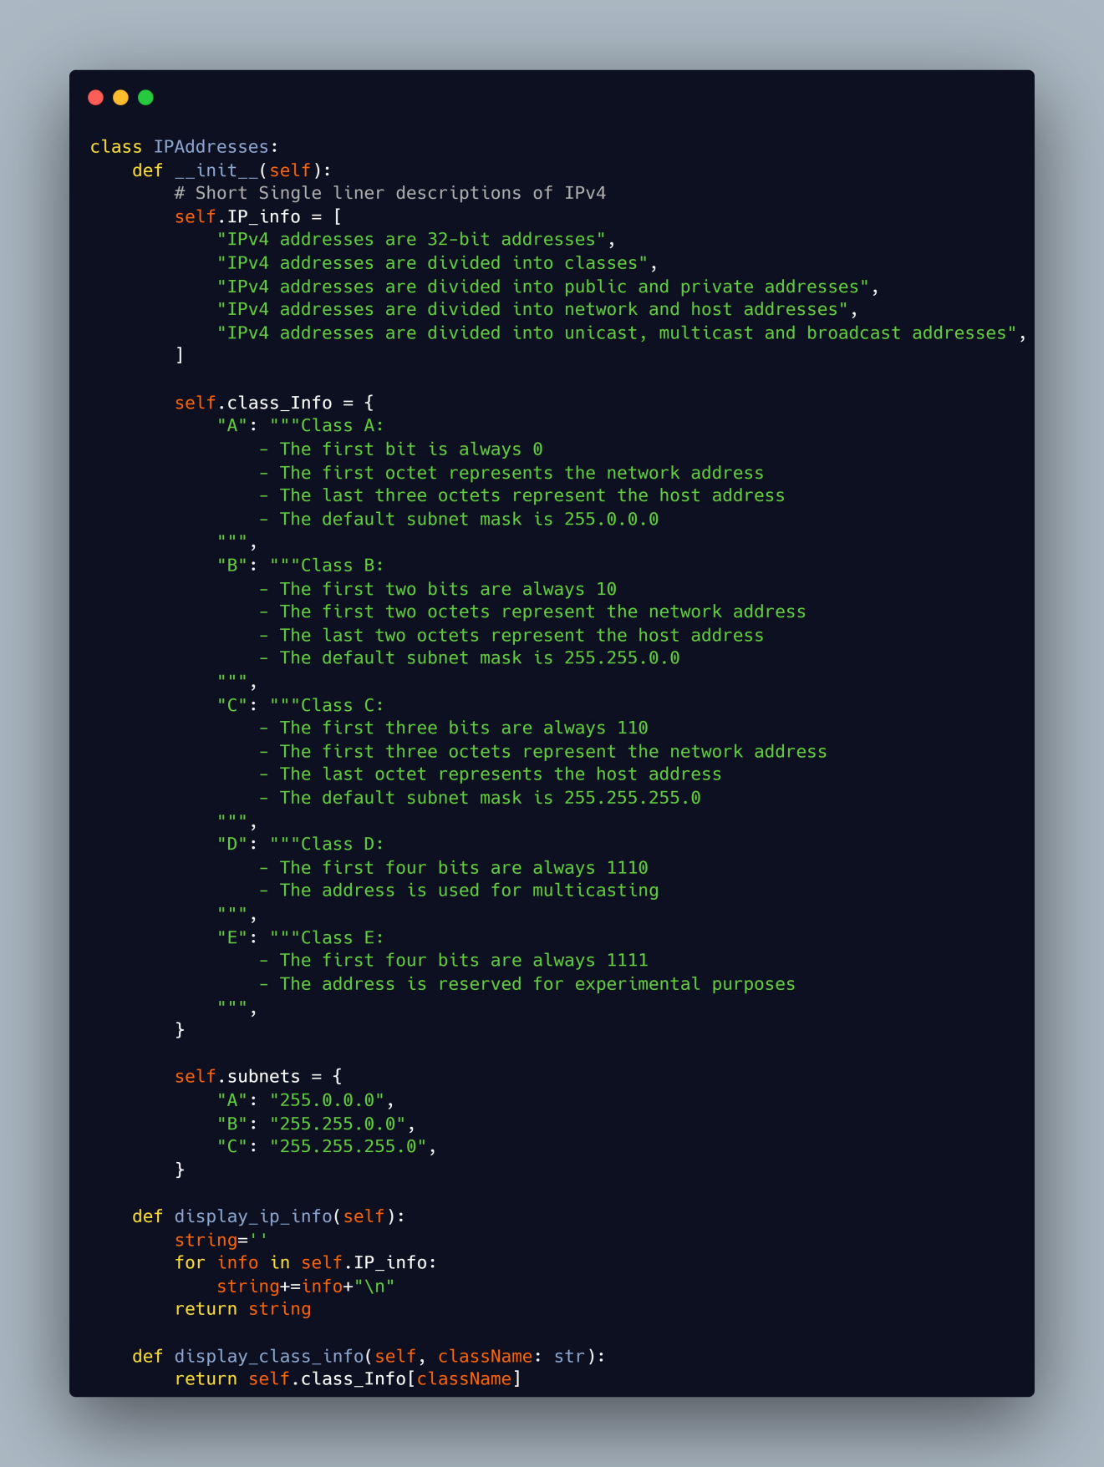

Solution Code

