

**COMPUTER**

**NETWORKS**

**Sarvesh Anand Mankar**

**142203013**

**TY Comp Div-2, T4 Batch**

1. **ifconfig**

- Description: Displays or configures network interface parameters.

- Syntax: ifconfig [interface] [options]

- Use: Used to view or configure network interface settings, IP addresses, and network-related statistics.

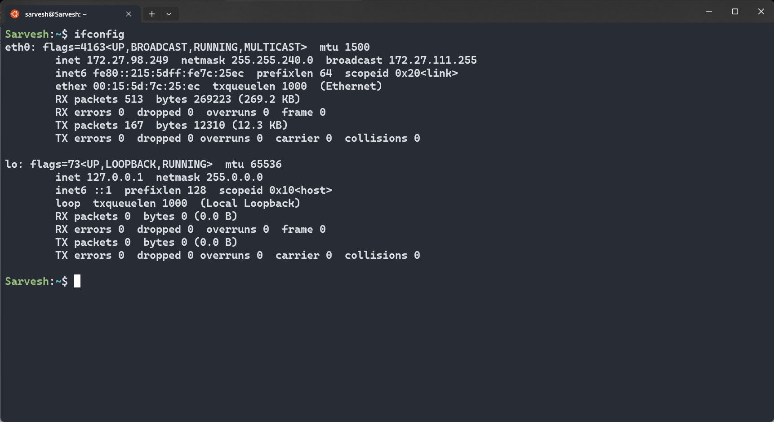

2. **ip**

- Description: A versatile tool for network configuration and management.

- Syntax: ip [options] object command

- Use: Used for a wide range of networking tasks, including configuring interfaces, routing tables, and more. Replaces many functionalities of ifconfig and route .

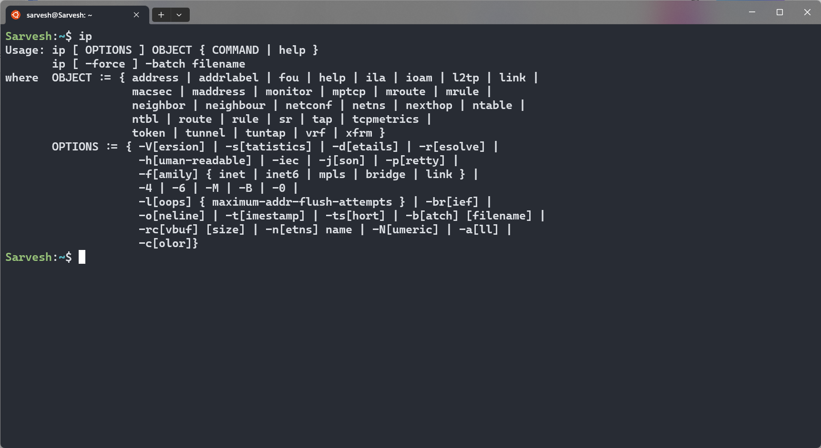

3. **traceroute**

- Description: Traces the route that packets take to reach a destination.

- Syntax: traceroute [options] destination

- Use: Helps diagnose network connectivity issues by showing the path and delays packets encounter on their way to a destination.

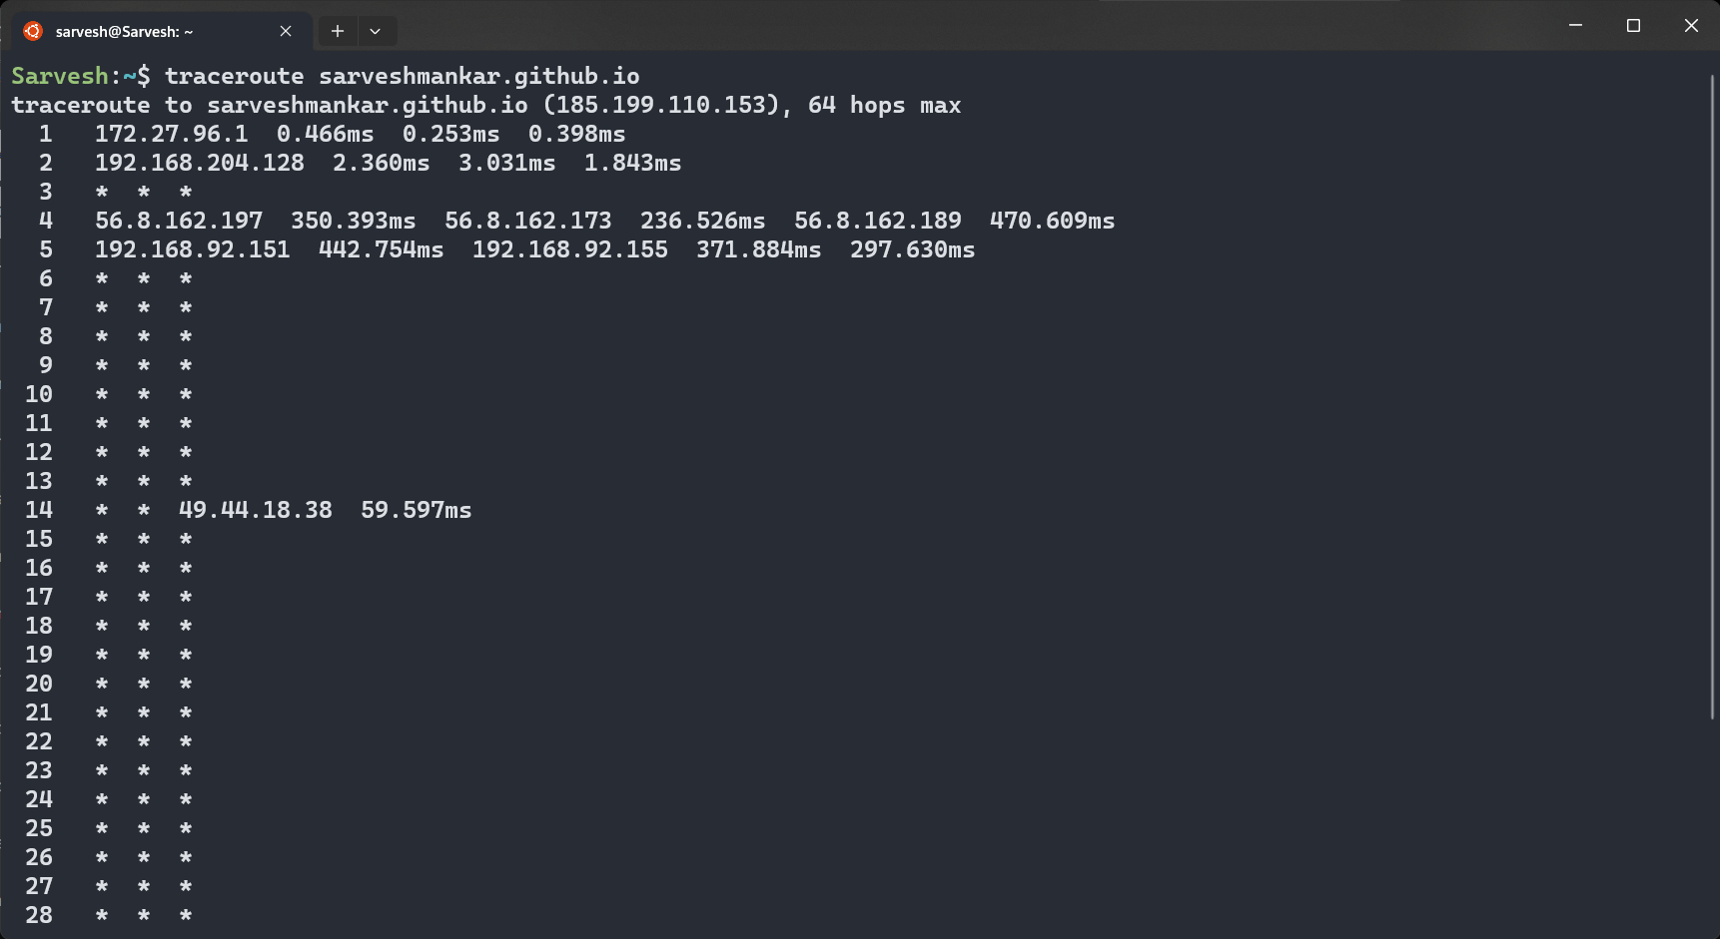

4. **tracepath**

- Description: A simplified alternative to traceroute .

- Syntax: tracepath [options] destination

- Use: Similar to traceroute but with a simpler output format for quick network troubleshooting.

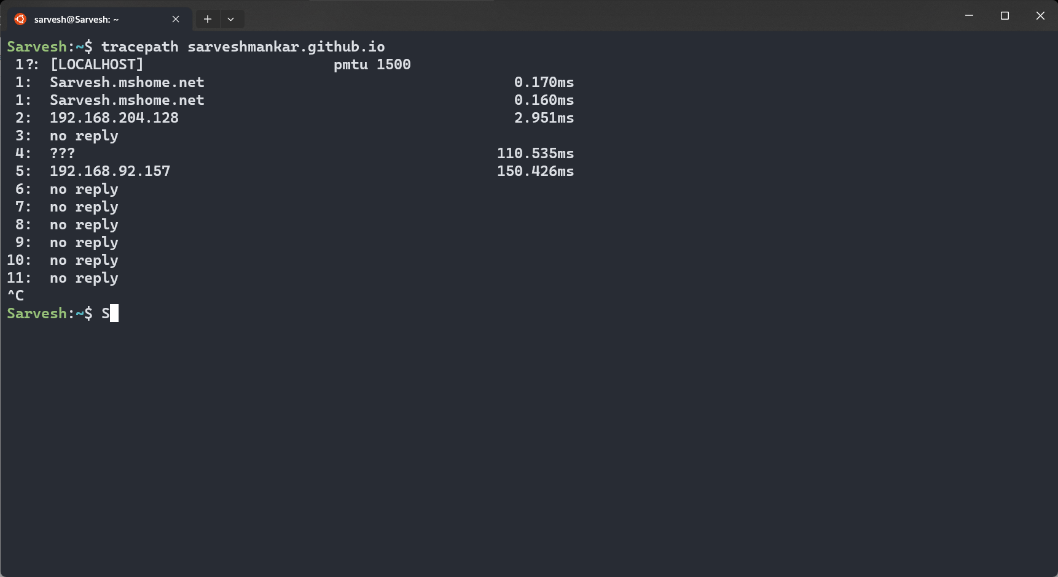

5. **ping**

- Description: Sends ICMP echo requests to a host to check its network reach-ability.

- Syntax: ping [options] destination

- Use: Used for basic network connectivity testing. It measures round-trip time and packet loss to a target host.

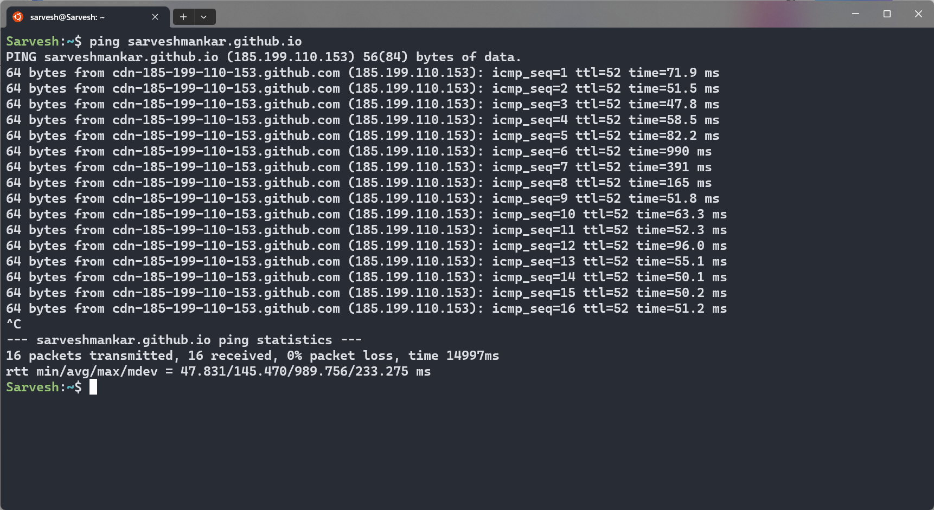

6. **netstat**

- Description: Displays network statistics and active network connections.

- Syntax: netstat [options]

- Use: Useful for monitoring network connections, routing tables, and interface statistics.

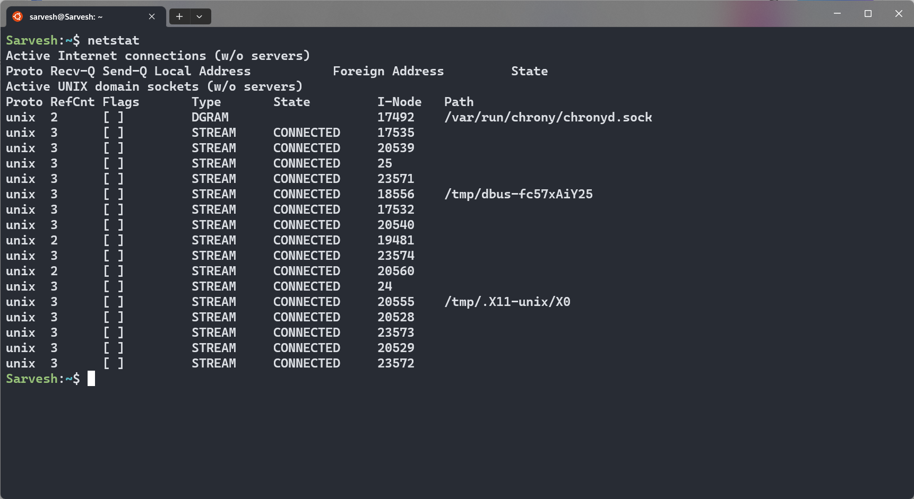

7. **nslookup**

- Description: Queries DNS servers for domain name information.

- Syntax: nslookup [options] hostname

- Use: Used to resolve domain names into IP addresses and vice versa, as well as to query DNS server information.

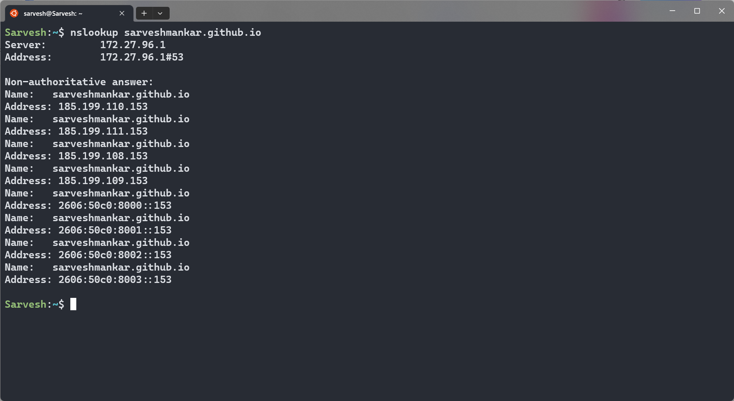

8. **dig**

- Description: A more advanced DNS query tool.

- Syntax: dig [options] hostname

- Use: Provides detailed DNS information, including DNS records, server responses, and more.

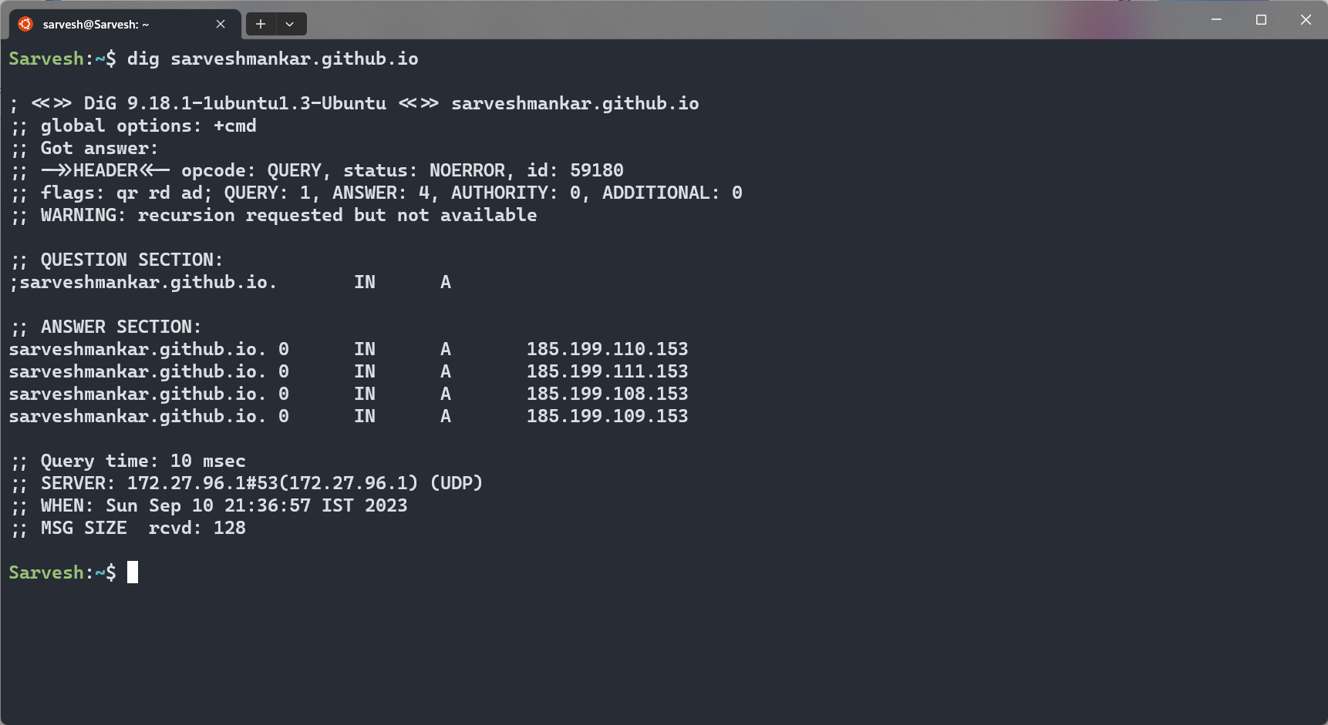

9. **route**

- Description: Manages the IP routing table.

- Syntax: route [options]

- Use: Used to display or modify the kernel routing table, which determines how packets are forwarded in a network.

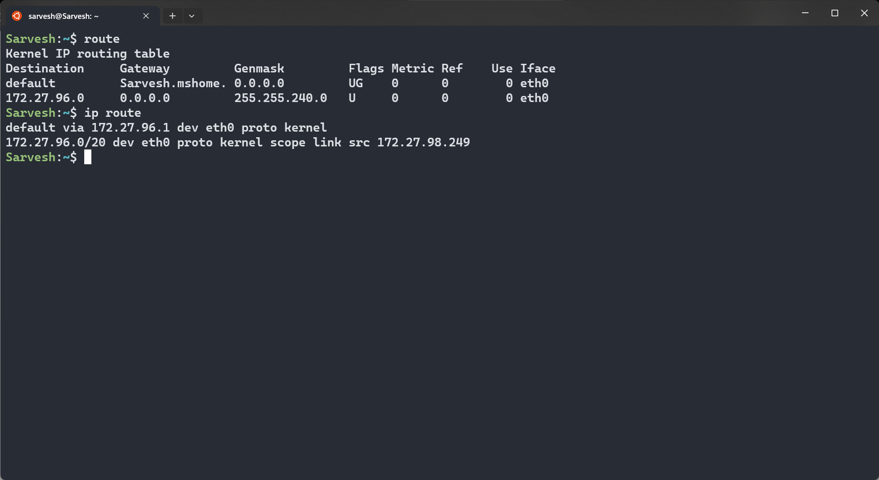

10. **host**

- Description: Performs DNS lookups on a given hostname.

- Syntax: host [options] hostname

- Use: Similar to nslookup , it resolves hostnames to IP addresses and vice versa.

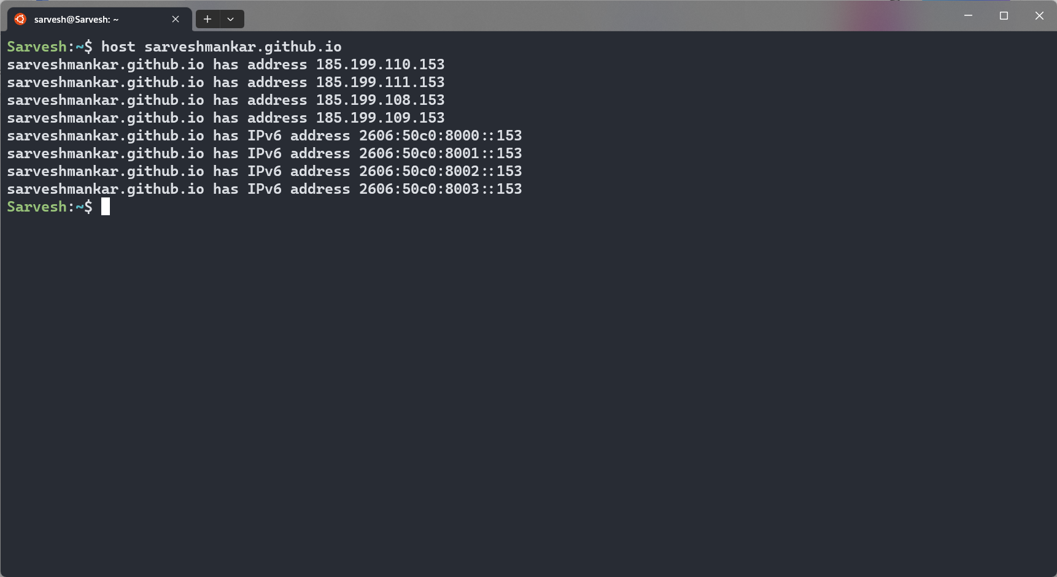

11. **arp**

- Description: Displays and manages the ARP (Address Resolution Protocol) cache.

- Syntax: arp [options]

- Use: Used to view and manipulate ARP cache entries, which map IP addresses to MAC addresses on a local network.

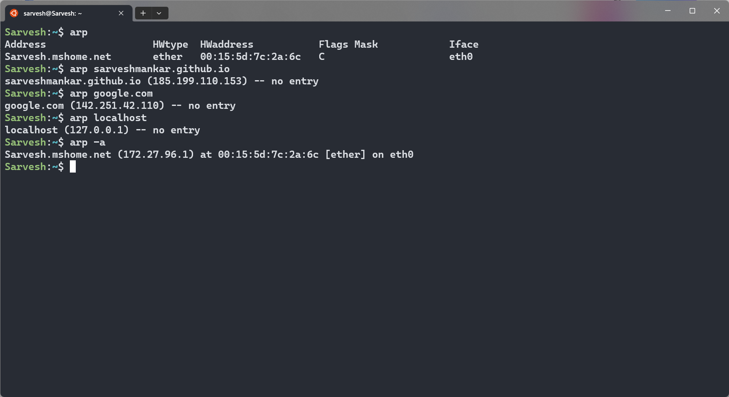

12. **iwconfig**

- Description: Configures wireless network interfaces.

- Syntax: iwconfig [interface] [options]

- Use: Primarily used to configure wireless network settings and view information about wireless interfaces.

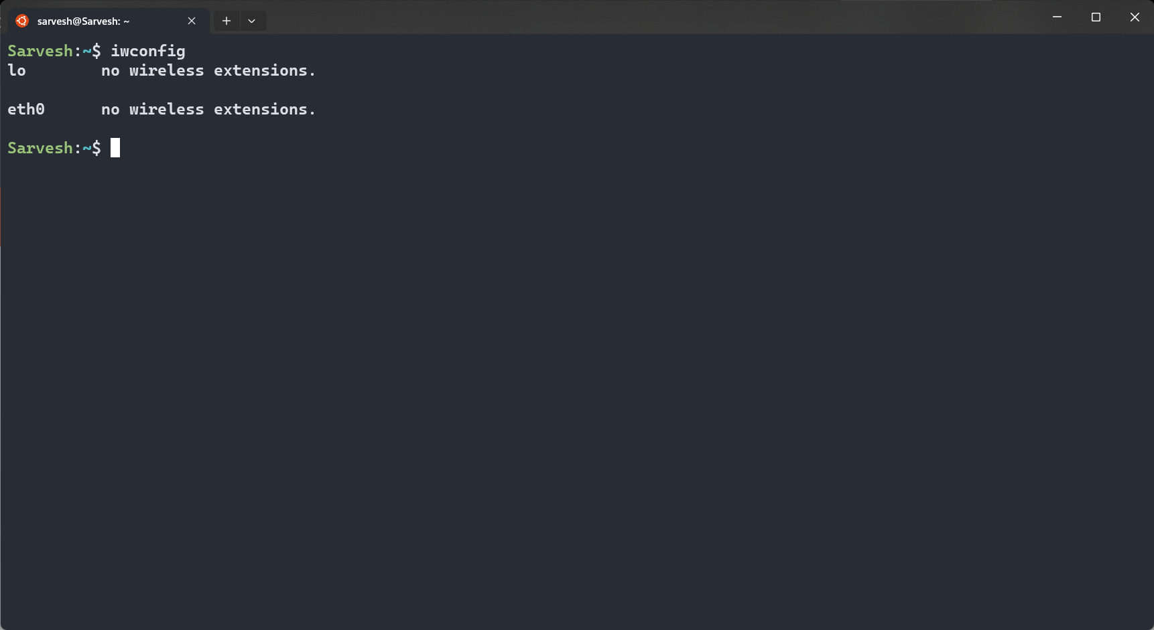

13. **curl**

- Description: A command-line tool for transferring data with URLs.

- Syntax: curl [options] URL

- Use: Used to fetch data from or send data to remote servers, making it useful for testing network services.

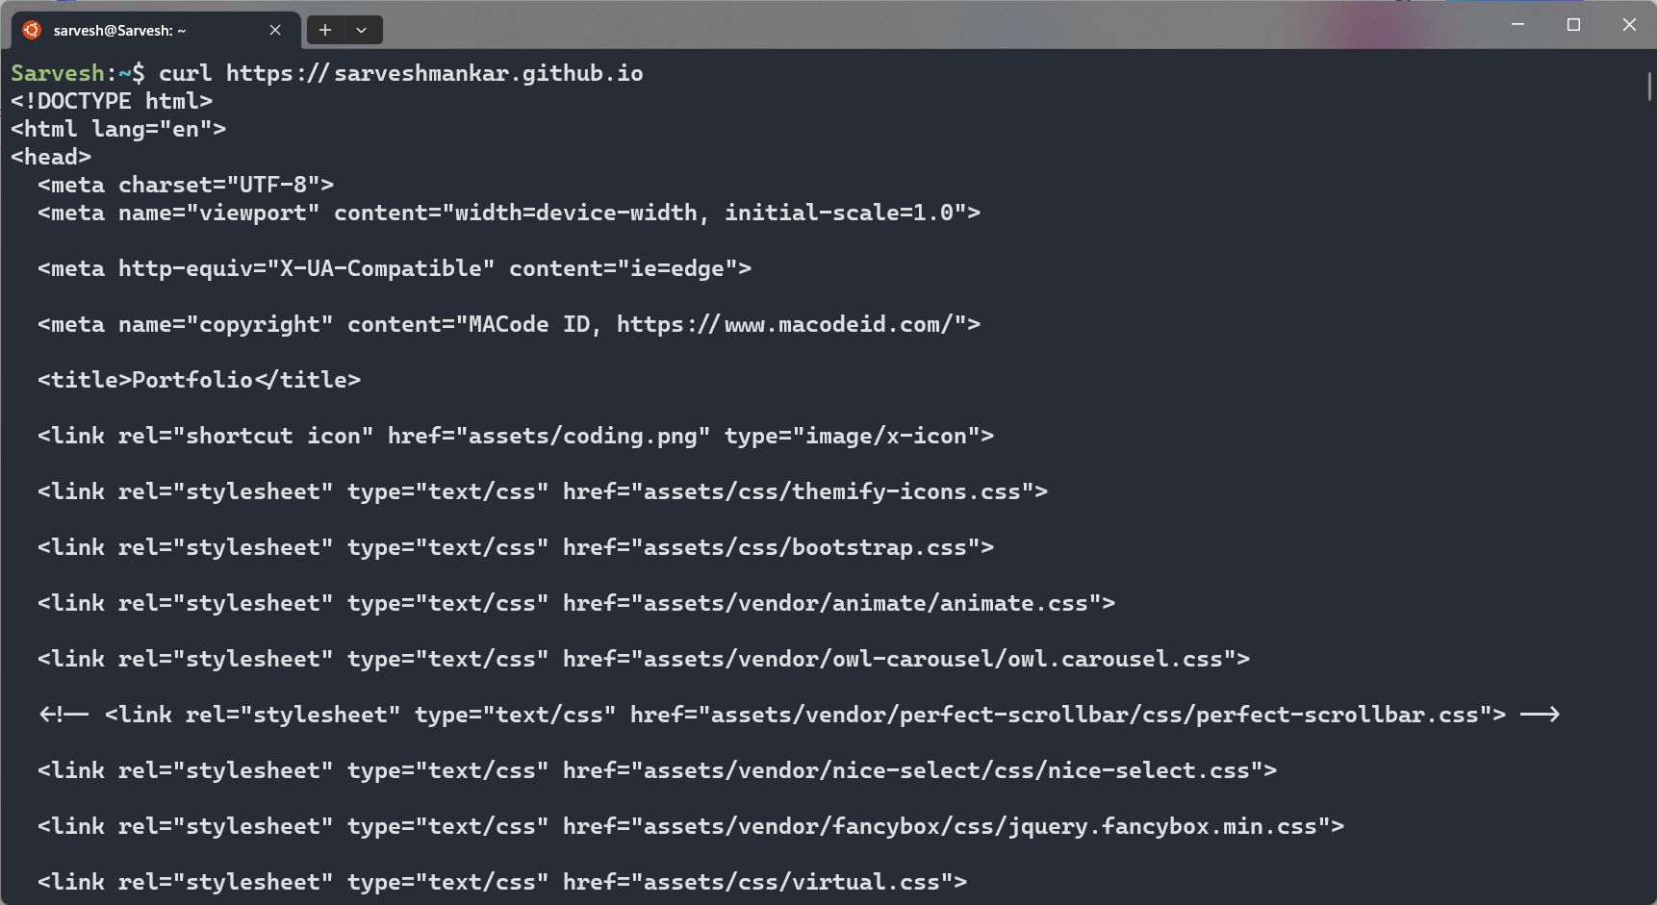

14. **wget**

- Description: Downloads files from the internet using HTTP, HTTPS, or FTP.

- Syntax: wget [options] URL

- Use: Used for downloading files or web pages from the internet via the command line.

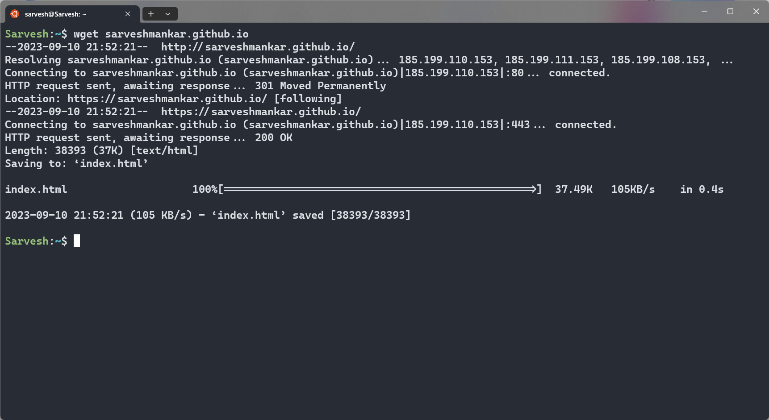

15. **telnet**

- Description: Provides terminal access to remote hosts.

- Syntax: telnet [options] hostname [port]

- Use: Allows interactive access to remote systems over a network, but is considered less secure and less commonly used today.

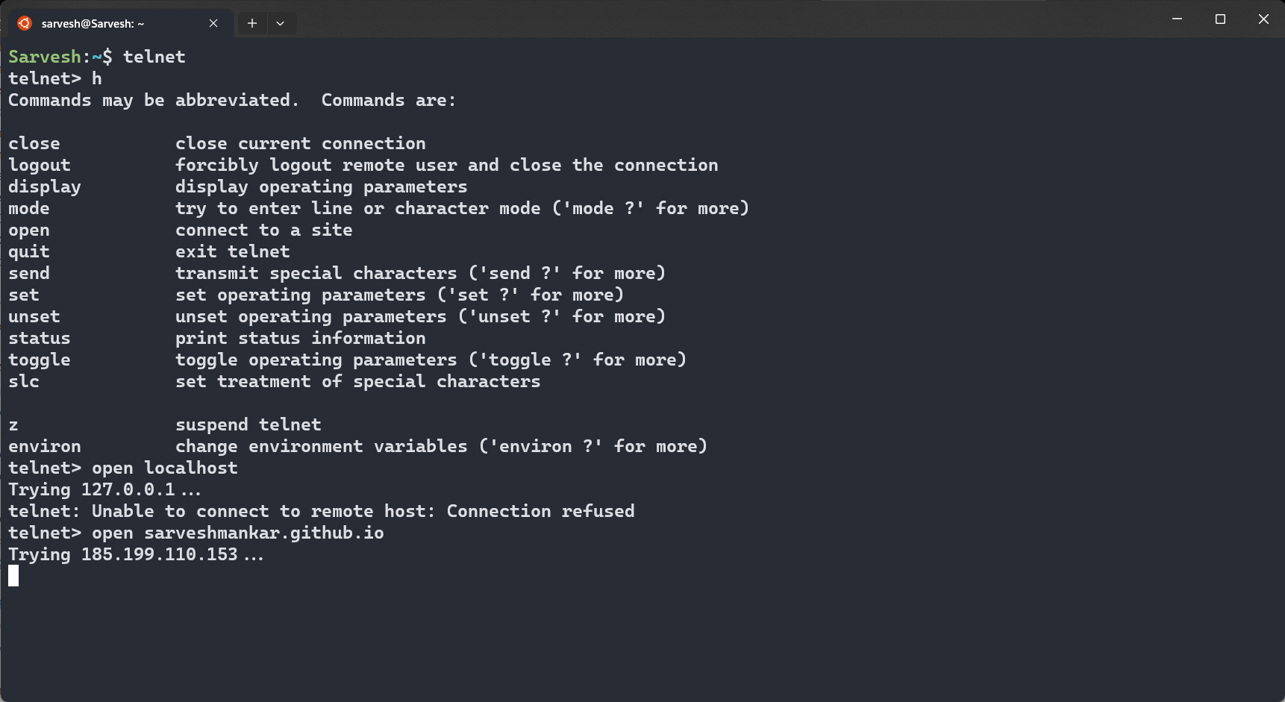

16. **whois**

- Description: Queries WHOIS databases for domain registration information.

- Syntax: whois [options] domain

- Use: Retrieves domain registration information, including ownership details, from WHOIS databases.

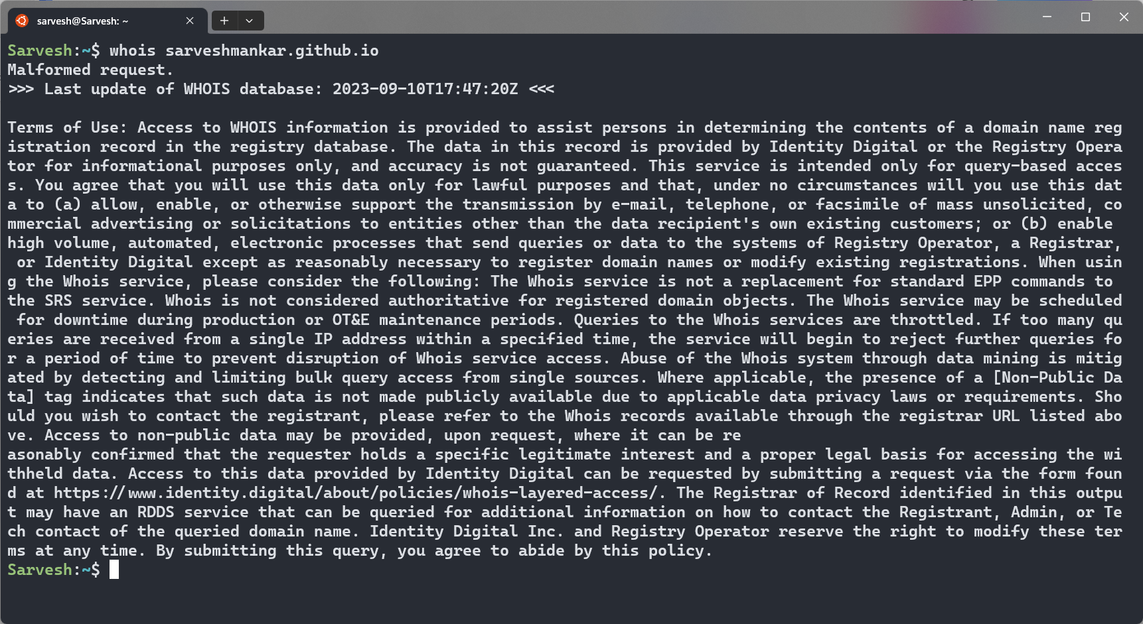

17. **ifplugstatus**

- Description: Checks the link status of network interfaces.

- Syntax: ifplugstatus [interface]

- Use: Used to determine whether a network cable is connected or disconnected to a specific network interface.

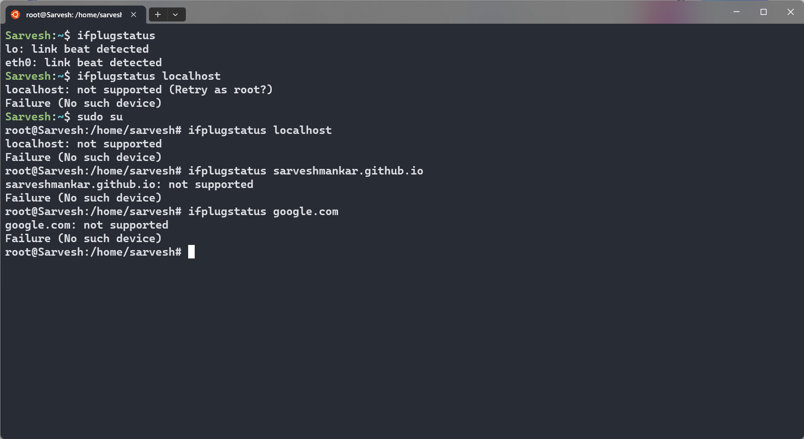

18. **nload**

- Description: Monitors network traffic and bandwidth usage in real-time.

- Syntax: nload [options] [interface]

- Use: Provides a visual representation of network traffic, including incoming and outgoing data rates.

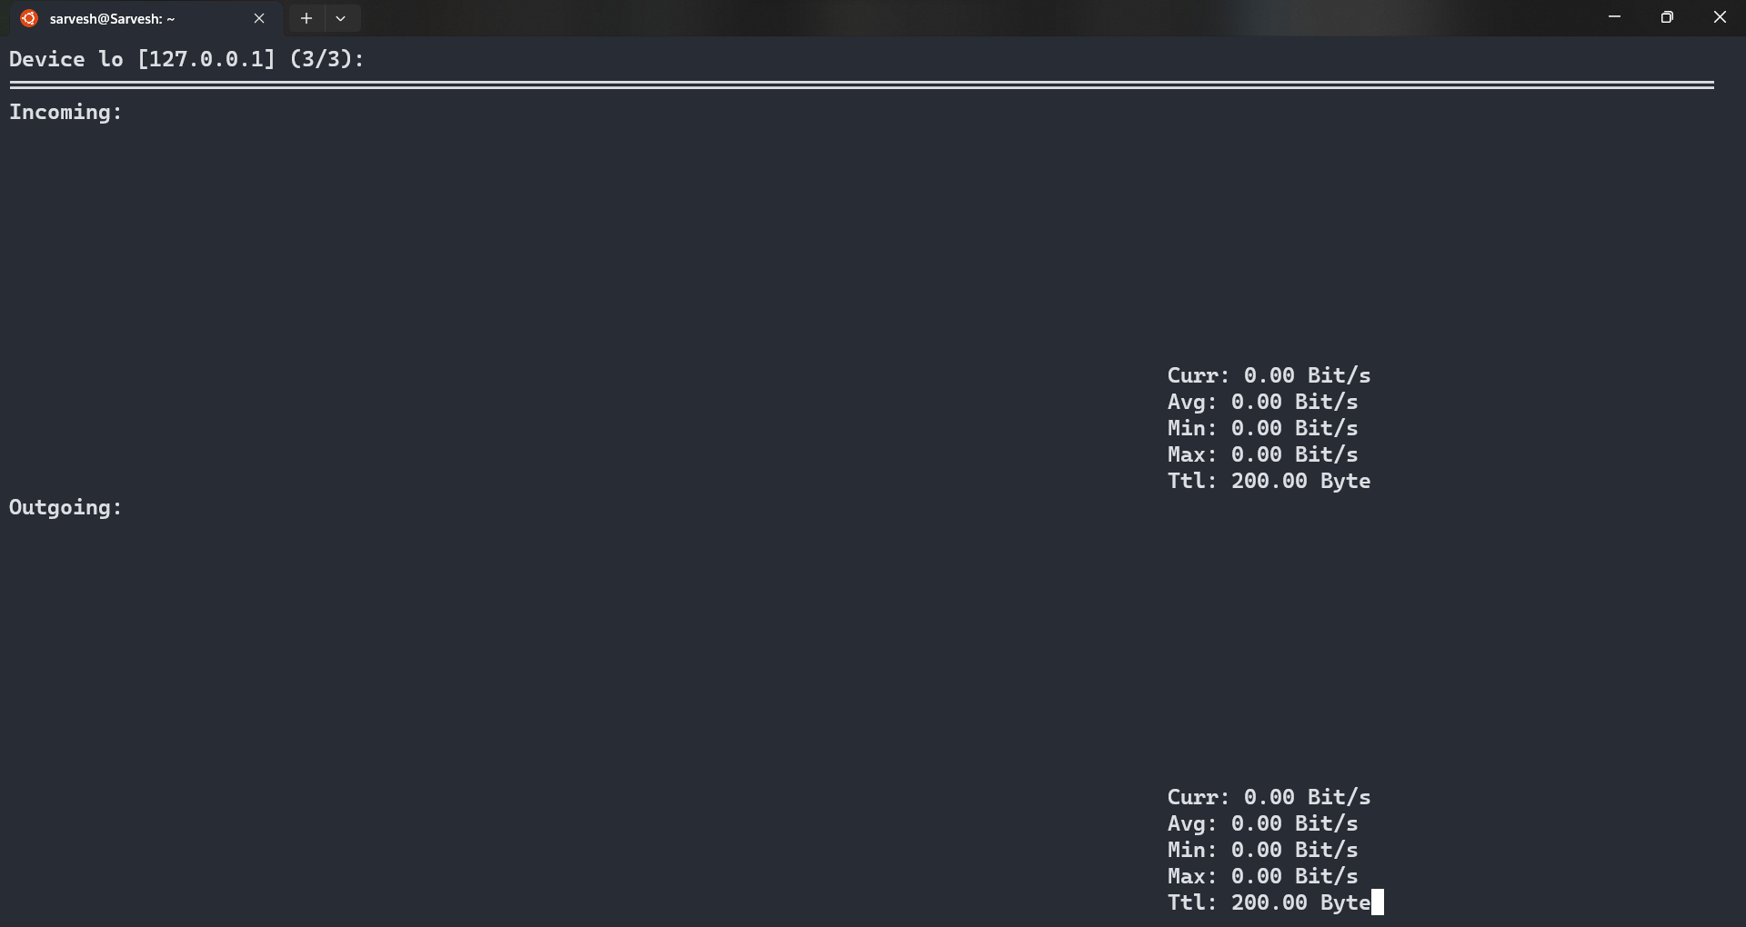

19. **mail**

- Description: Sends and receives email from the command line.

- Syntax: mail [options] [recipient]

- Use: Used to send, receive, and manage email messages directly from the command line.