

**COMPUTER**

**NETWORKS**

**Sarvesh Anand Mankar**

**142203013**

**TY Comp Div-2, T4 Batch**

**Assignment-3: Client-Server Communication**

**Server.py**

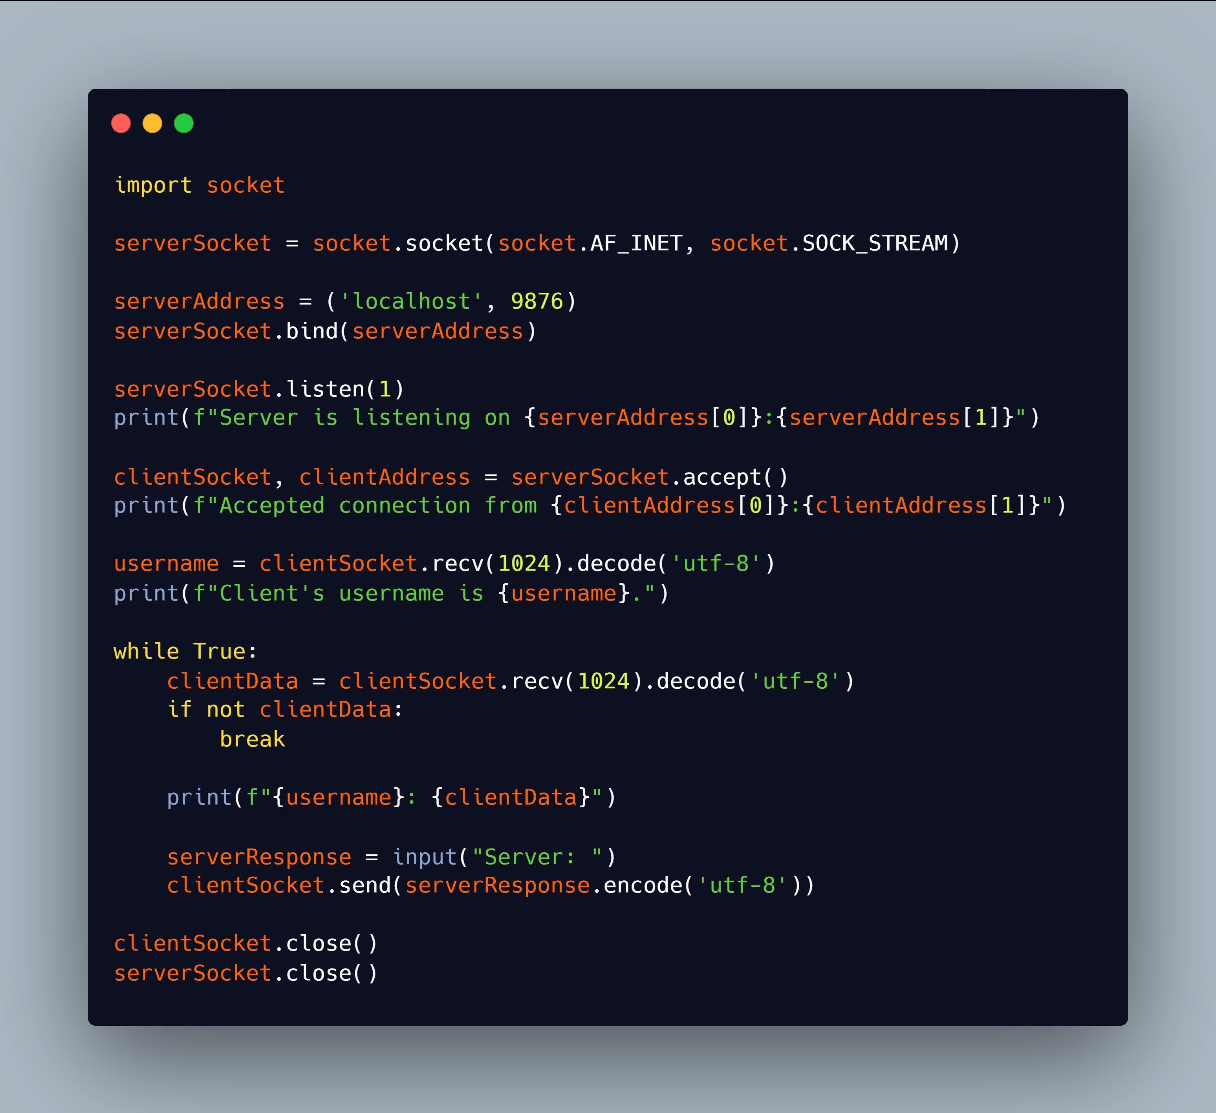

**Client.py**

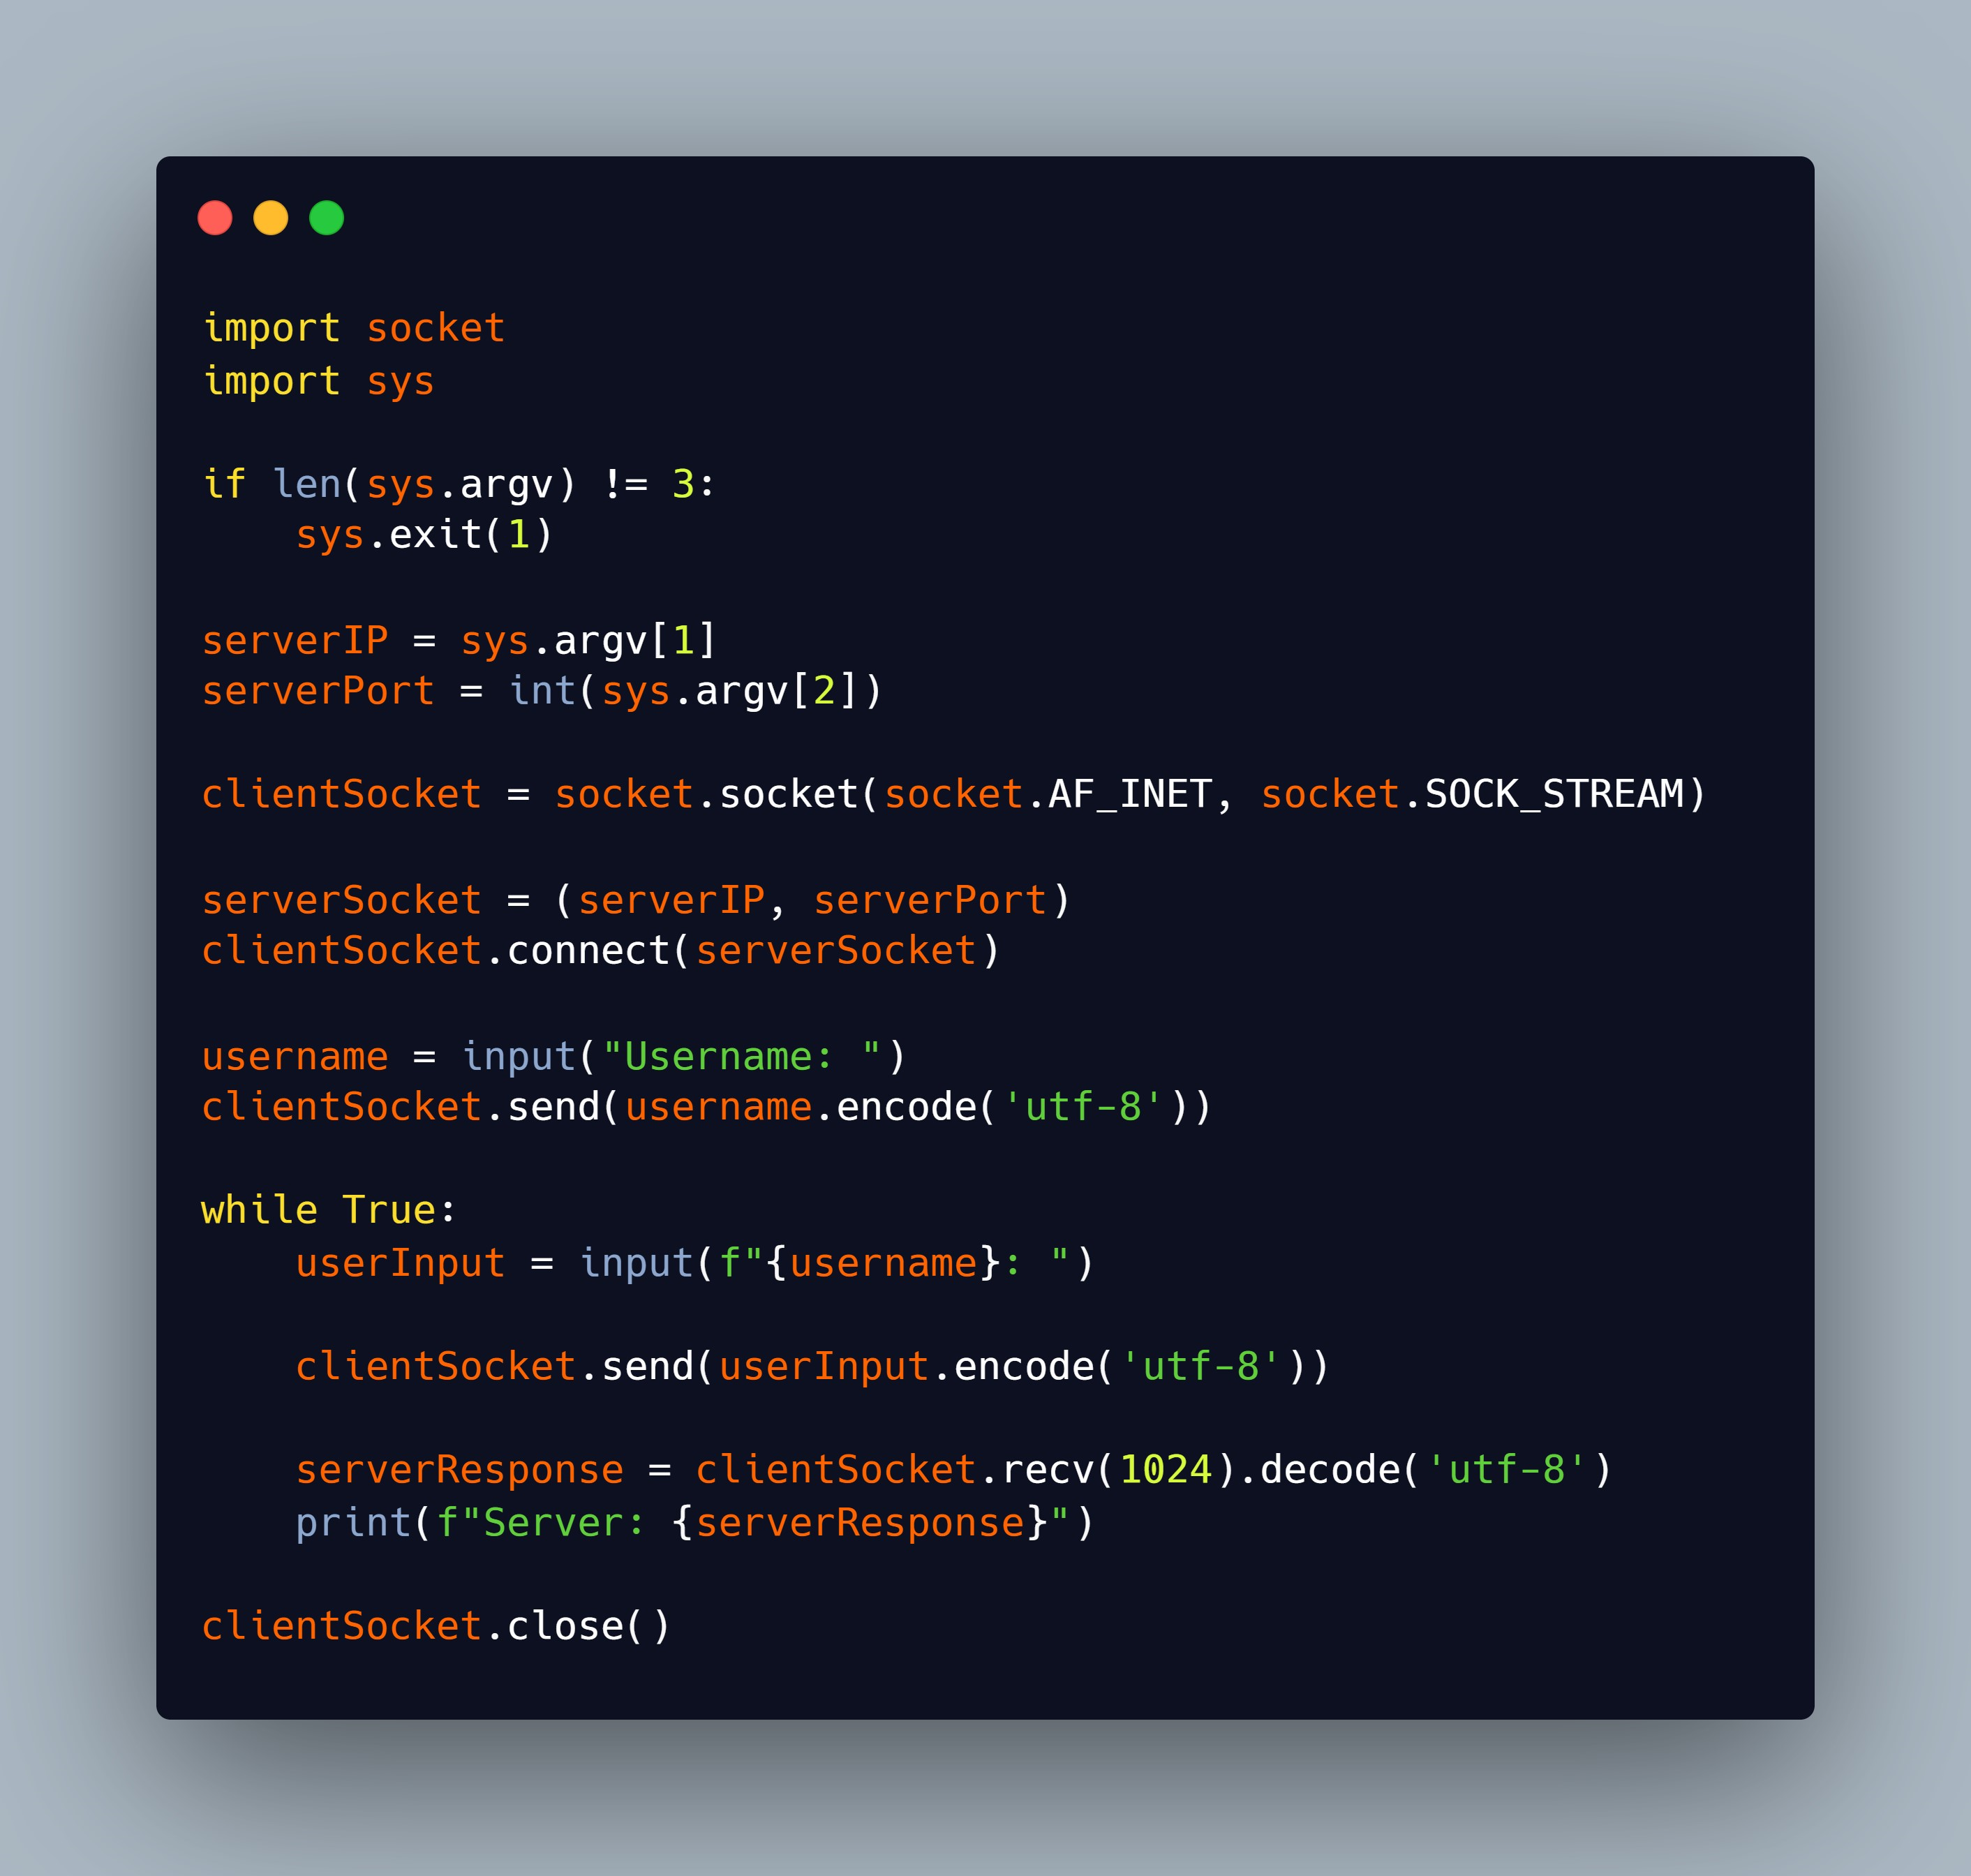

**Output:**

