

**COMPUTER**

**NETWORKS**

**Sarvesh Anand Mankar**

**142203013**

**TY Comp Div-2, T4 Batch**

**Assignment-4: Chat Room**

**Server.py**

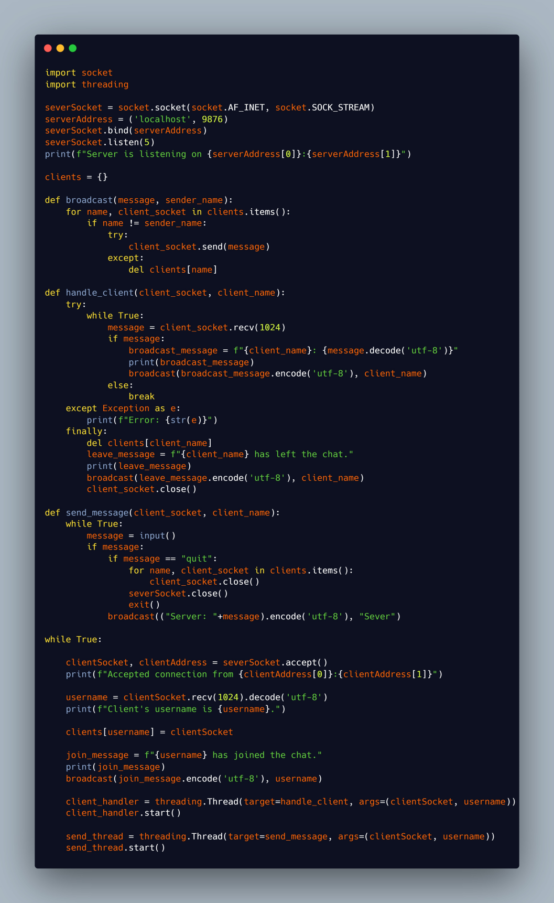

**Client.py**

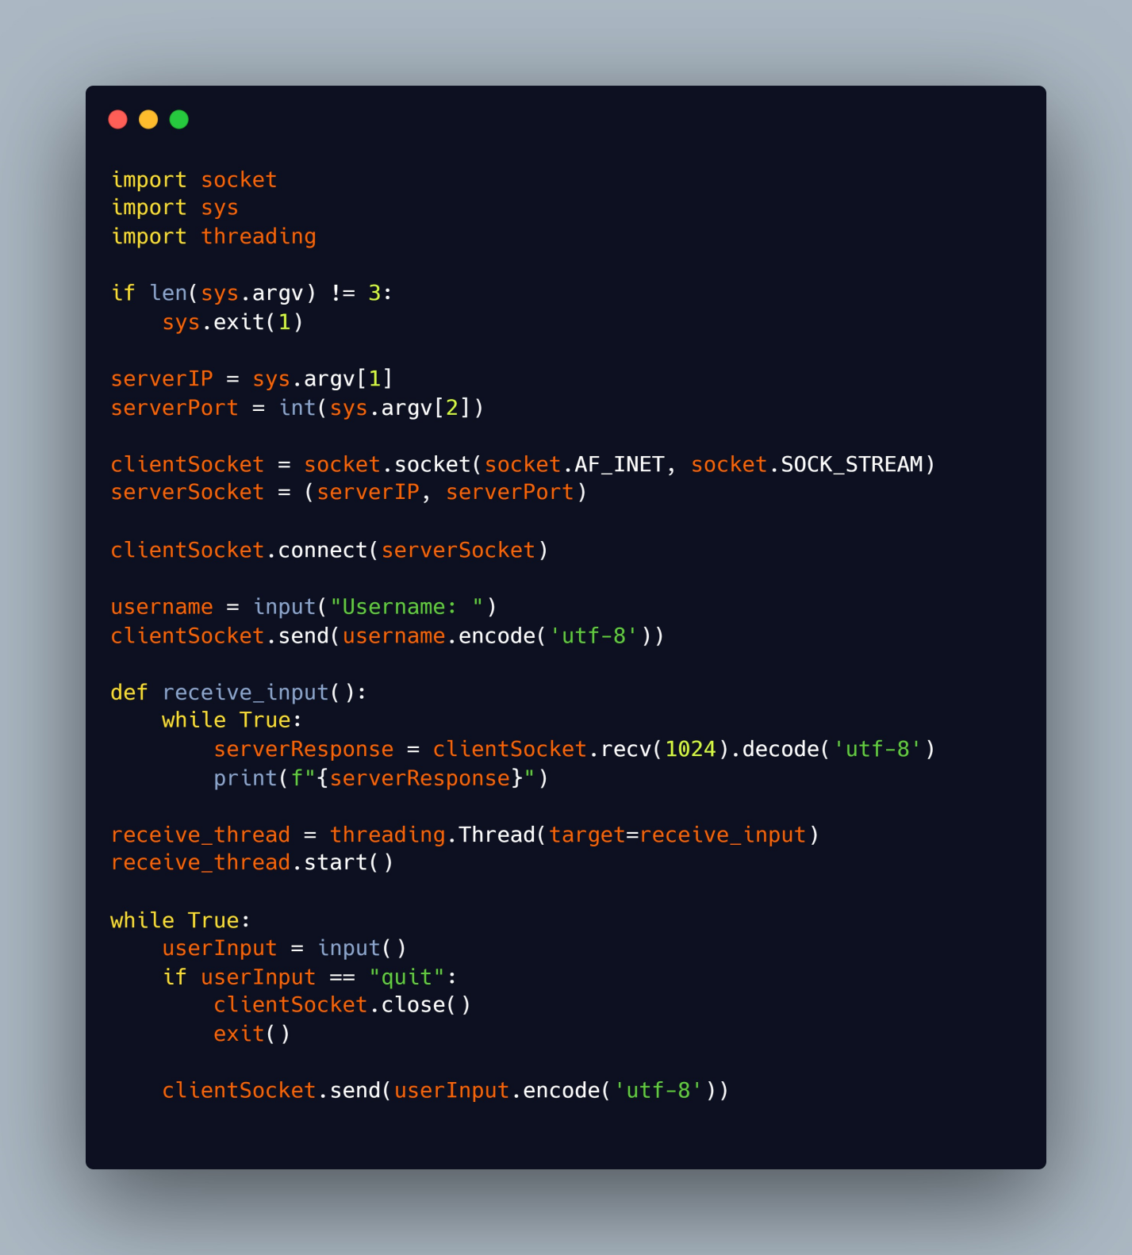

**Output:**

Connected to users

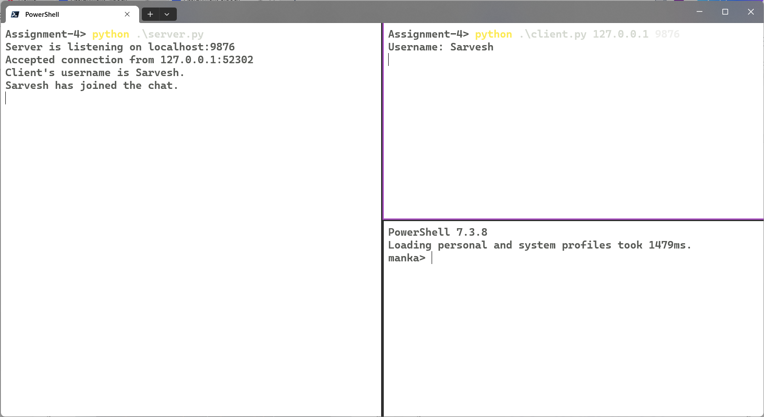

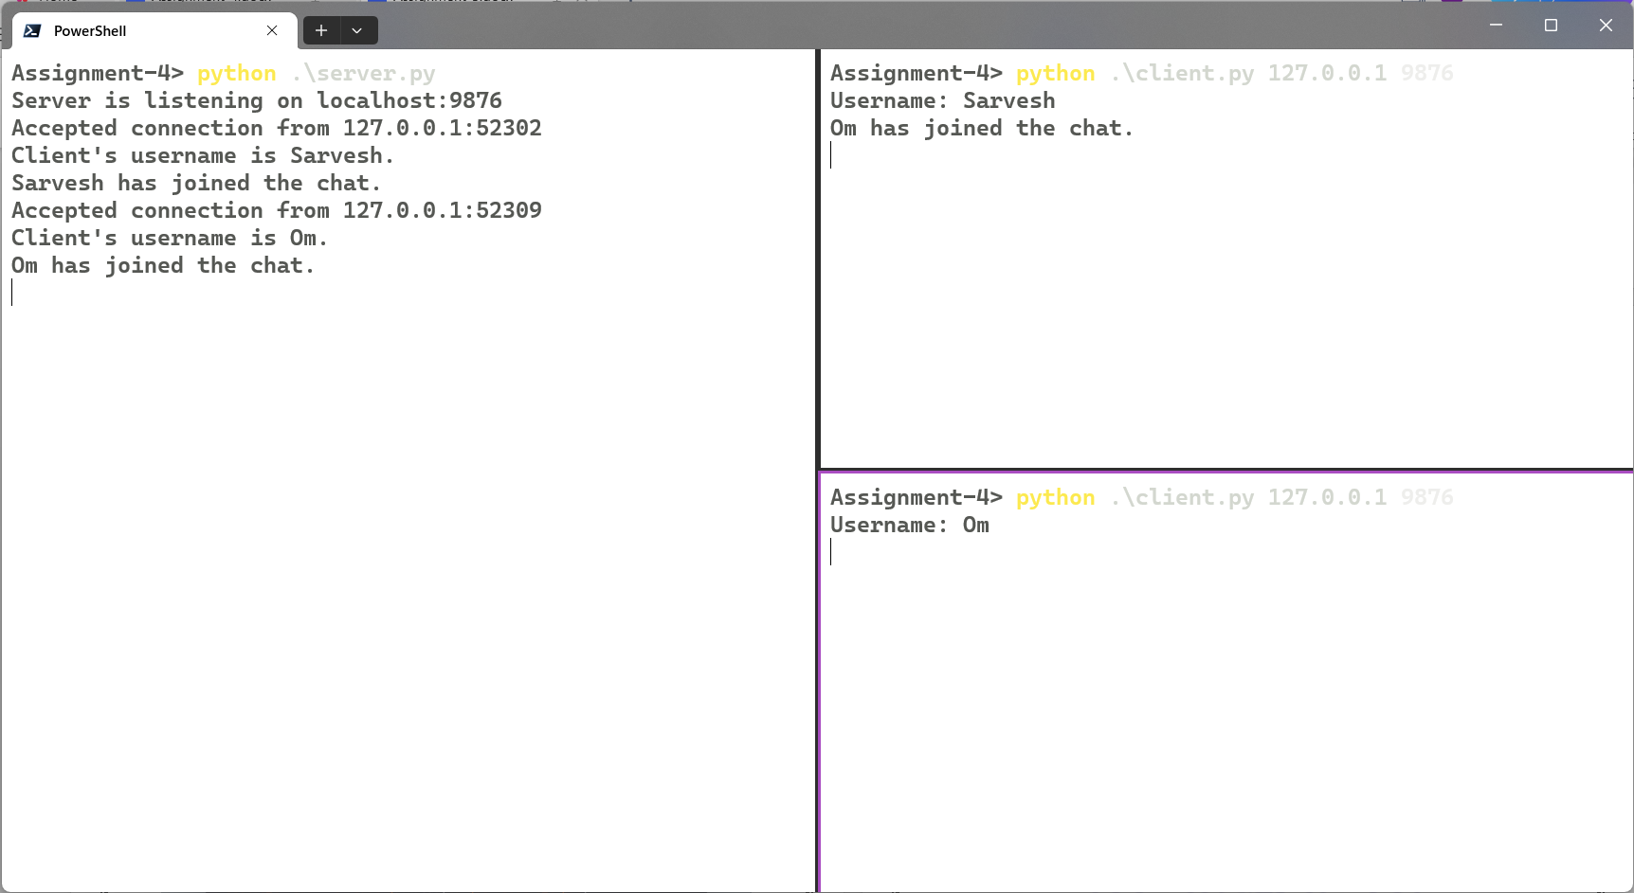

Server Sending broadcast message to all clients

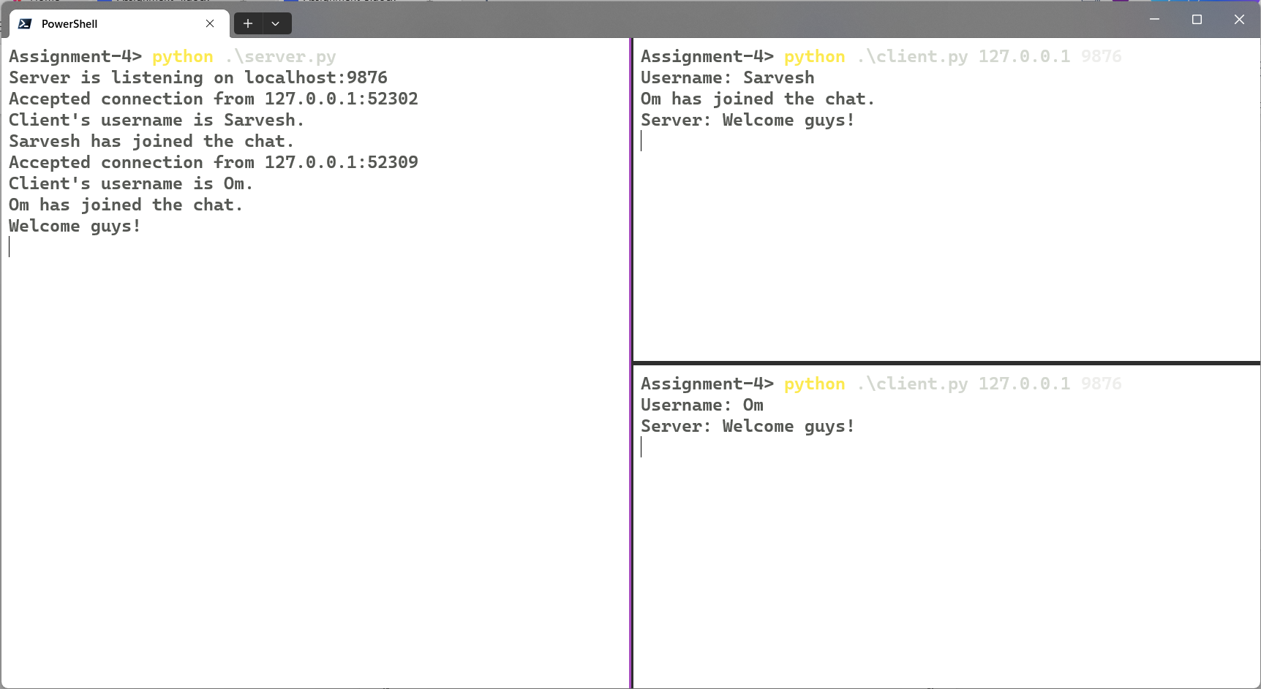

Chatting

