

**Database**

**Management**

**Systems**

**Sarvesh Anand Mankar**

**142203013**

**TY Comp Div-2, T4 Batch**

**University Schema**

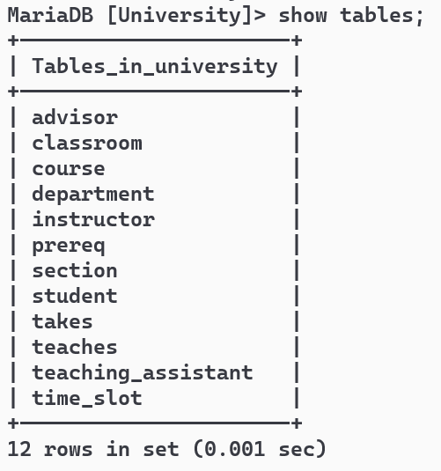

Find the names of all the students whose total credits are greater than 100 .

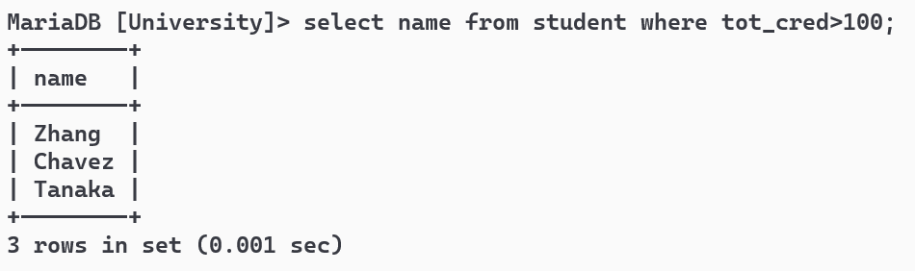

Find the course id and grades of all courses taken by any student named 'Tanaka'.

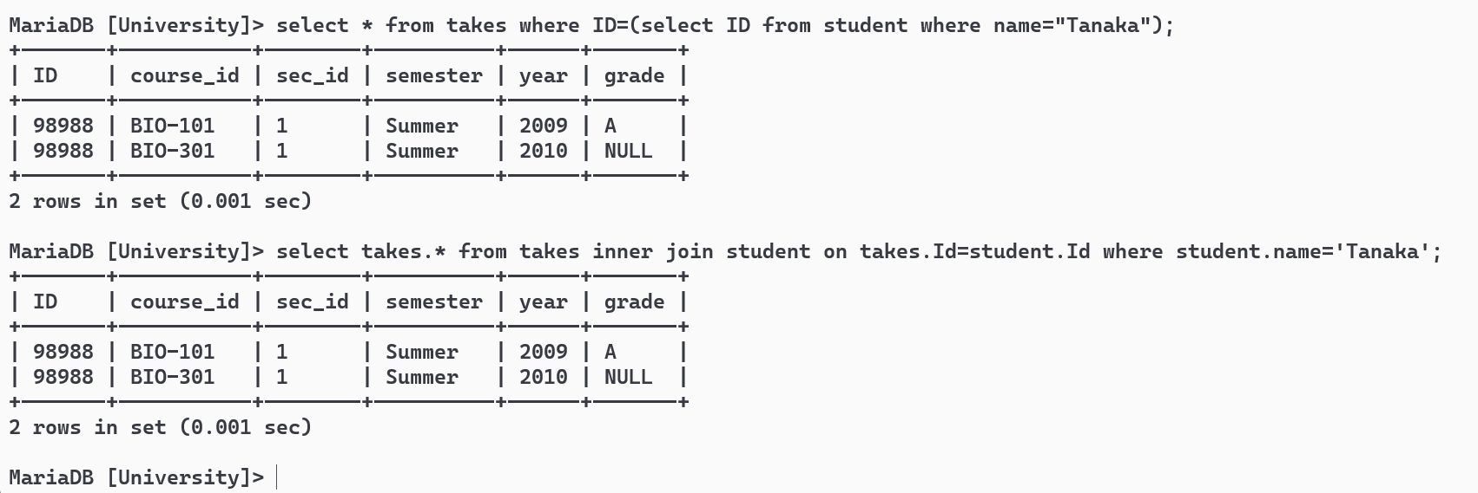

Find the courses which are offered in both 'Fall' and 'Spring' semester (not necessarily in the same year).

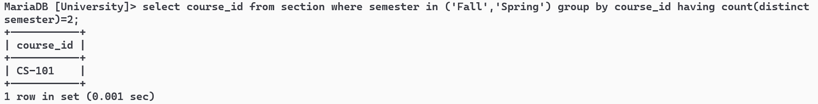

Find the names of all the instructors from Comp. Sci. department.

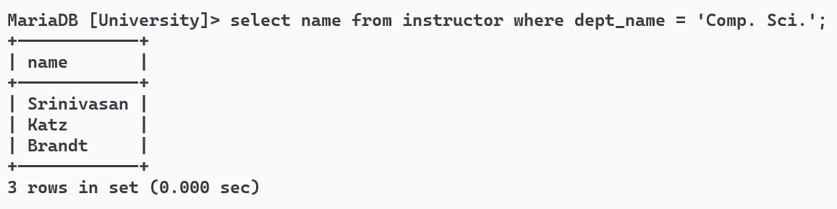

Find the course id and titles of all courses taught by an instructor named 'Srinivasan

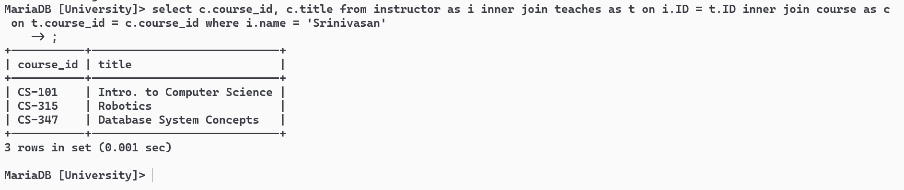

Find the names of instructors who have taught at least one course in Spring 2009.

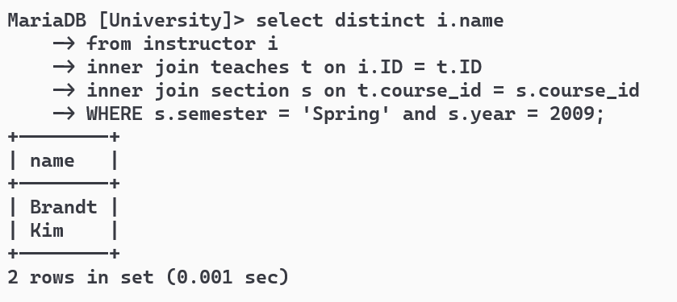

**Railway Schema**

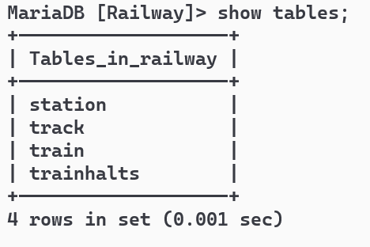

Find pairs of stations (station codes) that have a track (direct connection) with distance less than 20Kms between them.

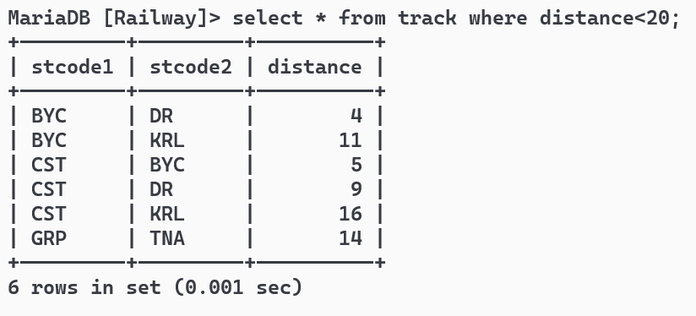

Find the IDs of all the trains which have a stop at THANE

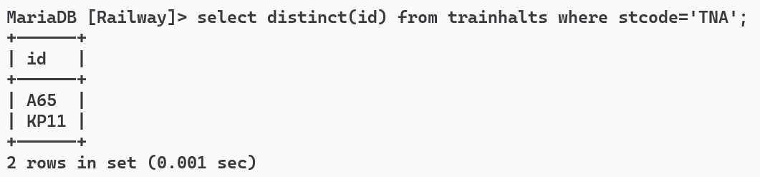

Find the names of all trains that start at MUMBAI.

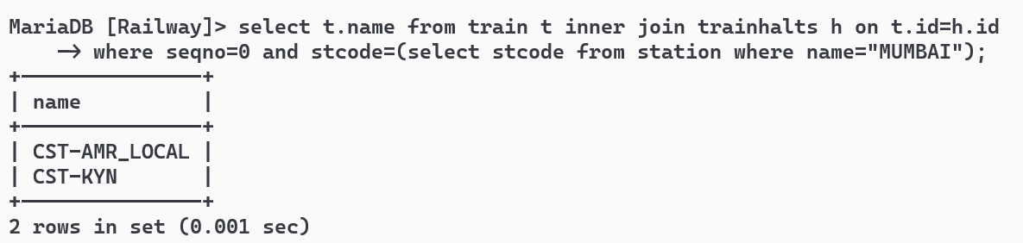

List all the stations in order of visit by the train 'CST-AMR_LOCAL'.

