

**Database**

**Management**

**Systems**

**Sarvesh Anand Mankar**

**142203013**

**TY Comp Div-2, T4 Batch**

**Asssignment - 2**

**University Schema**

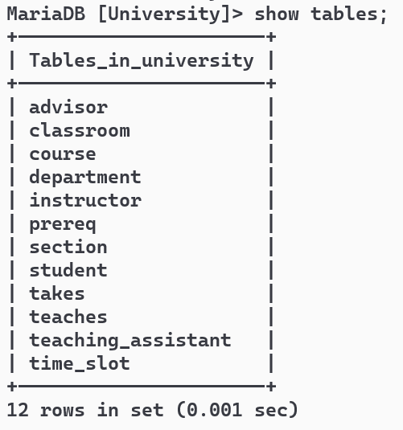

Find the number of instructors who have never taught any course. If the result of your query is empty, add the appropriate data (and include corresponding insert statements) to ensure the result is not empty.

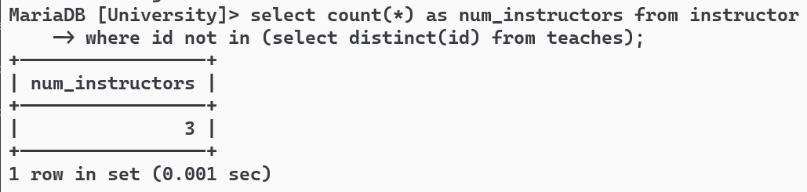

Find the total capacity of every building in the university.

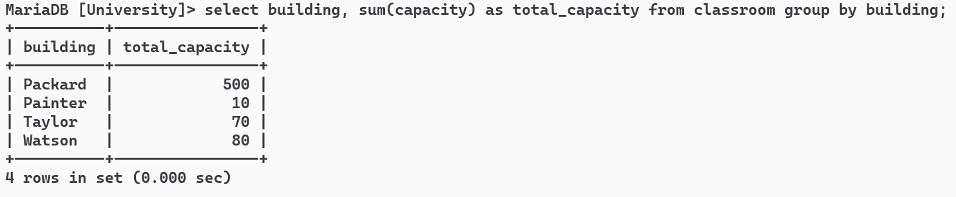

Find all departments that have at least one instructor, and list the names of the departments along with the number of instructors; order the result in descending order of number of instructors.

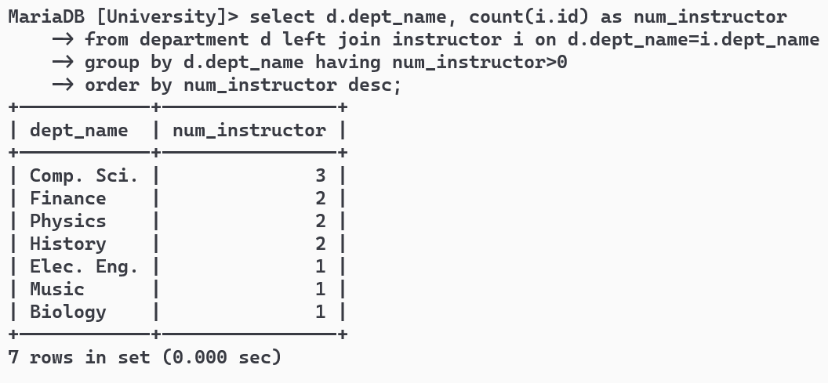

For each student, compute the total credits they have successfully completed, i.e. total credits of courses they have taken, for which they have a non-null grade other than 'F'. Do NOT use the tot_credits attribute of student.

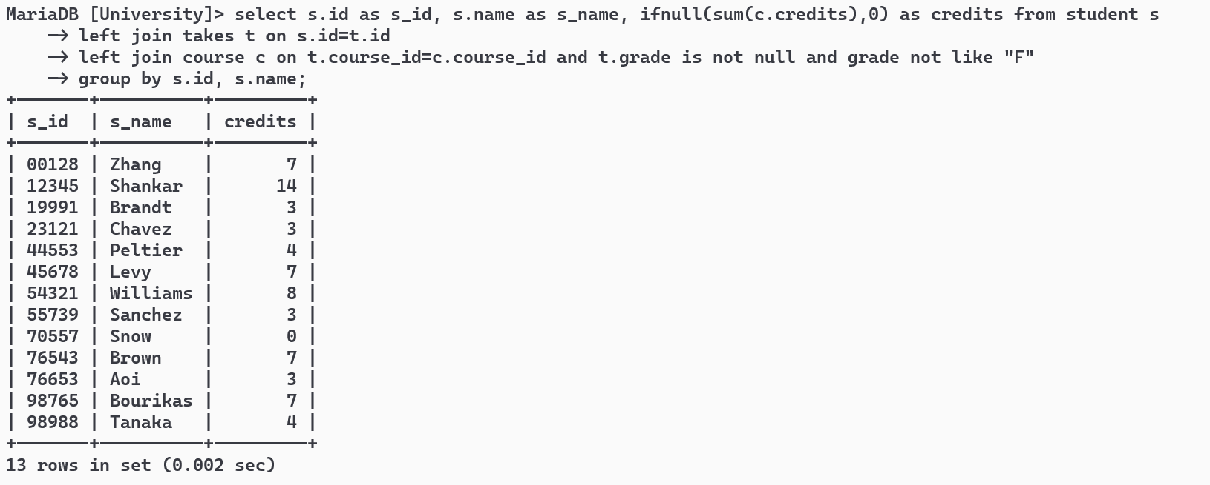

Find the id and title of all courses which do not require any prerequisites.

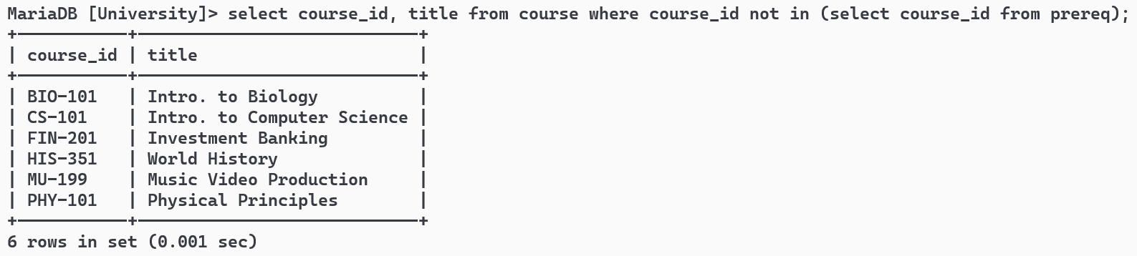

Find the names of students who have not taken any biology dept. courses.

