

**Database**

**Management**

**Systems**

**Sarvesh Anand Mankar**

**142203013**

**TY Comp Div-2, T4 Batch**

**Asssignment - 3**

**University Schema**

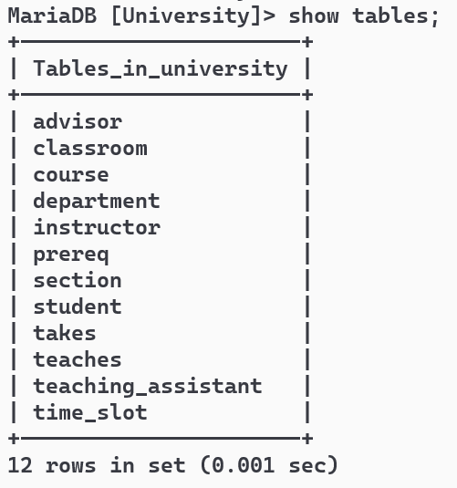

Each offering of a course (i.e. a section) can have many Teaching assistants; each teaching assistant is a student. Extend the existing schema(Add/Alter tables) to accommodate this requirement.

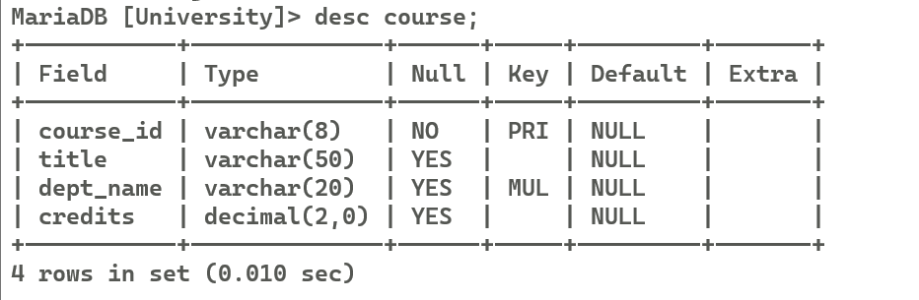

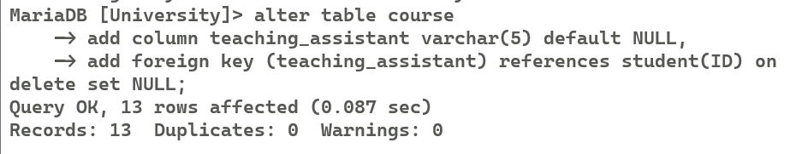

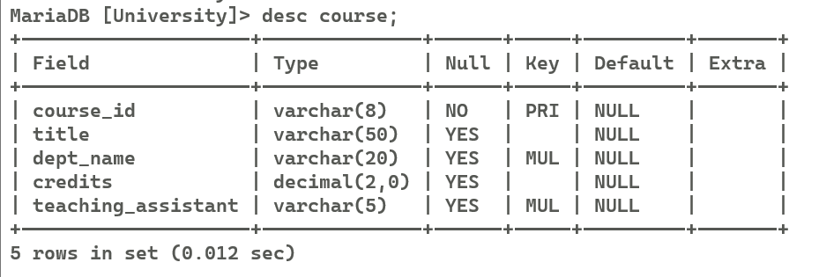

Alter the schema to allow a student to have multiple advisors and make sure that you are able to insert multiple advisors for a student.

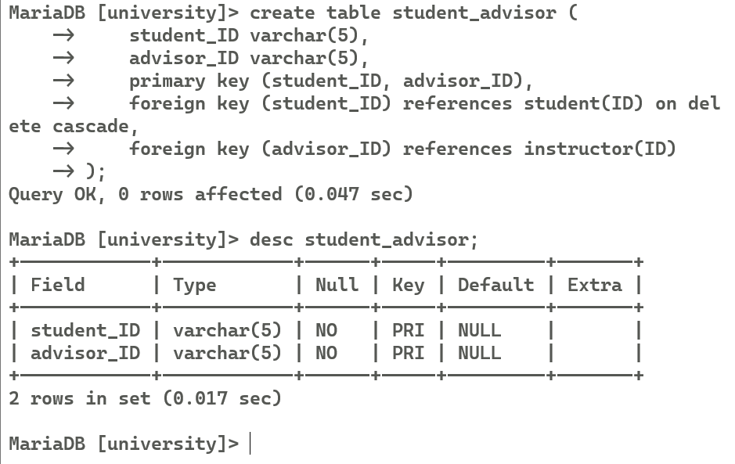

insert into course values ('CS-101L', 'CS-101 Labs', 'Comp. Sci.', '1', '00128');

insert into course values ('CS-101A', 'CS-101 Labs', 'Comp. Sci.', '4', '44553');

insert into course values ('PHY-201', 'Physics Labs', 'Physics', '4', '54321');

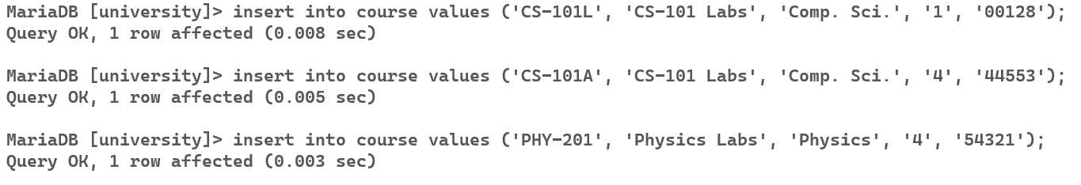

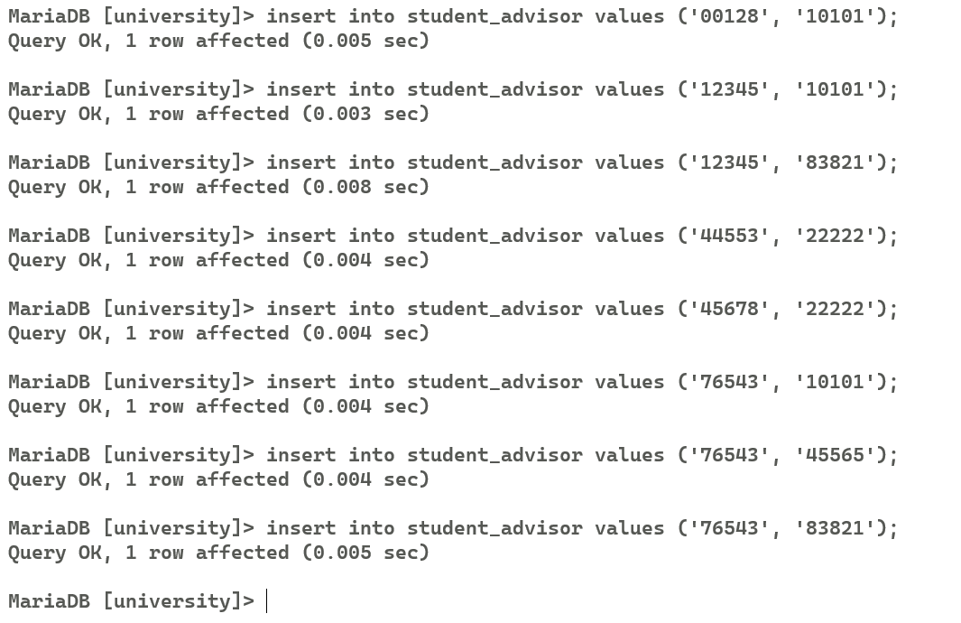

Find all students who have more than 3 advisors

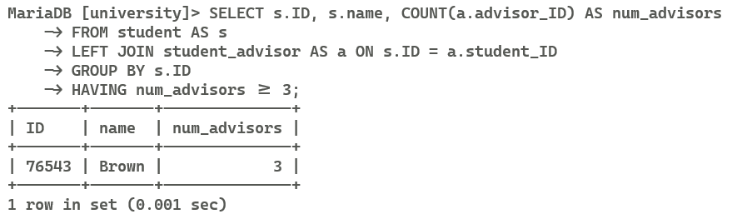

SELECT s.ID, s.name, COUNT(a.advisor_ID) AS num_advisors

FROM student AS s

LEFT JOIN student_advisor AS a ON s.ID = a.student_ID

GROUP BY s.ID

HAVING num_advisors >= 3;

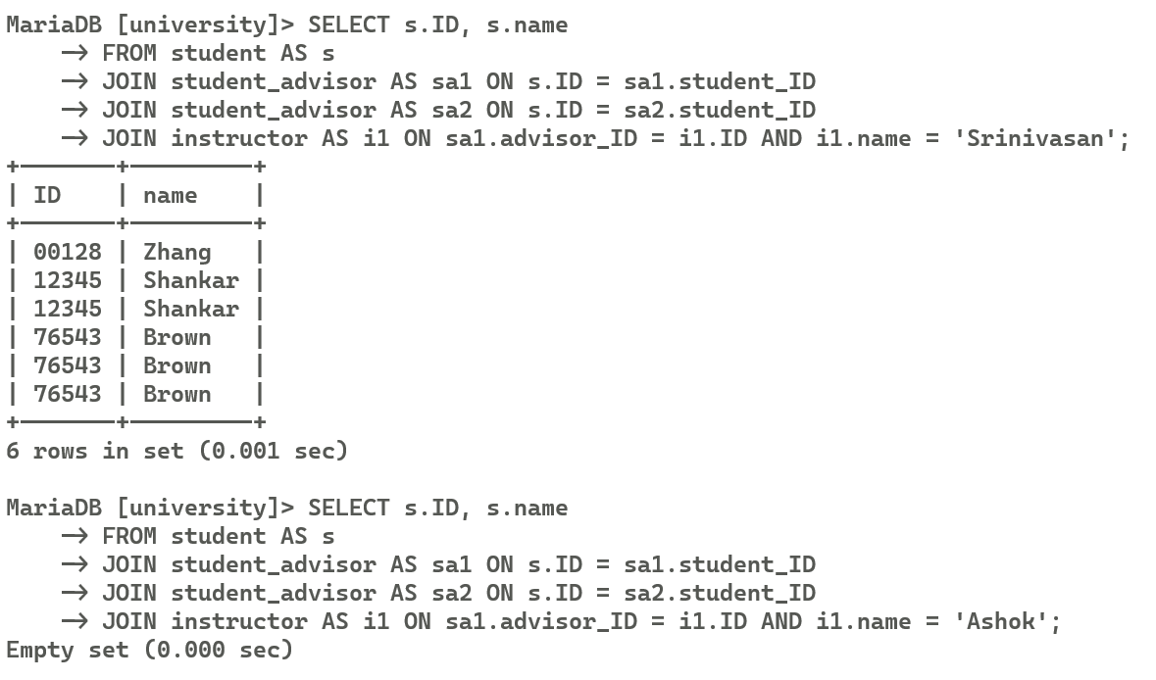

SELECT s.ID, s.name

FROM student AS s

JOIN student_advisor AS sa1 ON s.ID = sa1.student_ID

JOIN student_advisor AS sa2 ON s.ID = sa2.student_ID

JOIN instructor AS i1 ON sa1.advisor_ID = i1.ID AND i1.name = 'Srinivasan';

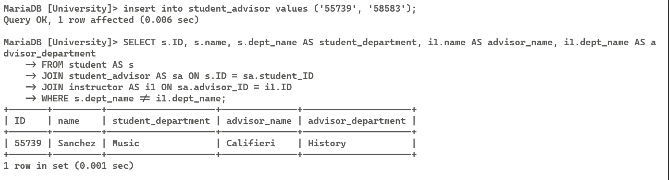

SELECT s.ID, s.name, s.dept_name AS student_department, i1.name AS advisor_name, i1.dept_name AS advisor_department

FROM student AS s

JOIN student_advisor AS sa ON s.ID = sa.student_ID

JOIN instructor AS i1 ON sa.advisor_ID = i1.ID

WHERE s.dept_name != i1.dept_name;



