

**Database**

**Management**

**Systems**

**Sarvesh Anand Mankar**

**142203013**

**TY Comp Div-2, T4 Batch**

**Asssignment - 4**

Modify the trains schema which we saw earlier to create constraints to check the following:

* The value of timein is always less than or equal to timeout

ALTER TABLE trainhalts

ADD CONSTRAINT time_check CHECK (timein <= timeout);

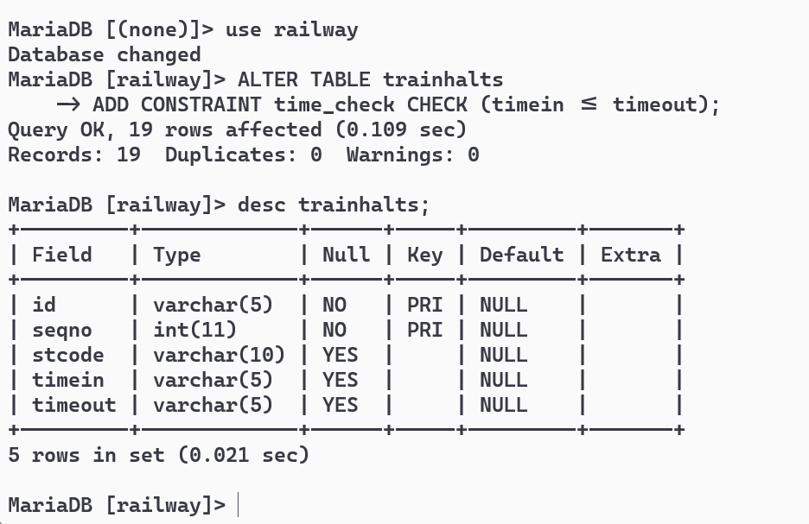

* When a train is removed from service, all its halts should be deleted.

ALTER TABLE trainhalts

ADD CONSTRAINT fk_train

FOREIGN KEY (id)

REFERENCES train(id)

ON DELETE CASCADE;

* Insert inconsistent data and verify the constraints.



Write SQL Create table statements to create the following schema.  Include all appropriate primary and foreign key declarations.  Choose appropriate types for each attribute.

remotecentre(centreId, college, town, state)

CREATE TABLE remotecentre (

centreId INT PRIMARY KEY,

college VARCHAR(50),

town VARCHAR(50),

state VARCHAR(50)

);

person(ID, name, email)

CREATE TABLE person (

ID INT PRIMARY KEY,

name VARCHAR(50),

email VARCHAR(100)

);

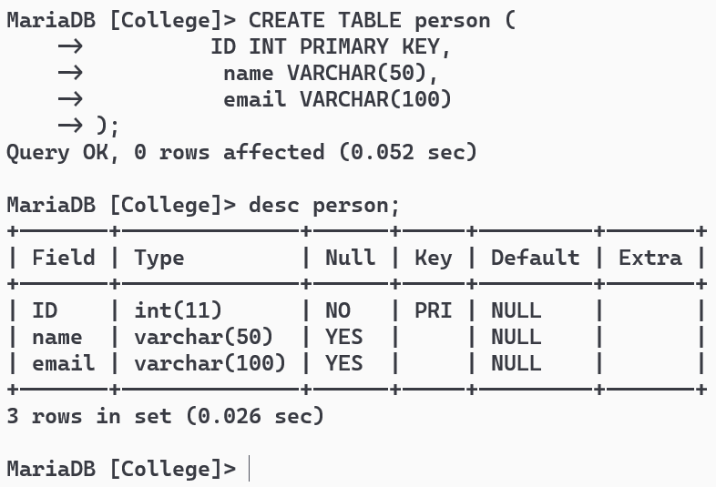

programme(progId, title, fromdate, todate)

CREATE TABLE programme (

progId INT PRIMARY KEY,

title VARCHAR(100),

fromdate DATE,

todate DATE

);

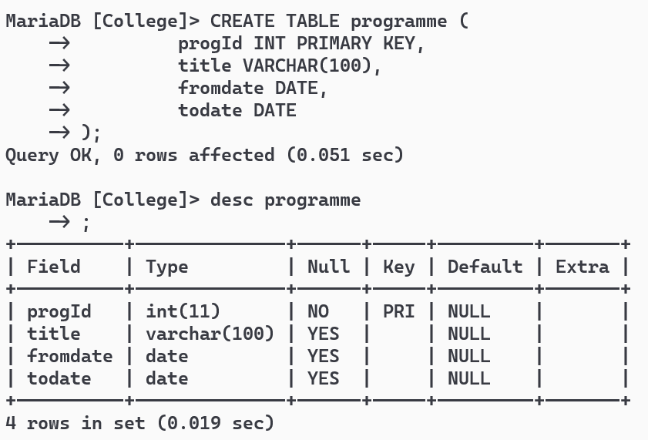

coordinator(ID, progId, centreId)

CREATE TABLE coordinator (

ID INT,

progId INT,

centreId INT,

PRIMARY KEY (ID, progId, centreId),

FOREIGN KEY (ID) REFERENCES person(ID),

FOREIGN KEY (progId) REFERENCES programme(progId),

FOREIGN KEY (centreId) REFERENCES remotecentre(centreId)

);

participant(ID, progId, centreId)

CREATE TABLE participant (

ID INT,

progId INT,

centreId INT,

PRIMARY KEY (ID, progId, centreId),

FOREIGN KEY (ID) REFERENCES person(ID),

FOREIGN KEY (progId) REFERENCES programme(progId),

FOREIGN KEY (centreId) REFERENCES remotecentre(centreId)

);

