MCQ Quiz Application

By

Sarvesh Anand Mankar

194009 DCP [T.Y.]

UNDER GUIDANCE of

Patil Madam

(PHP Subject Lecturer)

This project will overcome the time consuming problem of manual system. Apart from that in current system, checking the answer sheets after taking test, waste the examiners time, so this application do all these works in effective manner. The users who don’t have high computing knowledge they also can use this applications as it’s user-friendly and has a documentation. The conclusion of this project will be that it saves a lot of time of Examiner and will be more efficient and effective in conducting and managing quizzes. Examiner will be able to have a proper look at the data and it will become easy to get a summary out of the quiz.

The primary reason to choose this particular topic:-

Due to pandemic the educational institutes have shifted to online platforms for conducting daily lectures and exams. There is a need of a quick and easy to use Online MCQ Conducting Platform. This Project will make it easy to conduct tests for ones who don’t have a good technical experience.

The main objective of the project:-

It is not easy to conduct test on online software like Google Forms , Testmoz, etc. nowadays. They are not easy to use and it takes a lot of time for the users who have just started using it. So I have designed a MCQ Platform which makes it easy for conducting and managing MCQ Exams. It will include from taking a Quiz from examiner, making it available for students in particular period of time, saving the information of all participants, showing data statistically for have a clear look at the picture, showing results to each participant, etc. The only work of Examiner is to upload the question and all the rest work is done by the application. This application will work more effective than manual systems and will save a lot of time.

Scope of the Project:-

1. Able the examiners to upload the MCQ questions online.
2. Able the users to solve the questions online.
3. Examiners can manage the information regarding exam.
4. Correct answers will be evaluated by system.
5. Users can see their result after submitting the test.
6. Data is shown in Statistical format so Examiner can have summarized view of the results.

Working Methodology:-

1. Making a basic GUI to work on.
2. Examiner Login page and Dashboard.

Dashboard is a way to approach all the Features made available for Examiner.

Features:-

1. Creating quiz and uploading questions.
2. Updating the quiz questions, deleting it, etc.
3. Activating quiz.
4. Viewing the submission and having a statistical look at the data.
5. Give some permission to participants.
6. Creating a Survey Form and viewing that data.
7. Student’s Login Page and allowing them to access the questions of activated quiz.
8. Saving the answers and checking those. Marks of each individual participant is calculated.
9. Examiner can view all submissions given by participants.
10. Statistical view is given for having a summarized look for the examiner.
11. Participants can see their result after submitting the test.
12. Testing the Software.
13. Designing more user-friendly and attractive GUI.
14. Deploying the software.

Tools which I’ll use:-

1. HTML
2. Bootstrap
3. PHP
   1. MySQL Database
   2. PHPSpreadSheet
   3. Sessions [For Authentication purposes]
   4. JPGraph / Google Charts

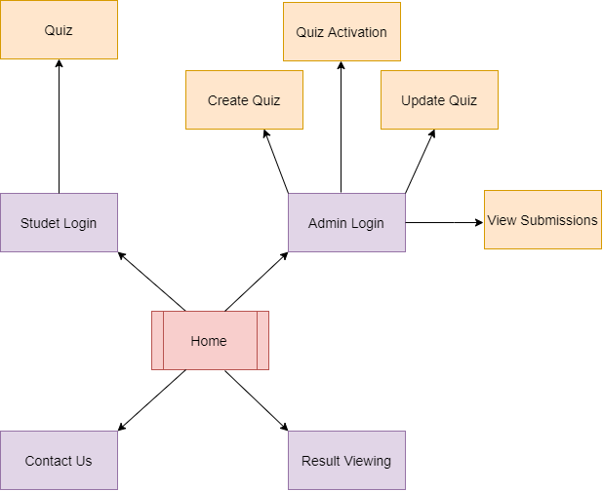

Design of my Application

Thank You!