**FAMILIAR AND UNFAMILIAR**

**NAVIGATION ELEMENTS** **EXPERIMENT – 04**

1)Login page:

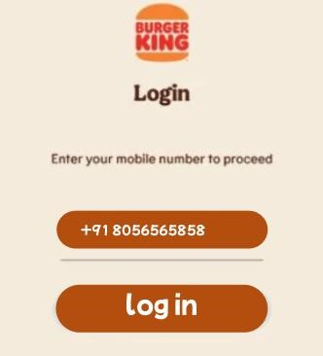

*This is a **familiar** Burger King login screen. It asks the user to enter their **mobile number** to log in. The screen features the **Burger King logo**, a phone number input field (with the **+91 India code**), and a **"log in" button** in brown. This is likely used for ordering food or accessing a customer account

2)Unfamiliar Display:

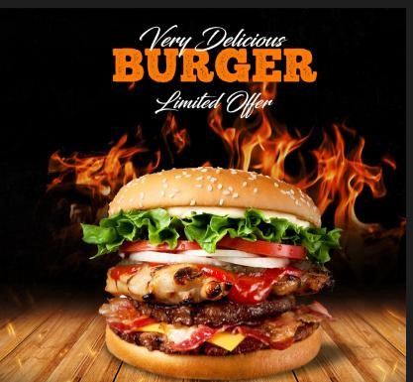

*The burger image represents an **unfamiliar interactive display** where touching any part of it **navigates to another page** instead of behaving like a regular static image. This approach is similar to **unfamiliar navigation methods**, such as **Infinite**

**Scrolling without visible indicators**, where traditional user expectations are challenged. It is likely part of a **digital ad, clickable banner, or food app UI**, designed to engage users and seamlessly direct them to a **menu, ordering page, or promotional offer** without conventional navigation elements.

3)Offer page:

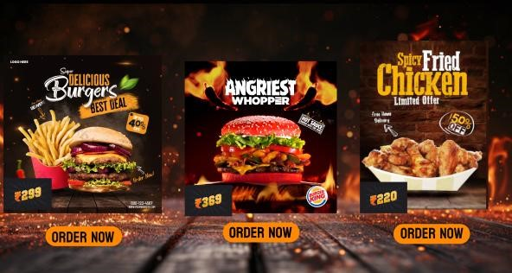

This image is a **Burger King offer page**, showcasing limited-time deals on popular menu items. It features three promotions: a **burger with fries for ₹299** at **40% off**, the **Angriest Whopper for ₹369**, and **Spicy Fried Chicken for ₹220** with **50% off**. Each offer is highlighted with bold prices and

**"ORDER NOW"** buttons, making it easy for customers to place an order. The fiery background and engaging visuals enhance the appeal of the deals.

4)Thanking page:

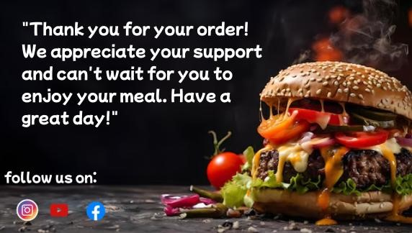

* The image appears to be a thank-you message from a restaurant or food business, expressing appreciation for a customer's order. It features a visually appealing burger with melted cheese, fresh vegetables, and a sesame seed bun, giving it an appetizing and professional look. The message is friendly and customer-focused, reinforcing a positive dining experience.

Familiar icon:

The image displays an Instagram profile page with a familiar layout, including a profile picture, bio, follower count, and action buttons like "Follow" and "Message." If you're looking to incorporate an Instagram icon on your thank-you page, it should be linked directly to your business profile, making it easy for customers to engage with your brand. A clear call-to-action, such as "Follow us for exclusive deals and updates," can encourage interaction. Additionally, maintaining a clean and professional design ensures consistency with your brand identity while enhancing customer engagement.

Done by:

230701294