

**Department of Computer Engineering**

**Academic Year**

**"Abhiyanta" Newsletter**

**For Semester, Volume**

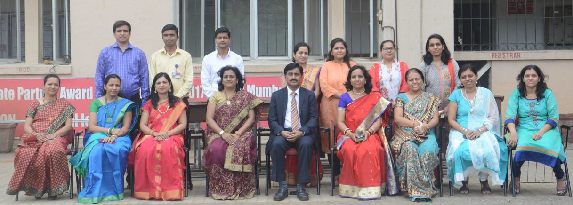

**About Department:**

The Computer Engineering department was established in the year 2001 for providing excellent education to all students with an aim to foster creativity in Learning, research and building a knowledge base along with imparting quality education. The department possesses well qualified and motivated faculty members and support staff. The laboratories are adequately equipped with state-of-the-art facilities. The department offers add-on courses to cope with the latest trends in technology. It organizes industry visits and many series of expert lectures for the students on the latest developing trends in Computer Industry. Students of our department have won prizes in various national and international level paper presentation competition and project exhibitions. Every year a remarkable number of students place in companies such as Infosys, TCS, Accenture, Cognizant, L&T Infotech, CSC, Tech Mahindra, Mastek, TPG Axon, Artistivity etc.

**Vision:**

*To be the finest centre of learning by imparting quality teaching in the field of computer engineering.*

**Mission:**

 *To inculcate in student the ability to analyse, design and develop software projects.*

 *To prepare students to be ready for ever changing scenario in the field of Computer Engineering.*

 *To help the students to attain and utilize their potential for successful carrier and to the need of society and industry.*

**Program Educational Objectives (PEOs):**

Students will possess:

PEO 1: *Sound knowledge of mathematics, science and engineering fundamentals required for a lifelong career in computer engineering domains.*

PEO 2: *Skill to design and develop software projects for solving real world problems with the use of modern tools and techniques.*

PEO 3: *Professional ethics, leadership qualities and social awareness in the students.*

|  |  |
| --- | --- |
|  |  |
| **Placement Statistics** | **Result Statistics** |
|  |  |
| **Students placed in various Companies** | **Percentage of Students Passed** |