Worksheet 1

Student Name:Sarvesh yadav UID:25IMC13002
Branch: UIC Section/Group:25MAM-3(B)
Semester: 2 Date of Performance:27/01/2004
Subject Name: Machine Learning Subject Code: 25CAP-672

- Aim:

The aim of this experiment is to implement Logistic Regression using Python and scikit-learn to classify students into two classes (label) based on their academic scores (grade1 and grade2), and to evaluate the prediction accuracy of the model on test data.
2. Apparatus:

Supported Operating Systems:
- Windows 10 64-bit Pro, Enterprise, or Education
Programming Language:
- Python
Development Environment:
- Jupyter

3.Coding :

import numpy as np
import matplotlib.pyplot as plt
import pandas as pd
df = pd.read_csv('data.csv')
df.head(10)

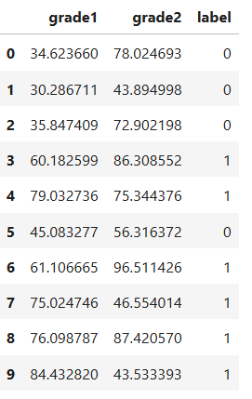

from sklearn.model_selection import train_test_split

X = df[["grade1","grade2"]]
y = df['label']
X_train,X_test,y_train,y_test = train_test_split(X,y,test_size=0.35,random_state=4)

print(X_train.shape)
print(y_train.shape)

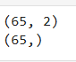

print(X_test.shape)
print(y_test.shape)
X_test.head()

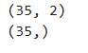

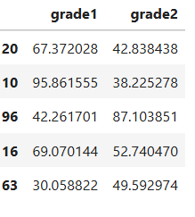

from sklearn.linear_model import LogisticRegression
model = LogisticRegression(solver='newton-cg')
model.fit(X_train,y_train)

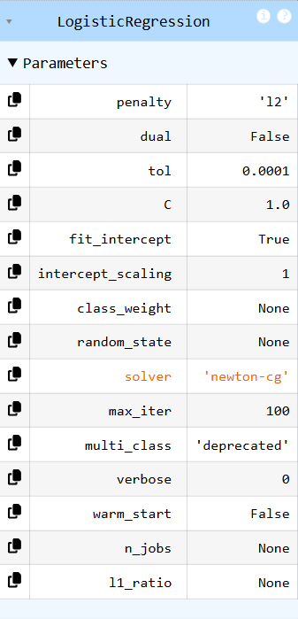

score = model.score(X_test,y_test)
print("Prediction accuracy : ",score,"%")

f = np.array([60.6,60.9]).reshape(1, -1)
print(f)
res = model.predict(f)
res

yp = model.predict(X_test)

plt.plot(X_train['grade1'],y_train,'o',color='g')
plt.plot(X_test['grade1'],yp,'.',color='black')
plt.legend(['taining values','predicted values'])

4)Output-

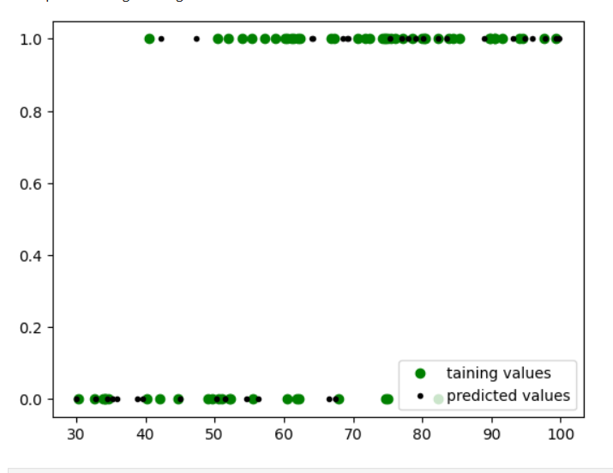

5. Learning outcomes (What I have learnt):

- Understand the concept of Logistic Regression and its role in supervised machine learning classification problems.
- Apply Logistic Regression in Python using libraries such as NumPy, Pandas, and scikit-learn on real-world datasets.
- Evaluate the performance of the model by splitting data into training and testing sets and calculating prediction accuracy.
- Analyze and interpret model predictions to classify new input data based on learned decision boundaries.

