Worksheet 3

Student Name:Sarvesh yadav UID:25IMC13002
Branch: UIC Section/Group:25MAM-3(B)
Semester: 2 Date of Performance:17/02/2004
Subject Name: Machine Learning Subject Code: 25CAP-672

- Aim:

To implement and evaluate a Support Vector Machine (SVM) model for breast cancer classification using data preprocessing, feature scaling, and performance metrics like confusion matrix, MSE, and R² score.

2. Apparatus:

Supported Operating Systems:
- Windows 10 64-bit Pro, Enterprise, or Education
Programming Language:
- Python
Development Environment:
- Jupyter

3.Coding :

import pandas as pd
import matplotlib.pyplot as plt
import seaborn as sns

from sklearn.model_selection import train_test_split
from sklearn.preprocessing import StandardScaler
from sklearn.svm import SVC
from sklearn.metrics import confusion_matrix, mean_squared_error, r2_score

data = pd.read_csv(r"C:\Users\Sarvesh Yadav\OneDrive\Desktop\breast-cancer.csv")

if "id" in data.columns:
data.drop(columns=["id"], inplace=True)

data["diagnosis"] = data["diagnosis"].map({"M": 0, "B": 1})

X = data.drop("diagnosis", axis=1)
y = data["diagnosis"]

scaler = StandardScaler()
X_scaled = scaler.fit_transform(X)

X_train, X_test, y_train, y_test = train_test_split(
X_scaled, y, test_size=0.2, random_state=42
)

model = SVC(kernel='rbf')
model.fit(X_train, y_train)

y_pred = model.predict(X_test)

cm = confusion_matrix(y_test, y_pred)

print("Confusion Matrix:\n", cm)

print("MSE:", mean_squared_error(y_test, y_pred))
print("R-Square:", r2_score(y_test, y_pred))

plt.figure(figsize=(5,4))
sns.heatmap(cm, annot=True, fmt='d', cmap='Blues',
xticklabels=["Malignant", "Benign"],
yticklabels=["Malignant", "Benign"])

plt.xlabel("Predicted")
plt.ylabel("Actual")
plt.title("Confusion Matrix - SVM")
plt.show()

4)Output-

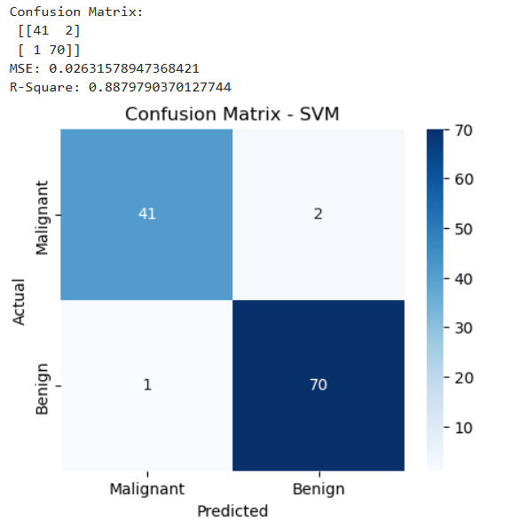

5. Learning outcomes (What I have learnt):

- Learned how to preprocess data by cleaning columns and encoding categorical values.
Also applied feature scaling using StandardScaler for better SVM performance.
- Understood how to split data into training and testing sets.
Trained an SVM model using the RBF kernel for classification.
- Evaluated model performance using confusion matrix, MSE, and R² score.
Gained insight into how well the model predicts cancer diagnosis.
- Visualized results using matplotlib and seaborn heatmap.
Improved ability to interpret classification performance graphically

