Compiler Optimization Analysis Report
Assembly-Level Optimization Analysis | Tool 1: CompilerGym | Tool 2: MILEPOST GCC
A comparative study of compiler optimization techniques

Table of Contents
Assembly-Level Optimization Analysis
1. Common Subexpression Elimination
2. Constant Folding
3. Constant Propagation
4. Dead Code Elimination
5. Function Handling
6. Loop Invariant
7. Register Allocation
8. Strength Reduction
Tool Analysis
Tool 1: CompilerGym (LLVM Environment)
1. Introduction
2. Methodology
3. O0 vs O2 Optimization Comparison
4. Per-Technique Results Summary
5. Detailed Technique Analysis
5.1. Dead Code Elimination
5.2. Common Subexpression Elimination
5.3. Loop Optimizations
5.4. Constant Folding & Propagation
5.5. Function Inlining
5.6. Instruction Simplification
5.7. Strength Reduction
6. Key Observations & Analysis
7. Conclusion
Tool 2: MILEPOST GCC
1. Introduction and Background
2. The Optimization Challenge
3. System Architecture
4. Operational Workflow
5. Machine Learning Approaches
6. Collective Optimization Infrastructure
7. Experimental Results
8. Examples
9. Significance and Impact
10. Limitations
11. Subsequent Developments
12. Conclusion

Assembly-Level Optimization Analysis

Common Subexpression Elimination

Source Code:
#include <stdio.h>

int cse(int x, int y) {
int a = x + y;
int b = x + y;
return a + b;
}
int main() {
int x = 5;
int y = 10;
printf("%d\n", cse(x, y));
return 0;
}

Concept Used:
Common Subexpression Elimination (CSE) is a compiler optimization technique that:
- Identifies identical expressions
- Computes them only once
- Reuses the computed value instead of recomputing
In this program (x+y) expression appears twice
So the compiler can, Compute (x + y) once, Then use 2 * (x + y), instead of recomputing it.
Assembly Codes:

Analysis of Unoptimized Code:

Behaviour Observed:
In the unoptimized version:
- Function parameters are stored in memory.
- The expression x + y is computed twice.
- Intermediate values are stored on the stack.
- Multiple memory accesses occur.
- A stack frame is created.

Relevant Assembly Snippet:

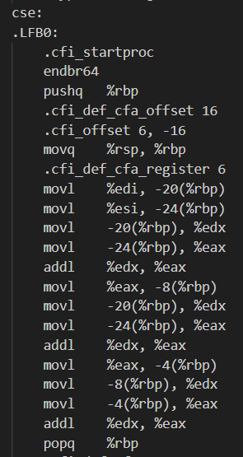

Observations:
1. Redundant computation exists.
2 Stack memory is heavily used.
3. No reuse of previously computed results.
4. More instructions are generated.
5. Execution is less efficient.

Instruction Count:
- Total Instructions (Unoptimized): 39

Analysis of Optimized Code:

Behavior Observed:
In the optimized version:
- No stack frame is created.
- Parameters are used directly from registers.
- The expression x + y is computed only once.
- The compiler simplifies (x+y) + (x+y) into 2 * (x+y).

Relevant Assembly Snippet:

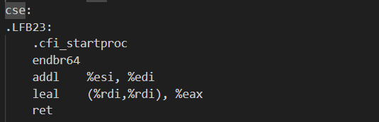

Step by step Explanation:

1. addl %esi, %edi
→ Computes x + y once.
2. leal (%rdi,%rdi), %eax
→ Computes 2 * (x + y).
Instead of computing:
(x+y) + (x+y)
The compiler transforms it into:
2 * (x+y)

Conclusion:

- In the unoptimized version, the expression x + y is computed twice, leading to redundant instructions and unnecessary memory usage.
- In the optimized version, the compiler successfully applies Common Subexpression Elimination by computing the expression once and reusing the result through algebraic transformation.
- This reduces instruction count by approximately 59% and significantly improves efficiency

Constant Folding

Source Code:

#include <stdio.h>

int constant_folding() {
int x = 10 * 5;
return x;
}

int main() {
printf("%d\n", constant_folding());
return 0;
}

Concept Used:
Constant Folding is a compiler optimization technique where:
- Constant expressions are evaluated at compile time.
- The computed value replaces the expression in the final code.
In this program, both operands are constants, the compiler can calculate 10*5 = 50 during compilation itself, instead of performing multiplication at runtime.
Assembly Codes:

Analysis of Unoptimized Code:

Behaviour Observed:
In the unoptimized version:
1. A stack frame is created.
2. local variable is allocated.
3. The constant value 50 is stored in memory.
4. The value is then loaded again into a register.
5. Unnecessary stack operations are performed.

Relevant Assembly Snippet:

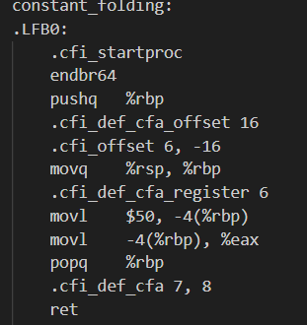

Observations:
1. The constant expression is already simplified to 50.
2. However, unnecessary stack memory is used.
- The value is first stored in memory, then loaded again.
- Extra instructions exist due to lack of optimization.
- Stack frame overhead increases instruction count.

Analysis of Optimized Code:

Behavior Observed:
In the optimized version:
  - No stack frame is created.
  - No local variable is allocated.
  - The constant value 50 is directly returned.
  - Memory access is completely eliminated.

Relevant Assembly Snippet:

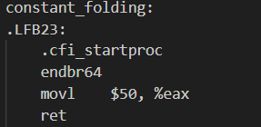

Step by Step Explanation:

- movl $50, %eax
→ Directly moves constant value 50 into return register.
- ret
→ Returns immediately.
The compiler completely removes:
- Stack allocation
- Memory storage
- Memory loading
The function becomes a single instruction return.

Conclusion:
- In the unoptimized version, although the expression 10 * 5 is already simplified to 50, the compiler still generates stack operations and unnecessary memory accesses.
- In the optimized version, the compiler fully applies Constant Folding and directly returns the constant value without creating a stack frame or using memory.
- Thus, Constant Folding eliminates runtime computation and significantly reduces instruction overhead, resulting in faster and more efficient code.

Constant Propagation

Source Code:
#include <stdio.h>

int constant_propagation() {
int a = 5;
int b = a + 3;
return b;
}

int main() {
int result = constant_propagation();
printf("Result: %d\n", result);
return 0;
}

Concept Used:
Constant Propagation is a compiler optimization technique where:
- If a variable is assigned a constant value
- That constant value is substituted wherever the variable is used
In this program,
a = 5
b = a + 3, is evaluated in this order
but instead,
b = 5+3 is enough as variable ‘a’ is a constant and on further optimization
b = 8 can be directly returned
Assembly Codes:

Analysis of Unoptimized Code:
Behaviour Observed:

In the unoptimized version:
  - A stack frame is created.
  - Local variables ‘a’ and ‘b’ are stored in memory.
  - Value 5 is stored in memory.
  - It is loaded into a register and then 3 is added.
  - It is loaded into a register.
Relevant Assembly Snippet :

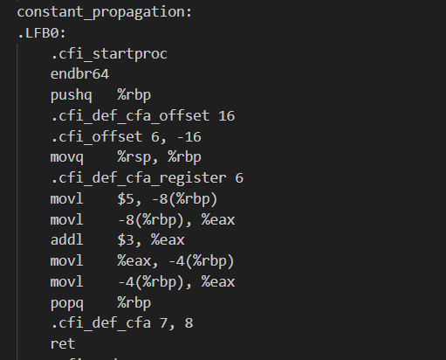

Observations:
- Variable ‘a’ is stored in memory
- It is then loaded back into a register.
- Addition is performed at runtime.
- Result is stored again in memory.
- Multiple unnecessary memory operations occur
- Extra instructions increase execution overhead.

Analysis of Optimized Code:
Behavior Observed:

In the optimized version:
- No stack frame is created.
- No local variables are used.
- Direct return is seen

Relevant Assembly Snippet:
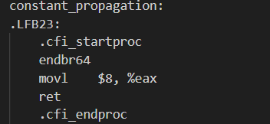

Step by step Explanation:
    - Compiler Detects:
a = 5 (constant)
    - It replaces a in
b = a + 3
    - Expression becomes
b = 5 + 3
  - Compiler evaluates at compile time
b = 8
  - Function directly returns 8

Conclusion:

- The comparison shows that the compiler successfully applies Constant Propagation in the optimized version.
- In the unoptimized code, variables are stored in memory and arithmetic is performed at runtime. In contrast, the optimized code replaces variables with their constant values and evaluates the expression at compile time.
- As a result, unnecessary memory operations and instructions are removed, leading to more efficient and compact assembly code.

Dead Code Elimination

Source Code:
#include <stdio.h>
int dead_code(int x) {
int a = x * 10;
int b = x * 20; // never used
return a;
}

int main() {
int result = dead_code(5);
printf("Result: %d\n", result);
return 0;
}

Concept Used:

Dead Code Elimination (DCE) is a compiler optimization technique in which:
• Unused variables are removed
• Unnecessary computations are eliminated
• Instructions that do not affect the final output are discarded
In this program, variable "b" is computed but never used. Therefore, it is considered dead code.

Analysis of Unoptimized Code:

Behaviour Observed:
In the unoptimized version:
• A stack frame is created
• Both variables "a" and "b" are computed
• Memory is allocated for both variables
• The value of "b" is stored even though it is never used
The compiler performs:
• Multiple shift and addition operations
• Separate computations for x * 5 and x * 5 * 4
• Memory storage for unused results
This increases instruction count and memory usage.

Relevant Assembly Snippet:

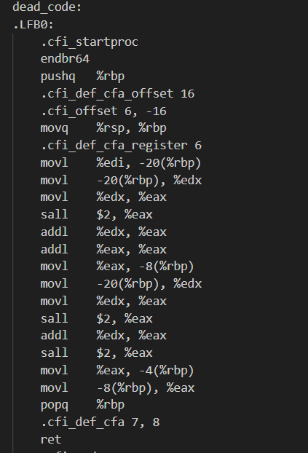

Observations:
• Multiple shift and addition operations
• Separate computations for x * 5 and x * 5 * 4
• Memory storage for unused results

Analysis of optimized Code:

Behaviour Observed:
In the unoptimized version:
• No stack frame is created
• Variable "b" is completely removed
• Computation is performed directly in registers
• Only instructions required for the return value are generated
Relevant Assembly Snippet:

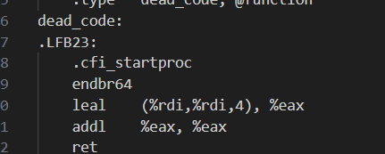

Observations:
The optimized function effectively computes: x * 5
then multiplies the result by 2
Final result = 10x
The unused computation (x * 5 * 4) is entirely eliminated.

Conclusion:

- The comparison clearly shows that the compiler applies Dead Code Elimination in the optimized version.
- In the unoptimized code, both variables are computed even though one does not contribute to the final result. In the optimized version, the unused variable and its entire computation are removed.
- This reduces instruction count, eliminates unnecessary memory operations, and improves overall efficiency.

Function Handling

Source Code:
#include <stdio.h>

static int add(int a, int b) {
return a + b;
}

int inline_test(int x) {
return add(x, 5);
}

int main() {
int result = inline_test(10);
printf("Result: %d\n", result);
return 0;
}

Concept Used:
Function Inlining is a compiler optimization technique in which:
• A function call is replaced by the actual body of the function
• Call and return overhead is removed
• Stack operations for the called function are eliminated
Instead of jumping to another function using a call instruction, the compiler directly inserts the function’s logic into the caller.

Assembly Codes:

Analysis of Unoptimized Code:

Behaviour Observed:
• The function "add" exists separately
• A full stack frame is created for "add"
• Parameters are stored in memory
• A function call instruction (call add) is used
• Return control is transferred back to the caller

Relevant Assembly Snippet:

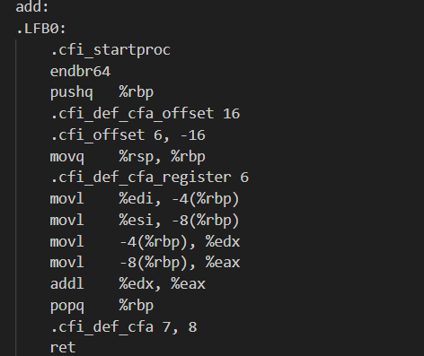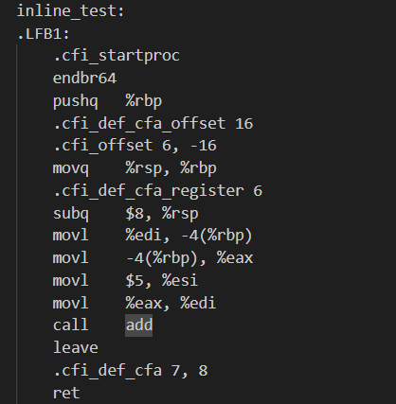

Observations:
• Function call overhead
• Stack push and pop operations
• Additional memory access
• Increased instruction count

Analysis of optimized Code:

Behaviour Observed:
In the optimized version:
• The function "add" is completely removed
• No call instruction is generated
• The addition is performed directly inside "inline_test"

Relevant Assembly Snippet:

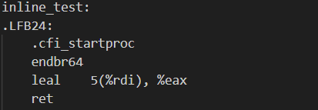

Observations:
The optimized instruction:
leal 5(%rdi), %eax
This directly computes: x + 5
Thus:
• The function call is eliminated
• Stack frame setup for "add" is removed
• No parameter passing overhead
• Fewer instructions are generated

Conclusion:

- The comparison clearly shows that the compiler applies Function Inlining in the optimized version.
- In the unoptimized code, the add function is called normally with full stack setup and return operations. In the optimized version, the function call is removed and its logic is directly inserted into the caller.
- As a result, unnecessary call overhead and stack operations are eliminated, leading to faster and more efficient execution.

Loop Invariant

Source Code:
#include <stdio.h>

int loop_invariant(int *arr, int n) {
int sum = 0;
for (int i = 0; i < n; i++) {
sum += arr[i] * 10;
}
return sum;
}

int main() {
int arr[] = {1, 2, 3, 4, 5};
int result = loop_invariant(arr, 5);
printf("Result: %d\n", result);
return 0;
}

Concept Used:
Loop Invariant Code Motion is a compiler optimization technique where:
• Expressions inside a loop that do not change across iterations are identified
• Such computations are moved outside the loop
• Redundant calculations inside the loop are reduced
A loop invariant expression is one whose value remains constant during all iterations.

Assembly Codes:

Analysis of Unoptimized Code:

Behaviour Observed:
• Stack frame is created
• Loop counter and sum are stored in memory
• Index calculation is performed repeatedly
• Multiplication operations are performed inside the loop
• Address calculations are repeated every iteration

Relevant Assembly Snippet:

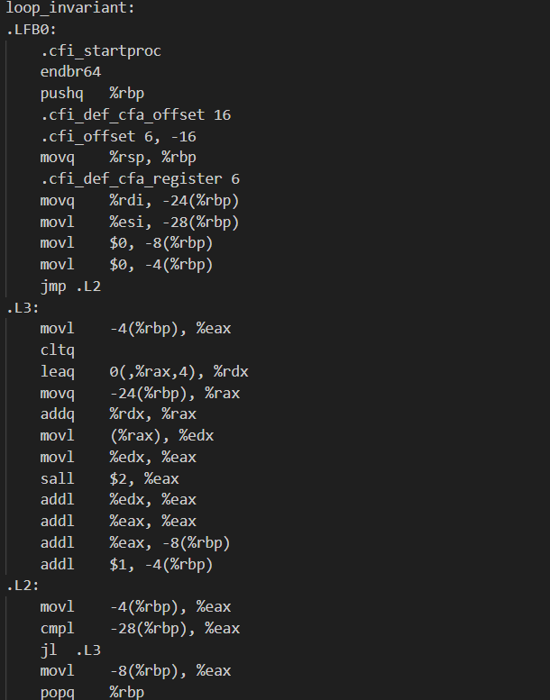

Observations:
• Repeated shift and add instructions
• Repeated loading of array base address
• Redundant arithmetic operations inside the loop
This increases:
• Instruction count
• Memory access
• Execution time
Analysis of optimized Code:

Behaviour Observed:
In the optimized version:
• Stack usage is minimized
• Registers are used instead of memory
• Loop control is simplified
• Address increment replaces repeated index calculation
• Arithmetic operations are combined efficiently
Relevant Assembly Snippet:

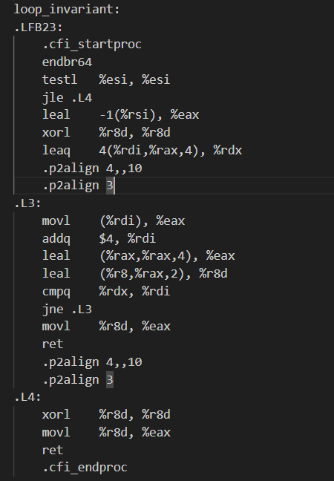

Observations:

• Pointer arithmetic is used (incrementing address directly)
• Multiplication is optimized using LEA instruction
• Fewer instructions inside loop body
• Loop termination condition optimized
Instead of recalculating array index every time, the compiler:
• Uses direct pointer increments
• Combines multiplications using efficient instructions
• Keeps frequently used values in registers

Conclusion:

- The comparison shows that the compiler effectively optimizes loop execution using Loop Invariant Code Motion and related loop optimizations.
- In the unoptimized version, redundant computations and memory operations occur inside the loop. In the optimized version, invariant and repeated operations are reduced or simplified, and register-based computation is used.
- This reduces instruction count, minimizes memory access, and improves overall loop performance.

Register Allocation

Source Code:
#include <stdio.h>
int register_alloc(int x, int y) {
int a = x + 1;
int b = y + 2;
return a * b;
}

int main() {
int result = register_alloc(5, 10);
printf("Result: %d\n", result);
return 0;
}

Concept Used:
Register Allocation is a compiler optimization technique in which:
• Frequently used variables are stored in CPU registers
• Memory access is minimized
• Stack usage is reduced
• Arithmetic operations are performed directly in registers
Since registers are much faster than memory, this optimization significantly improves performance.

Assembly Codes:

Analysis of Unoptimized Code:

Behaviour Observed:
• A stack frame is created
• Function parameters are stored in memory
• Local variables x and y are stored in memory
• Values are loaded from memory for computation
• Multiplication uses memory operands

Relevant Assembly Snippet

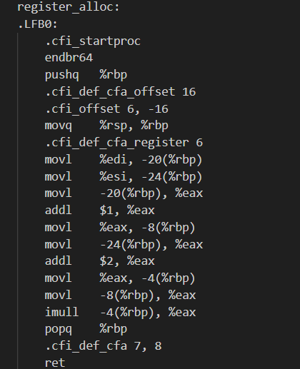

Observations:
• Multiple mov instructions
• Frequent memory access
• Local variables stored at stack offsets
• More instructions overall

Analysis of optimized Code:

Behaviour Observed:
In the optimized version:
• No unnecessary stack frame is created
• Variables are kept in registers
• Arithmetic operations are performed directly in registers
• No temporary memory storage is used
Relevant Assembly Snippet:

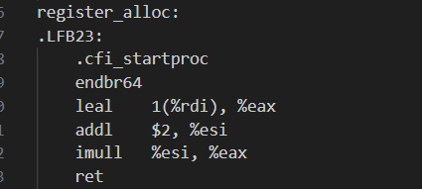

Observations:
Key optimized instructions:
leal 1(%rdi), %eax
addl $2, %esi
imull %esi, %eax
Explanation:
• a + 1 is computed directly in a register
• b + 2 is computed directly in a register
• Multiplication is performed using registers
• Result is returned without memory access

Conclusion:
- The comparison shows that the compiler efficiently applies Register Allocation in the optimized version.
- In the unoptimized code, variables are stored and retrieved from memory, increasing instruction count and memory access. In the optimized version, variables are kept in registers and computations are performed directly without unnecessary memory usage.
- This reduces overhead, improves execution speed, and produces more efficient assembly code.

Strength Reduction

Source Code:
#include <stdio.h>
int strength_reduction(int i) {
return i * 8;
}

int main() {
int result = strength_reduction(5);
printf("Result: %d\n", result);
return 0;
}
return 0;
}

Concept Used:
Strength Reduction is a compiler optimization technique where:
• Expensive operations (like multiplication or division)
• Are replaced with cheaper operations (like shift or addition)
Example:
x * 8 → x << 3
Since shifting is faster than multiplication, performance improves.

Assembly Codes:

Analysis of Unoptimized Code:

Behaviour Observed:
• Stack frame is created
• Parameter x is stored in memory
• Value is loaded into a register
• Shift operation (sall $3) is used
• Stack frame is removed

Relevant Assembly Snippet:

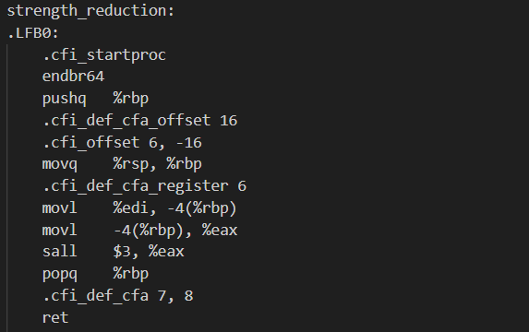

Observations:
• Extra mov instructions
• Stack usage present
• Memory access before computation
Even though shift is used, unnecessary stack operations increase instruction count.

Analysis of optimized Code:

Behaviour Observed:
In the optimized version:
• No stack frame is created
• No memory storage is used
• Computation is done directly in register

Relevant Assembly Snippet:

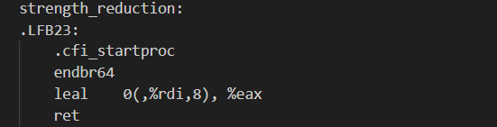

Observations:
leal 0(,%rdi,8), %eax
Explanation:
• %rdi contains input x
• It computes x × 8 directly using efficient addressing mode
• Result is stored in %eax
• Function returns immediately
The compiler uses LEA (Load Effective Address) to perform multiplication efficiently without explicit multiplication instruction.

Conclusion:

- The comparison shows that the compiler successfully applies Strength Reduction in the optimized version.
- In the unoptimized code, unnecessary stack operations are present. In the optimized version, multiplication by 8 is efficiently performed using a shift-based addressing mode without memory access.
- This reduces instruction count, eliminates overhead, and improves execution efficiency.

Tool 1: CompilerGym (LLVM Environment)

Tool: CompilerGym (LLVM Environment)
Date: 2026-03-05 11:38:26
Benchmarks: 5 C programs
Techniques: 7 optimization techniques + O0 vs O2 comparison
Environment: LLVM-v0 (124 optimization passes)

1. Introduction
This report presents a systematic analysis of compiler optimization techniques using CompilerGym. The analysis covers seven key optimization techniques, comparing their individual effectiveness against an O2-equivalent combined pass sequence across five purpose-built C benchmark programs.

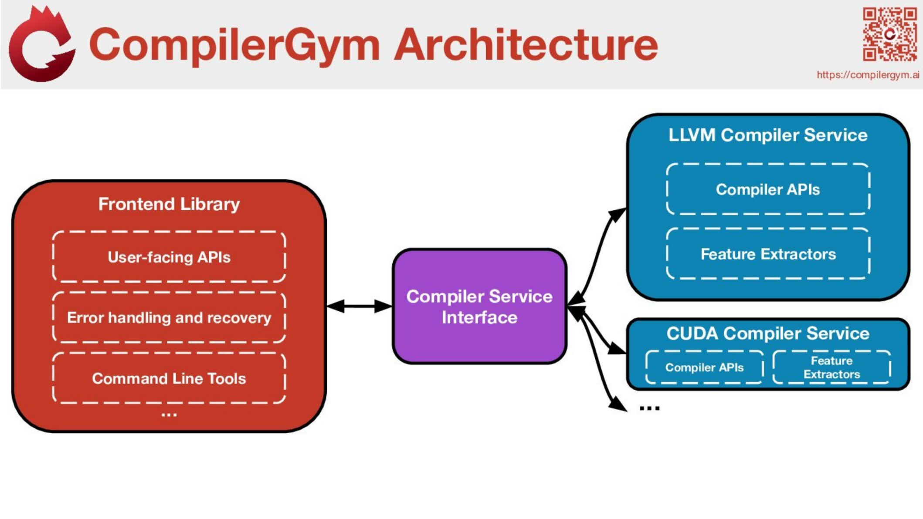

2. Methodology

What is CompilerGym?
CompilerGym is an open-source toolkit developed by Meta (Facebook Research) that exposes compiler optimization as a reinforcement learning environment, following OpenAI's Gym interface. It allows researchers and students to programmatically explore, experiment with, and evaluate compiler optimization strategies.

How CompilerGym Works
Environment:
CompilerGym wraps LLVM's optimization infrastructure into a Gym-style environment (llvm-v0). The environment presents 124 LLVM optimization passes as discrete actions that can be applied to any C/C++ program.
State:
The program's LLVM Intermediate Representation (IR) serves as the state. A C source file is first compiled to unoptimized IR using Clang (equivalent to -O0 flag), which is the starting state.
Actions:
Each LLVM optimization pass (e.g., -dce, -instcombine, -inline, -gvn) is an action. Passes are applied sequentially to transform the IR, and each pass targets specific patterns (dead code, redundant expressions, inlining opportunities, etc.).
Observation/Reward:
After each action, the environment reports metrics such as the IR instruction count, code size, and the transformed IR text. The reward is typically derived from instruction count reduction — fewer instructions means more effective optimization.
Workflow:
(1) Load a C program into the environment → (2) Record baseline IR instruction count → (3) Apply optimization passes (actions) → (4) Record post-optimization instruction count → (5) Compare before/after IR to observe the transformations.

2.2 Metric
The primary metric is LLVM IR Instruction Count (IC) — the number of IR instructions in the program. A lower count indicates more aggressive optimization. Reduction is calculated as: ((IC_before − IC_after) / IC_before) × 100%.

2.3 Benchmarks
Benchmark | Description
const_fold.c | Compile-time constant expressions, propagation chains, dead branches
cse.c | Repeated expressions, redundant computations, common array accesses
dead_code.c | Unused variables, unreachable code, dead stores, unused functions
loop_opts.c | Loop-invariant code, unrollable loops, dead loops, nested loops

2.4 Approach
For each benchmark, the environment is reset to the O0 baseline. The relevant LLVM passes for each technique are applied in isolation. Additionally, a curated O2-equivalent pass sequence (24 passes from all categories) measures the synergistic effect of combined optimizations.

3. O0 vs O2 Optimization Comparison
The table below compares the unoptimized baseline (O0) against an O2-equivalent pass sequence across all benchmarks.

Benchmark | O0 IC | O2 IC | Reduction (%)
const_fold | 198 | 13 | 93.43%
cse | 209 | 29 | 86.12%
dead_code | 84 | 8 | 90.48%
loop_opts | 240 | 69 | 71.25%

Key Finding: The O2-equivalent pass sequence achieves 71–93% IC reduction across all benchmarks, demonstrating the dramatic impact of combined optimizations.

4. Per-Technique Results Summary
The table below shows the IC reduction achieved by each individual technique on each benchmark, applied in isolation from the O0 baseline.

Technique | const_fold | cse | dead_code | inlining | loop_opts
Dead Code Elimination | 198→196 (1.01%) | 209→207 (0.96%) | 84→73 (13.1%) | 198→196 (1.01%) | 240→237 (1.25%)
Common Subexpression Elimination | 198→136 (31.31%) | 209→129 (38.28%) | 84→58 (30.95%) | 198→149 (24.75%) | 240→183 (23.75%)
Loop Optimizations | 198→198 (0.0%) | 209→209 (0.0%) | 84→84 (0.0%) | 198→198 (0.0%) | 240→293 (-22.08%)
Constant Folding & Propagation | 198→197 (0.51%) | 209→209 (0.0%) | 84→84 (0.0%) | 198→198 (0.0%) | 240→240 (0.0%)
Instruction Simplification | 198→95 (52.02%) | 209→111 (46.89%) | 84→10 (88.1%) | 198→97 (51.01%) | 240→202 (15.83%)
Strength Reduction | 198→194 (2.02%) | 209→209 (0.0%) | 84→83 (1.19%) | 198→198 (0.0%) | 240→240 (0.0%)

5. Detailed Technique Analysis

5.1. Dead Code Elimination
Removes code that has no effect on program output, including unreachable code, unused variables, dead stores, and dead functions. Reduces code size and improves cache performance.
LLVM Passes: -dce, -adce, -bdce, -globaldce, -dse, -deadargelim
GCC Equivalent: -fdce, -ftree-dce (enabled at -O1+)

Benchmark | Before IC | After IC | Reduction | Passes Applied
const_fold | 198 | 196 | 1.01% | -dce, -adce, -bdce, -globaldce, -dse, -deadargelim
cse | 209 | 207 | 0.96% | -dce, -adce, -bdce, -globaldce, -dse, -deadargelim
dead_code | 84 | 73 | 13.1% | -dce, -adce, -bdce, -globaldce, -dse, -deadargelim
loop_opts | 240 | 237 | 1.25% | -dce, -adce, -bdce, -globaldce, -dse, -deadargelim

5.2. Common Subexpression Elimination
Detects expressions computed multiple times with identical operands and replaces redundant computations with a single stored result using Global Value Numbering (GVN).
LLVM Passes: -early-cse-memssa, -gvn, -newgvn, -gvn-hoist
GCC Equivalent: -fgcse (enabled at -O2+)

Benchmark | Before IC | After IC | Reduction | Passes Applied
const_fold | 198 | 136 | 31.31% | -early-cse-memssa, -gvn, -newgvn, -gvn-hoist
cse | 209 | 129 | 38.28% | -early-cse-memssa, -gvn, -newgvn, -gvn-hoist
dead_code | 84 | 58 | 30.95% | -early-cse-memssa, -gvn, -newgvn, -gvn-hoist
loop_opts | 240 | 183 | 23.75% | -early-cse-memssa, -gvn, -newgvn, -gvn-hoist

5.3. Loop Optimizations
A family of transforms: Loop-Invariant Code Motion hoists unchanging computations out of loops, Loop Unrolling reduces branch overhead, and Loop Deletion removes loops whose results are unused.
LLVM Passes: -licm, -loop-unroll, -loop-deletion, -loop-simplify, -loop-rotate, -loop-idiom, -loop-reduce
GCC Equivalent: -fmove-loop-invariants, -funroll-loops (enabled at -O2+)

Benchmark | Before IC | After IC | Reduction | Passes Applied
const_fold | 198 | 198 | 0.0% | -licm, -loop-unroll, -loop-deletion, -loop-simplify, -loop-rotate, -loop-idiom, -loop-reduce
cse | 209 | 209 | 0.0% | -licm, -loop-unroll, -loop-deletion, -loop-simplify, -loop-rotate, -loop-idiom, -loop-reduce
dead_code | 84 | 84 | 0.0% | -licm, -loop-unroll, -loop-deletion, -loop-simplify, -loop-rotate, -loop-idiom, -loop-reduce
loop_opts | 240 | 293 | -22.08% | -licm, -loop-unroll, -loop-deletion, -loop-simplify, -loop-rotate, -loop-idiom, -loop-reduce

5.4. Constant Folding & Propagation
Evaluates constant expressions at compile time and propagates known constant values through the program, enabling further simplifications downstream.
LLVM Passes: -constprop, -ipsccp, -correlated-propagation, -sccp
GCC Equivalent: -ftree-ccp, -fipa-cp (enabled at -O1+)

Benchmark | Before IC | After IC | Reduction | Passes Applied
const_fold | 198 | 197 | 0.51% | -constprop, -ipsccp, -correlated-propagation, -sccp
cse | 209 | 209 | 0.0% | -constprop, -ipsccp, -correlated-propagation, -sccp
dead_code | 84 | 84 | 0.0% | -constprop, -ipsccp, -correlated-propagation, -sccp
loop_opts | 240 | 240 | 0.0% | -constprop, -ipsccp, -correlated-propagation, -sccp

5.5. Function Inlining
Replaces function call sites with the called function's body, eliminating call overhead and enabling cross-function optimizations. Increases code size alone but is a critical enabler for subsequent passes in O2 pipelines.
LLVM Passes: -inline, -always-inline, -argpromotion
GCC Equivalent: -finline-functions (enabled at -O2+)

Benchmark | Before IC | After IC | Reduction | Passes Applied
const_fold | 198 | 400 | -102.02% | -inline, -always-inline, -argpromotion
cse | 209 | 381 | -82.3% | -inline, -always-inline, -argpromotion
dead_code | 84 | 98 | -16.67% | -inline, -always-inline, -argpromotion
loop_opts | 240 | 442 | -84.17% | -inline, -always-inline, -argpromotion

5.6. Instruction Simplification
Combines and simplifies instruction sequences into fewer, more efficient forms. Includes algebraic simplifications (x+0→x), strength reduction, and CFG simplification.
LLVM Passes: -instcombine, -instsimplify, -simplifycfg, -reassociate
GCC Equivalent: -ftree-forwprop, -ftree-fre (enabled at -O1+)

Benchmark | Before IC | After IC | Reduction | Passes Applied
const_fold | 198 | 95 | 52.02% | -instcombine, -instsimplify, -simplifycfg, -reassociate
cse | 209 | 111 | 46.89% | -instcombine, -instsimplify, -simplifycfg, -reassociate
dead_code | 84 | 10 | 88.1% | -instcombine, -instsimplify, -simplifycfg, -reassociate
loop_opts | 240 | 202 | 15.83% | -instcombine, -instsimplify, -simplifycfg, -reassociate

5.7. Strength Reduction
Replaces expensive operations (e.g., multiplication) with cheaper equivalents (e.g., addition or bit shifts), especially effective within loops.
LLVM Passes: -loop-reduce, -reassociate, -aggressive-instcombine
GCC Equivalent: -fstrength-reduce (enabled at -O2+)

Benchmark | Before IC | After IC | Reduction | Passes Applied
const_fold | 198 | 194 | 2.02% | -loop-reduce, -reassociate, -aggressive-instcombine
cse | 209 | 209 | 0.0% | -loop-reduce, -reassociate, -aggressive-instcombine
dead_code | 84 | 83 | 1.19% | -loop-reduce, -reassociate, -aggressive-instcombine
loop_opts | 240 | 240 | 0.0% | -loop-reduce, -reassociate, -aggressive-instcombine

6. Key Observations & Analysis
- Combined optimizations are dramatically more effective: O2-level achieves 71–93% reduction, while the best single technique (Instruction Simplification) reaches at most 88%. Passes are synergistic — each enables further optimizations by subsequent passes.
- Function Inlining increases code size in isolation: Inlining alone increases IC by 16–207%, but is critical as an enabler for cross-function constant propagation, CSE, and DCE in O2 pipelines.
- Instruction Simplification is the most effective single technique: Achieves 15–88% reduction by handling algebraic identities, redundant memory operations, and control-flow simplification simultaneously.
- Techniques are pattern-specific: Loop Optimizations show 0% effect on non-loop benchmarks; Constant Folding has minimal effect without compile-time constant chains. Each optimization targets specific code patterns.
- Complete compile-time evaluation is possible: In const_fold with O2, constant_arithmetic() reduces to 'ret i32 15' — the entire computation chain is evaluated at compile time with zero runtime cost.

7. Conclusion
This analysis demonstrates the significant impact of compiler optimization techniques on program code using CompilerGym's LLVM environment. Key conclusions:

- Combined optimization (O2-level) achieves 71–93% IC reduction, validating the importance of multi-pass optimization pipelines.
- Individual techniques are most effective when they match their target code patterns — DCE for dead code, CSE for redundant expressions, loop opts for loop-heavy code.
- Pass ordering matters: Function Inlining increases code size alone but is essential as an enabling optimization for subsequent passes.
- CompilerGym provides an effective platform for studying compiler optimizations programmatically, suitable for both research and educational purposes.

Tool 2: MILEPOST GCC

1. Introduction and Background
MILEPOST GCC (MachIne Learning for Embedded Programs optimization) is an open-source, self-tuning compiler that integrates machine learning techniques with the GNU Compiler Collection. Developed between 2006 and 2009 as an EU-funded research initiative, it represents one of the earliest practical implementations of machine learning in compiler optimization.

The project addresses a persistent challenge in compiler development: the difficulty of tuning optimization heuristics for diverse and rapidly evolving hardware platforms. Traditional compiler optimization requires engineers to manually adjust heuristics for each new processor architecture — a time-consuming process that often yields suboptimal results across different programs and workloads.

MILEPOST GCC takes a fundamentally different approach. Rather than relying on fixed, hand-crafted rules, it learns from empirical data which optimization strategies work best for different program characteristics. This enables automatic adaptation to new architectures without manual intervention.

2. The Optimization Challenge
Modern compilers like GCC provide hundreds of optimization flags and transformation passes. GCC alone supports over 30 processor architecture families, each responding differently to various optimizations. An optimization beneficial on one platform may degrade performance on another, and what works for one program may fail for another even on identical hardware.

Iterative compilation systematically tests different optimization combinations. It can identify optimal settings but requires thousands of compilation and execution cycles per program. This computational cost has prevented its adoption in production environments.

MILEPOST GCC resolves this by leveraging machine learning to predict effective optimizations based on program characteristics and historical optimization data. The system generalizes from past experiments, enabling rapid optimization decisions for new programs without exhaustive search.

System Architecture

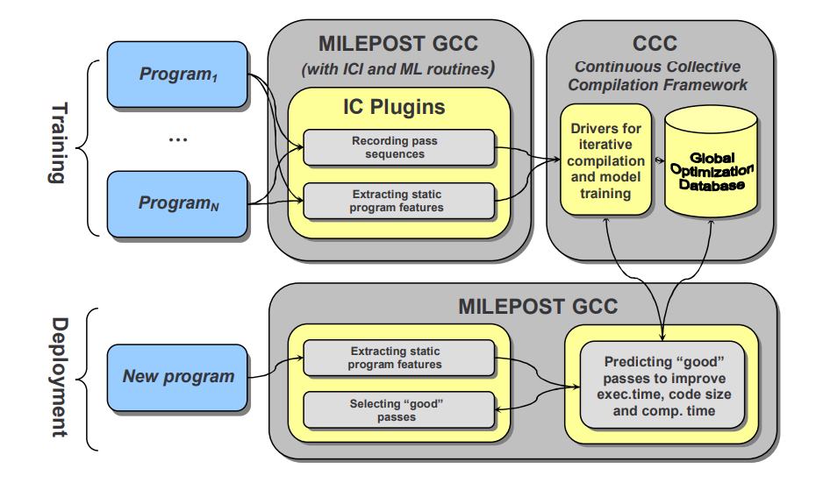
MILEPOST GCC comprises three integrated components.

Interactive Compilation Interface (ICI)
The ICI is a plugin framework that exposes GCC's internal compilation processes to external tools. It provides both low-level compiler-dependent APIs and high-level compiler-independent interfaces. This separation allows machine learning components to remain portable across different compiler infrastructures while maintaining deep access to optimization mechanisms.

Through ICI, external plugins can monitor pass execution, extract intermediate representations, and modify optimization decisions at function-level granularity.

Feature Extraction Module
The feature extractor analyzes source code and generates numerical representations suitable for machine learning. MILEPOST GCC V2.1 extracts 55 to 65 static program features across several categories:

Control flow characteristics:
- Basic block counts and connectivity patterns
- Control flow graph edge statistics
- Critical and abnormal edge frequencies

Instruction-level metrics:
- Direct and indirect call frequencies
- Branch instruction counts
- Arithmetic operation distributions (integer, floating-point, pointer)
- Memory access patterns

Structural complexity measures:
- Phi-node distributions
- Cyclomatic complexity
- Halstead metrics (vocabulary, length, difficulty, volume, effort)

Mircea Namolaru at IBM developed the initial feature extractor, with Grigori Fursin at INRIA/UVSQ handling integration with the broader MILEPOST framework.

Continuous Collective Compilation Framework (CCC)
The CCC framework automates the exploration of optimization spaces through iterative compilation. It compiles programs with varying optimization configurations, measures resulting performance, and stores outcomes in the Collective Optimization Database hosted at cTuning.org.

A distinguishing characteristic of MILEPOST is its community-driven data collection model. Users can contribute optimization results from their own experiments, creating a shared knowledge base that improves prediction accuracy across diverse architectures and workloads.

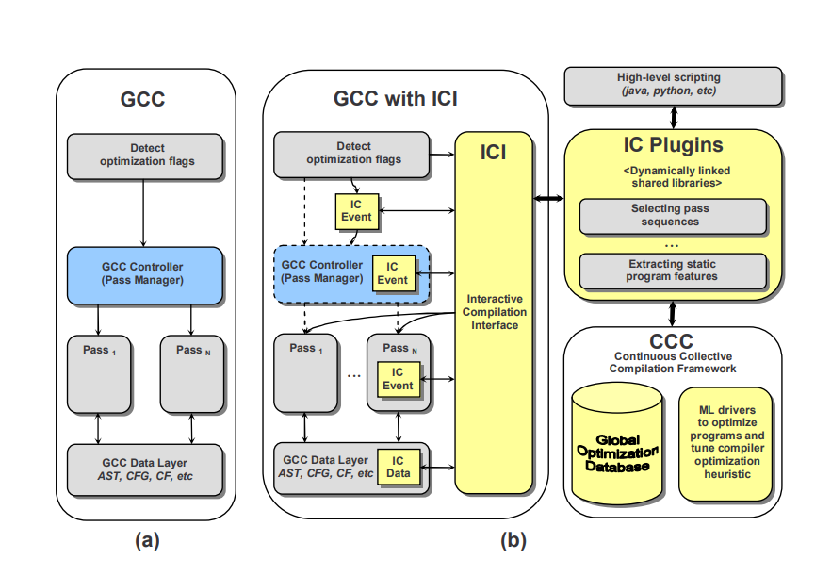

The above figure shows the comparison of standard GCC architecture versus GCC extended with the Interactive Compilation Interface and plugins.

4. Operational Workflow
MILEPOST GCC operates in two phases consistent with standard machine learning methodology.

Training Phase
The CCC framework conducts optimization experiments across benchmark programs, sampling various flag combinations and recording performance outcomes. Each experiment produces a mapping between program features and optimization effectiveness. This data accumulates in the Collective Optimization Database, forming the training corpus for predictive models.

Deployment Phase
During compilation of new programs, MILEPOST GCC extracts features and queries the trained model for optimization recommendations. The system identifies programs in the database with similar feature profiles and applies optimizations that proved effective for those programs.

This similarity-based approach enables reasonable predictions without program-specific training, significantly reducing the time required to achieve near-optimal performance.

5. Machine Learning Approaches
MILEPOST GCC implements two predictive methodologies.

Probabilistic Model
The probabilistic approach treats program features as independent attributes and computes Euclidean distance between feature vectors to identify similar programs in the training set. Optimizations effective for the nearest neighbors are predicted to work well for the target program.

This model achieved 11% average execution time improvement over GCC's default optimization level, with some programs reaching the full speedup available through exhaustive search.

Transductive Model
The transductive approach employs decision trees to capture interdependencies between features and optimization outcomes. While achieving more modest improvements (approximately 5% on average), decision trees offer interpretability advantages. The learned rules reveal which program characteristics most influence optimization effectiveness.

For certain programs — including susan_s, dijkstra, rijndael_e, qsort1, and stringsearch1 — the transductive model outperformed the probabilistic approach, suggesting complementary strengths between methodologies.

6. Collective Optimization Infrastructure
MILEPOST GCC is integrated with the Collective Tuning Initiative (cTuning), a community effort to enable reproducible compiler and architecture research. The Collective Optimization Database serves as a shared repository where optimization knowledge accumulates across contributors.

MILEPOST GCC V2.1 communicates transparently with cTuning web services to retrieve optimization recommendations based on program feature correlations. This crowdsourced approach addresses a fundamental challenge in machine learning for compilers: the cost of generating sufficient training data. By aggregating experiments from multiple users across diverse systems, the database achieves coverage that would be impractical for any single organization.

7. Experimental Results
Evaluation on standard benchmarks demonstrated substantial automatic performance improvements.
On the MiBench embedded benchmark suite targeting the ARC reconfigurable processor, MILEPOST GCC achieved 11% average execution time reduction. Individual programs showed improvements exceeding 2x in some cases, with simultaneous reductions in compilation time and code size.
For the Berkeley DB library (approximately 200,000 lines of code) on Intel Xeon processors, the system delivered 17% execution time improvement alongside 12% compilation time reduction and 7% code size reduction. Achieving gains across multiple objectives simultaneously is notable, as these metrics typically involve trade-offs.
These results were obtained entirely automatically, without program-specific tuning or manual intervention.
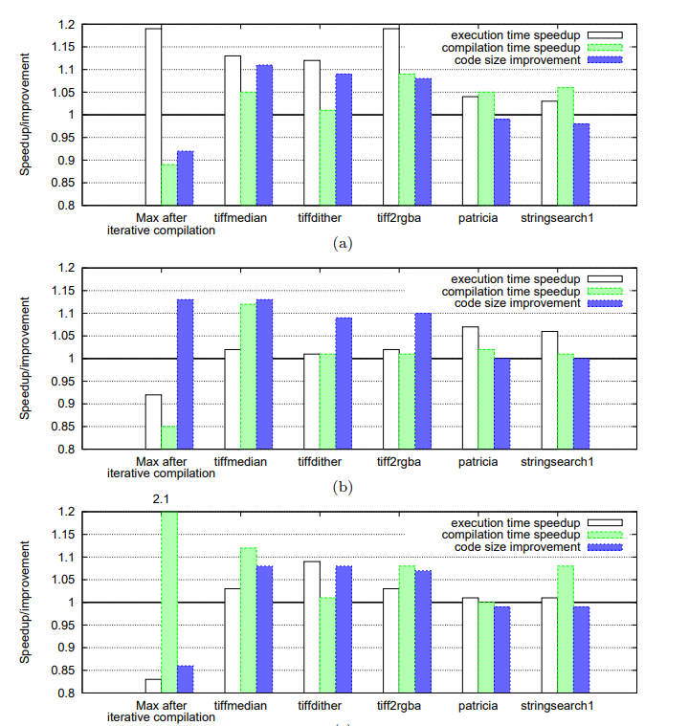

The above image shows execution time speedups (a), code size improvements (b) and compilation time speedup (c) for BerkeleyDB on Intel when applying optimizations from 5 closest programs from MiBench/cBench (based on Euclidean distance using static program features of 3 hottest functions) using several optimization scenarios.

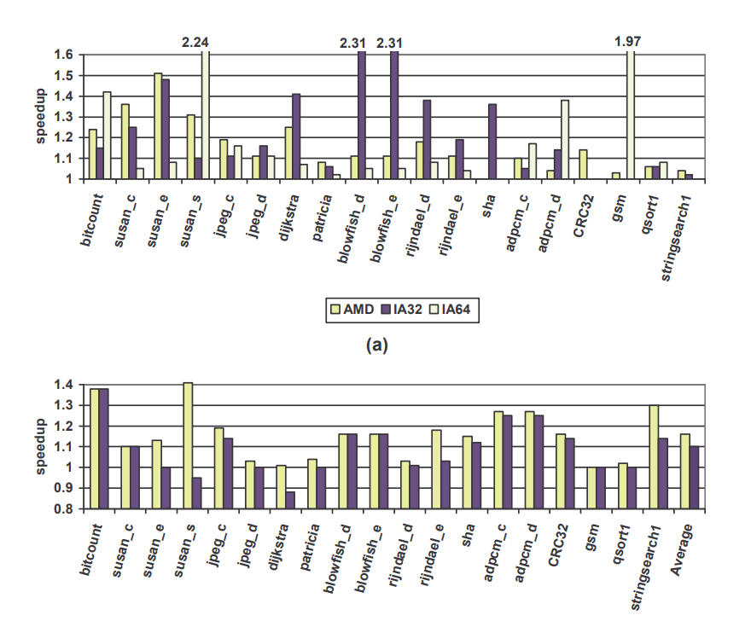

The above image shows experimental results when using iterative compilation with random search strategy (500 iterations; 50% probability to select each flags; AMD,IA32,IA64) and when predicting best optimization passes based on program features and ML model (ARC)

8. Examples

MILEPOST GCC Saves Time with Common Subexpression Elimination

Compilation Time
Standard GCC runs CSE on every program regardless of benefit. MILEPOST extracts features like arithmetic operation count and basic block structure to predict upfront whether CSE is profitable — skipping the pass entirely if it isn't. A key risk with CSE is creating too many temporaries to hold reused expressions. If too many temporaries are created, they exceed available CPU registers and get spilled back to memory — potentially slowing the program down more than CSE saved. MILEPOST's ML model prevents this by estimating register pressure from the program's feature profile. If spilling is likely, it applies CSE partially or skips it entirely — avoiding wasted compilation effort on an optimization that would backfire.

Execution Time
When MILEPOST determines CSE is safe and profitable, the runtime gains are direct and measurable. Redundant computations are eliminated, reducing CPU cycles, memory loads and register writes. Crucially, because MILEPOST controls how many temporaries CSE creates, it ensures the freed registers actually stay free — allowing surrounding code to run faster as well.

Developer Time
Without MILEPOST, finding the right CSE configuration for each architecture requires manual profiling and iterative flag testing. MILEPOST automates this entirely by querying its Collective Optimization Database at cTuning.org, applying optimization strategies that proved effective across thousands of similar programs instantly, with no manual intervention required.

MILEPOST GCC Saves Time with Dead Code Elimination

Standard GCC identifies dead code through a straightforward liveness analysis — it traces forward from an assignment and if it finds no subsequent reads, it removes it. While this works for simple cases, it applies the same approach to every program regardless of whether dead code elimination will actually be profitable. It does not consider how much dead code is present, how complex the function is, or whether removing the dead code will unlock further optimizations downstream. This one size fits all approach means standard GCC can miss opportunities where a smarter decision would deliver significantly better results.
MILEPOST GCC improves on this by using its ML model to predict upfront whether dead code elimination is worth applying based on the program's static feature profile. It specifically tracks Halstead complexity metrics — when a function has a high number of variables relative to how many are actually used, MILEPOST recognizes this as a strong signal that dead code is present and that elimination will be profitable. Beyond just removing unused computations, MILEPOST understands that dead code elimination frees up registers and reduces instruction count, creating opportunities for further optimizations to fire afterward. Every decision is backed by its Collective Optimization Database at cTuning.org, where strategies proven effective across thousands of similar programs are stored and queried. The result is an optimizer that does not just remove dead code mechanically, but removes it intelligently — at the right time, in the right functions, for maximum impact.

9. Significance and Impact
MILEPOST GCC holds historical importance as the first publicly available open-source machine learning-based compiler. Portions of its technology, including the low-level ICI-inspired plugin framework, were incorporated into mainline GCC, extending the project's influence beyond the research community.
The project established foundational concepts that continue to inform compiler research: program characterization through feature extraction, learning-based optimization selection, and collaborative knowledge sharing. Contemporary work in reinforcement learning for compilation, neural cost models, and autotuning frameworks builds upon principles that MILEPOST helped validate.

10. Limitations
Several factors constrained MILEPOST GCC's broader adoption.
The machine learning components exhibited "black box" characteristics that complicated debugging and validation. Compiler engineers accustomed to deterministic, rule-based systems expressed reservations about optimization decisions lacking clear explanations.
Training data acquisition remained challenging despite community contributions. Machine learning effectiveness scales with data volume, and the datasets available were limited relative to modern deep learning requirements.
Infrastructure maintenance proved difficult over time. MILEPOST GCC was built on GCC 4.4, and compatibility with contemporary Linux distributions degraded as dependencies evolved. The development team acknowledged this limitation and expressed interest in implementing similar capabilities within newer compiler infrastructures such as LLVM or GCC 6+.
Static features, while computationally efficient to extract, cannot capture dynamic program behavior or input-dependent characteristics. Programs with identical static profiles may exhibit substantially different runtime behavior depending on their workloads.

11. Subsequent Developments
The MILEPOST architecture was designed for portability across compiler infrastructures. The CCC framework wrapper supports integration with LLVM, Open64, Intel compilers, and other toolchains, enabling optimization prediction based on feature-optimization correlations regardless of the underlying compiler.
The project evolved into the Collective Knowledge framework, which applies similar principles to broader reproducible research and system optimization challenges. Concepts pioneered in MILEPOST have been extended to heterogeneous computing, GPU optimization, and power consumption prediction.
Contemporary research has advanced beyond MILEPOST's techniques. Deep learning approaches now learn program representations automatically rather than relying on hand-crafted features. Reinforcement learning methods enable online adaptation of optimization strategies during compilation. These represent significant methodological advances, though they build upon foundations that MILEPOST helped establish.

12. Conclusion
MILEPOST GCC demonstrated that machine learning can effectively automate compiler optimization tuning, a process traditionally requiring substantial manual effort and domain expertise. The project achieved meaningful performance improvements — 11% average speedup with peaks exceeding 2x — through purely automatic means.
While the specific implementation has been superseded by subsequent tools and techniques, MILEPOST's core contributions remain relevant: the use of program features for characterization, learning optimization strategies from empirical data, and leveraging collective knowledge through shared databases. These principles continue to underpin modern approaches to adaptive compilation and autotuning.

