Common Subexpression Elimination

Source Code:
#include <stdio.h>

int cse(int x, int y) {
int a = x + y;
int b = x + y;
return a + b;
}
int main() {
int x = 5;
int y = 10;
printf("%d\n", cse(x, y));
return 0;
}

Concept Used:
Common Subexpression Elimination (CSE) is a compiler optimization technique that:
- Identifies identical expressions
- Computes them only once
- Reuses the computed value instead of recomputing
In this program (x+y) expression appears twice
So the compiler can, Compute (x + y) once, Then use 2 * (x + y), instead of recomputing it.
Assembly Codes:

Analysis of Unoptimized Code:
- Behaviour Observed
In the unoptimized version:
- Function parameters are stored in memory.
- The expression x + y is computed twice.
- Intermediate values are stored on the stack.
- Multiple memory accesses occur.
- A stack frame is created.
- Relevant Assembly Snippet
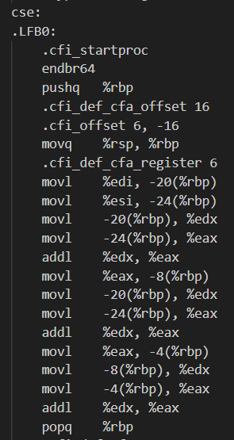
- Observations
- Redundant computation exists.
- Stack memory is heavily used.
- No reuse of previously computed results.
- More instructions are generated.
- Execution is less efficient.
- Instruction Count
- Total Instructions (Unoptimized): 39
Analysis of Optimized Code:
- Behavior Observed
In the optimized version:
- No stack frame is created.
- Parameters are used directly from registers.
- The expression x + y is computed only once.
- The compiler simplifies (x+y) + (x+y) into 2 * (x+y).
Relevant Assembly Snippet
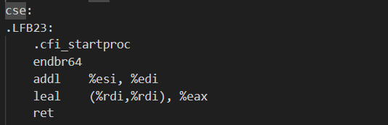
- Step by step Explanation
1. addl %esi, %edi
→ Computes x + y once.
2. leal (%rdi,%rdi), %eax
→ Computes 2 * (x + y).
Instead of computing:
(x+y) + (x+y)
The compiler transforms it into:
2 * (x+y)

Conclusion:
- In the unoptimized version, the expression x + y is computed twice, leading to redundant instructions and unnecessary memory usage.
- In the optimized version, the compiler successfully applies Common Subexpression Elimination by computing the expression once and reusing the result through algebraic transformation.
- This reduces instruction count by approximately 59% and significantly improves efficiency

Constant Folding

Source Code:
#include <stdio.h>

int constant_folding() {
int x = 10 * 5;
return x;
}

int main() {
printf("%d\n", constant_folding());
return 0;
}

Concept Used:
Constant Folding is a compiler optimization technique where:
- Constant expressions are evaluated at compile time.
- The computed value replaces the expression in the final code.
In this program, both operands are constants, the compiler can calculate
  - 10*5 = 50
during compilation itself, instead of performing multiplication at runtime.

Assembly Codes:

Analysis of Unoptimized Code:
- Behaviour Observed
In the unoptimized version:
- A stack frame is created.
- local variable is allocated.
- The constant value 50 is stored in memory.
- The value is then loaded again into a register.
- Unnecessary stack operations are performed.
- Relevant Assembly Snippet
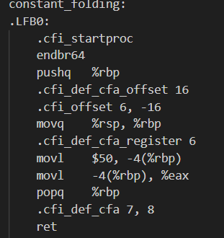
- Observations
- The constant expression is already simplified to 50.
- However, unnecessary stack memory is used.
- The value is first stored in memory, then loaded again.
- Extra instructions exist due to lack of optimization.
- Stack frame overhead increases instruction count.

Analysis of Optimized Code:
- Behaviour Observed
In the optimized version:
- No stack frame is created.
- No local variable is allocated.
- The constant value 50 is directly returned.
- Memory access is completely eliminated.
- Relevant Assembly Snippet
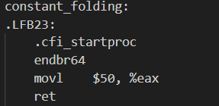
- Step by Step Explanation
- movl $50, %eax
→ Directly moves constant value 50 into return register.
- ret
→ Returns immediately.
The compiler completely removes:
- Stack allocation
- Memory storage
- Memory loading
The function becomes a single instruction return.

Conclusion:
- In the unoptimized version, although the expression 10 * 5 is already simplified to 50, the compiler still generates stack operations and unnecessary memory accesses.
- In the optimized version, the compiler fully applies Constant Folding and directly returns the constant value without creating a stack frame or using memory.
- Thus, Constant Folding eliminates runtime computation and significantly reduces instruction overhead, resulting in faster and more efficient code.

Constant Propagation

Source Code:
#include <stdio.h>

int constant_propagation() {
int a = 5;
int b = a + 3;
return b;
}

int main() {
int result = constant_propagation();
printf("Result: %d\n", result);
return 0;
}

Concept Used:
Constant Propagation is a compiler optimization technique where:
- If a variable is assigned a constant value
- That constant value is substituted wherever the variable is used
In this program,
a = 5
b = a + 3, is evaluated in this order
but instead,
b = 5+3
is enough as variable ‘a’ is a constant and on further optimization
b = 8
can be directly returned
Assembly Codes:

Analysis of Unoptimized Code:
- Behaviour Observed
In the unoptimized version:
- A stack frame is created.
- Local variables ‘a’ and ‘b’ are stored in memory.
- Value 5 is stored in memory.
- It is loaded into a register and then 3 is added.
- It is loaded into a register.
- Relevant Assembly Snippet

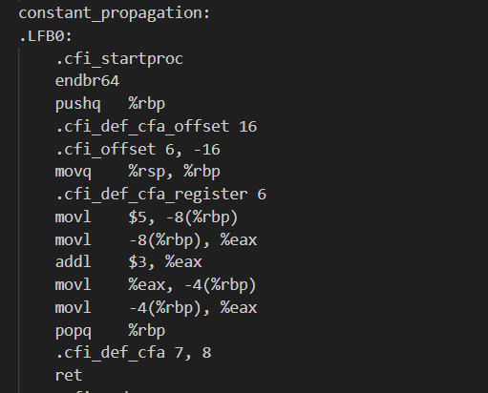

- Observations
- Variable ‘a’ is stored in memory.
- It is then loaded back into a register.
- Addition is performed at runtime.
- Result is stored again in memory.
- Multiple unnecessary memory operations occur.
- Extra instructions increase execution overhead.

Analysis of Optimized Code:
- Behavior Observed
In the optimized version:
- No stack frame is created.
- No local variables are used.
- Direct return is seen
Relevant Assembly Snippet
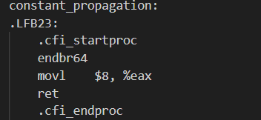
- Step by step Explanation
  - Compiler Detects:
    - a = 5 (constant)
  - It replaces a in
    - b = a + 3
  - Expression becomes
    - b = 5 + 3
  - Compiler evaluates at compile time
    - b = 8
  - Function directly returns 8
Conclusion:
- The comparison shows that the compiler successfully applies Constant Propagation in the optimized version.
- In the unoptimized code, variables are stored in memory and arithmetic is performed at runtime. In contrast, the optimized code replaces variables with their constant values and evaluates the expression at compile time.
- As a result, unnecessary memory operations and instructions are removed, leading to more efficient and compact assembly code.

Dead Code Elimination

Source Code:
#include <stdio.h>
int dead_code(int x) {
int a = x * 10;
int b = x * 20; // never used
return a;
}

int main() {
int result = dead_code(5);
printf("Result: %d\n", result);
return 0;
}

Concept Used:
Dead Code Elimination (DCE) is a compiler optimization technique in which:
• Unused variables are removed
• Unnecessary computations are eliminated
• Instructions that do not affect the final output are discarded
In this program, variable "b" is computed but never used. Therefore, it is considered dead code.

Analysis of Unoptimized Code:
- Behaviour Observed
In the unoptimized version:
• A stack frame is created
• Both variables "a" and "b" are computed
• Memory is allocated for both variables
• The value of "b" is stored even though it is never used
The compiler performs:
• Multiple shift and addition operations
• Separate computations for x * 5 and x * 5 * 4
• Memory storage for unused results
This increases instruction count and memory usage.

- Relevant Assembly Snippet
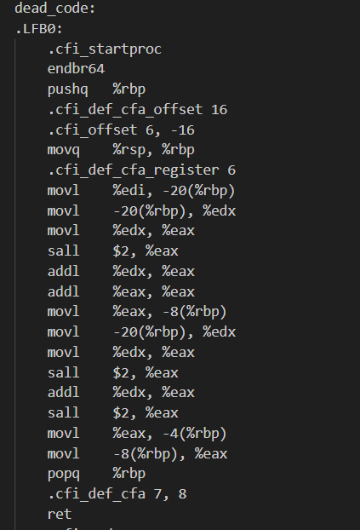
- Observations
• Multiple shift and addition operations
• Separate computations for x * 5 and x * 5 * 4
• Memory storage for unused results

Analysis of optimized Code:
- Behaviour Observed
In the unoptimized version:
• No stack frame is created
• Variable "b" is completely removed
• Computation is performed directly in registers
• Only instructions required for the return value are generated
- Relevant Assembly Snippet
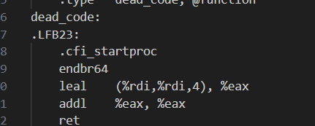
- Observations
The optimized function effectively computes:
x * 5
then multiplies the result by 2
Final result = 10x
The unused computation (x * 5 * 4) is entirely eliminated.

Conclusion:
- The comparison clearly shows that the compiler applies Dead Code Elimination in the optimized version.
- In the unoptimized code, both variables are computed even though one does not contribute to the final result. In the optimized version, the unused variable and its entire computation are removed.
- This reduces instruction count, eliminates unnecessary memory operations, and improves overall efficiency.

Function Handling

Source Code:
#include <stdio.h>

static int add(int a, int b) {
return a + b;
}

int inline_test(int x) {
return add(x, 5);
}

int main() {
int result = inline_test(10);
printf("Result: %d\n", result);
return 0;
}

Concept Used:
Function Inlining is a compiler optimization technique in which:
• A function call is replaced by the actual body of the function
• Call and return overhead is removed
• Stack operations for the called function are eliminated
Instead of jumping to another function using a call instruction, the compiler directly inserts the function’s logic into the caller.
Assembly Codes:

Analysis of Unoptimized Code:
- Behaviour Observed
• The function "add" exists separately
• A full stack frame is created for "add"
• Parameters are stored in memory
• A function call instruction (call add) is used
• Return control is transferred back to the caller

Relevant Assembly Snippet

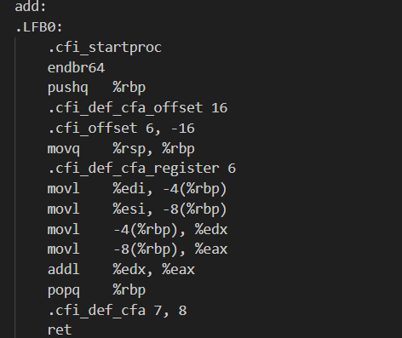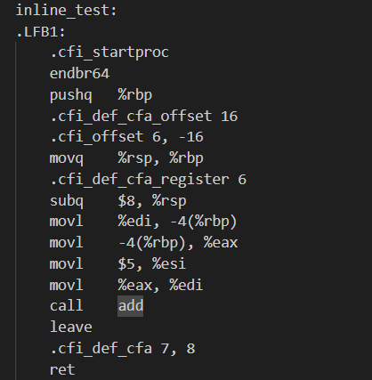

- Observations
• Function call overhead
• Stack push and pop operations
• Additional memory access
• Increased instruction count
Analysis of optimized Code:
- Behaviour Observed
In the optimized version:
• The function "add" is completely removed
• No call instruction is generated
• The addition is performed directly inside "inline_test"

- Relevant Assembly Snippet
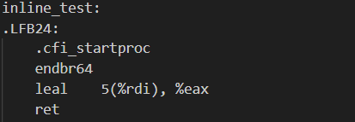
- Observations
The optimized instruction:
leal 5(%rdi), %eax
This directly computes:
x + 5
Thus:
• The function call is eliminated
• Stack frame setup for "add" is removed
• No parameter passing overhead
• Fewer instructions are generated

Conclusion:
- The comparison clearly shows that the compiler applies Function Inlining in the optimized version.
- In the unoptimized code, the add function is called normally with full stack setup and return operations. In the optimized version, the function call is removed and its logic is directly inserted into the caller.
- As a result, unnecessary call overhead and stack operations are eliminated, leading to faster and more efficient execution.

Loop Invariant

Source Code:
#include <stdio.h>

int loop_invariant(int *arr, int n) {
int sum = 0;
for (int i = 0; i < n; i++) {
sum += arr[i] * 10;
}
return sum;
}

int main() {
int arr[] = {1, 2, 3, 4, 5};
int result = loop_invariant(arr, 5);
printf("Result: %d\n", result);
return 0;
}

Concept Used:
Loop Invariant Code Motion is a compiler optimization technique where:
• Expressions inside a loop that do not change across iterations are identified
• Such computations are moved outside the loop
• Redundant calculations inside the loop are reduced
A loop invariant expression is one whose value remains constant during all iterations.

Assembly Codes:

Analysis of Unoptimized Code:
- Behaviour Observed
• Stack frame is created
• Loop counter and sum are stored in memory
• Index calculation is performed repeatedly
• Multiplication operations are performed inside the loop
• Address calculations are repeated every iteration

Relevant Assembly Snippet

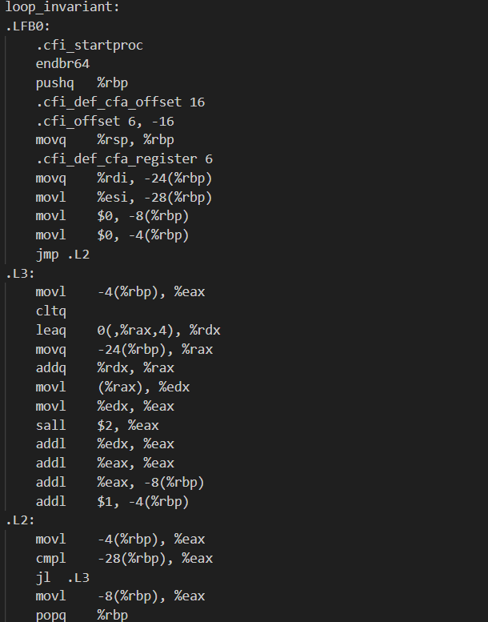

- Observations
• Repeated shift and add instructions
• Repeated loading of array base address
• Redundant arithmetic operations inside the loop
This increases:
• Instruction count
• Memory access
• Execution time
Analysis of optimized Code:
- Behaviour Observed
In the optimized version:
• Stack usage is minimized
• Registers are used instead of memory
• Loop control is simplified
• Address increment replaces repeated index calculation
• Arithmetic operations are combined efficiently
- Relevant Assembly Snippet
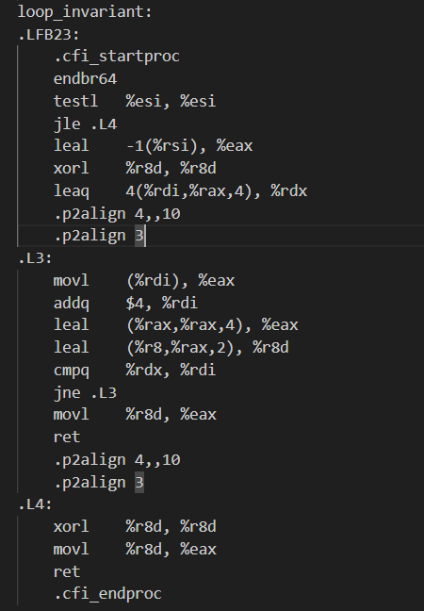
- Observations
• Pointer arithmetic is used (incrementing address directly)
• Multiplication is optimized using LEA instruction
• Fewer instructions inside loop body
• Loop termination condition optimized
Instead of recalculating array index every time, the compiler:
• Uses direct pointer increments
• Combines multiplications using efficient instructions
• Keeps frequently used values in registers

Conclusion:
- The comparison shows that the compiler effectively optimizes loop execution using Loop Invariant Code Motion and related loop optimizations.
- In the unoptimized version, redundant computations and memory operations occur inside the loop. In the optimized version, invariant and repeated operations are reduced or simplified, and register-based computation is used.
- This reduces instruction count, minimizes memory access, and improves overall loop performance.

Register Allocation

Source Code:
#include <stdio.h>
int register_alloc(int x, int y) {
int a = x + 1;
int b = y + 2;
return a * b;
}

int main() {
int result = register_alloc(5, 10);
printf("Result: %d\n", result);
return 0;
}

Concept Used:
Register Allocation is a compiler optimization technique in which:
• Frequently used variables are stored in CPU registers
• Memory access is minimized
• Stack usage is reduced
• Arithmetic operations are performed directly in registers
Since registers are much faster than memory, this optimization significantly improves performance.

Assembly Codes:

Analysis of Unoptimized Code:
- Behaviour Observed
• A stack frame is created
• Function parameters are stored in memory
• Local variables x and y are stored in memory
• Values are loaded from memory for computation
• Multiplication uses memory operands
Relevant Assembly Snippet

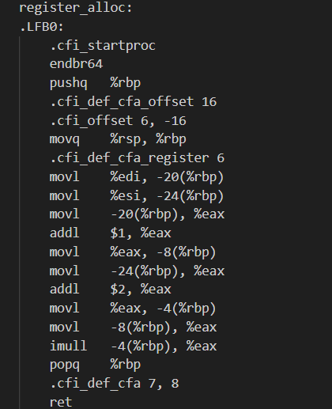

- Observations
• Multiple mov instructions
• Frequent memory access
• Local variables stored at stack offsets
• More instructions overall

Analysis of optimized Code:
- Behaviour Observed
In the optimized version:
• No unnecessary stack frame is created
• Variables are kept in registers
• Arithmetic operations are performed directly in registers
• No temporary memory storage is used
- Relevant Assembly Snippet
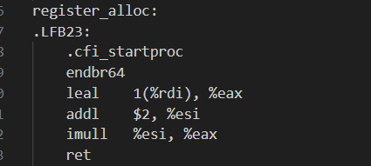
- Observations
Key optimized instructions:
leal 1(%rdi), %eax
addl $2, %esi
imull %esi, %eax
Explanation:
• a + 1 is computed directly in a register
• b + 2 is computed directly in a register
• Multiplication is performed using registers
• Result is returned without memory access

Conclusion:
- The comparison shows that the compiler efficiently applies Register Allocation in the optimized version.
- In the unoptimized code, variables are stored and retrieved from memory, increasing instruction count and memory access. In the optimized version, variables are kept in registers and computations are performed directly without unnecessary memory usage.
- This reduces overhead, improves execution speed, and produces more efficient assembly code.

Strength Reduction

Source Code:
#include <stdio.h>
int strength_reduction(int i) {
return i * 8;
}

int main() {
int result = strength_reduction(5);
printf("Result: %d\n", result);
return 0;
}
return 0;
}

Concept Used:
Strength Reduction is a compiler optimization technique where:
• Expensive operations (like multiplication or division)
• Are replaced with cheaper operations (like shift or addition)
Example:
x * 8 → x << 3
Since shifting is faster than multiplication, performance improves.

Assembly Codes:

Analysis of Unoptimized Code:
- Behaviour Observed
• Stack frame is created
• Parameter x is stored in memory
• Value is loaded into a register
• Shift operation (sall $3) is used
• Stack frame is removed

Relevant Assembly Snippet

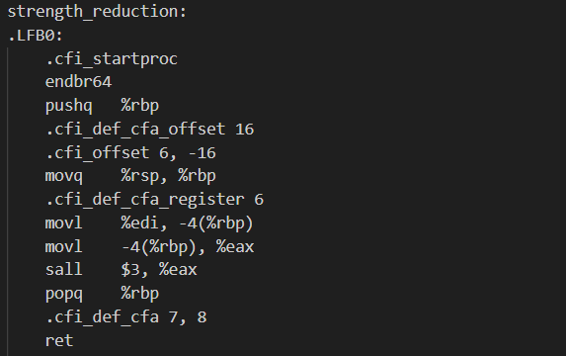

- Observations
• Extra mov instructions
• Stack usage present
• Memory access before computation
Even though shift is used, unnecessary stack operations increase instruction count.

Analysis of optimized Code:
- Behaviour Observed
In the optimized version:
• No stack frame is created
• No memory storage is used
• Computation is done directly in register
- Relevant Assembly Snippet
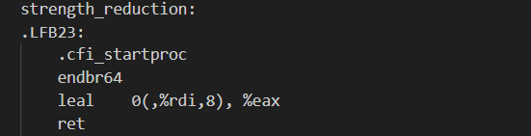
- Observations
leal 0(,%rdi,8), %eax
Explanation:
• %rdi contains input x
• It computes x × 8 directly using efficient addressing mode
• Result is stored in %eax
• Function returns immediately
The compiler uses LEA (Load Effective Address) to perform multiplication efficiently without explicit multiplication instruction.

Conclusion:
- The comparison shows that the compiler successfully applies Strength Reduction in the optimized version.
- In the unoptimized code, unnecessary stack operations are present. In the optimized version, multiplication by 8 is efficiently performed using a shift-based addressing mode without memory access.
- This reduces instruction count, eliminates overhead, and improves execution efficiency.

