Lab 2: Containerization & Orchestration — Docker / Podman Storage
Lab Report — Ephemeral Container Layers, Named Volumes, and Host Bind Mounts
Student Name: | Sarvesh Chandran
Roll Number: | 2301730032
Course & Faculty: | DevOps Lab (ENSP461) — Prof. Amit Kumar Singh
Target System: | oveRthinkLM Recursive Engine & Sandbox (FastAPI + Redis)
GitHub Repository: | https://github.com/Sarveshero3/oveRthinkLM

1. Objective
To empirically analyze and demonstrate container storage mechanics using the oveRthinkLM native architecture:
1. Demonstrate the loss of container-layer data upon container deletion (ephemeral write layer).
2. Implement persistent storage using a Docker / Podman Named Volume across container lifecycles.
3. Implement bi-directional persistent storage using a Host Bind Mount between the Windows filesystem and the container.
2. Part A: Container Layer Data Loss (Ephemeral Storage)
Step A.1: Write Data to Writable Container Layer
The container initializes with a thin read-write container layer on top of the immutable image layers. We record an active RLM run state into /app/scratchpad.json.
podman run -d --name overthink-ephemeral overthink-engine:1.0
podman exec overthink-ephemeral python3 -c "open('/app/scratchpad.json', 'w').write('ephemeral-data-rlm-run-401')"
podman exec overthink-ephemeral cat /app/scratchpad.json
Output / Execution Screenshot:
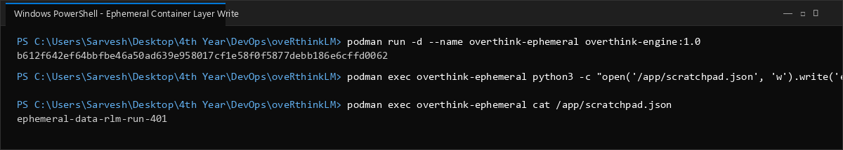

Step A.2: Delete Container and Verify Permanent Data Loss in New Container
Upon removing 'overthink-ephemeral', its read-write layer is permanently destroyed. Spawning a new container from 'overthink-engine:1.0' confirms that /app/scratchpad.json does not exist.
podman stop overthink-ephemeral; podman rm overthink-ephemeral
podman run -d --name overthink-ephemeral-new overthink-engine:1.0
podman exec overthink-ephemeral-new ls -l /app/scratchpad.json
Output / Execution Screenshot:
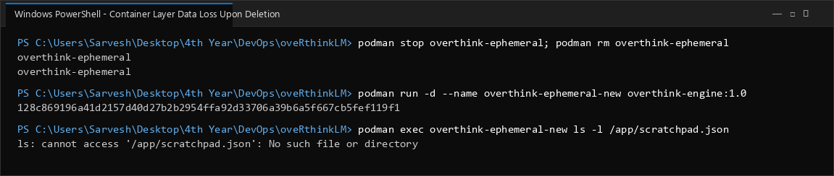

3. Part B: Persistent Storage Using Named Volumes
Step B.1: Create and Inspect Docker / Podman Named Volume
A dedicated named volume 'overthink-volume-store' is initialized. Inspection confirms its host storage mountpoint (/var/lib/containers/storage/volumes/...) and local driver management.
podman volume create overthink-volume-store
podman volume inspect overthink-volume-store
Output / Execution Screenshot:
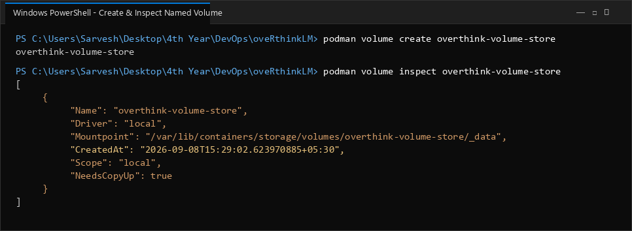

Step B.2: Mount Named Volume and Write Persistent Trajectory Data
The volume is mounted to /app/cache inside the container. An RLM trajectory index is written to the volume mount and validated.
podman run -d --name overthink-vol-app -v overthink-volume-store:/app/cache overthink-engine:1.0
podman exec overthink-vol-app python3 -c "open('/app/cache/trajectory_index.json', 'w').write('trajectory-cache-run-99: status=persisted')"
podman exec overthink-vol-app cat /app/cache/trajectory_index.json
Output / Execution Screenshot:
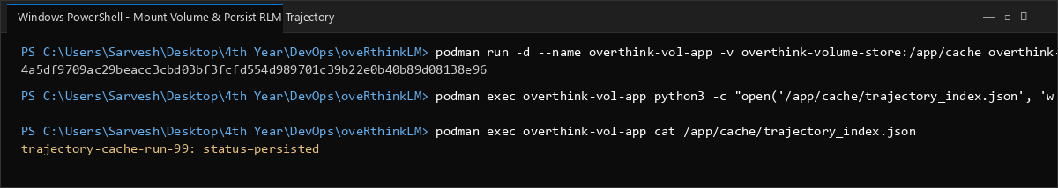

Step B.3: Delete Container and Verify Volume Persistence in Independent Container
The writer container is stopped and deleted. A newly spawned consumer container mounts the exact same volume and successfully reads the persisted trajectory data.
podman stop overthink-vol-app; podman rm overthink-vol-app
podman run -d --name overthink-vol-reader -v overthink-volume-store:/app/cache overthink-engine:1.0
podman exec overthink-vol-reader cat /app/cache/trajectory_index.json
Output / Execution Screenshot:
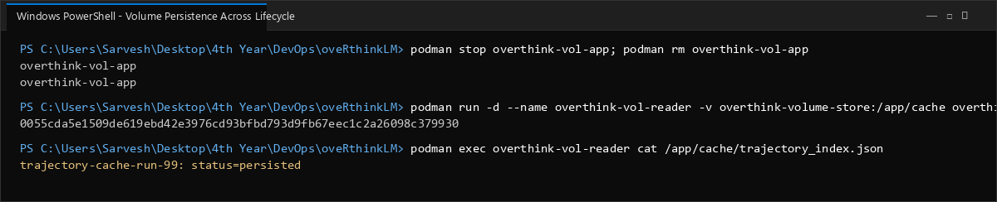

4. Part C: Persistent Storage Using Host Bind Mounts
Step C.1: Initialize Host Directory on Windows Workstation
A host directory 'storage_mount' is created on the Windows workstation with a configuration manifest 'host_config.json'.
mkdir storage_mount
Set-Content -Path "storage_mount\host_config.json" -Value '{"source": "host_system", "sync": true}'
dir storage_mount
Output / Execution Screenshot:
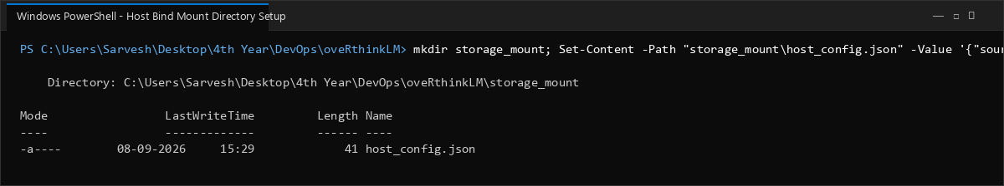

Step C.2: Mount Host Directory into Container and Verify Bi-Directional Sync
The host directory is mounted to /app/host_sync. The container reads the host manifest and outputs telemetry log data directly to the host filesystem.
podman run -d --name overthink-bind-app -v "C:\Users\Sarvesh\Desktop\4th Year\DevOps\oveRthinkLM\storage_mount:/app/host_sync" overthink-engine:1.0
podman exec overthink-bind-app cat /app/host_sync/host_config.json
podman exec overthink-bind-app python3 -c "open('/app/host_sync/engine_telemetry.log', 'w').write('checkpoint: epoch=10, val_loss=0.0812')"
dir storage_mount
Output / Execution Screenshot:
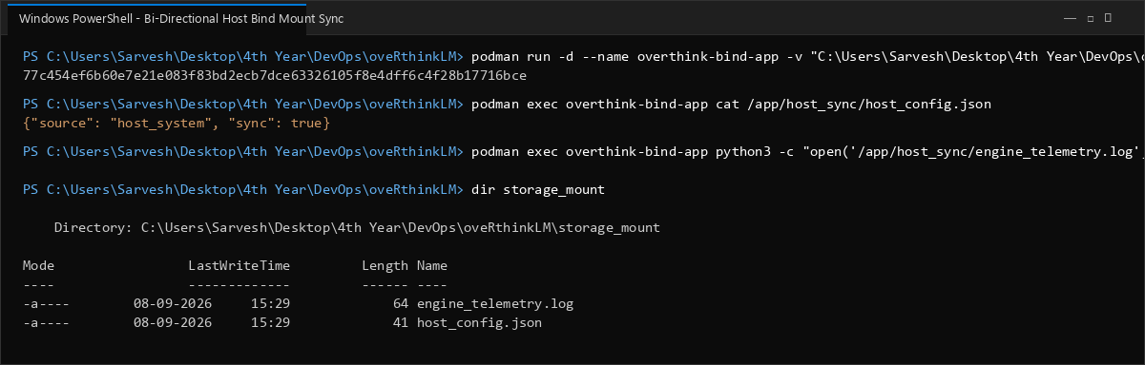

Step C.3: Delete Container and Confirm Host Data Retention
Even after destroying the container, all checkpoint files and configuration manifests reside safely on the Windows host filesystem.
podman stop overthink-bind-app; podman rm overthink-bind-app
dir storage_mount
Output / Execution Screenshot:
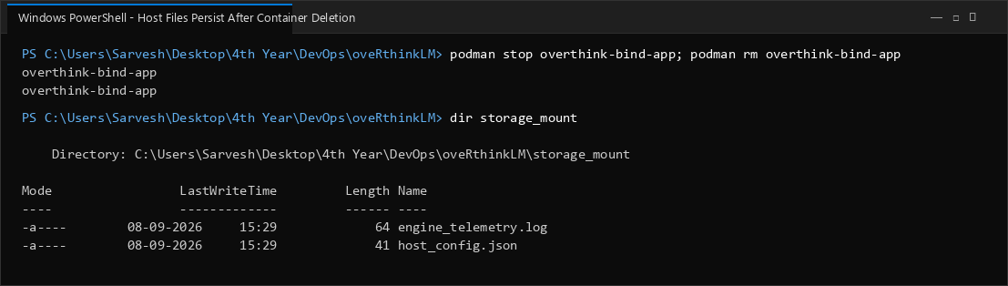

5. Storage Mechanisms Comparative Analysis
Storage Type | Lifecycle / Scope | Host Location | Primary Use Case in oveRthinkLM
Container Layer | Tied directly to container lifecycle; wiped on 'rm'. | Isolated overlayfs diff directory inside WSL container storage. | Ephemeral execution scratchpads, temporary REPL sandbox evaluation.
Named Volume | Independent of container lifecycle; managed by Podman/Docker. | /var/lib/containers/storage/volumes/<name>/_data | Persistent trajectory store, Redis state dumps, cached embeddings.
Bind Mount | Independent of container; bound directly to host path. | Arbitrary host path (e.g. C:\...\storage_mount). | Host-engine configuration sync, developer code mounting, real-time logging.
6. Conclusion
Through empirical execution on the oveRthinkLM native stack, container storage paradigms were validated:
• The writable container layer is inherently non-persistent, resulting in total data eviction when containers are removed.
• Named volumes decouple data lifecycle from execution containers, providing high-performance managed persistence suited for production cache layers.
• Host bind mounts establish bi-directional synchrony between the Windows host and containerized processes, vital for configuration ingestion and telemetry retention.

