Assignment 1: Containerize a Sample Application Using Docker
Lab Report
Name: | Swaraj Bhattacharjee
Roll No: | 2301730011
Date: | August 31, 2026

1. Objective
To containerize a sample Flask web application using Docker — writing a Dockerfile, building the image, running the container, and documenting the image layers and container behavior.

2. Project Files
The following three files were created inside the app1 folder.
app.py
from flask import Flask
app = Flask(__name__)

@app.route('/')
def hello():
return "Hello from my containerized app!"

if __name__ == '__main__':
app.run(host='0.0.0.0', port=5000)

requirements.txt
flask==3.0.0

Dockerfile
FROM python:3.11-slim
WORKDIR /app
COPY requirements.txt .
RUN pip install --no-cache-dir -r requirements.txt
COPY app.py .
EXPOSE 5000
CMD ["python", "app.py"]

3. Commands Executed
3.1 Create project folder
mkdir docker-lab
cd docker-lab
mkdir app1
cd app1

3.2 Verify files were created
dir
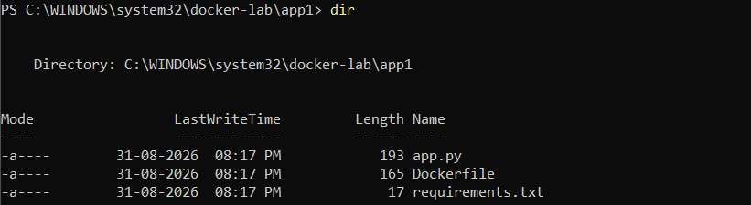

3.3 Build the Docker image
3.4 Run the container
docker build -t sample-flask-app:1.0 .
docker run -d -p 5000:5000 --name flask-container sample-flask-app:1.0

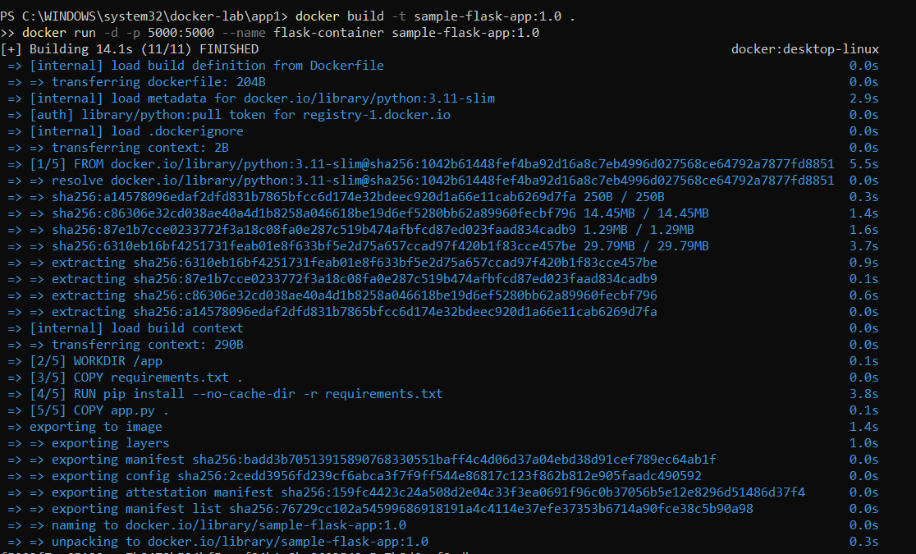

3.5 Confirm the container is running
docker ps

3.6 Access the application
Open a browser and navigate to http://localhost:5000
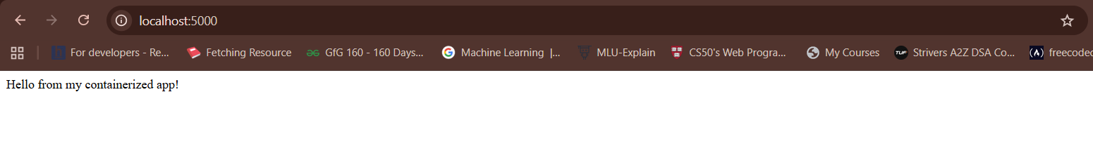

3.7 View container logs
docker logs flask-container
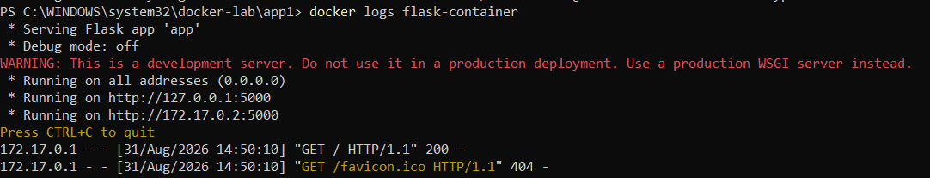

4. Documenting Image Layers
4.1 View image build history / layers
docker history sample-flask-app:1.0
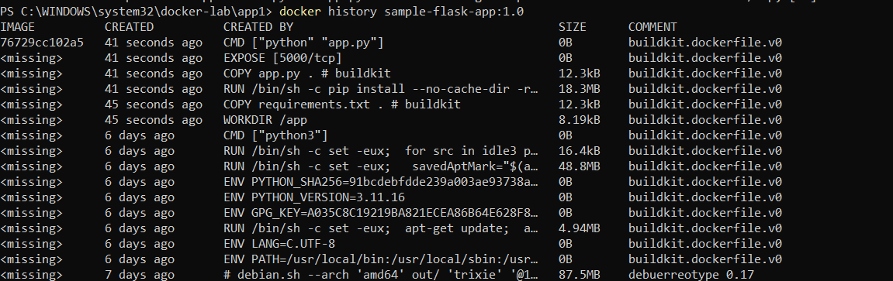

4.2 Inspect image metadata
docker inspect sample-flask-app:1.0
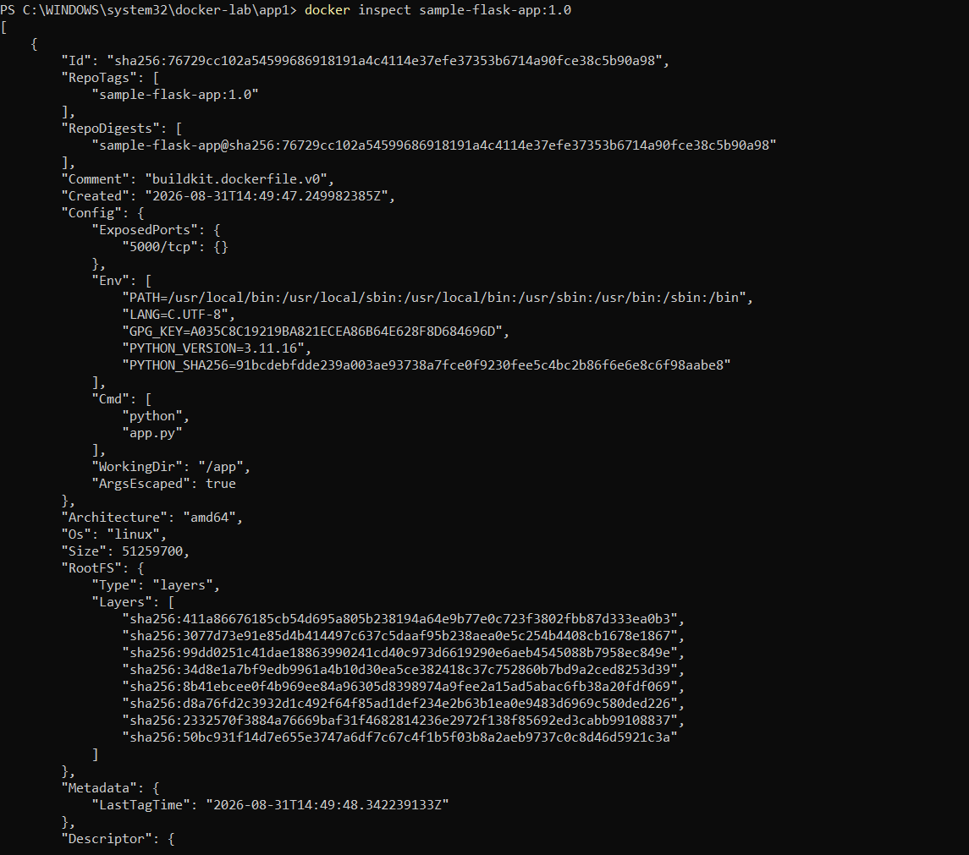

4.3 Check image size
docker images
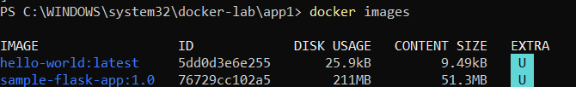

5. Observations
Fill in based on your actual output above:
Parameter | Data to fill
Base image used | python:3.11-slim
Number of layers created | 8 layers
Total image size | 51.3 MB (content size) / 211 MB (disk usage)
Time taken to build image | 14.1 seconds
Container behavior on start | Container started in detached mode and served the Flask application on port 5000. Accessible through http://localhost:5000.
Container behavior on stop | When stopped, the Flask server terminates and the container changes to the Exited/Stopped state.
Any issues faced & how resolved | No major issues were encountered. The Docker image built successfully, the container started successfully, and the Flask application returned HTTP 200 OK.

6. Conclusion
The sample Flask application was successfully containerized using Docker. A Dockerfile was written specifying the base image, dependencies, application code, and startup command. The image was built and a container was run from it, successfully serving the web application on port 5000. The 'docker history' command confirmed the image was composed of distinct layers, one per Dockerfile instruction, demonstrating Docker's layered image architecture.

