Assignment 2: Manage Docker Containers and Images
Containerization and Orchestration Lab — Docker container/image management, Docker Hub, and Docker Compose.
Github Link : https://github.com/SwarajBhattacharjee/docker-k8s-lab

Part A: Container and Image Management
Step A.1: List running containers
Command(s) to run:
docker ps

Paste output / screenshot below:
[ PASTE SCREENSHOT HERE: docker ps output ]

Step A.2: List all containers (including stopped)
Command(s) to run:
docker ps -a

Paste output / screenshot below:
[ PASTE SCREENSHOT HERE: docker ps -a output ]

Step A.3: Stop the running container
Command(s) to run:
docker stop flask-container

Paste output / screenshot below:
[ PASTE SCREENSHOT HERE: docker stop output + docker ps -a showing Exited status ]

Step A.4: Start the container again
Command(s) to run:
docker start flask-container
docker ps

Paste output / screenshot below:

Step A.5: Restart the container
Command(s) to run:
docker restart flask-container

Paste output / screenshot below:

Step A.6: View container logs
Command(s) to run:
docker logs flask-container

Paste output / screenshot below:
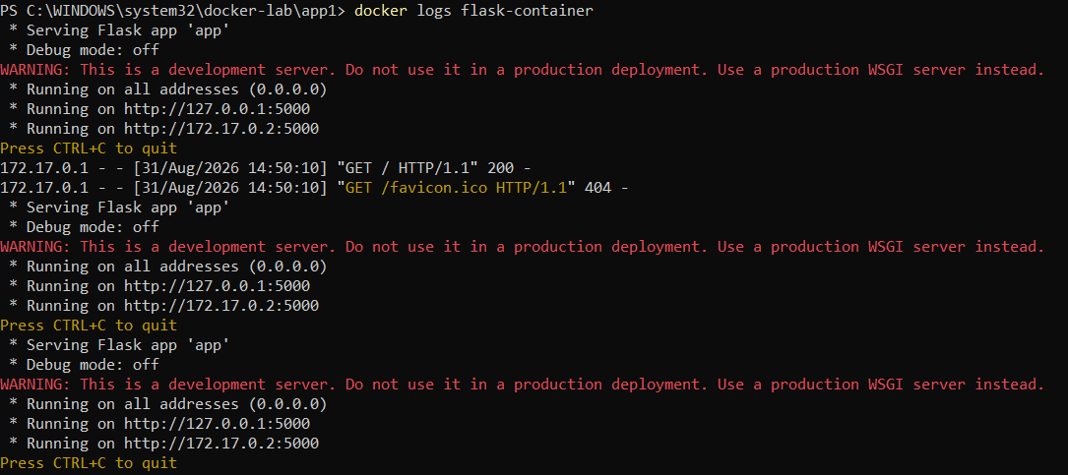

Step A.7: Remove the container
Command(s) to run:
docker stop flask-container
docker rm flask-container
docker ps -a

Paste output / screenshot below:
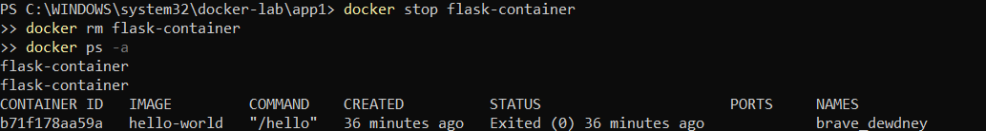

Step A.8: List images
Command(s) to run:
docker images

Paste output / screenshot below:
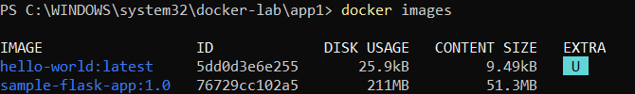

Step A.9: Remove an unused image (cleanup demo)
Command(s) to run:
docker rmi hello-world:latest
docker images

Observation: if a stopped container still references the image, Docker refuses to delete it with a conflict error. Remove the dependent container first (docker rm <container_id>), then retry docker rmi.
Paste output / screenshot below:

Step A.10: Prune unused containers and images
Command(s) to run:
docker container prune -f
docker image prune -f

Paste output / screenshot below:
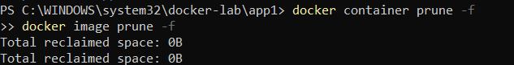

Part B: Tag and Push Image to Docker Hub
Step B.1: Log in to Docker Hub
Command(s) to run:
docker login

Paste output / screenshot below:
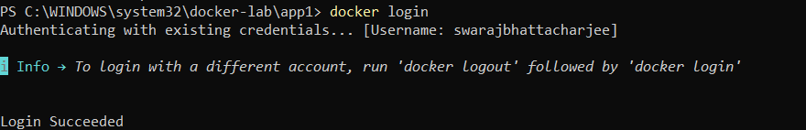

Step B.2: Tag the image for Docker Hub
Command(s) to run:
docker tag sample-flask-app:1.0 <dockerhub-username>/sample-flask-app:1.0

Paste output / screenshot below:
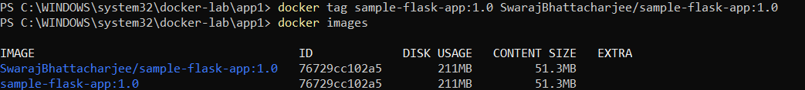

Step B.3: Verify the tag was created
Command(s) to run:
docker images

Paste output / screenshot below:

Step B.4: Push the image to Docker Hub
Command(s) to run:
docker push <dockerhub-username>/sample-flask-app:1.0

Paste output / screenshot below:
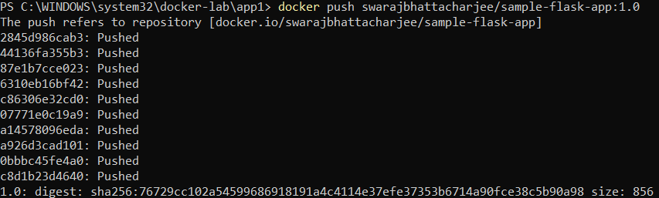

Step B.5: Verify on Docker Hub
Command(s) to run:
# Open hub.docker.com and check your repository page

Paste output / screenshot below:
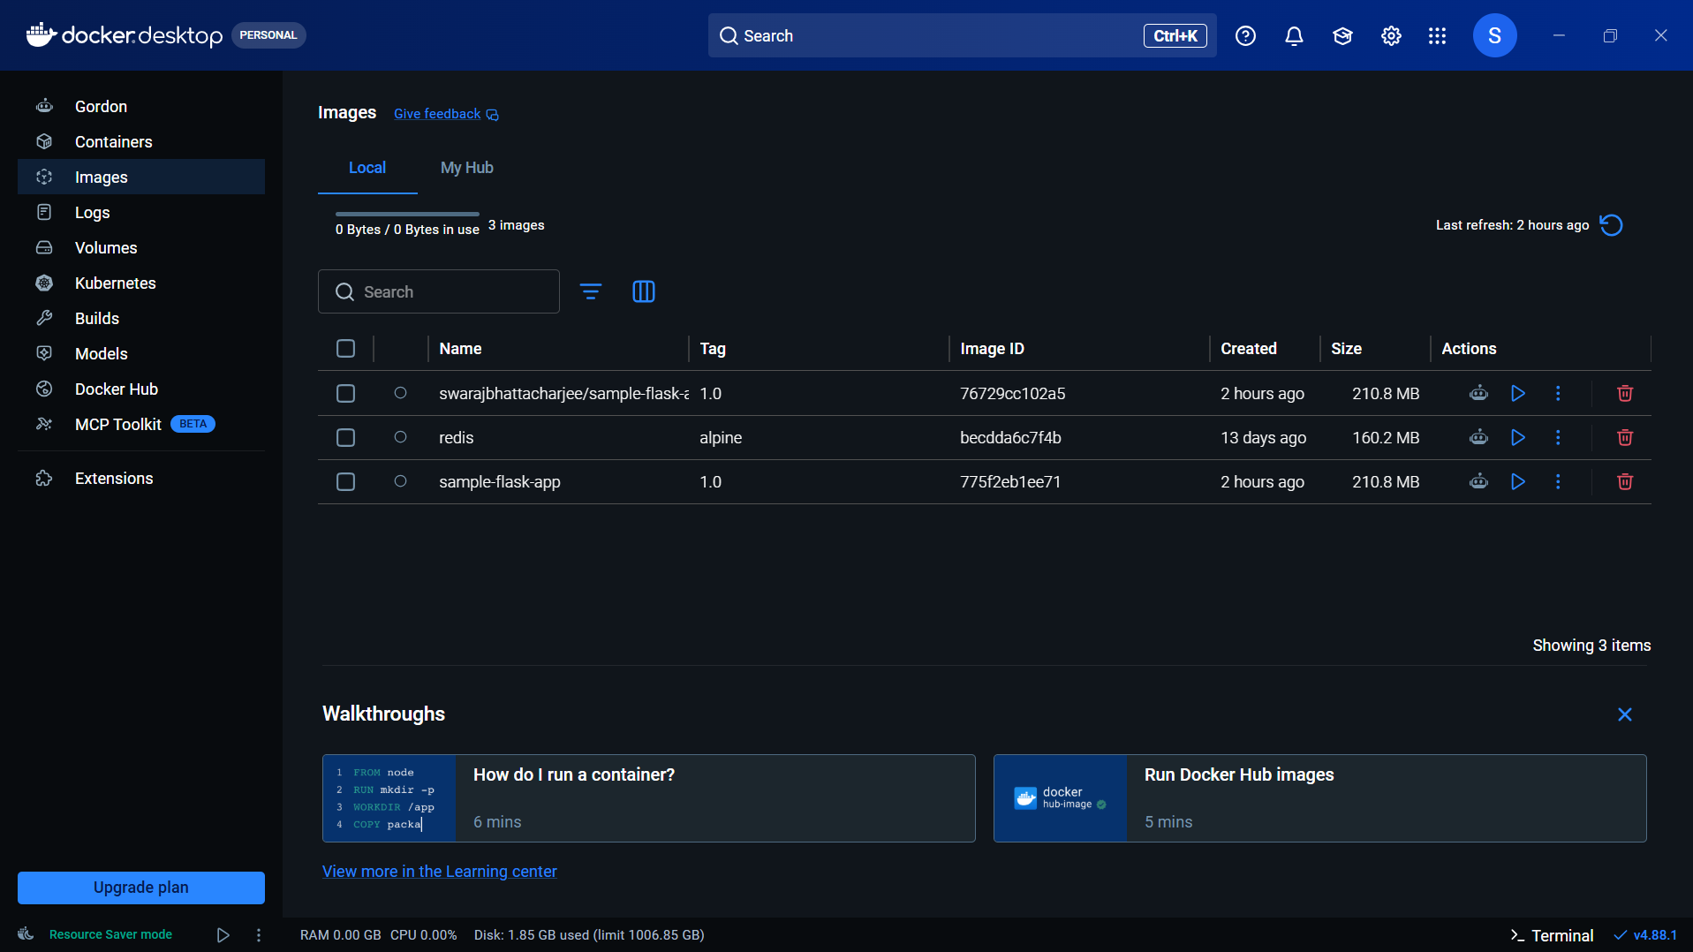

Part C: Docker Compose Multi-Container Setup
Step C.1: Create docker-compose.yml
Command(s) to run:
version: "3.9"

services:
web:
build: .
image: sample-flask-app:1.0
container_name: flask-container
ports:
- "5000:5000"
depends_on:
- redis
environment:
- REDIS_HOST=redis
networks:
- app-network

redis:
image: redis:alpine
container_name: redis-container
restart: always
networks:
- app-network

networks:
app-network:
driver: bridge

Paste output / screenshot below:
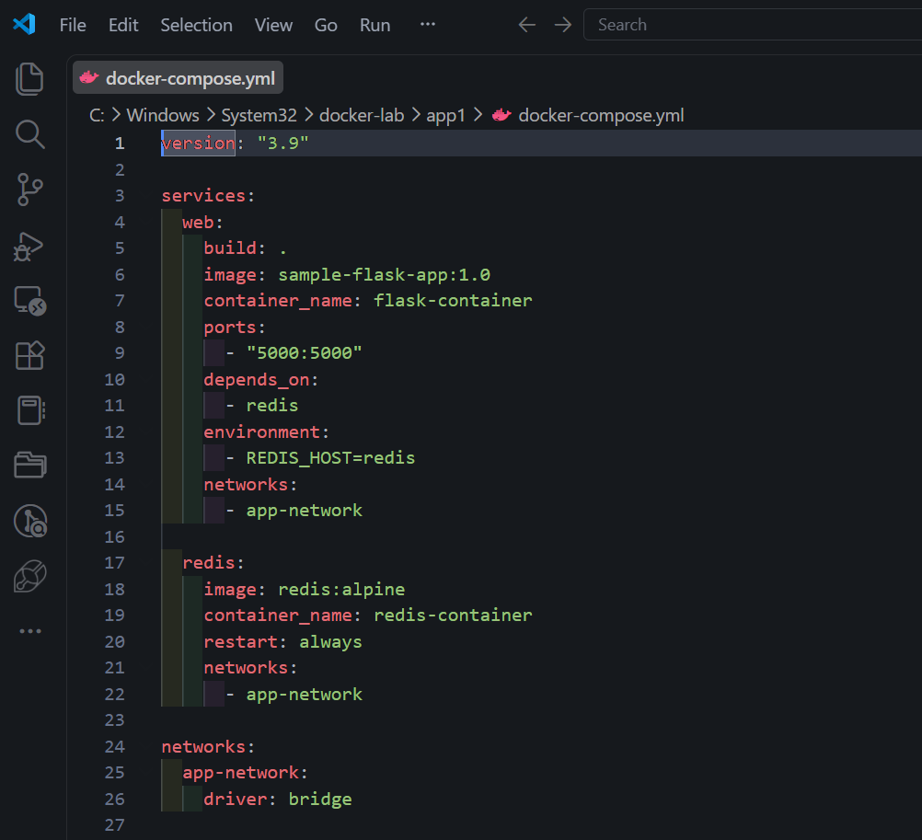

Step C.2: Build and start both containers
Command(s) to run:
docker compose up -d --build

Paste output / screenshot below:
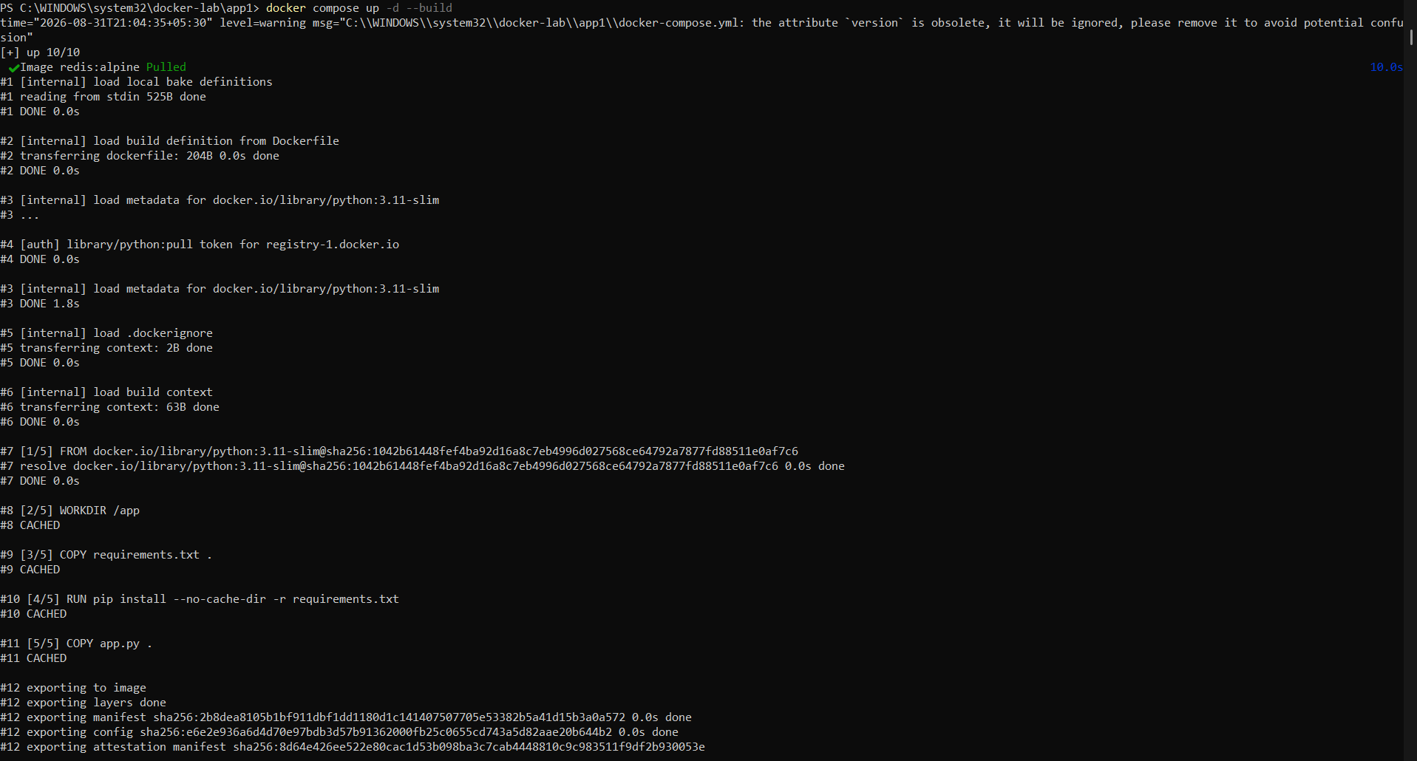

Step C.3: Verify both services are running
Command(s) to run:
docker compose ps

Paste output / screenshot below:

Step C.4: Check logs of each service
Command(s) to run:
docker compose logs web
docker compose logs redis

Paste output / screenshot below:
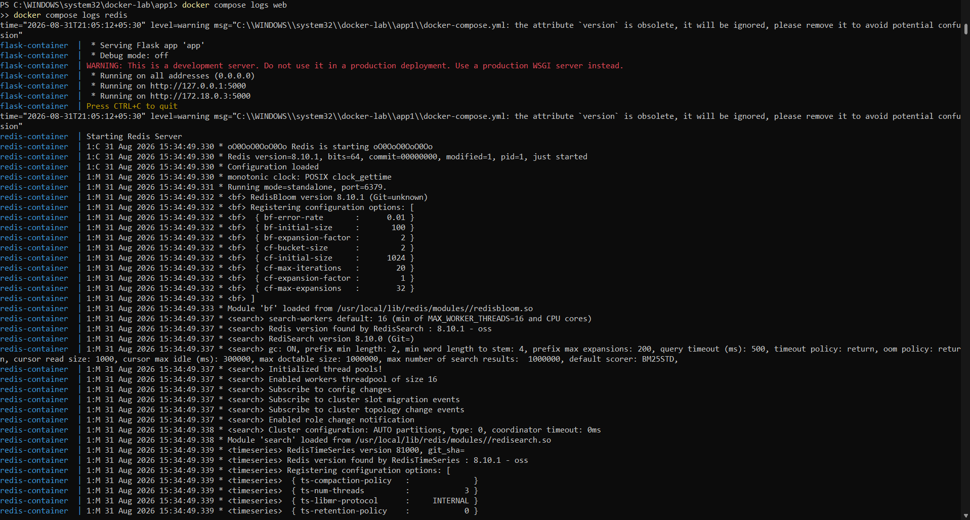

Step C.5: Test that the app is reachable
Command(s) to run:
curl http://localhost:5000

Note: In PowerShell, curl is aliased to Invoke-WebRequest, not GNU curl — this is expected behavior, not an error.
Paste output / screenshot below:
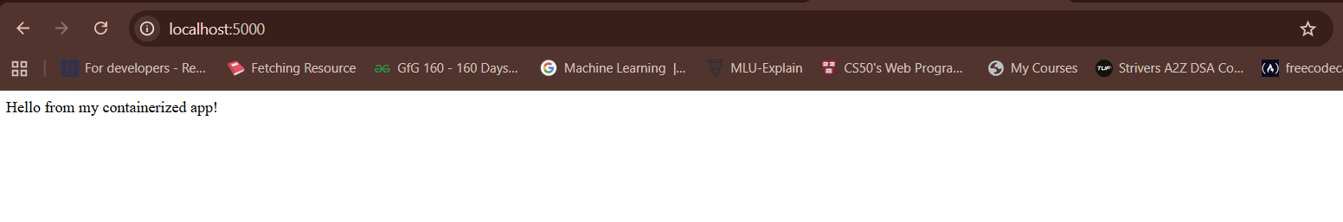

Step C.6: Stop and remove the multi-container setup
Command(s) to run:
docker compose down

Paste output / screenshot below:

Observations Summary
• Stopping/starting a container preserves its Container ID; removing and re-running creates a new one.
• Tagging an image does not duplicate disk space — multiple tags can point to the same Image ID.
• docker push only uploads layers not already present on the registry.
• Docker Hub repository names must be lowercase; capitalized usernames cause a DNS-style push failure.
• Docker Compose automatically creates a bridge network connecting services by service name (e.g. 'web' could reach 'redis' by hostname).
• container_name fixes a container's identity and prevents Compose from scaling that service to multiple replicas.
• Redis started without authentication by default — acceptable for local development, but should be secured in production.

