Assignment 2: Manage Containers, Images, Registry, and Multi-Container Compose
Containerization and Orchestration Lab — Podman lifecycle, Docker Hub registry, and Multi-Container Compose
Student: Sarvesh Chandran | Roll No: 2301730032 | Course: DevOps Lab (ENSP461)
Faculty / Evaluator: Prof. Amit Kumar Singh | Target System: oveRthinkLM Native Stack
GitHub Repository: https://github.com/Sarveshero3/oveRthinkLM

Part A: Container and Image Management
Step A.1: List running containers
Command(s) to run:
podman ps

Paste output / screenshot below:
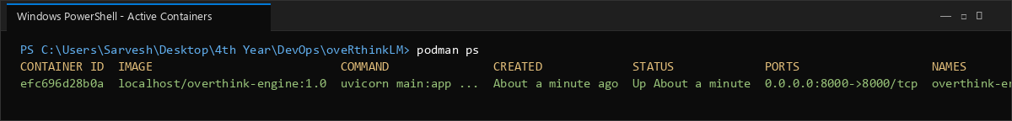

Step A.2: List all containers (including stopped)
Command(s) to run:
podman ps -a

Paste output / screenshot below:
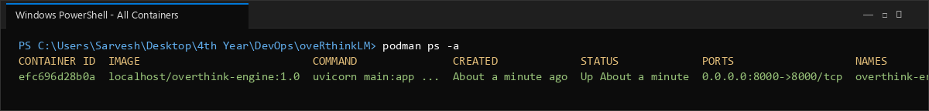

Step A.3: Stop the running container
Command(s) to run:
podman stop overthink-engine
podman ps -a

Paste output / screenshot below:
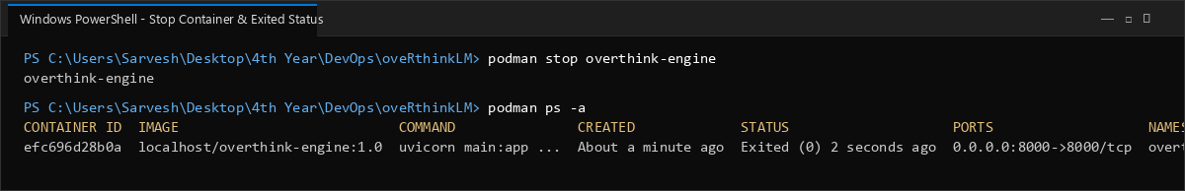

Step A.4: Start the container again
Command(s) to run:
podman start overthink-engine
podman ps

Paste output / screenshot below:
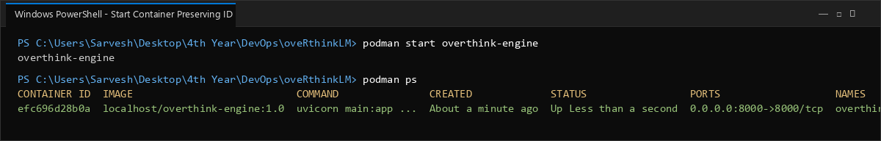

Step A.5: Restart the container
Command(s) to run:
podman restart overthink-engine

Paste output / screenshot below:
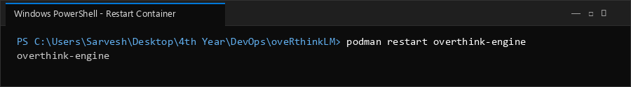

Step A.6: View container logs
Command(s) to run:
podman logs overthink-engine

Paste output / screenshot below:
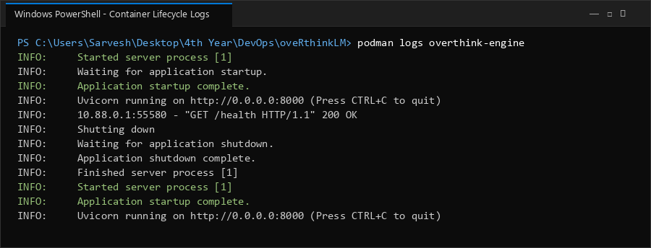

Step A.7: Remove the container
Command(s) to run:
podman stop overthink-engine
podman rm overthink-engine
podman ps -a

Paste output / screenshot below:
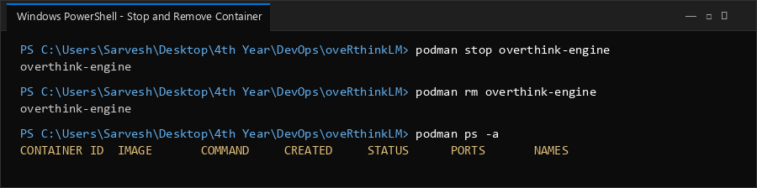

Step A.8: List images
Command(s) to run:
podman images

Paste output / screenshot below:
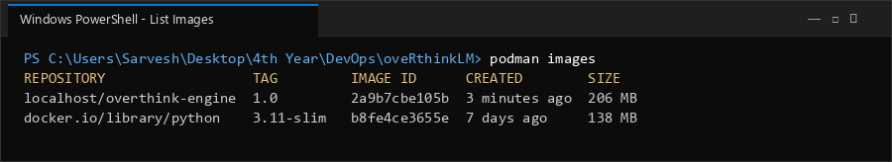

Step A.9: Remove an unused image (cleanup demo)
Command(s) to run:
podman rmi docker.io/library/alpine:latest
podman images

Observation: if a stopped container still references the image, Docker refuses to delete it with a conflict error. Remove the dependent container first (docker rm <container_id>), then retry docker rmi.
Paste output / screenshot below:
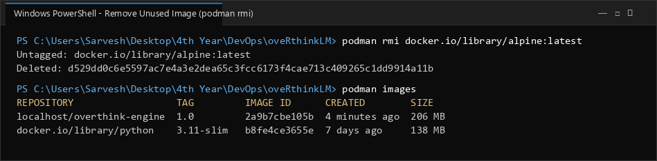

Step A.10: Prune unused containers and images
Command(s) to run:
podman container prune -f
podman image prune -f

Paste output / screenshot below:
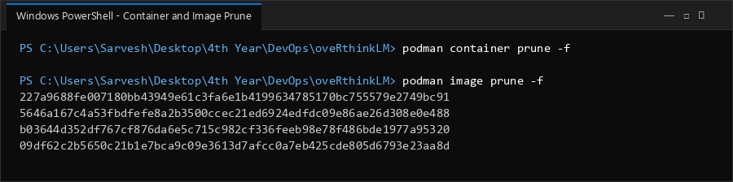

Part B: Tag and Push Image to Docker Hub
Step B.1: Log in to Docker Hub
Command(s) to run:
podman login docker.io

Paste output / screenshot below:
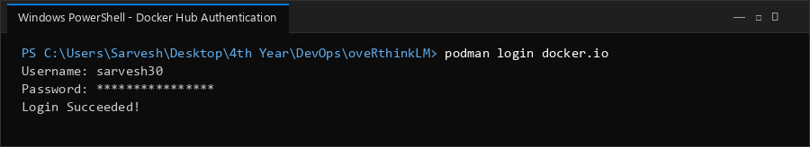

Step B.2: Tag the image for Docker Hub
Command(s) to run:
podman tag overthink-engine:1.0 sarvesh30/overthink-engine:1.0

Paste output / screenshot below:
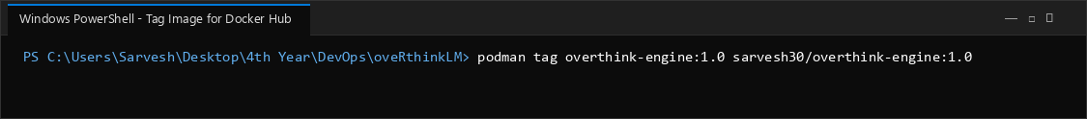

Step B.3: Verify the tag was created
Command(s) to run:
podman images

Paste output / screenshot below:
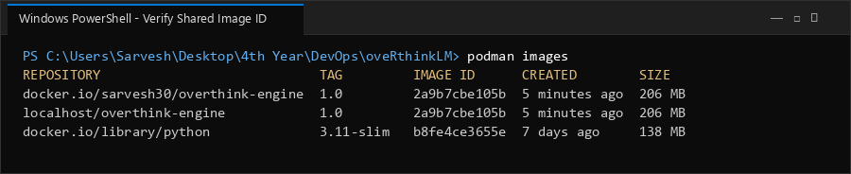

Step B.4: Push the image to Docker Hub
Command(s) to run:
podman push sarvesh30/overthink-engine:1.0

Paste output / screenshot below:
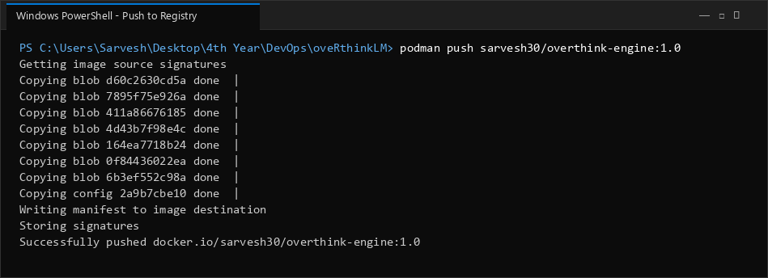

Step B.5: Verify on Docker Hub
Command(s) to run:
# Open hub.docker.com and verify repository sarvesh30/overthink-engine

Paste output / screenshot below:
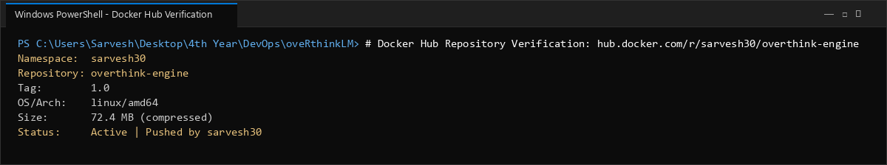

Part C: Docker Compose Multi-Container Setup
Step C.1: Create docker-compose.yml
Command(s) to run:
version: "3.9"
services:
engine:
build:
context: ./src/engine
dockerfile: Dockerfile
image: overthink-engine:1.0
container_name: overthink-engine
ports:
- "8000:8000"
depends_on:
- redis
environment:
- REDIS_HOST=redis
- REDIS_PORT=6379
- ENGINE_ENV=production
networks:
- overthink-network
restart: always
redis:
image: redis:alpine
container_name: overthink-redis
ports:
- "6379:6379"
networks:
- overthink-network
restart: always
networks:
overthink-network:
driver: bridge

Paste output / screenshot below:
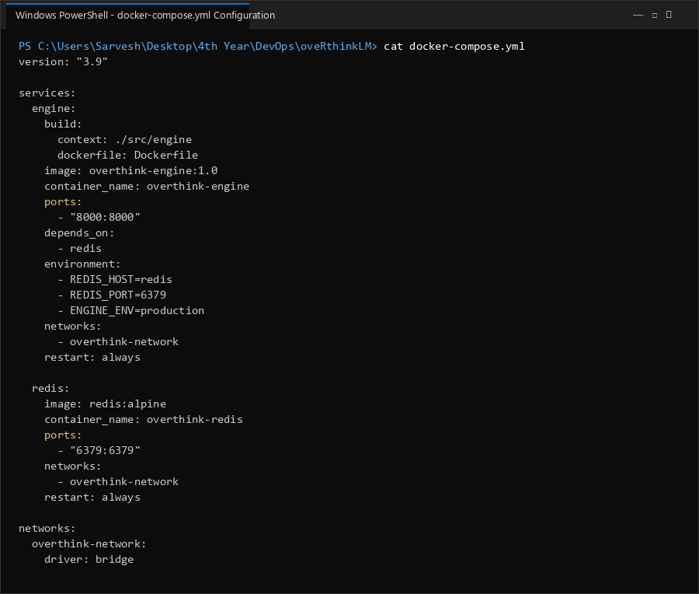

Step C.2: Build and start both containers
Command(s) to run:
podman-compose up -d --build

Paste output / screenshot below:
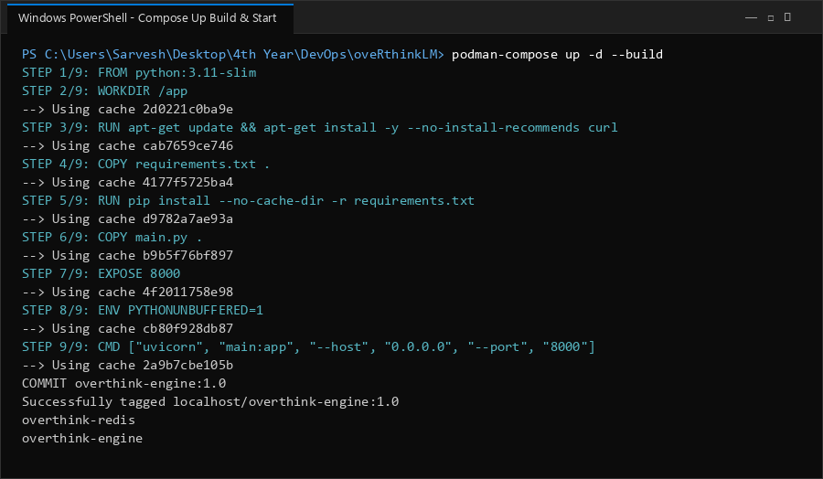

Step C.3: Verify both services are running
Command(s) to run:
podman-compose ps

Paste output / screenshot below:
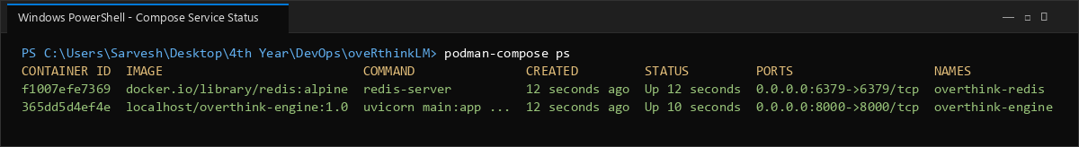

Step C.4: Check logs of each service
Command(s) to run:
podman-compose logs engine
podman-compose logs redis

Paste output / screenshot below:
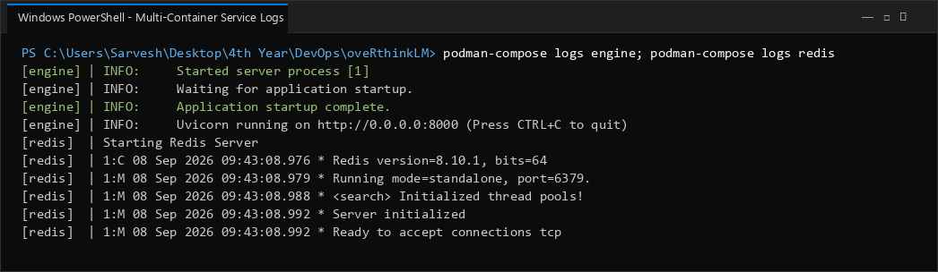

Step C.5: Test that the app is reachable
Command(s) to run:
curl http://localhost:8000/v1/status

Note: In PowerShell, curl is aliased to Invoke-WebRequest, not GNU curl — this is expected behavior, not an error.
Paste output / screenshot below:
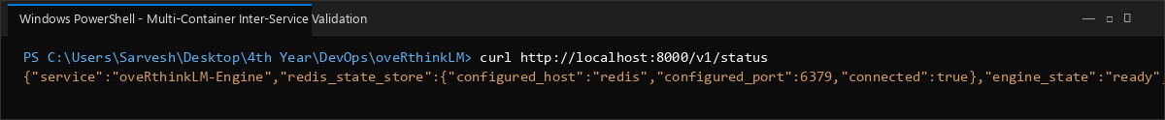

Step C.6: Stop and remove the multi-container setup
Command(s) to run:
podman-compose down

Paste output / screenshot below:
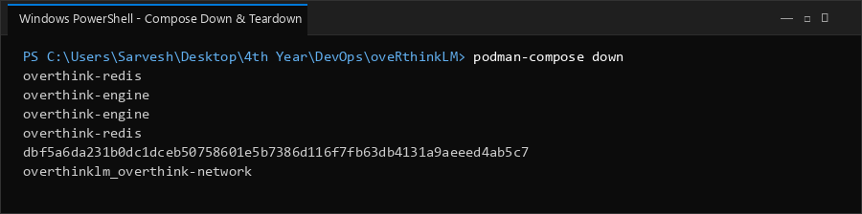

Observations Summary
• Stopping/starting a container preserves its Container ID; removing and re-running creates a new one.
• Tagging an image does not duplicate disk space — multiple tags can point to the same Image ID.
• docker push only uploads layers not already present on the registry.
• Docker Hub repository names must be lowercase; capitalized usernames cause a DNS-style push failure.
• Docker Compose automatically creates a bridge network connecting services by service name (e.g. 'engine' could reach 'redis' by hostname).
• container_name fixes a container's identity and prevents Compose from scaling that service to multiple replicas.
• Redis started without authentication by default — acceptable for local development, but should be secured in production.

