Title Page
JavaScript Mini Project
To-Do List Application

Submitted by:
Sarvesh Nabar

Internship: InternSpark Internship
Technology: HTML, CSS, JavaScript

Objective
The objective of this project is to develop an interactive To-Do List application using JavaScript and DOM manipulation. The application allows users to add, complete, and delete tasks dynamically. This project demonstrates basic JavaScript functionality and user interaction.

Technologies Used
• HTML – Structure of the application
• CSS – Styling and layout design
• JavaScript – DOM manipulation and functionality
• GitHub Pages – Hosting the project

Project Description / Working
The To-Do List application allows users to enter tasks into an input field and add them to a list. Each task can be marked as completed by clicking on it, and tasks can also be deleted using the delete button. JavaScript is used to dynamically create and manage elements in the DOM without refreshing the page.

Features
• Add new tasks
• Mark tasks as completed
• Delete tasks
• Interactive user interface
• Real-time updates using JavaScript

Home
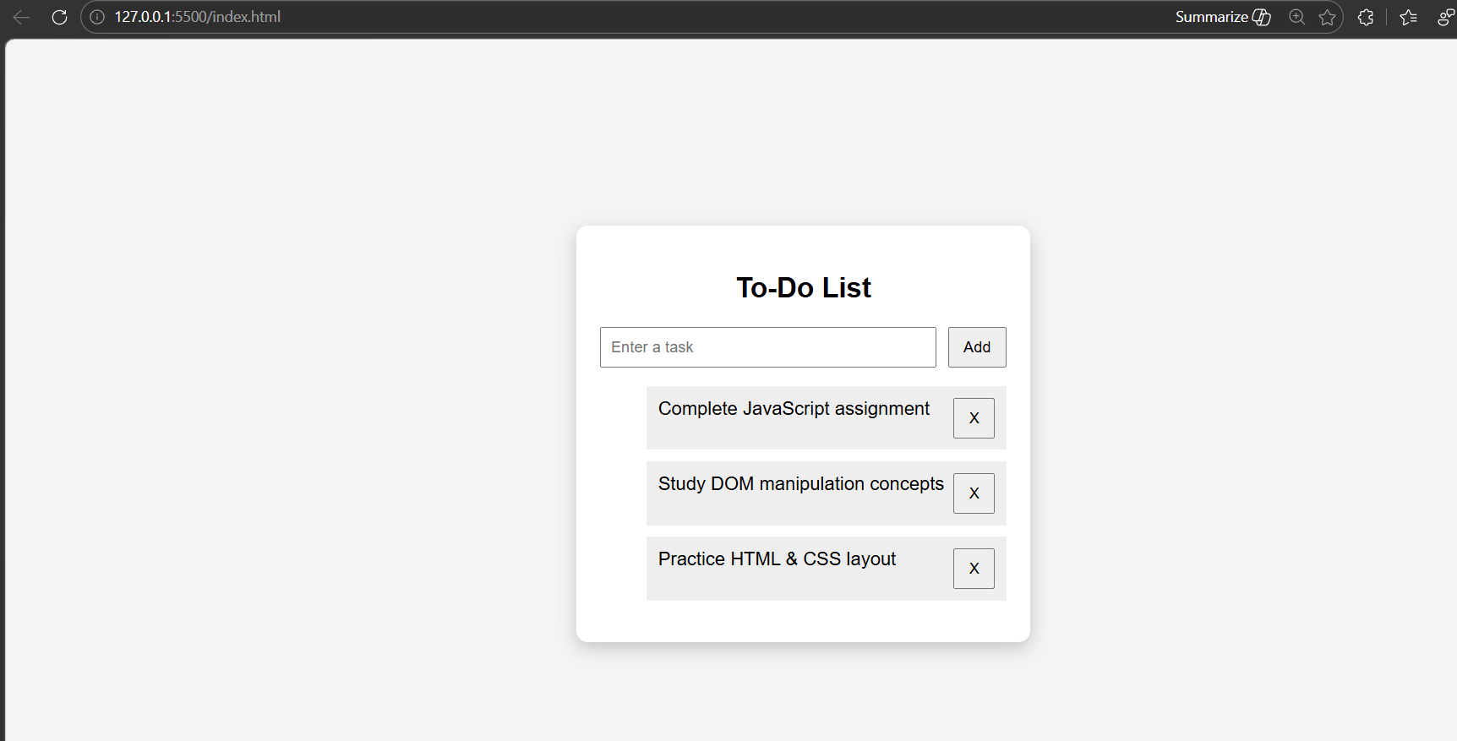

Index.html
<!DOCTYPE html>
<html lang="en">
<head>
<meta charset="UTF-8">
<meta name="viewport" content="width=device-width, initial-scale=1.0">
<title>To Do App</title>

<link rel="stylesheet" href="style.css">
</head>

<body>

<div class="container">
<h2>To-Do List</h2>

<div class="input-section">
<input type="text" id="taskInput" placeholder="Enter a task">
<button onclick="addTask()">Add</button>
</div>

<ul id="taskList"></ul>
</div>

<script src="script.js"></script>

</body>
</html>

Style.css
body {
font-family: Arial, sans-serif;
background: #f4f4f4;
display: flex;
justify-content: center;
align-items: center;
height: 100vh;
}

.container {
background: white;
padding: 20px;
width: 350px;
border-radius: 10px;
box-shadow: 0 5px 15px rgba(0,0,0,0.2);
}

h2 {
text-align: center;
}

.input-section {
display: flex;
gap: 10px;
}

input {
flex: 1;
padding: 8px;
}

button {
padding: 8px 12px;
cursor: pointer;
}

li {
list-style: none;
padding: 10px;
margin-top: 10px;
background: #eee;
display: flex;
justify-content: space-between;
cursor: pointer;
}

.completed {
text-decoration: line-through;
background: #c8f7c5;
}

Script.js
function addTask() {

let input = document.getElementById("taskInput");
let taskText = input.value;

if (taskText === "") {
alert("Enter a task");
return;
}

let li = document.createElement("li");
li.innerText = taskText;

li.onclick = function () {
li.classList.toggle("completed");
};

let deleteBtn = document.createElement("button");
deleteBtn.innerText = "X";

deleteBtn.onclick = function () {
li.remove();
};

li.appendChild(deleteBtn);

document.getElementById("taskList").appendChild(li);

input.value = "";
}

Github link
https://github.com/Sarveshnabar03/InternSpark-Internship.git

