**SCREEN SHOTS**

* + 1. **EMPLOYEE PAGE**
    2. **Login Page**

Employee can login using gmail, facebook or Username

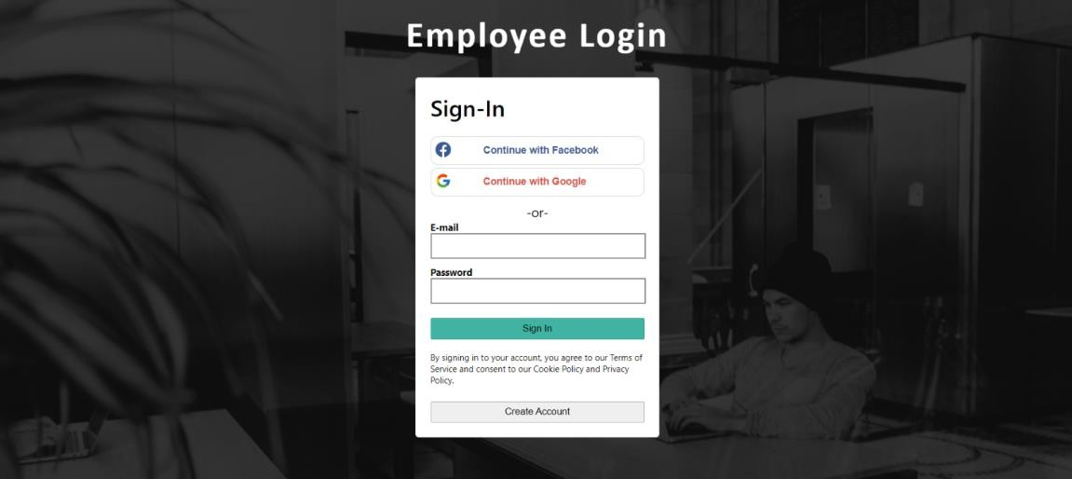

**Fig 10.2.1 Login Page**

* + 1. **Error Display On Login**

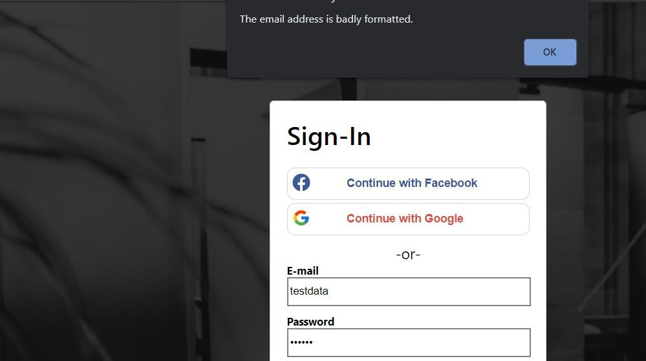Gives an error if details are incorrect while signing in

**Fig 10.2.2 Error Display On Login**

* + 1. **Sign In with Gmail**

Sign in Gmail



**Fig 10.2.3 Sign In with Gmail**

* + 1. **Login with Facebook**

Sign in Facebook

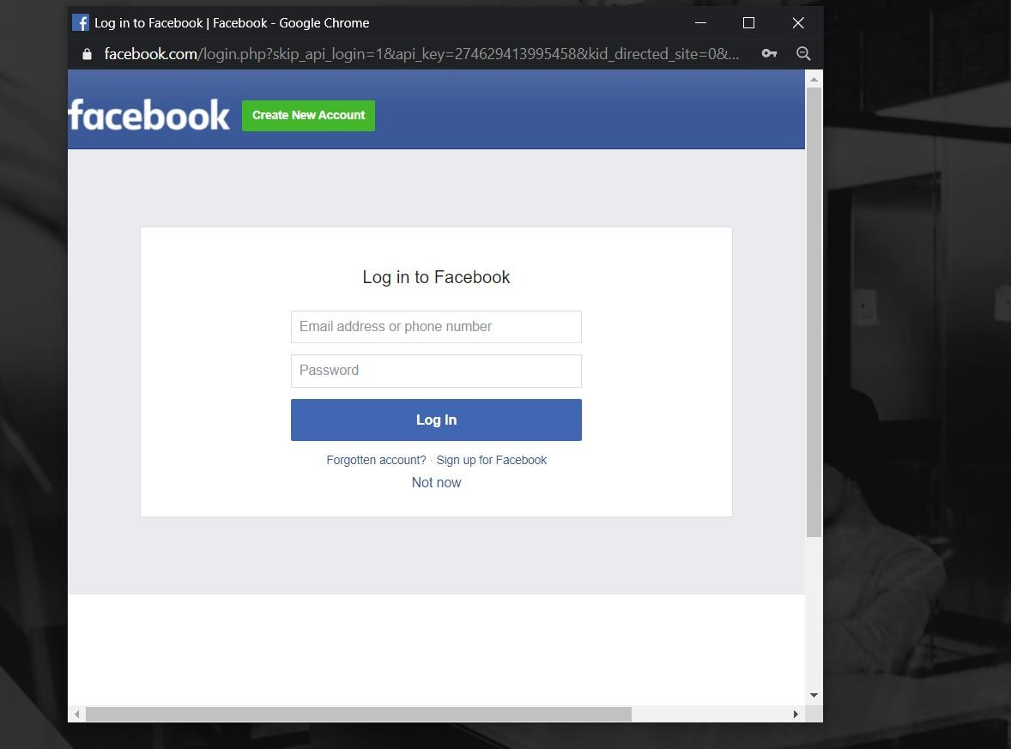

**Fig10.2.4 Login with Facebook**

* + 1. **Employee Main Page**

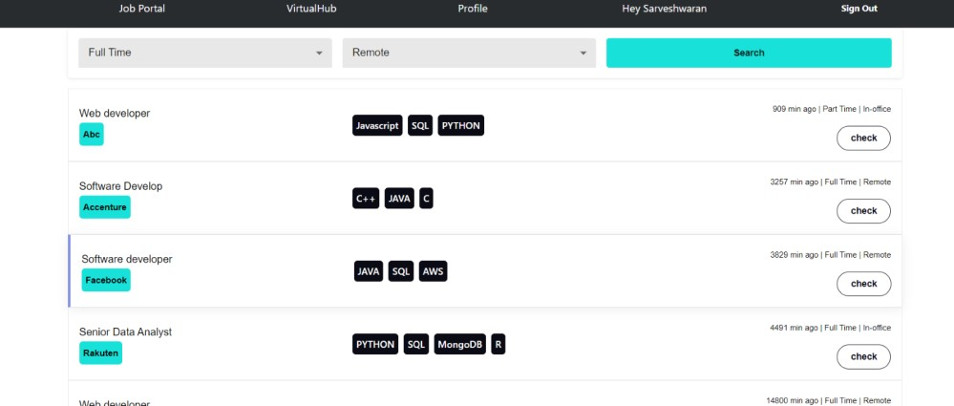Job Portal Page will be displayed after login, and user session is created

**Fig 10.2.5 Employee Main Page**

* + 1. **Filter Search**

User can filter their desired job and apply for it

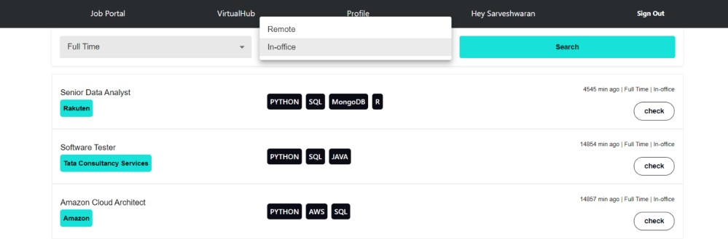

**Fig 10.2.6 Filter Search**

* + 1. **View Job**

User can view the job and apply for the same

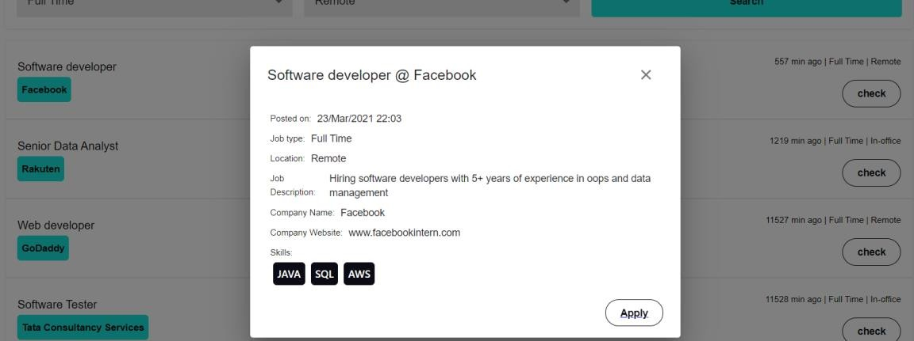

**Fig 10.2.7 View Job**

* + 1. **Quiz Session**

On clicking apply, User will undertake quiz to test their knowledge on the field.

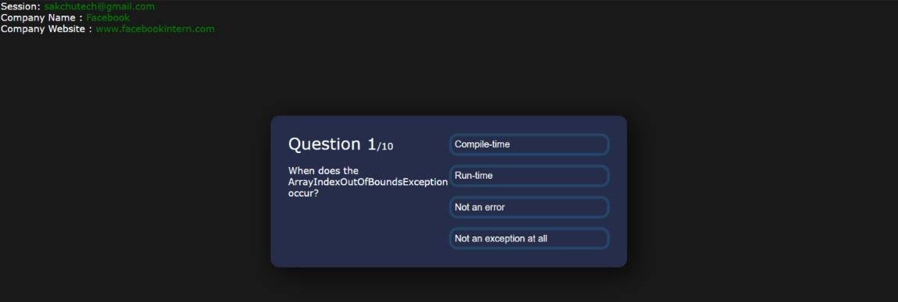

**Fig 10.2.8 Quiz Session**

* + 1. **Quiz End**

End of Quiz

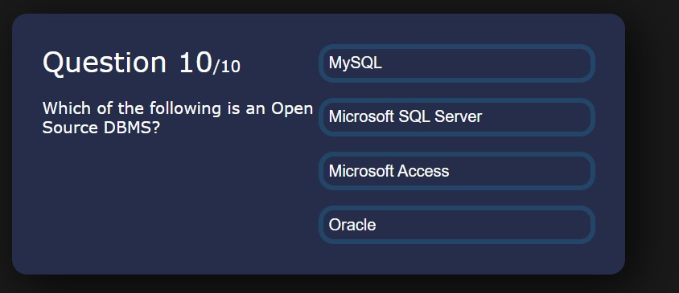

**Fig 10.2.9 Quiz End**

* + 1. **Apply After Quiz**

Apply for the job after Quiz

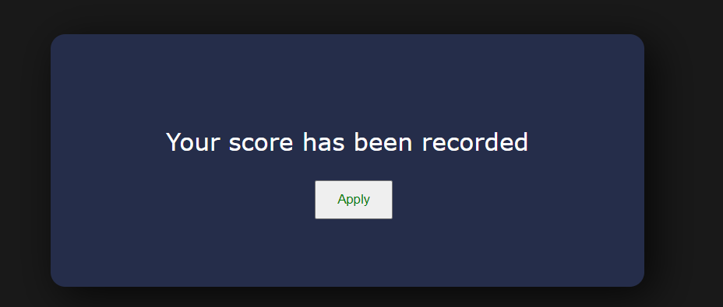

**Fig 10.2.10 Apply After Quiz**

* + 1. **Mail Sent to Employer**

Mail will be shared to the employer with user details and their resume

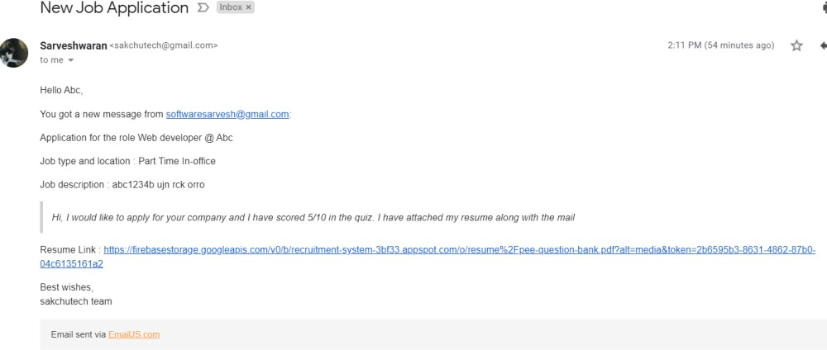

**Fig 10.2.11 Mail Sent to Employer**

* + 1. **Employee Profile**

Employee will have own profile page, where he/she can post and share their story or achievements.

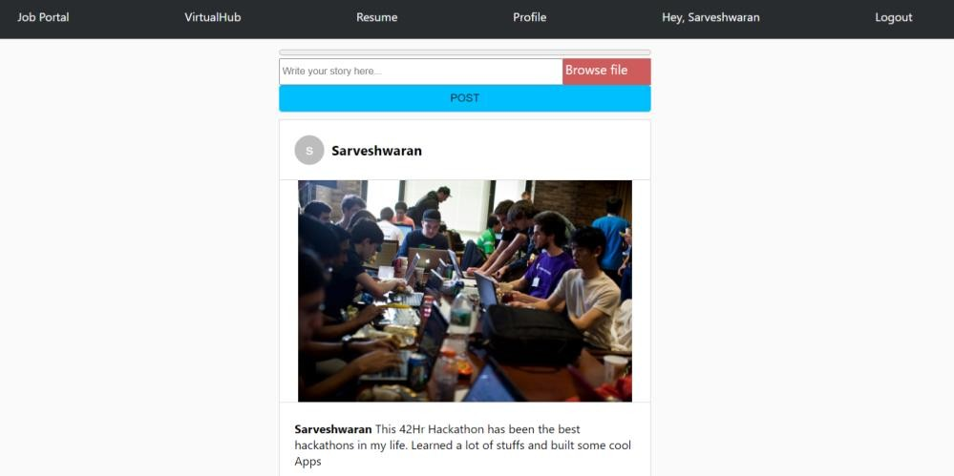

**Fig 10.2.12 Employee Profile**

* + 1. **Virtual Hub**

Post and stories of all the users can viewed globally as a Hub.

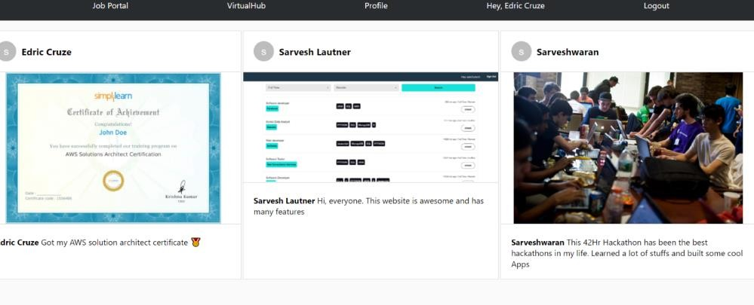

**Fig 10.2.13 Virtual Hub**

* + 1. **Resume Upload and Download**

Employee can upload their resume in their profile and also can download it later when needed, and it will be shared to the employer.

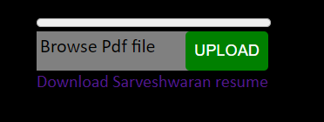

**Fig10.2.14 Resume Upload and Download**

* 1. **EMPLOYER PAGE**
     1. **Employer Login**

Login Page for Employer

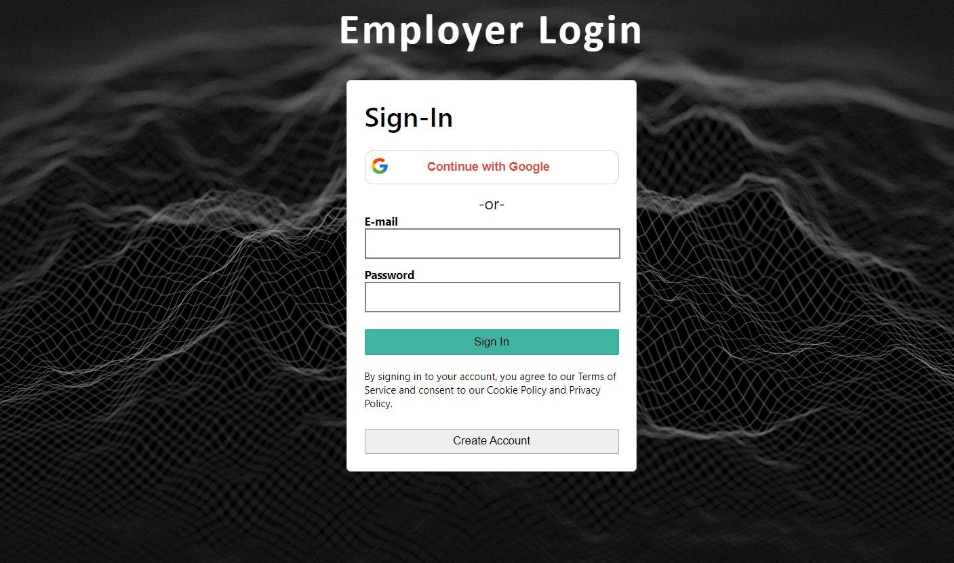

**Fig 10.3.1 Employer Login**

* + 1. **Employer Gmail Login**

Gmail Login



**Fig 10.3.2 Employer Gmail Login**

* + 1. **Post Job**

Employer can post job

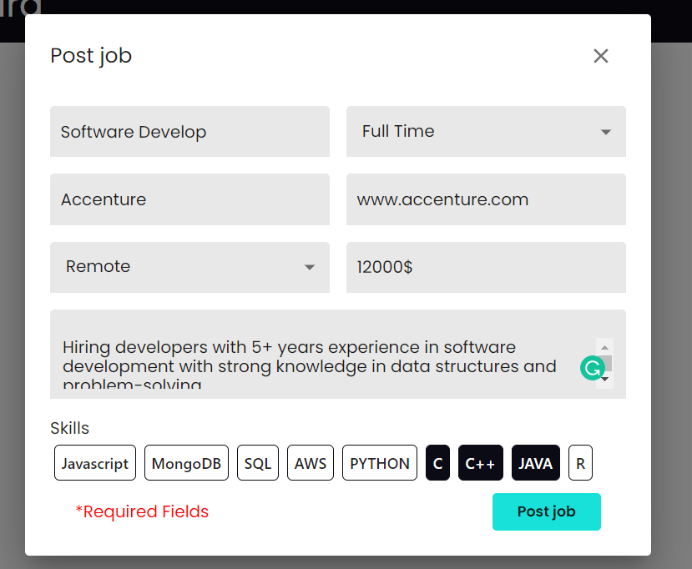

**Fig 10.3.3 Post Job**

* + 1. **Posted Job**

Posted Job of Employer

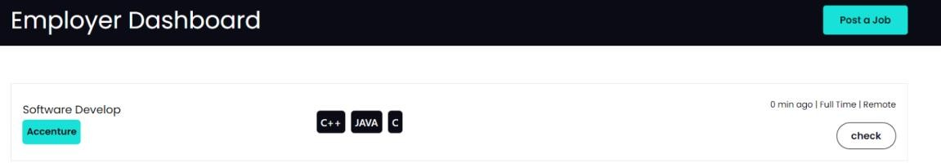

**Fig 10.3.4 Posted Job**

* + 1. **View Job**

View Posted Job

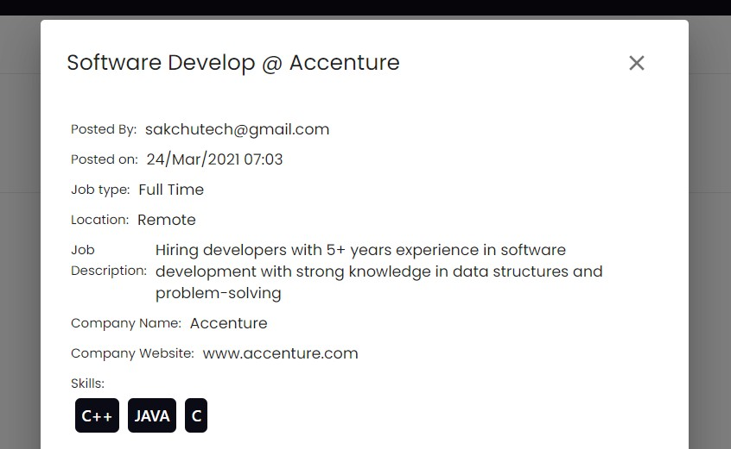

**Fig10.3.5 View Job**

* + 1. **Database Connectivity**

The backend database is been created and connected using Firebase

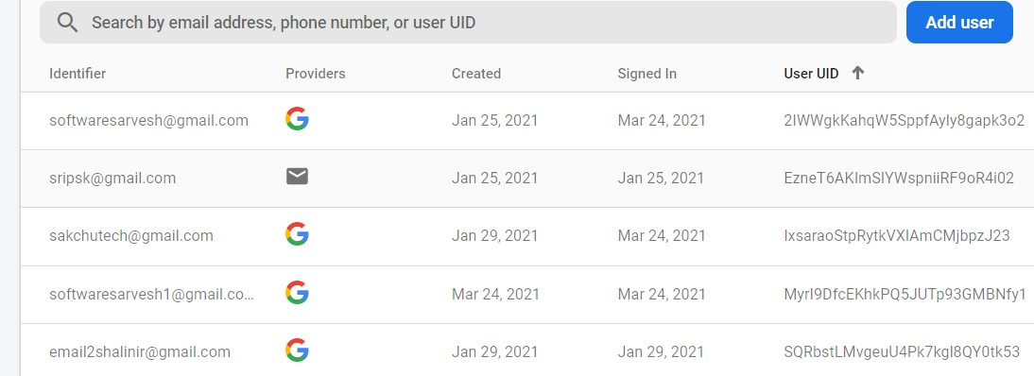

**Fig 10.3.6 Database Connectivity**

**Employer Job Database**

Job Database

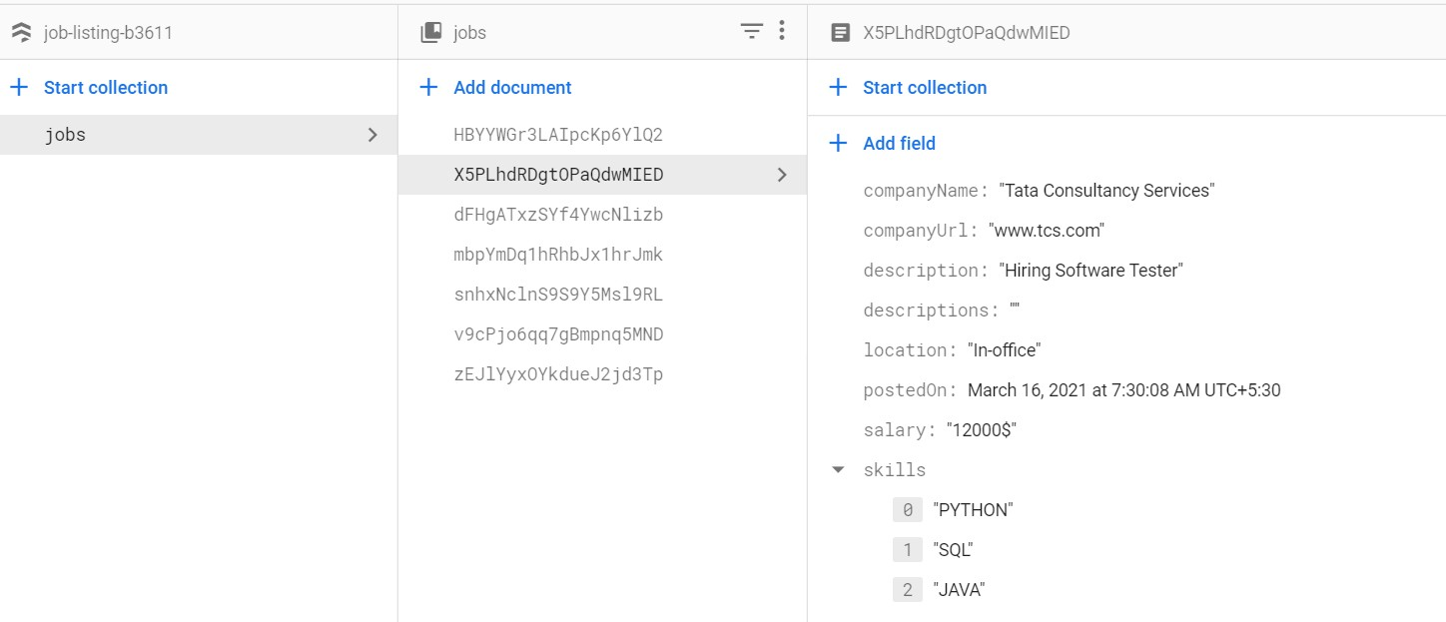

**Fig 10.3.7 Employer Job Database**