**Sarveshwaran_Spring_MVCLabSolution**

**🡪Output**

🡪**Below I provided the screenshots of all functionalities in this crud project.**

🡪 1).Print all records from the table.

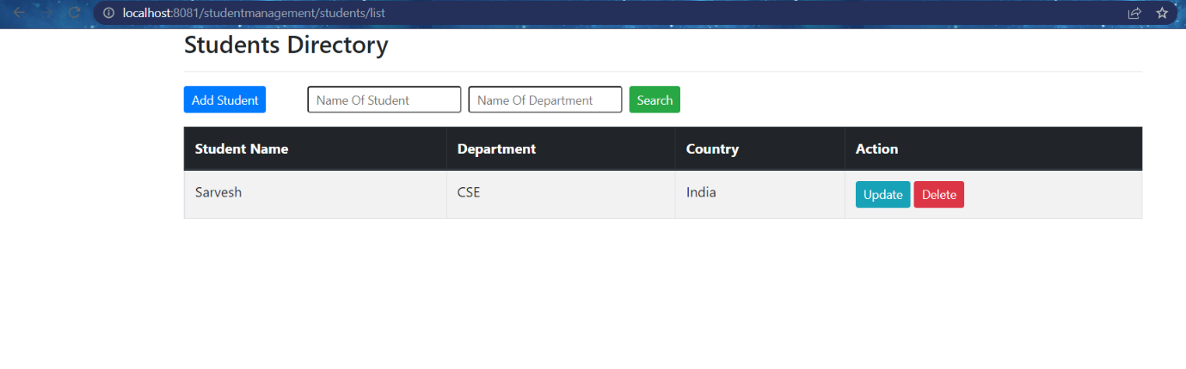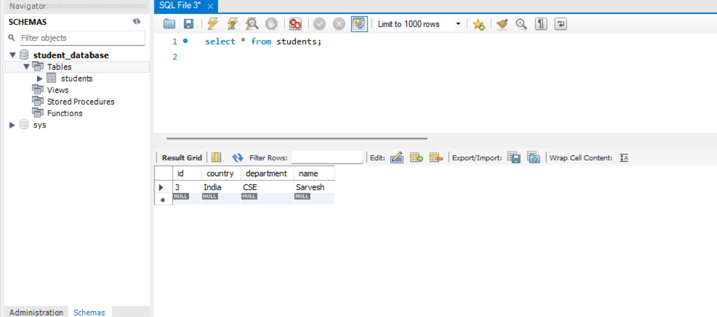

🡪 2).Insert new records into the table.

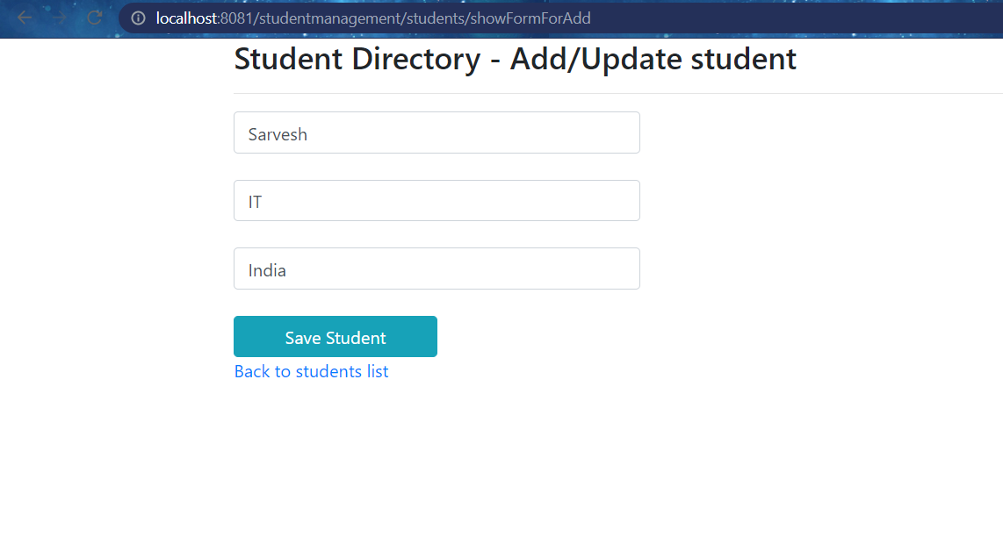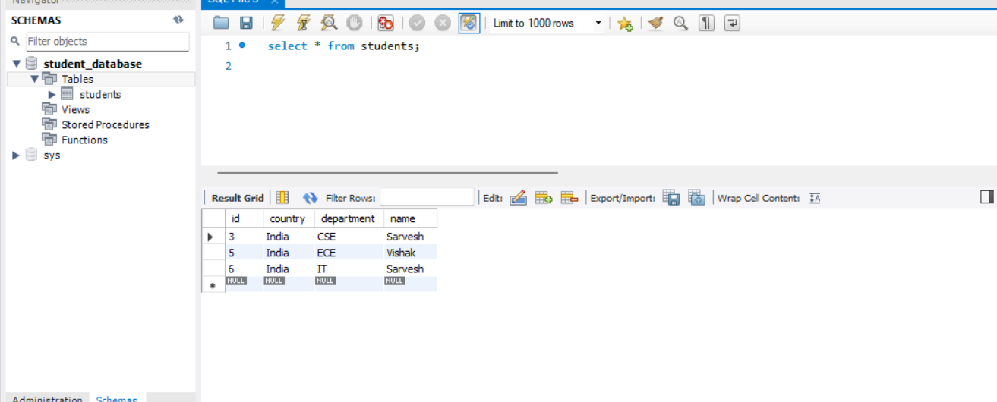

🡪 3).Update existing records into the table.

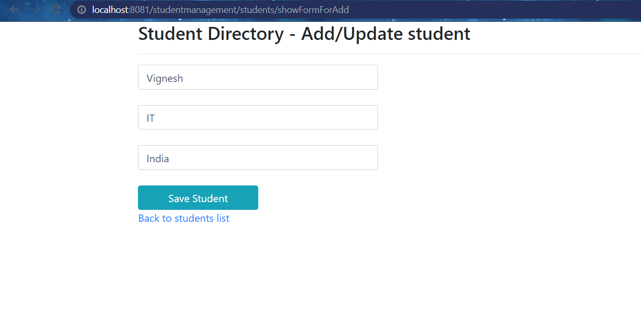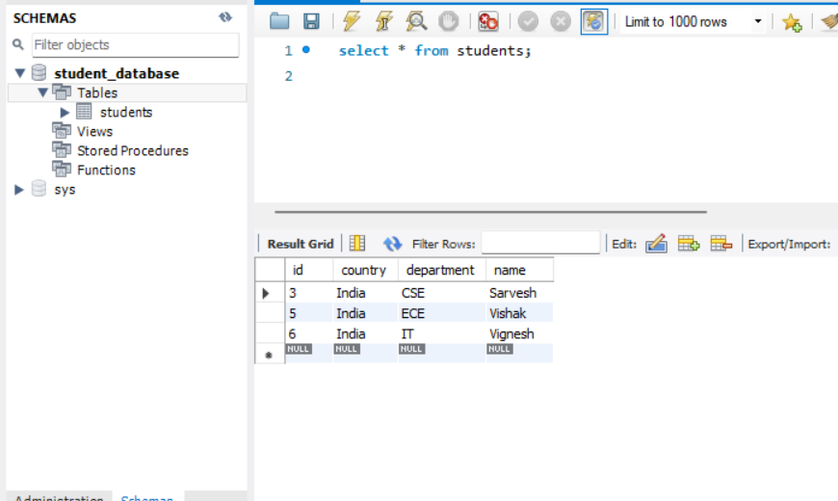

🡪 4).Delete existing records from the table.

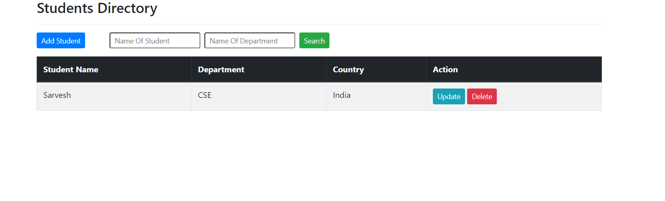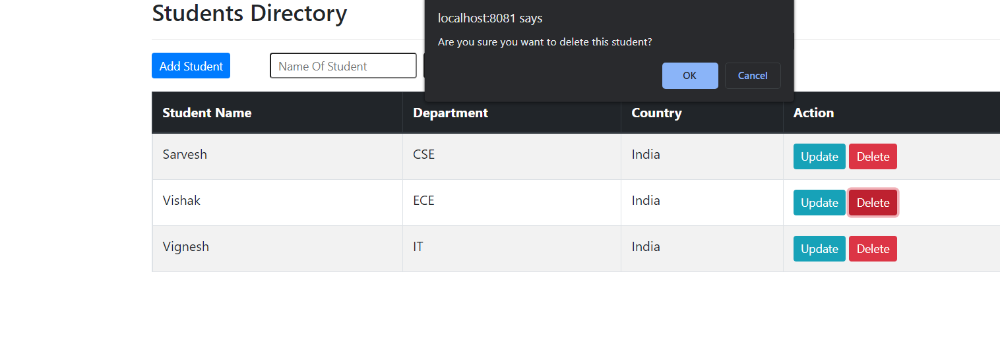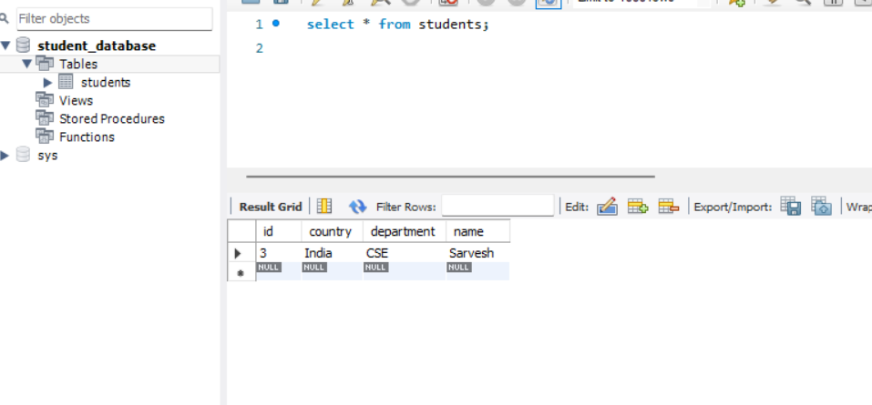

🡪 5).Search existing records from the table.

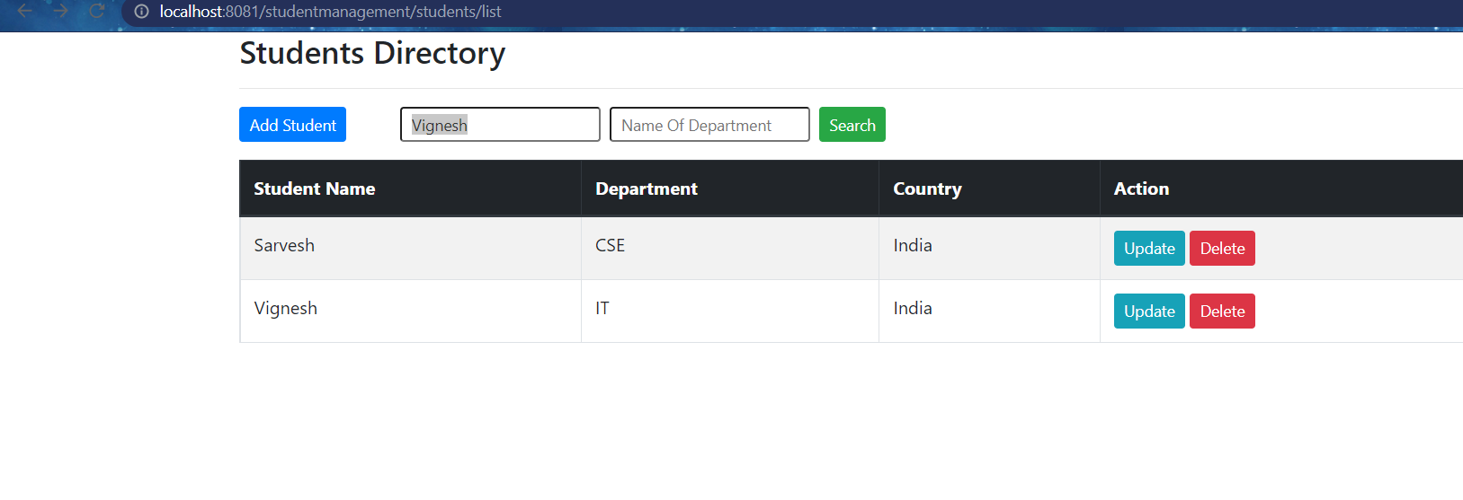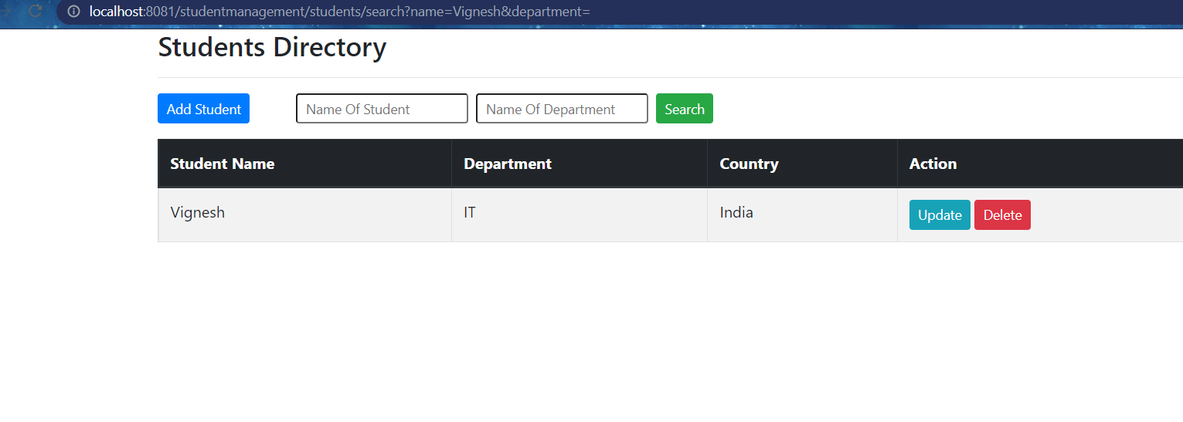

Thank you