Fraud Detection Analytics Dashboard Report

Dashboard Overview
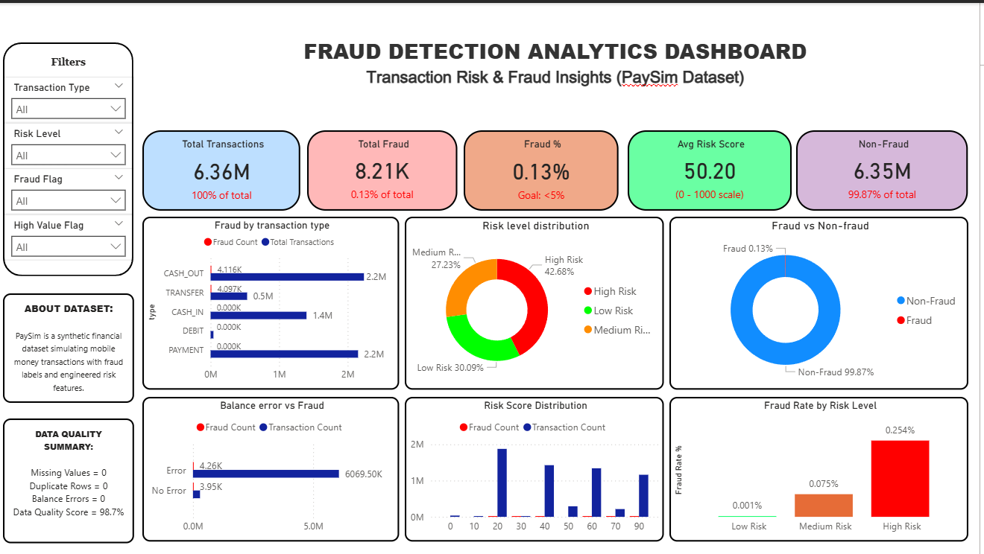
This dashboard provides a comprehensive overview of fraud detection insights using the PaySim dataset.
It is designed to support both Data Quality Engineers and Analytical Engineers in identifying patterns, validating data integrity,
and deriving actionable insights.

KPI Cards Analysis
The top KPI cards summarize key metrics:
- Total Transactions (6.36M): Indicates dataset scale.
- Total Fraud (8.21K): Shows fraud volume.
- Fraud % (0.13%): Highlights extreme class imbalance.
- Avg Risk Score (50.20): Represents overall risk level.
- Non-Fraud (6.35M): Confirms majority of transactions are legitimate.
Insight:
The dataset is highly imbalanced, requiring careful analytical and modeling approaches.

Fraud by Transaction Type
This chart shows fraud distribution across transaction types.
Key Insight:
- CASH_OUT and TRANSFER dominate fraud cases.
- PAYMENT, DEBIT, and CASH_IN show minimal fraud.
Business Value:
Helps prioritize monitoring on high-risk transaction types.

Risk Level Distribution
This donut chart shows the proportion of Low, Medium, and High-risk transactions.
Key Insight:
- Majority are Low Risk
- High Risk segment is smaller but critical
Engineering Value:
Validates effectiveness of risk scoring segmentation.

Fraud vs Non-Fraud
This visualization highlights the imbalance between fraud and non-fraud transactions.
Key Insight:
Fraud cases are extremely rare (~0.13%), reflecting real-world financial systems.
Analytical Impact:
Requires techniques like anomaly detection and class balancing.

Balance Error vs Fraud
Compares fraud occurrence in transactions with and without balance errors.
Key Insight:
Transactions with balance inconsistencies show higher fraud likelihood.
Data Quality Insight:
Balance validation is a strong fraud indicator.

Risk Score Distribution
Shows how transactions are distributed across different risk score bins.
Key Insight:
Higher risk score bins contain more fraud cases.
Analytical Value:
Validates scoring model effectiveness.

Fraud Rate by Risk Level
Displays fraud percentage across Low, Medium, and High risk levels.
Key Insight:
- High Risk → highest fraud rate (~0.25%)
- Medium Risk → moderate (~0.08%)
- Low Risk → negligible (~0.001%)
Business Value:
Helps prioritize investigation efforts.

Data Quality Summary
The dashboard confirms:
- No missing values
- No duplicate records
- No balance errors in final dataset
- Data Quality Score: 98.7%
Engineering Insight:
Indicates a clean and reliable dataset ready for analytics.

Conclusion
This dashboard demonstrates a complete data pipeline:
- Data ingestion and validation
- Feature engineering
- Risk scoring
- Business insight generation
For Data Quality Engineers:
Focus on validation rules and data integrity.
For Analytical Engineers:
Focus on feature creation, transformations, and insight delivery.
Overall, the system effectively identifies fraud patterns and supports decision-making.

