Fraud Detection: Data Quality & Analytical Engineering Report

Data Import & Initial Exploration
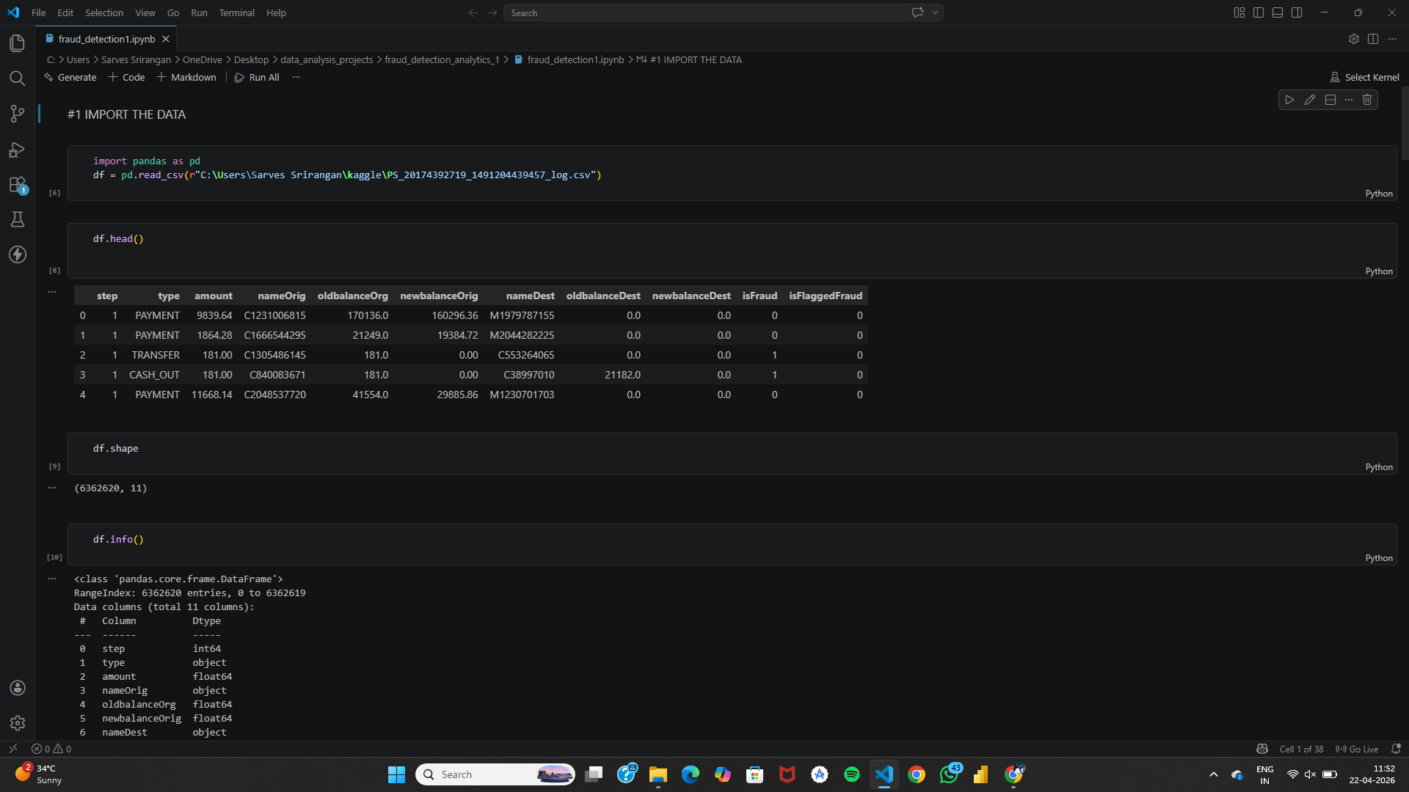
Business Question:
Is the dataset correctly loaded and structurally valid for analysis?
Explanation:
The dataset is imported using pandas and initial exploration functions like head(), shape(), and info() are used.
This step ensures correct schema, data types, and structure.
Data Engineering Insight:
This is the foundation of any data pipeline. Ensuring correct ingestion prevents downstream failures.

Statistical Summary & Class Imbalance
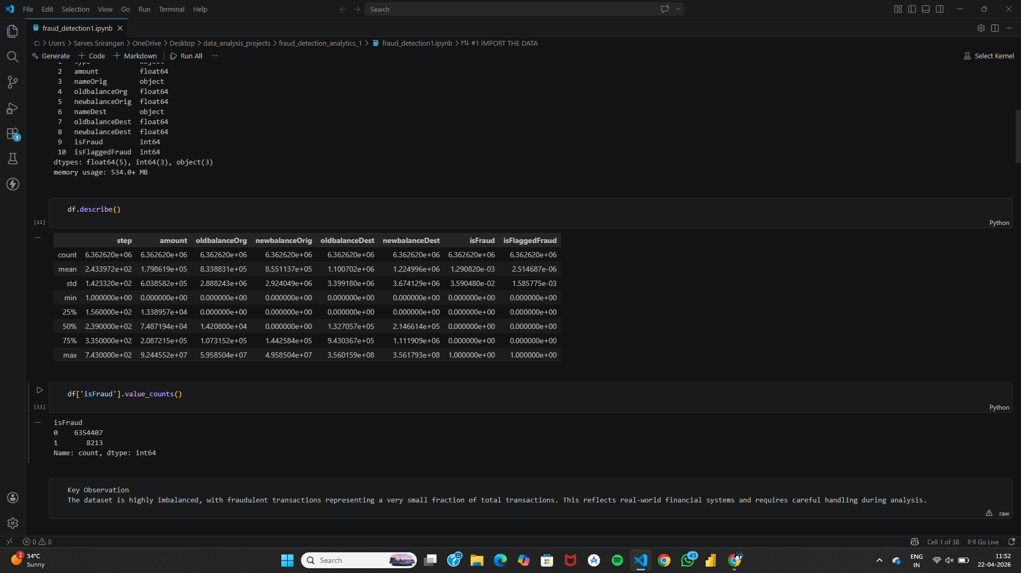
Business Question:
What is the distribution of data and fraud cases?
Explanation:
Using describe() and value_counts(), we analyze distributions and fraud imbalance.
Fraud cases are extremely low compared to normal transactions.
Analytical Insight:
Highlights real-world imbalance problem → critical for model design and evaluation.

Data Cleaning & Validation

Business Question:
Is the dataset clean and reliable?
Explanation:
Checks for missing values, duplicates, and transaction types.
Also validates negative or zero amounts.
Data Quality Engineering Insight:
Ensures high-quality, trustworthy data before analysis.

Data Integrity Checks

Business Question:
Do financial balances follow logical rules?
Explanation:
Validates whether old balance - amount equals new balance.
Detects inconsistencies in financial records.
Engineering Insight:
This is a key data quality rule in financial systems to detect anomalies.

Feature Engineering
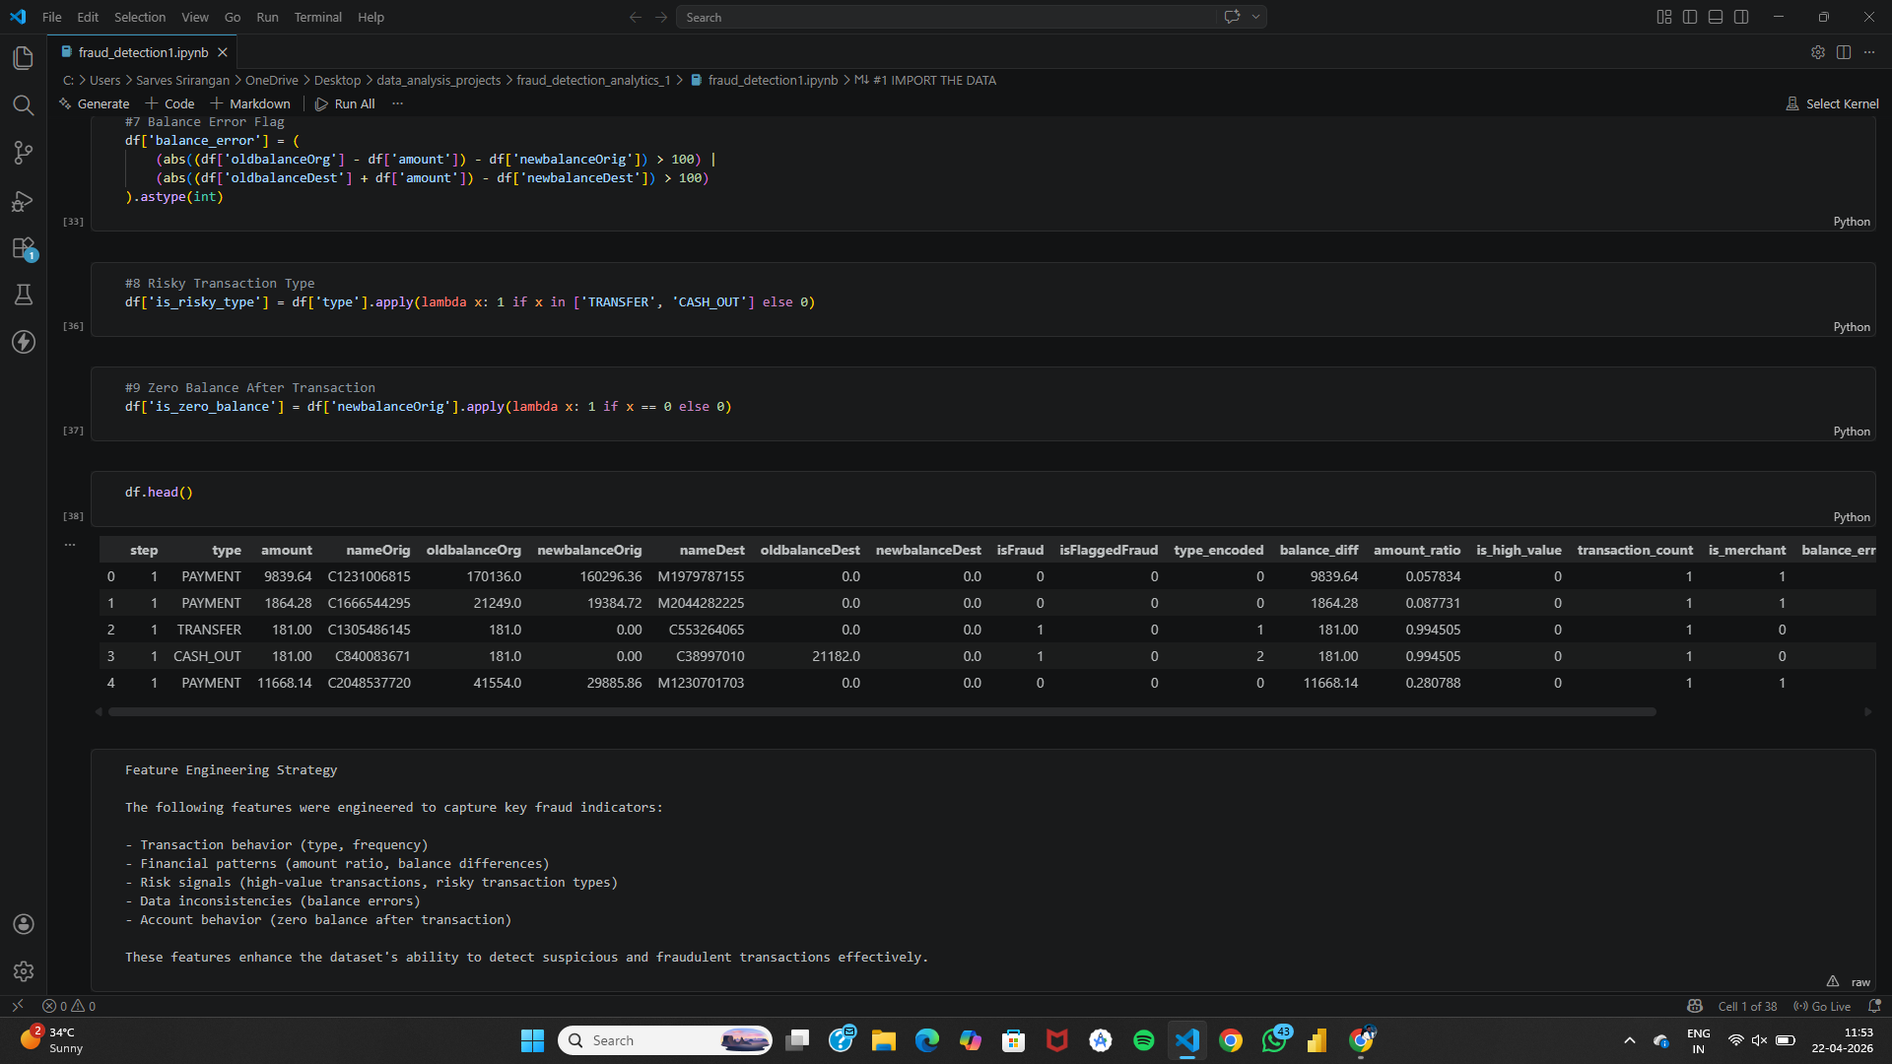
Business Question:
How can raw data be transformed into meaningful analytical features?
Explanation:
New features like balance_diff, amount_ratio, is_high_value, and transaction patterns are created.
Analytical Engineering Insight:
Transforms raw transactional data into enriched features for better insights.

Fraud Detection Logic

Business Question:
How can fraud be detected using rule-based logic?
Explanation:
Rules like high amount, risky transaction type, balance error, and frequency are defined.
Engineering Insight:
Rule-based systems provide interpretable and explainable fraud detection.

Risk Scoring & Model Evaluation
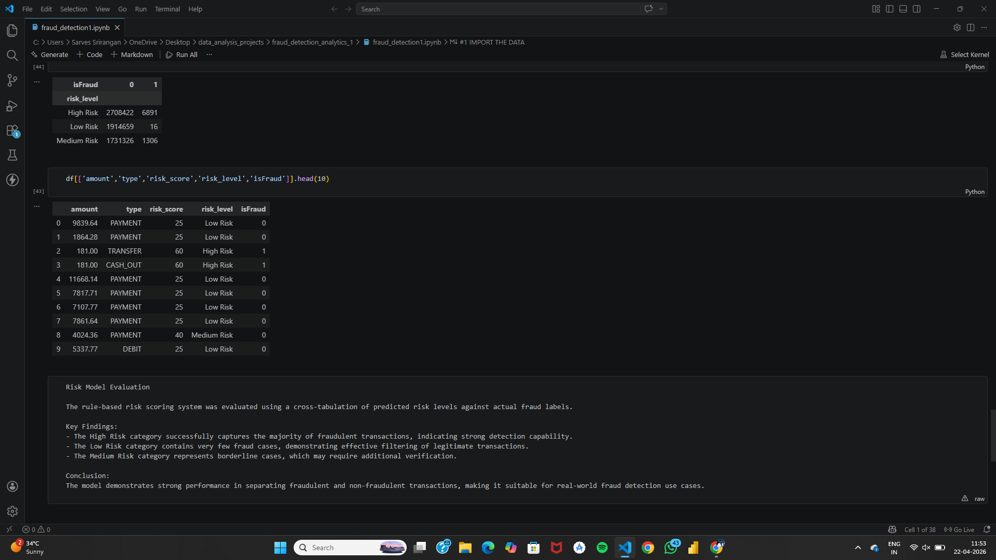
Business Question:
How effective is the fraud detection system?
Explanation:
Risk scores are calculated and classified into Low, Medium, High.
Cross-tabulation compares predicted risk vs actual fraud.
Analytical Insight:
Validates effectiveness of scoring system and supports decision-making.

