Top Fraudulent Customers
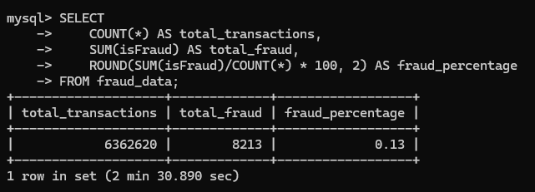
Business Question: Who are the top customers involved in fraudulent transactions?
Explanation:
This query groups transactions by sender (nameOrig) and counts total transactions and fraud cases.
It filters only those with fraud and shows top 10 users with highest fraud activity.
This helps identify suspicious accounts for monitoring or blocking.

Fraud by Risk Score
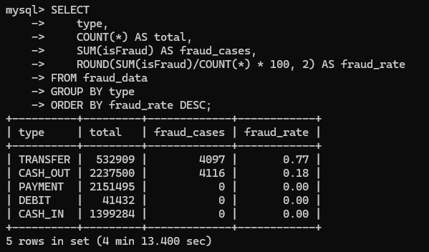
Business Question: How does fraud vary across different risk scores?
Explanation:
This query groups data by risk_score and calculates total transactions and fraud cases.
It shows that higher risk scores correspond to higher fraud occurrences, validating your risk scoring model.

Balance Error vs Fraud
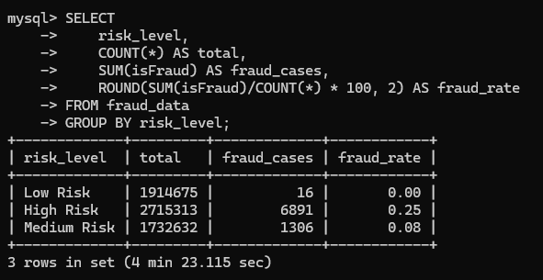
Business Question: Does balance inconsistency indicate fraud?
Explanation:
This query compares transactions with and without balance errors.
Fraud rate is calculated for both groups, showing whether inconsistencies are strong fraud indicators.

High Value Transactions vs Fraud
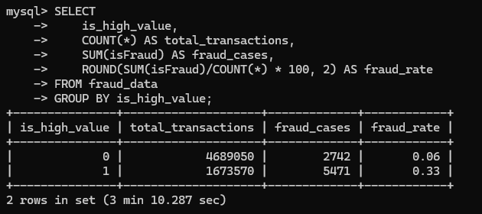
Business Question: Are high-value transactions more prone to fraud?
Explanation:
This query compares fraud rates between high-value and normal transactions.
Higher fraud rate in high-value transactions suggests priority monitoring is needed.

Fraud by Risk Level
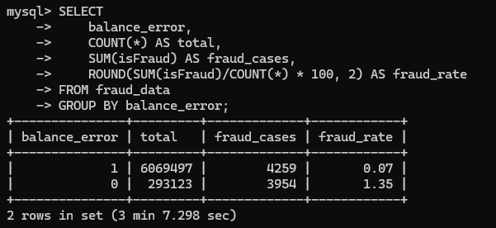
Business Question: Which risk level category has the highest fraud?
Explanation:
This query groups transactions by risk level (Low, Medium, High).
It shows fraud rate increases significantly with higher risk levels.

Fraud by Transaction Type
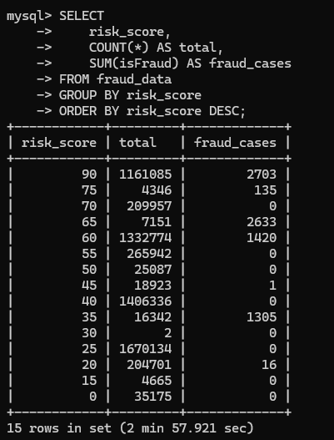
Business Question: Which transaction types are most vulnerable to fraud?
Explanation:
This query analyzes fraud by transaction type.
It reveals that TRANSFER and CASH_OUT have the highest fraud rates, indicating system exploitation patterns.

Overall Fraud Summary
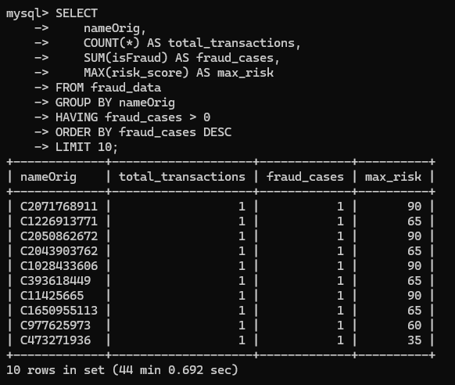
Business Question: What is the overall fraud percentage in the dataset?
Explanation:
This query calculates total transactions, total fraud cases, and fraud percentage.
It highlights the dataset imbalance (~0.13% fraud), which is critical for modeling and analysis.

