SQL-Workbench: Task

1: Find all tables in your database Task

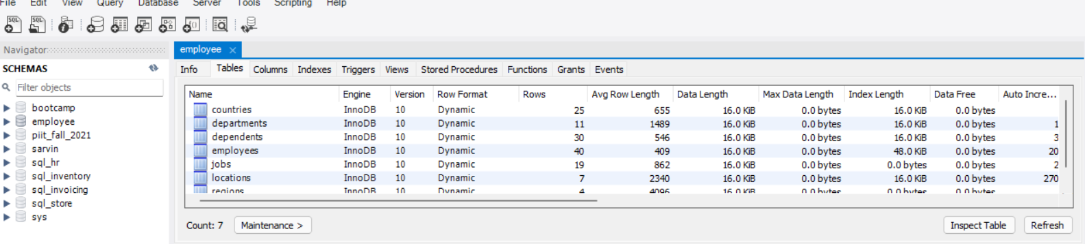

2: Write a query for to get all Employees from Employee table Task

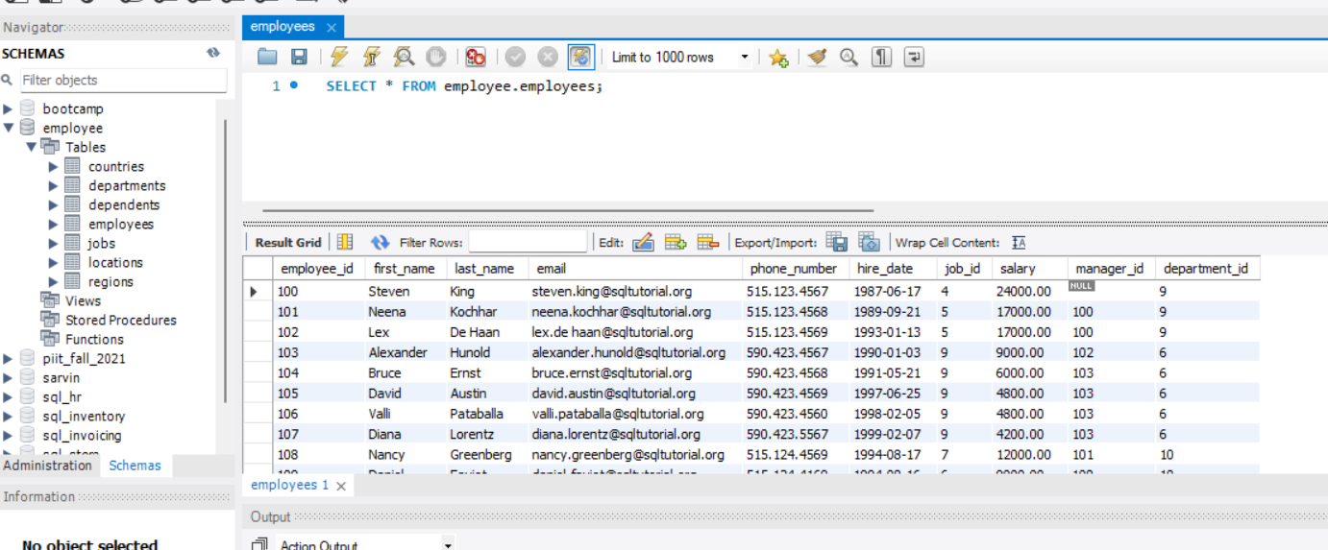

3: Write a query for to get the details of Employee for Second highest salary.

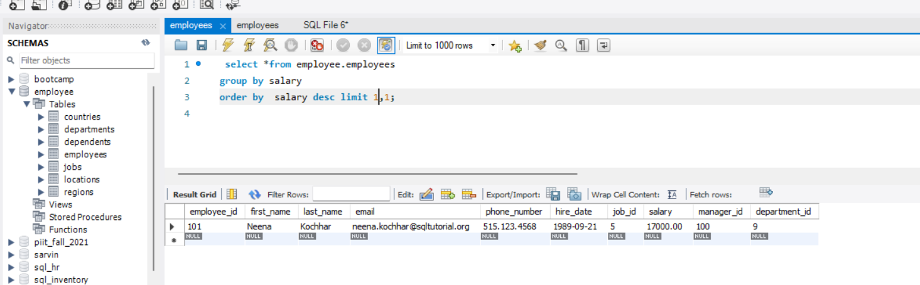

4: Write a query to get the minimum, maximum, and average salary of employees in each department.

Max salary

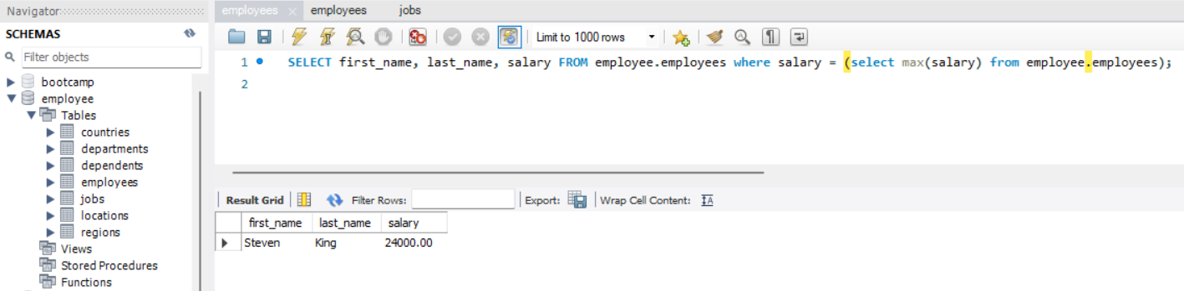

Min salary

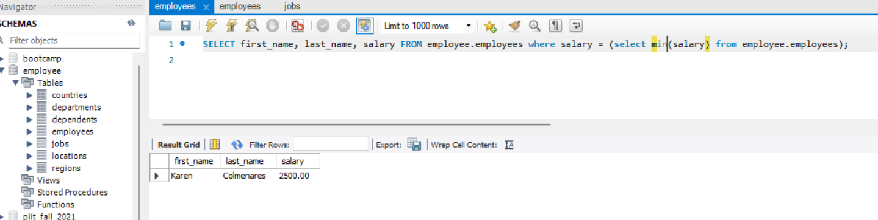

Average Salary

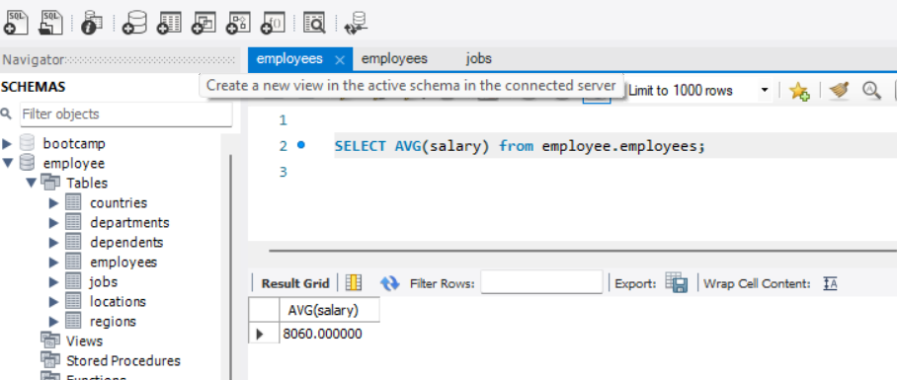

5: Write a query To get all employees who joined the company after January 1st, 1999

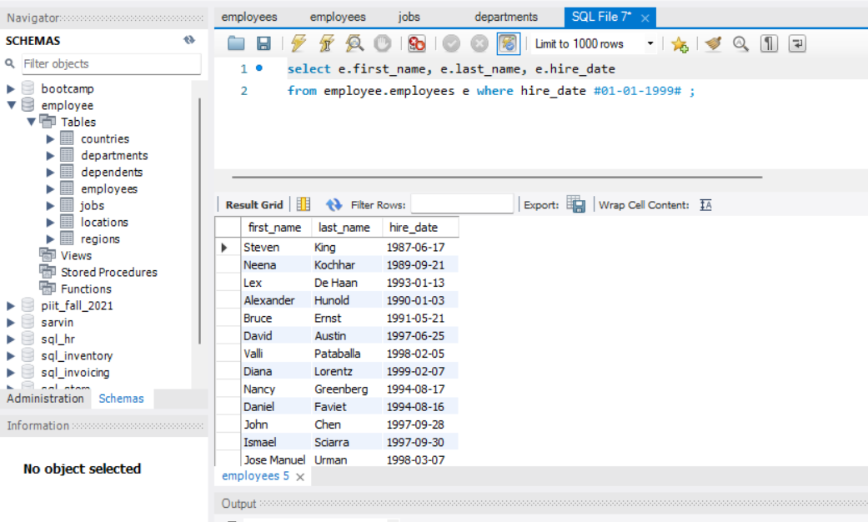

6: Write a query to finds all employees who have dependents.

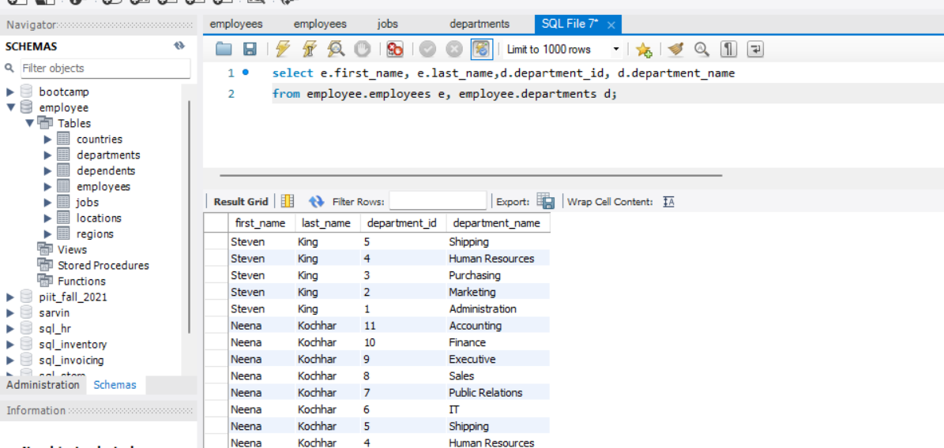

7: Write a query to find employees who work in the Marketing and Sales departments

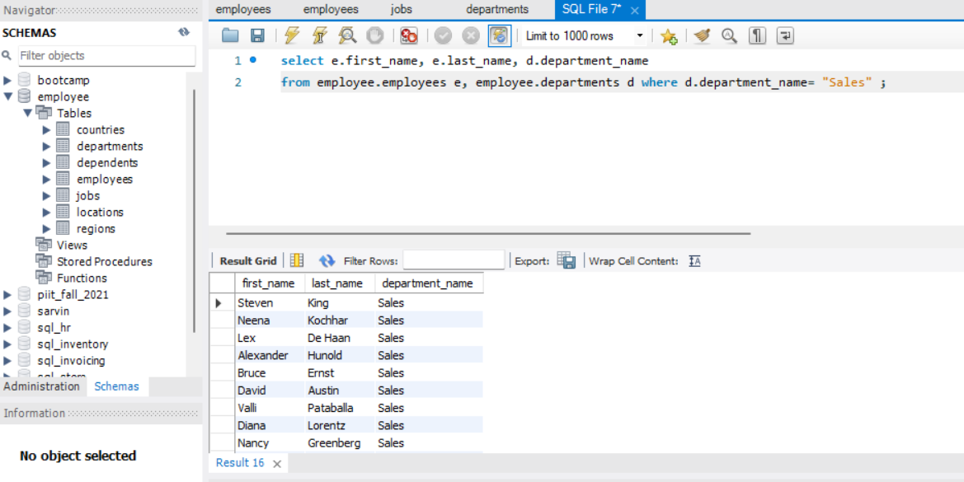

9: Write a query to the country names of US, UK, and China

11: . Write a query to join region, countries, and location

12: Write a query to get all available tables from your database?

**API Manual**