Assignment 3.1

1. A TV sales data is saved in vm and read as shown below

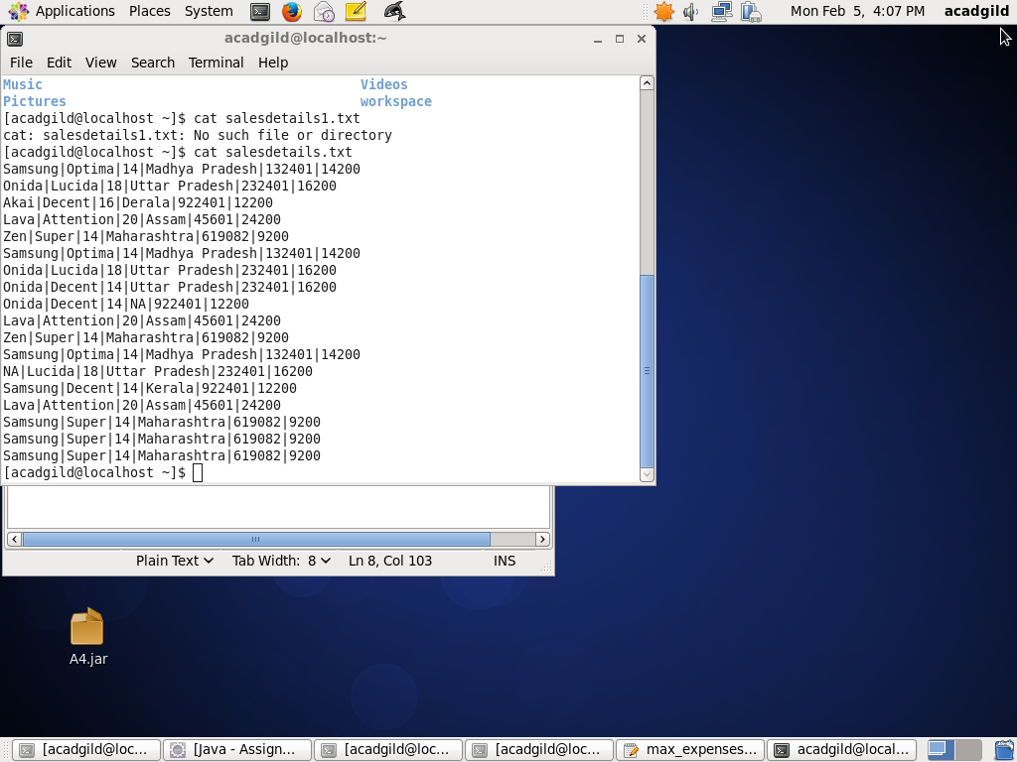

1. In the above sales data there are some records with NA in company name and product name below program is to find out such records. Map only job is programmed for this.

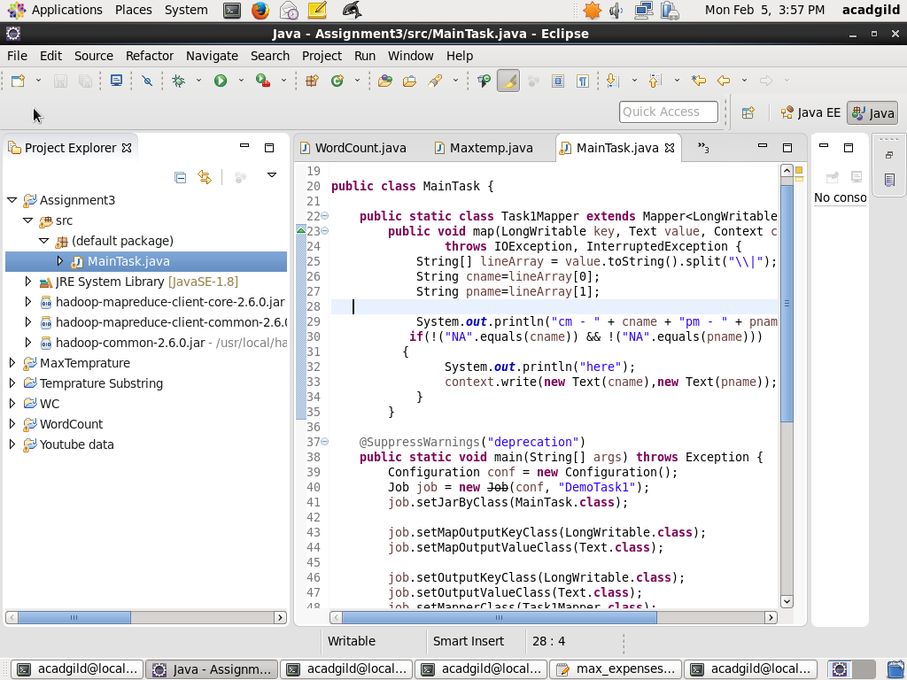

1. To execute above program in hadoop mode firstly the source file is exported in jar file on to desktop or any desired location , then in the virtual machine from the location using the below command the jar file is given input to execute and the output is extracted as shown below

$ hadoop jar A3.jar /user/acadgild/shabbu/salesdetails1.txt /joutput

