Assignment 6.2

1. **Fetch data from temperature_data where zip code is greater than 300000 and less than 399999**

By applying condition on the temperature_data table below is the result

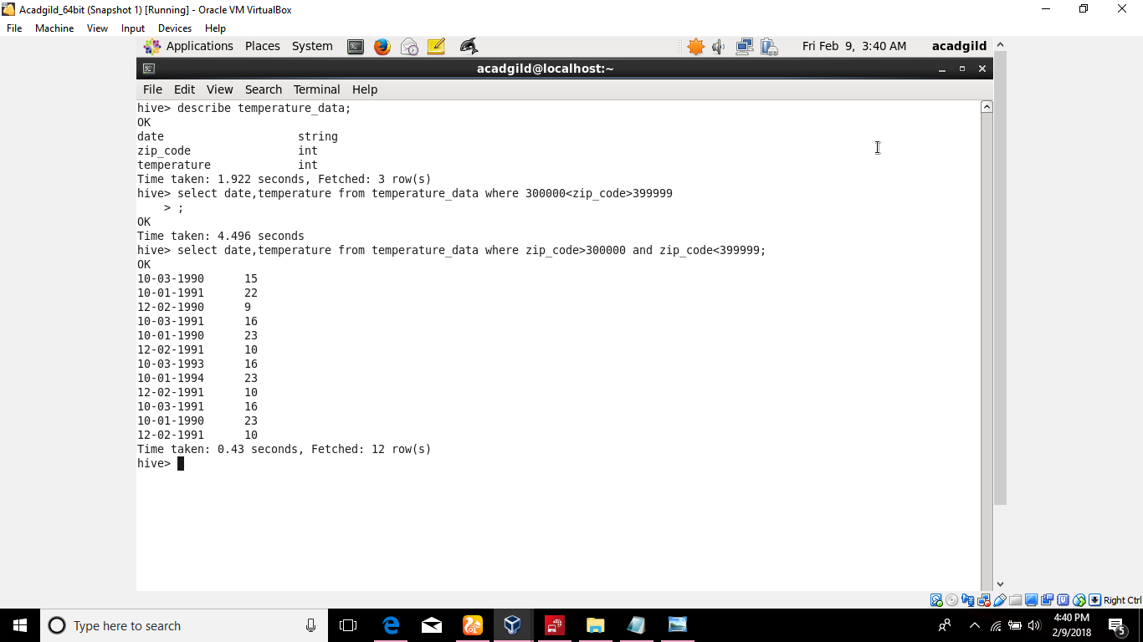



**2.Calcualte maximum temperature from temperature_data corresponding to each year.**