Assignment 7.1

**Calculate number of employees corresponding to skill from the table employee details given in the demo.**

1. First the emp_demo.txt is saved on Desktop of acadgild VM
2. Now a table name emp_details is created using create statement as shown below

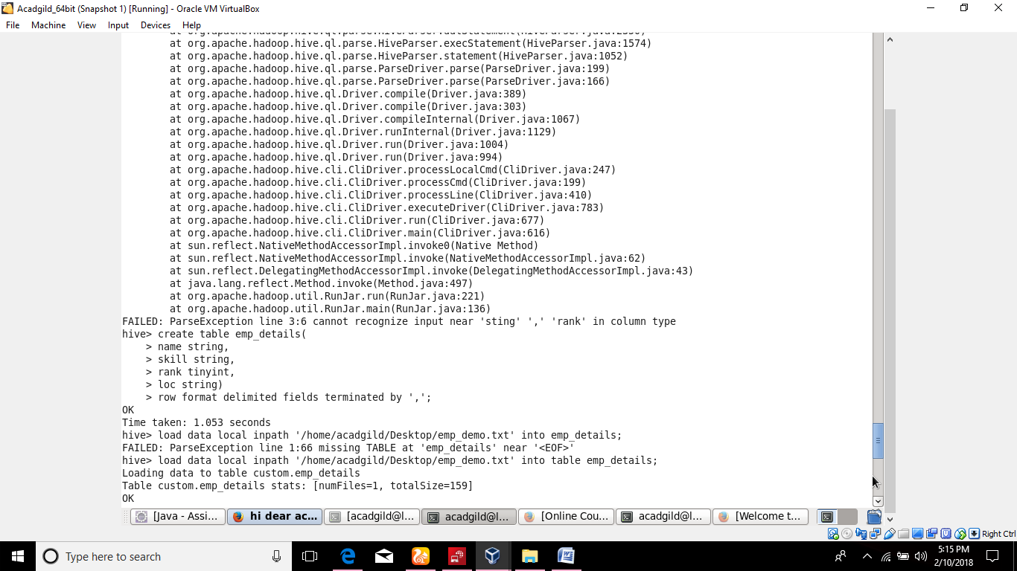

1. Emp_demo.txt is loaded using load statement as shown below.



1. Content of emp_details is viewed as shown below.

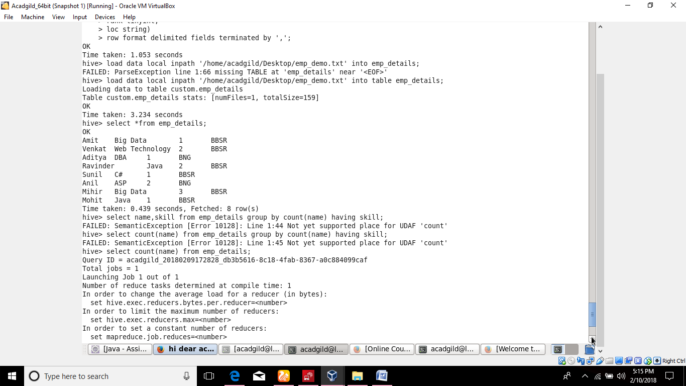

1. Number of employees with the same skill is displayed using count()and group by clause as shown below.

