**Assignment 9.2**

1. **Create an HBase table named ‘clicks’ with the column family hits such that it should be able to store last 5 values of qualifiers inside ‘hits’ column family.**

* Here is the HBase table created as below ,as mentioned able to store last 5 values of qualifiers inside hits so here versions is given the value 5 as below

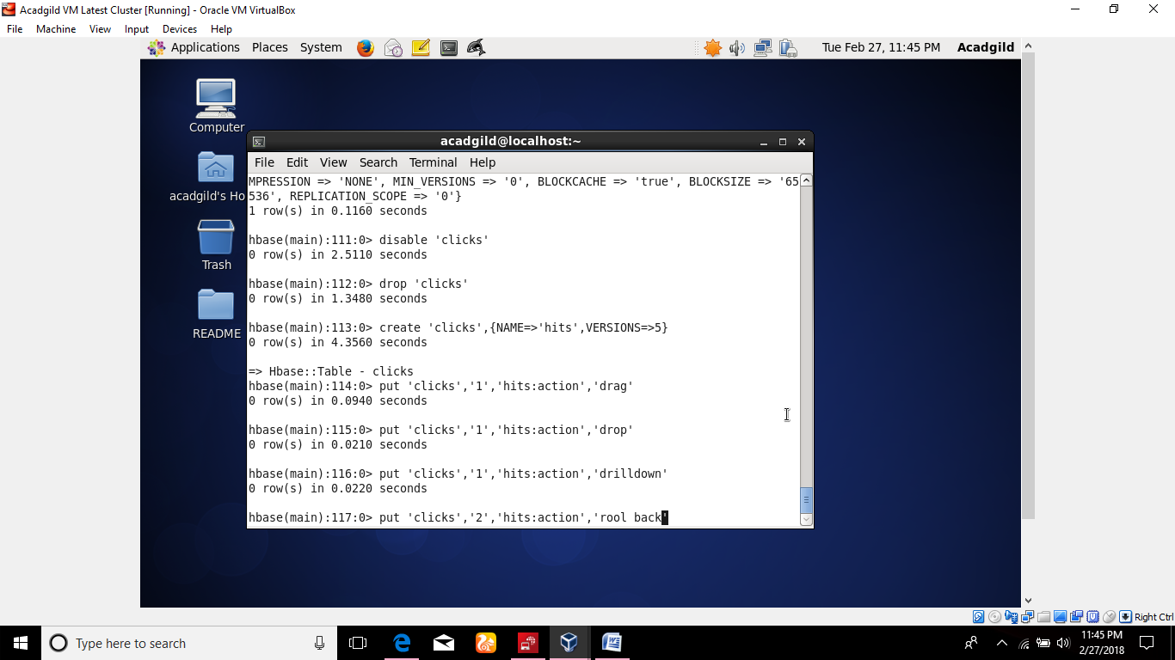

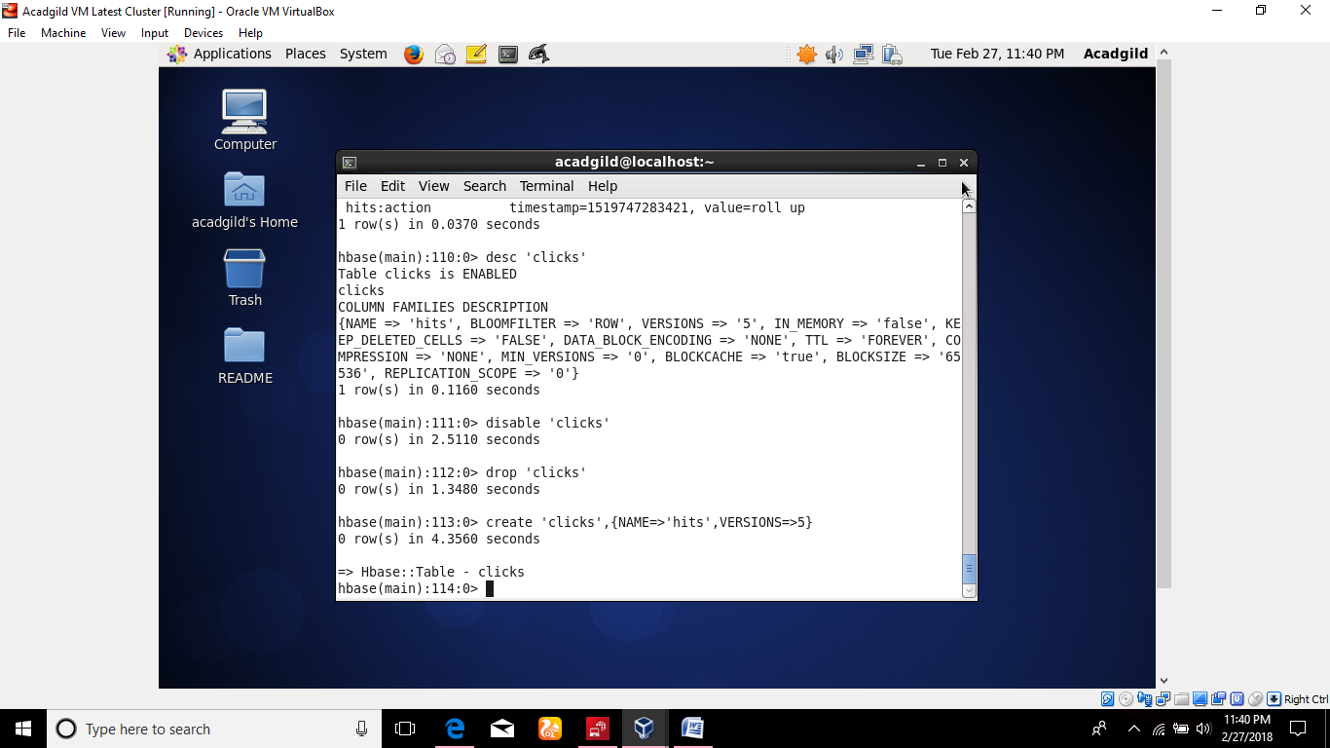

**Problem:2**

**Add few records in the table and update some of them. Use IP address as row-key. scan the table view if all the previous versions are getting displayed.**

**Here as below some records are updated into the clicks table**

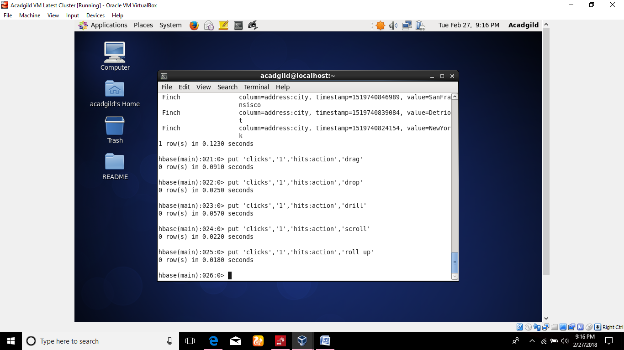

**Here are the following records presents accessed using get**

