**Project 1.2 - State-Wise Development Analysis in India**

Contents

1. Project Overview ........................................................................................................ 2

2. Product/Service Description…………......................................................................... 2

2.1 Assumptions…........................................................................................................... 2

2.2 Constraints.................................................................................................................. 2

3. Requirements…............................................................................................................ 2

4. Dataset ...........................................................................................................................2

5. Problem statement…..................................................................................................... 2

Problem Statement1 - Find out the districts who achieved 100 percent objective in BPL cards Export the results to MySQL using sqoop ...……................................................. 3

Task 1 – Place Dataset in the target using flume………………..................................... 4

Task2 – Create folders in the HDFS to store the outputs ……….....................................4

Task3 – Create Database and the Tables in the MySQL…...............................................5

Task4 - PIG query to process XML and store into PIG table…………........................... 6

Task5 – Find the districts who achieved 100 percent objective in BPL cards.................. 7

Task6 – Verifying the stored results in the HDFS………………......................................7

Task7 – Export the results into MySQL using sqoop…................................................... 10

Task8 – verify the data exported to MySQL.................................................................... 11

Problem statemet2 - Write a Pig UDF to filter the districts which have reached 80% of objectives of BPL cards. Export the results to MySQL using Sqoop.............................. 13

Task1 – Create a PIG UDF using Java ............................................................................ 13

Task2 - Write PIG query to find out the districts who achieved 80 percent objective in BPL cards......................................................................................................................... 14

Task3 – verify the result stored in the HDFS ..................................................................14

Task4 – Export the results into MySQL table using sqoop command……….……........23

Task5 – Verify the result in the MySQL .........................................................................24

**1. Project Overview**

To develop the System to analyze the log data (In XML format) of government progress of various development activities.

**1.1 Purpose and Scope of this Specification**

The following requirement will be addressed in phase 1 of Project:

• Developing system to handle the incoming log feed and store the information in Hadoop Cluster (Flume)

• Analyze the data and understand the progress

• Store the results in Hbase/RDBMS

**Out of scope**

We can use this data and visualization and get more insights

**2. Product/Service Description**

**2.1 Assumptions**

Log will be generated in XML format and stored in a server.

**2.2 Constraints**

Describe any item that will constrain the design options, including

• This system may not be used for searching for now. But it will be used for analysis and saving the relevant information as of now.

• System will be using mySql as a database

**3. Requirements**

• The FLUME job which will format the data and place the data to HDFS

• Pig/MapReduce job for parsing the XML data.

• Create Pig scripts/MapReduce jobs to analyze the data

• Create the Sqoop job to store the data in database

Priority Definitions

The following definitions are intended as a guideline to prioritize requirements.

• **Priority 1** – Create FLUME job for fetching log files from spool directory the data

• **Priority 2** – MapReduce/pig job to preprocess

**4. Dataset**

Download the dataset using the below link:

Link:

https://drive.google.com/file/d/0Bxr27gVaXO5sUjd2RWFQS3hQQUE/view?usp=sharing

Refer the below steps to understand the actual steps to create the above project.

**Step 1:**

Copy dataset from local file system to HDFS using flume.

Note: use the conf file by downloading from below link.

filecopy.conf

**Command:**

***flume-ng agent –n agent1 –c conf –f <path to filecopy.conf>***

**Step 2:**

Input file is in the XML format use Map reduce or pig to parse the data and get the results for the below problem statements.

**5. Problem statement**

1. Find out the districts who achieved 100 percent objective in BPL cards Export the results to mysql using sqoop

2. Write a Pig UDF to filter the districts which have reached 80% of objectives of BPL cards. Export the results to MySQL using Sqoop.

**PROJECT EXECUTION**

Problem Statement1 - Find out the districts who achieved 100 percent objective in BPL cards Export the results to mysql using sqoop

**Task 1 – Place Dataset in the target using flume**

Place the flume config file provided at the location, **/home/acadgild/apache-flume-1.6.0-bin/conf**

Copy the dataset downloaded from the link from local file system to HDFS using flume using the below command,

***flume-ng agent -n agent1 -c conf -f /home/acadgild/apache-flume-1.6.0-bin/conf/filecopy.conf***

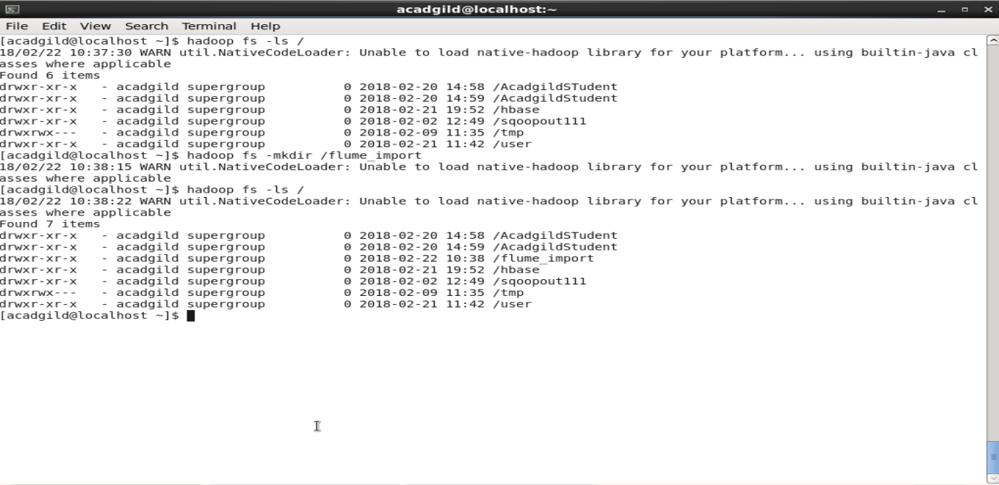

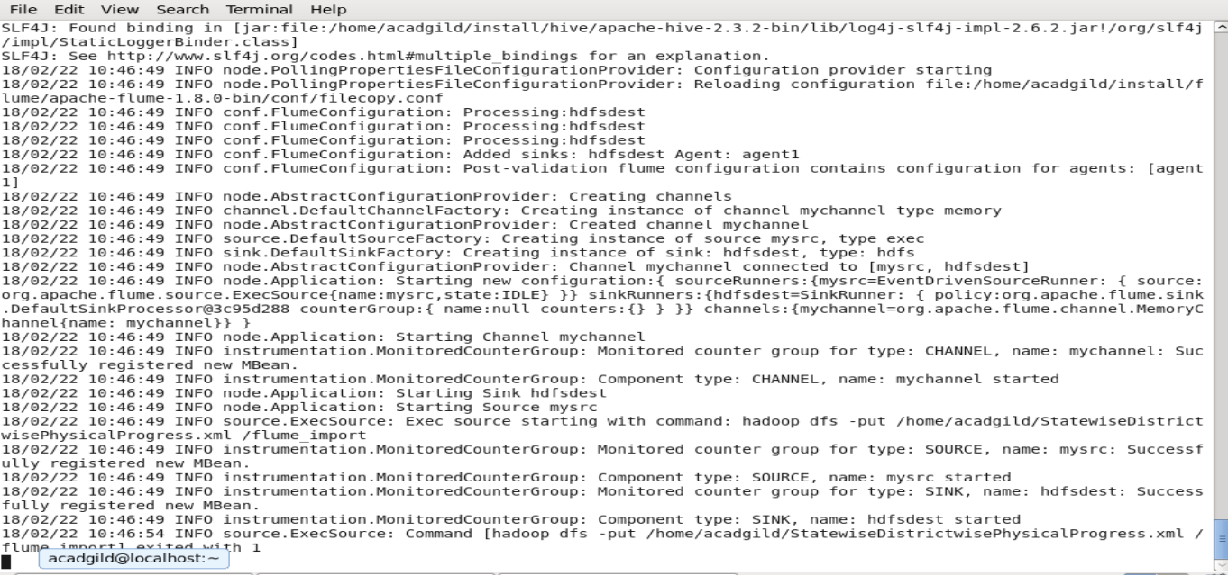

Verify whether the file is copied in the target,

***Hadoopfs –ls /flume_import***

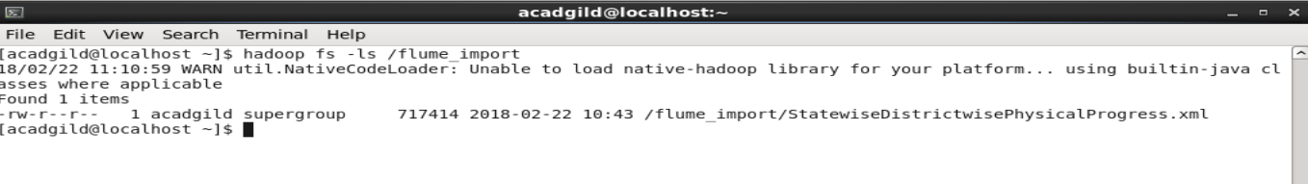

**Task2 – Create folders in the HDFS to store the outputs,**

Create 2 folders in the HDFS where we are going to store the output from PIG execution,

***hadoopfs -mkdir districts_100per_objectives***

***hadoopfs -mkdir districts_80per_objectives***

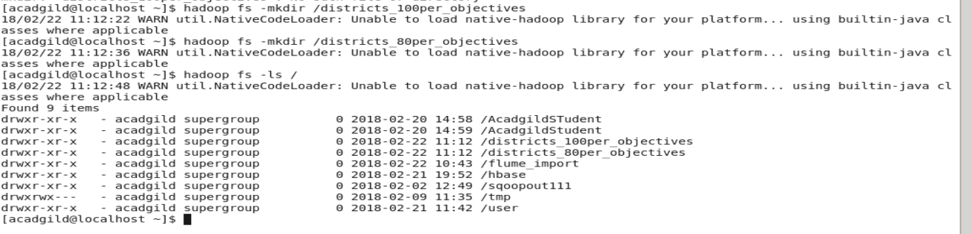

**Task3 – Create Database and the Tables in the mysql**

Start mysql>sudo service mysqld start

Login as root user,

***create database project_bpl_cards;***

***useproject_bpl_cards;***

***create table districts_100percent_objective (district_namevarchar(50));***

***create table districts_80percent_objective (district_namevarchar(50));***

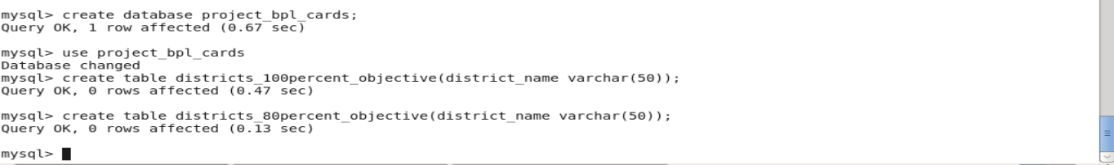

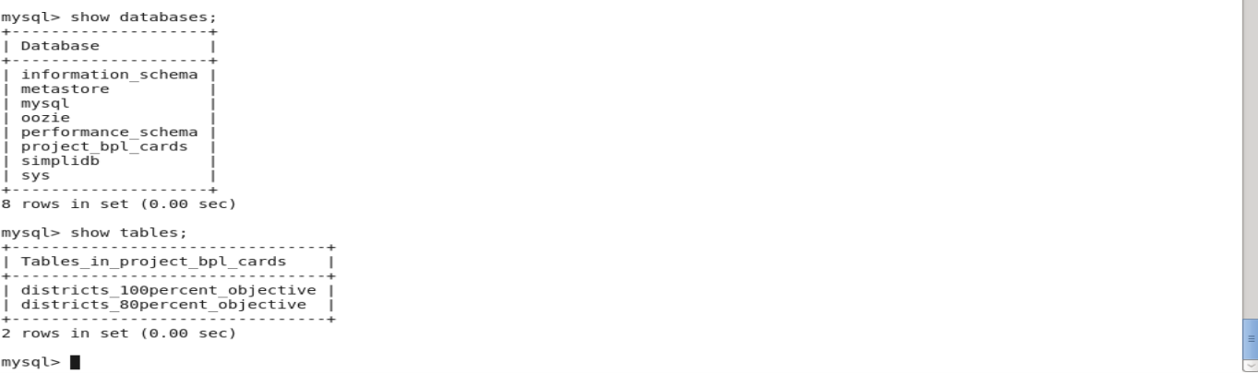

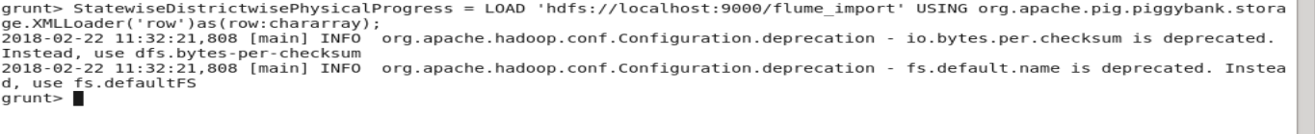

**Task4 - PIG query to process XML and store into PIG table**

In this section we are going to Load data from HDFS to PIG alias ***StatewiseDistrictwisePhysicalProgress***using below query:

**PIG Queries,**

***DEFINE XPathorg.apache.pig.piggybank.evaluation.xml.XPath;***

***StatewiseDistrictwisePhysicalProgress = LOAD 'hdfs://localhost:9000/flume_import' USING org.apache.pig.piggybank.storage.XMLLoader('row') as (row:chararray);***

Next, iterate over each row and load into alias ***StatewiseDistrictwisePhysicalProgress***which has schema fields same as XML schema hyphen (-) are replaced with underscore (_)

***PhysicalProgress = FOREACH StatewiseDistrictwisePhysicalProgress GENERATE XPath(row, 'row/State_Name') AS State_name,***

***XPath(row, 'row/District_Name') AS District_name,***

***XPath(row, 'row/Project_Objectives_IHHL_BPL') AS Project_Objectives_IHHL_BPL,***

***XPath(row, 'row/Project_Objectives_IHHL_APL') AS Project_Objectives_IHHL_APL,***

***XPath(row, 'row/Project_Objectives_IHHL_TOTAL') AS Project_Objectives_IHHL_TOTAL,***

***XPath(row, 'row/Project_Objectives_SCW') AS Project_Objectives_SCW,***

***XPath(row, 'row/Project_Objectives_Anganwadi_Toilets') AS Project_Objectives_Anganwadi_Toilets,***

***XPath(row, 'row/Project_Objectives_RSM') AS Project_Objectives_RSM,***

***XPath(row, 'row/Project_Objectives_PC') AS Project_Objectives_PC,***

***XPath(row, 'row/Project_Performance-IHHL_BPL') AS Project_Performance_IHHL_BPL,***

***XPath(row, 'row/Project_Performance-IHHL_APL') AS Project_Performance_IHHL_APL,***

***XPath(row, 'row/Project_Performance-IHHL_TOTAL') AS Project_Performance_IHHL_TOTAL,***

***XPath(row, 'row/Project_Performance-SCW') AS Project_Performance_SCW,***

***XPath(row, 'row/Project_Performance-School_Toilets') AS Project_Performance_School_Toilets,***

***XPath(row, 'row/Project_Performance-Anganwadi_Toilets') AS Project_Performance_Anganwadi_Toilets,***

***XPath(row, 'row/Project_Performance-RSM') AS Project_Performance_RSM,***

***XPath(row, 'row/Project_Performance-PC') AS Project_Performance_PC;***

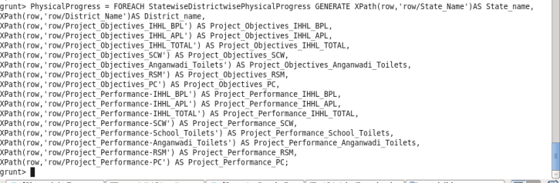

**Task5 – Find the districts who achieved 100 percent objective in BPL cards**

Filter the records by ***Project_Objectives_IHHL_BPL***is equal to ***Project_Performance_IHHL_BPL***

***PhysicalProgress_100_percentage_bpl = FILTER PhysicalProgress BY Project_Objectives_IHHL_BPL == Project_Performance_IHHL_BPL;***

Select only District_Name column,

***districts_100_percentage_bpl = FOREACH PhysicalProgress_100_percentage_bpl GENERATE District_name;***

Now store the data we received from the PIG alias ***districts_100_percentage_bpl*** into the HDFS location where we created at the Task2

***STORE districts_100_percentage_bpl INTO 'hdfs://localhost:9000/districts_100per_objectives';***

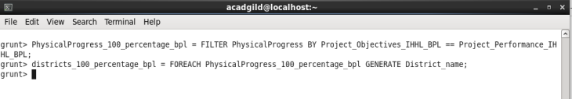

**Task6 – Verifying the stored results in the HDFS**

***hadoopfs -ls /districts_100per_objectives***

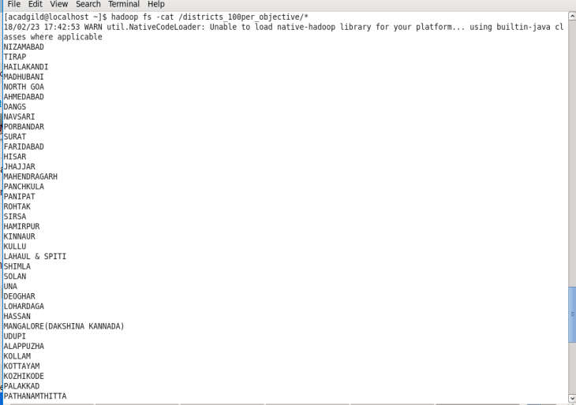

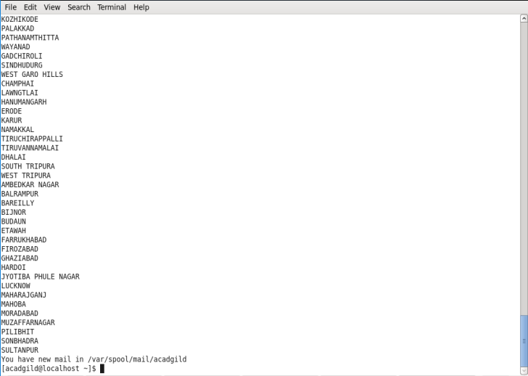

**Task7 – Export the results into mysql using sqoop**

Sqoop command to export,

***sqoop export --connect jdbc:mysql://localhost/project_bpl_cards --username root --password acadgild --table districts_100percent_objective --export-dir '/districts_100per_objectives' --input-fields-terminated-by ',' -m1 --columns district_name***

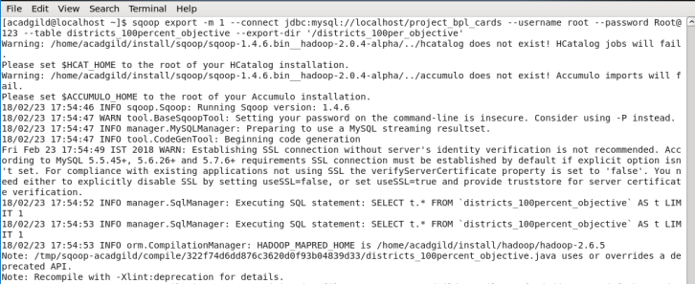

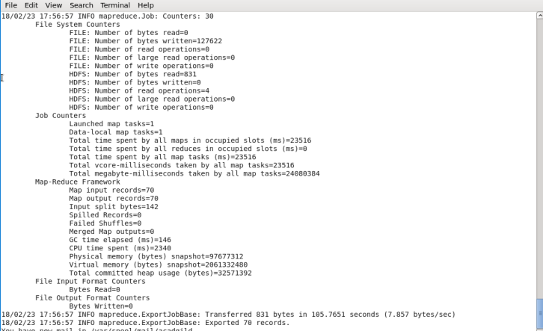

**Task8 – verify the data exported to mysql**

Use the following command in mysql to verify results in mysql

***Select COUNT(district_name) FROM districts_100percent_objective;***

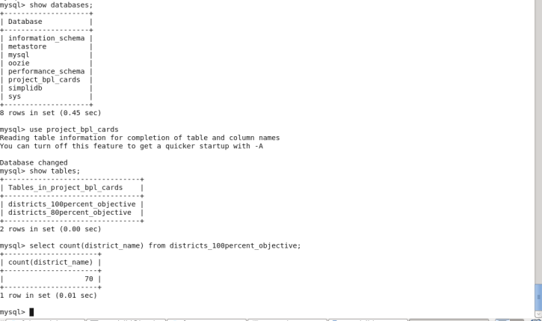

***select * from districts_100percent_objective;***

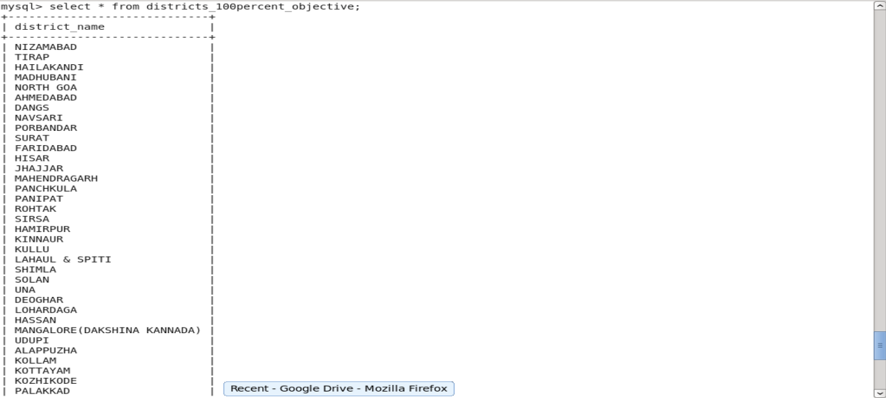

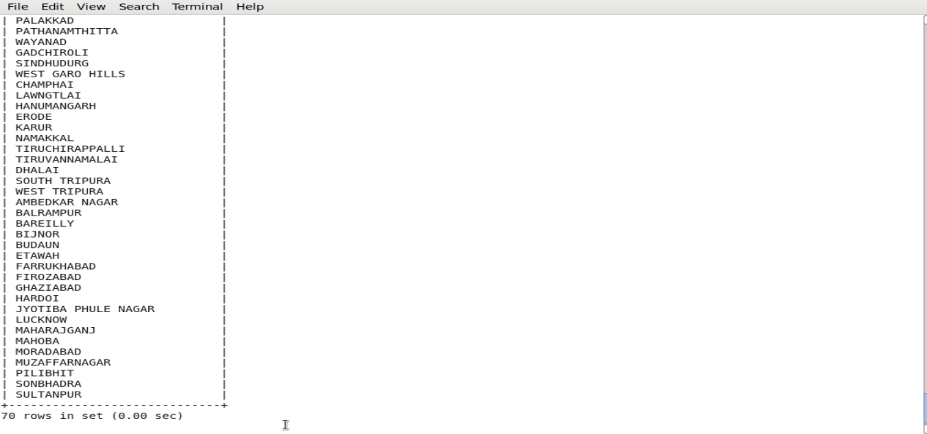

Thus, as per the problem statement 1, we have successfully exported the result from HDFS to mysql database **project_bpl_cards**and into the table **districts_100percent_objective.**

**Problem statemet2 - Write a Pig UDF to filter the districts which have reached 80% of objectives of BPL cards. Export the results to MySQL using Sqoop.**

**Task1 – Create a PIG UDF using Java**

Write a Java class **StateAnalysis**in eclipse which will filter those tuples for which 80 percent objective in BPL cards are achieved. The logic put in exec method is value of **Project_Performance_IHHL_BPL**is equal to more than 80% of **Project_Objectives_IHHL_BPL.**

Java Code

**packageStateAnalysis;**

**importjava.io.IOException;**

**importorg.apache.pig.FilterFunc;**

**importorg.apache.pig.backend.executionengine.ExecException;**

**importorg.apache.pig.data.Tuple;**

**public class** StateAnalysis**extends** FilterFunc

{

@Override

**public**Boolean exec(Tuple input) **throws** IOException

{

try

{

**if**(input == **null** || input.size() == 0)

{

return false;

}

Object valueTuple = input.get(0);

**if**(valueTuple**instanceof**Tuple)

{

Object value1 = ((Tuple) valueTuple).get(0);

Object value2 = ((Tuple) valueTuple).get(1);

**long**objective_value = Long.*valueOf*((String) value1);

**long**performance_value = Long.*valueOf*((String) value2);

**if**(performance_value>objective_value*80/100)

{

return true;

}

}

}

catch(ExecExceptionee)

{

throwee;

}

return false;

}

}

Compile this project and Export the project as .jar file to the acadgild local file system. Here we named the jar file as ***Statewise.jar.***

**Task2 - Write PIG query to find out the districts who achieved 80 percent objective in BPL cards**

***REGISTER /home/acadgild/Project2.jar;***

Next, using the UDF filter those tuple for which **Project_Performance_IHHL_BPL**is equal to more than 80% of **Project_Objectives_IHHL_BPL**

***physicalprogress_80_per_bpl = FILTER PhysicalProgress BY StateAnalysis.StateAnalysis(TOTUPLE(Project_Objectives_IHHL_BPL, Project_Performance_IHHL_BPL));***

Next, select only **District_Name**field using command below:

***district_80_percent_bpl = FOREACH physicalprogress_80_per_bpl GENERATE District_Name;***

Now store the data we received from the PIG alias ***district_80_percent_bpl*** into the HDFS location where we created at the Task2

***STORE district_80_percent_bpl INTO 'hdfs://localhost:9000/districts_having_80percent_objectives';***



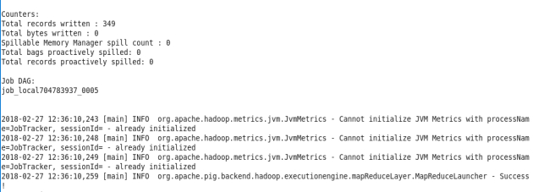

**Task3 – verify the result stored in the HDFS**

The following command shows that folders are created under districts_having_100percent_objectives,

***hadoopfs -ls / districts_80per_objectives***

***hadoopfs –ls / districts_80per_objectives/part-m-00000***

The output file has been generated in the HDFS location,

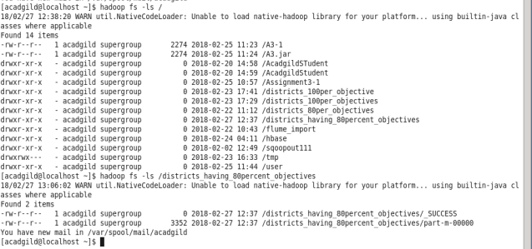

***hadoopfs -cat /districts_80per_objectives/\****

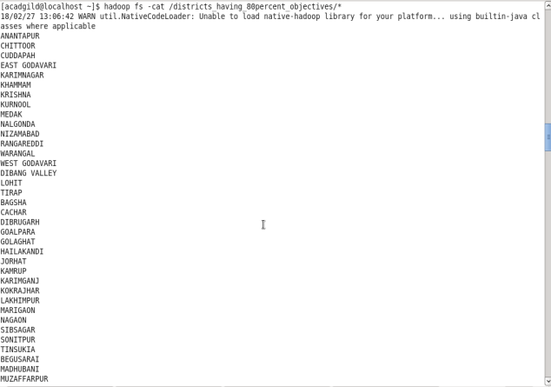

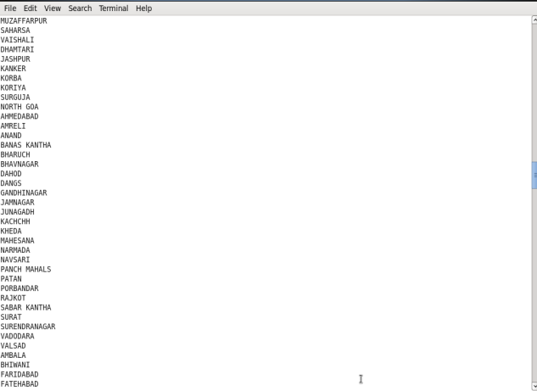

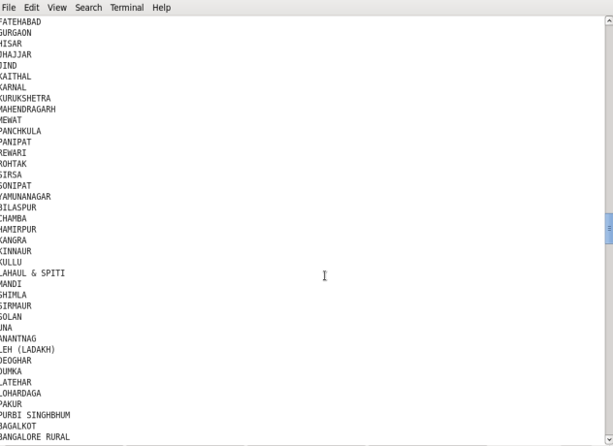

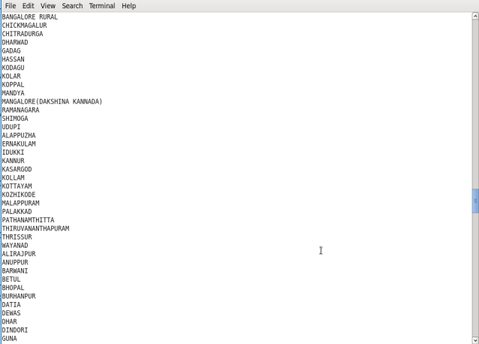

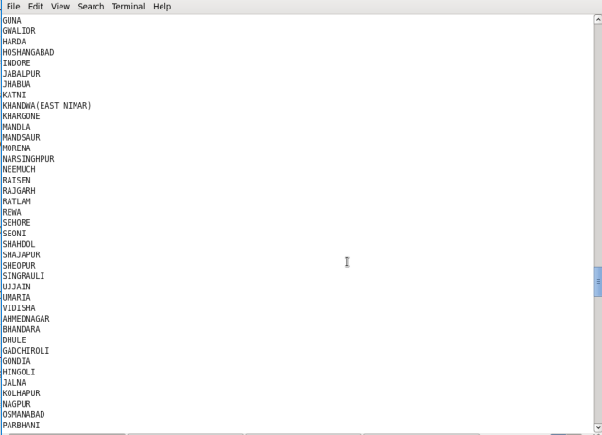

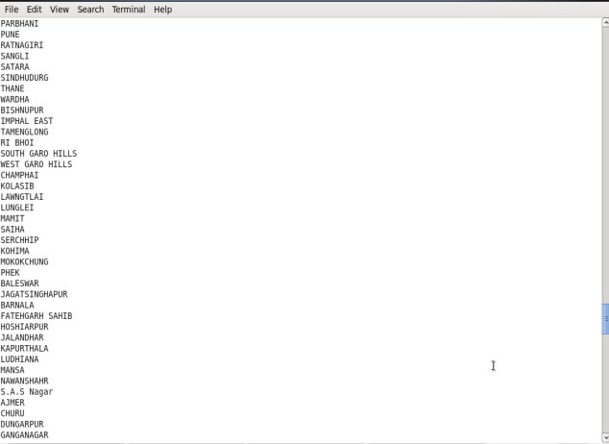

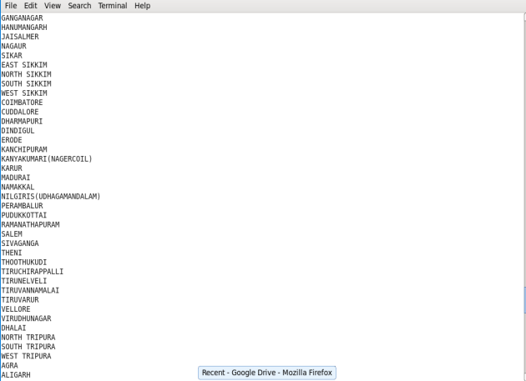

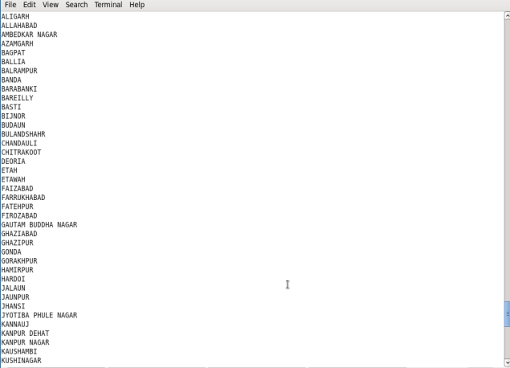

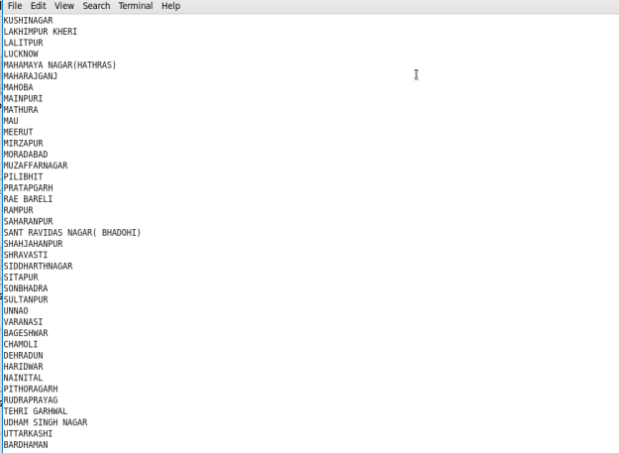

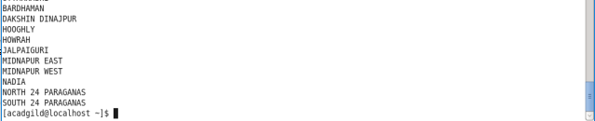

**Task4 – Export the results into mysql table using sqoop command**

In this task we are going use the sqoop to export the desired output stored in the HDFS location **hdfs://localhost:9000/districts_having_80percent_objectives** to the mysql table **districts_having_80percent_objectives** we created in the database **project_bpl_cards**

Sqoop command,

***sqoop export –m 1 --connect jdbc:mysql://localhost/*project_bpl_cards*--username root --password Root@123 --table* districts_80percent_objective *--export-dir '/districts_having_80per_objectives' ;***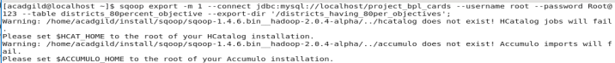

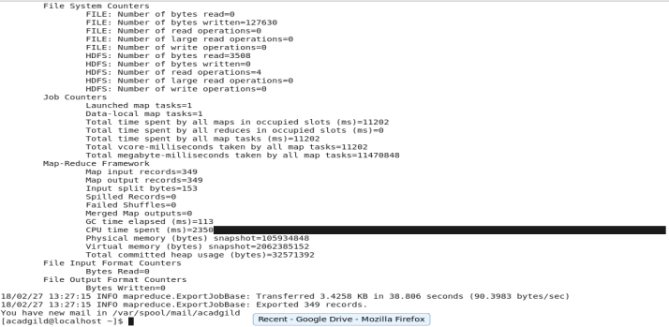

**Task5 – Verify the result in the mysql**

***Select COUNT(district_name) FROM districts_80percent_objective;***

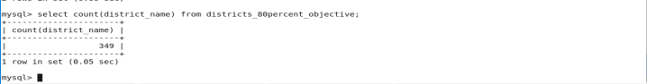

Now, verify the data present in the table

***Select * from districts_80percent_objective;***

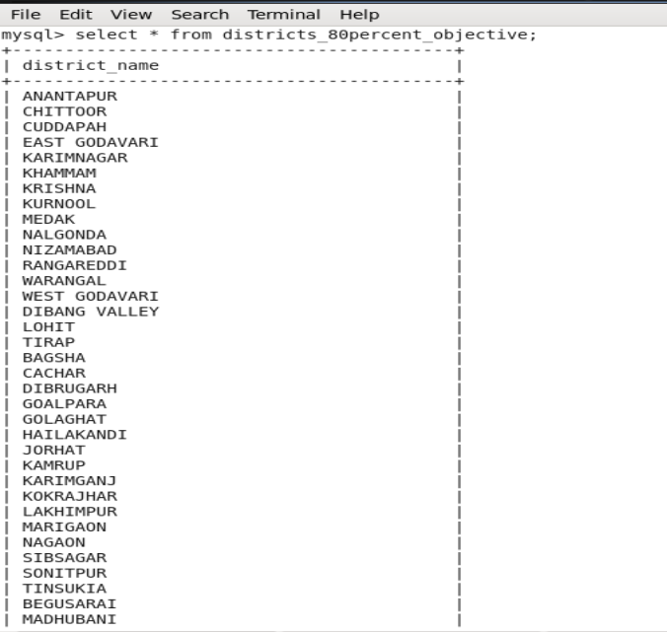

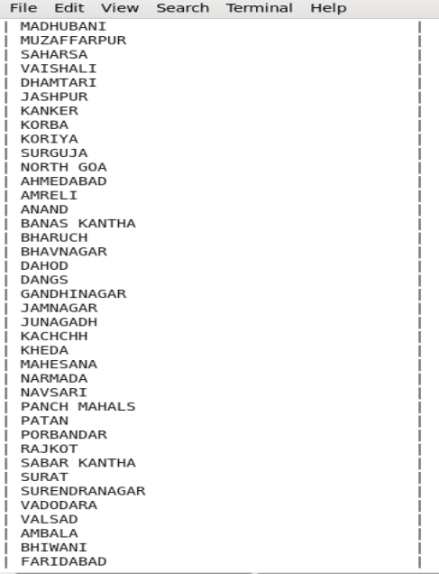

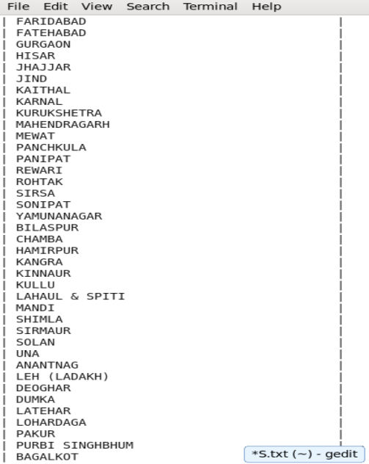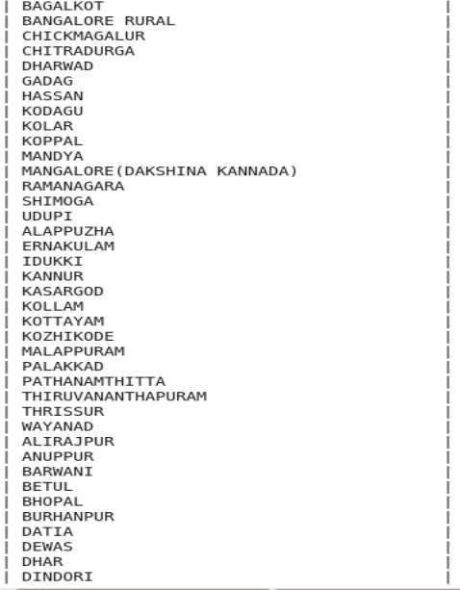

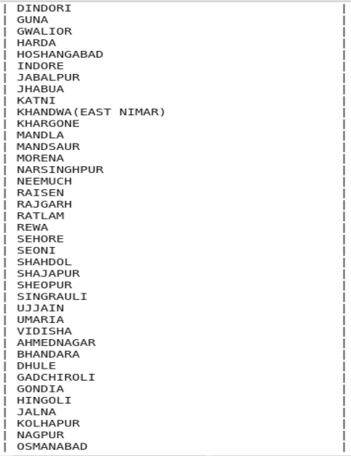

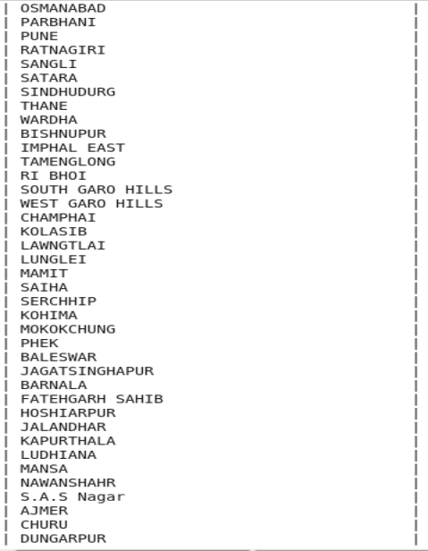

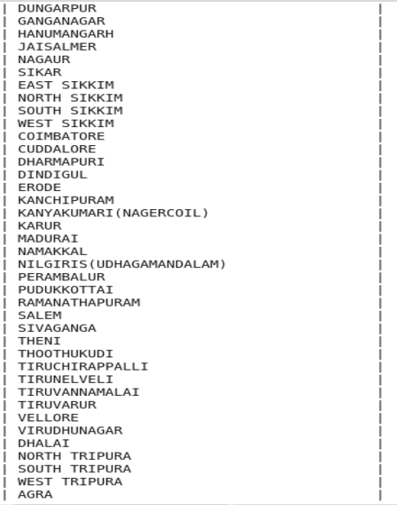

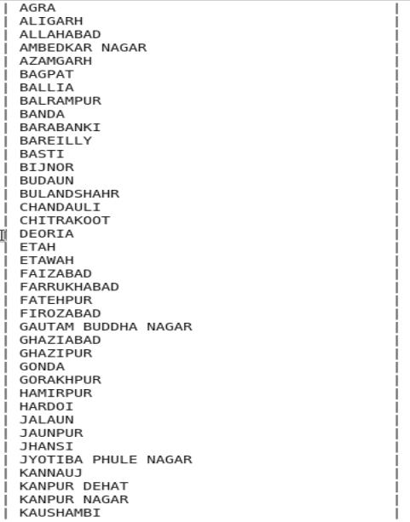

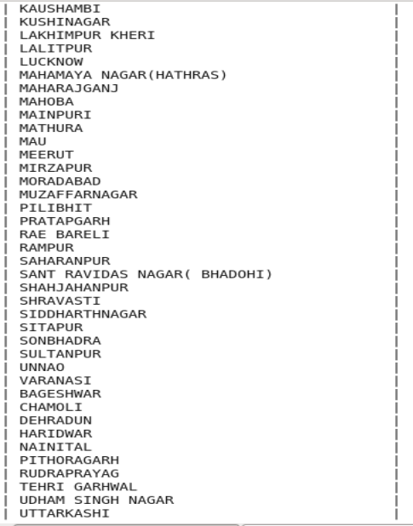

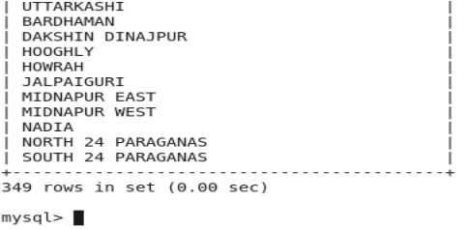

Hence, using PIG UDF we have got the required result and stored into the **mysql**table using **sqoop**commands.