**Assignment-15.2**

**1.Write a partial function to add three numbers in which one is constant and two numbers can be passed as inputs and define another method which can take the partial function as input and squares the result.**

**Source code:**

class Problem1{

val constant:Int =10;

def add(aInt,b:Int):Int = a+b;

object sumInt extends Function2[Int,Int,Int]{

override def apply(x:Int,y:Int):Int = add(add(x,y),constant)

} def squareInt(i:Int):Int={

Var retVal :Int =i*I;

Return retVal;

}

Object partialFunc{

Def main(args :Array[String]){

Var Problem1 = new Problem1();

Println(“partial function returns “+Problem1.sumInt(7,6));

Println(“square function returns “+Problem1.squareInt(Problem1.sumInt(7,6)));

}

}

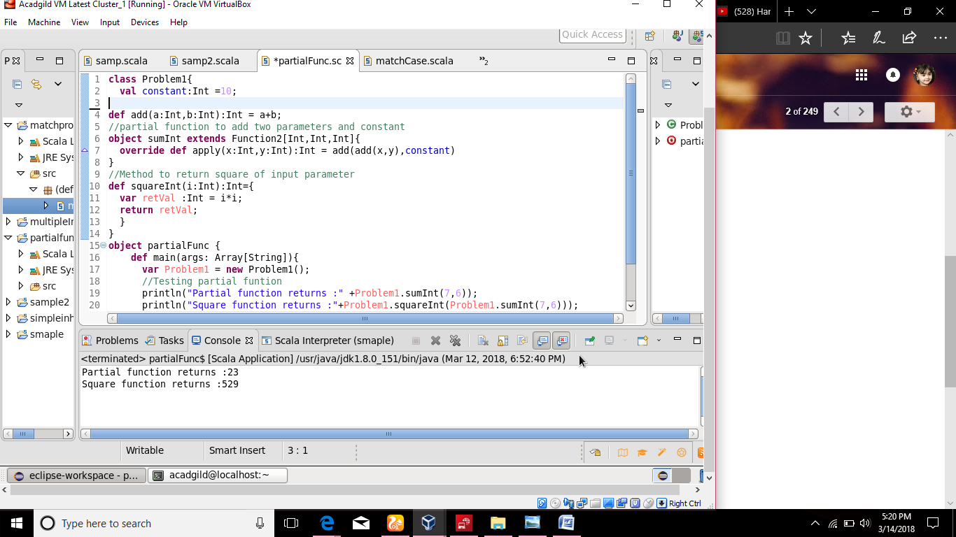

**2. Write a program to print of 4 courses of Acadgild :android-12999,Big Data Development:17999,Java-10000,Spark-19999 using match and add a default condition if the user enters any other course.**

**Source Code:**

Def matchCase{

Def main(args: Array[String])

{ println(“Acadgild courses prices\n”);

Val course = “Andriod”;

Course match{

Case “Android” => println(“Price :12999”);

Case “Android” => println(“Price :17999”);

Case “Android” => println(“Price :10000”);

Case “Android” => println(“Price :19999”);

Case _=> println(“Another course”); } } }

