**Assignment-16.1**

**List of numbers are taken as follows**

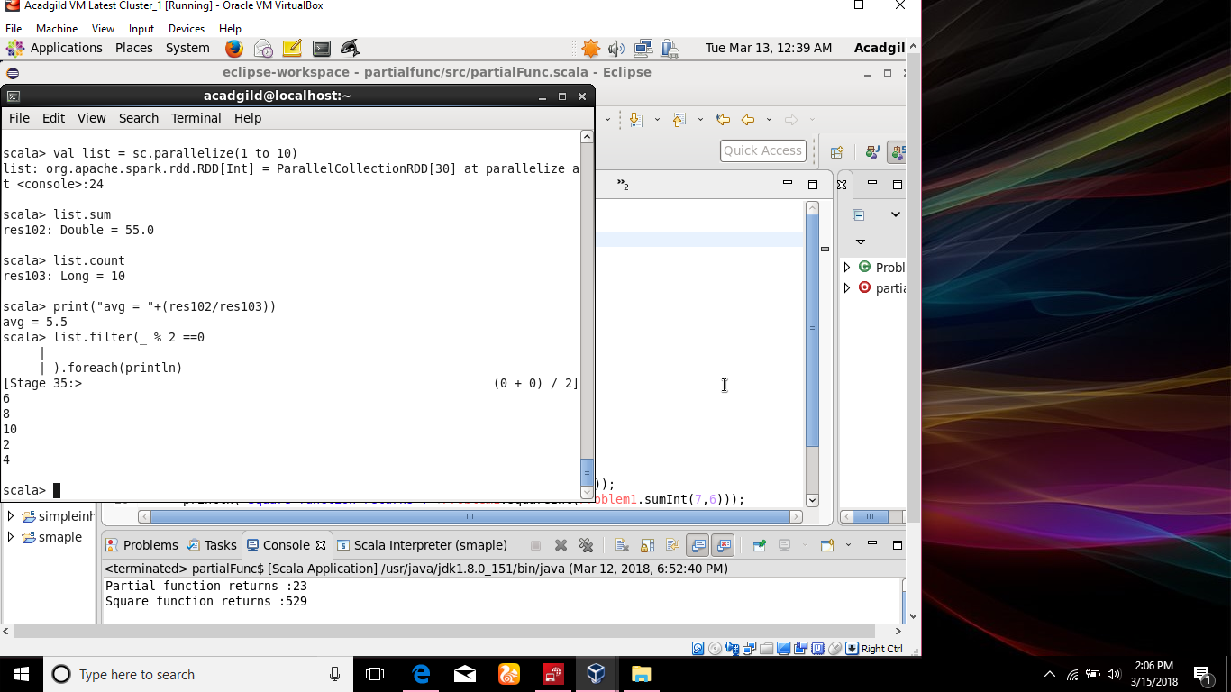

**1.Finding the sum of all numbers**



**2.Finding the total elements in the list**



**3. Claculate the average of the numbers in the list**



**4.Finding the sum of all the even numbers in the list**

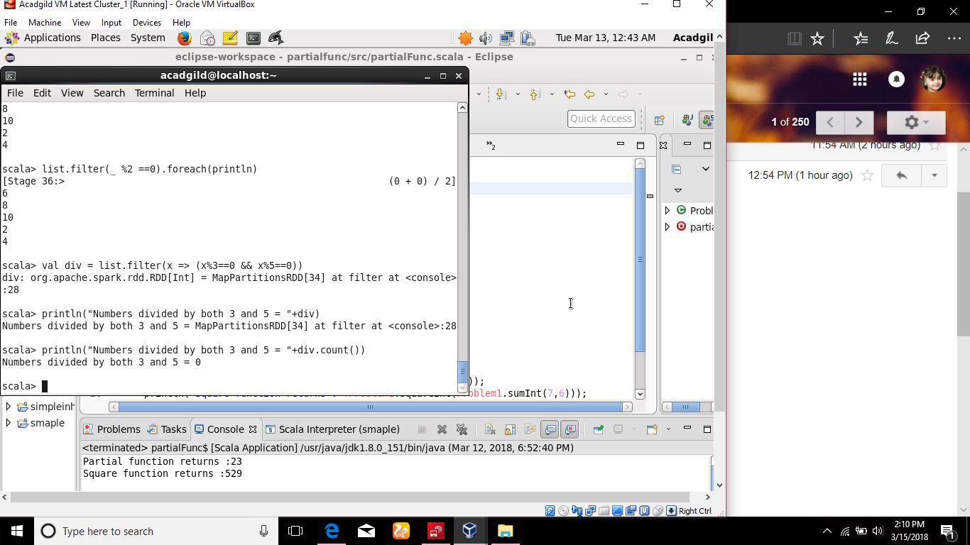

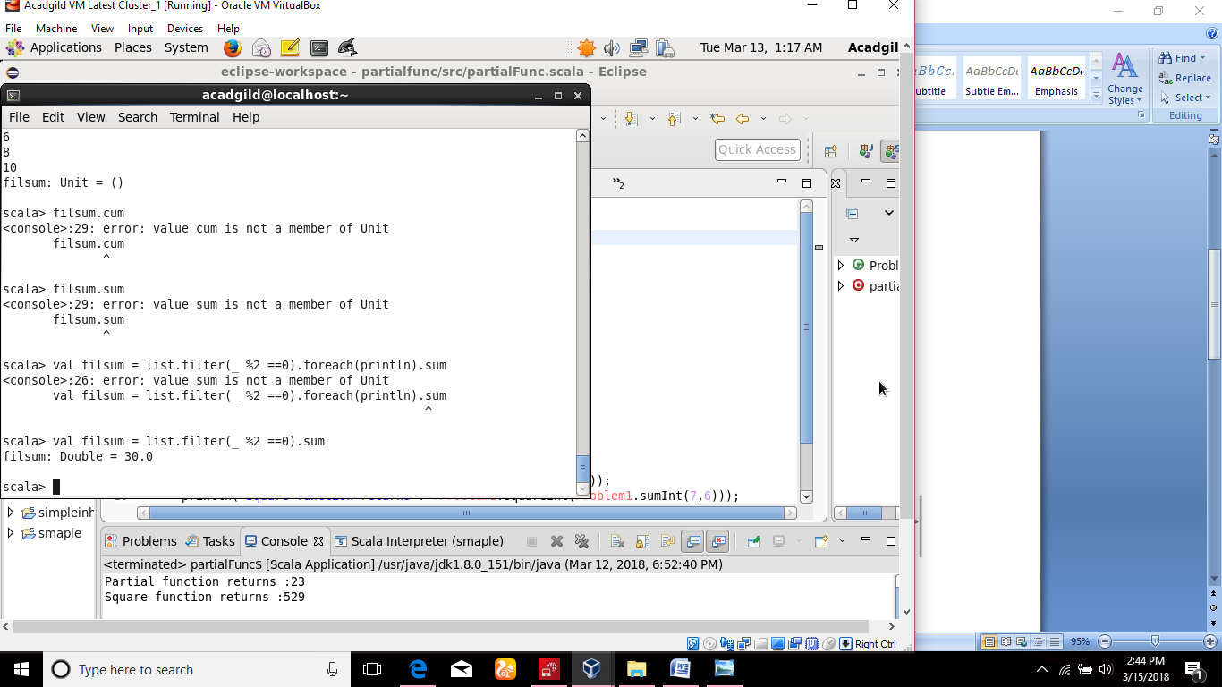

**5. Finding the total number of elements in the list divisible by both 5 and 3.**



